MODULE1: Introduction

MODULE2: Getting Started with NODEJS
NodeJS installation
Link : https://nodejs.org/en/download/prebuilt-installer
Check Version after installation:
Cmd >> node –version
_______________________________________________________________________________
MODULE3: NODE MODULE SYSTEM
M3.1: Global Object
- In NodeJS we don’t have window object instead we have global object.
console.log(global);
D:\PrathameshMES3\Courses\NodeJS\FirstNode_Program>node index.js
Prathamesh is good nodejs programmer:)
<ref *1> Object [global] {
global: [Circular *1],
clearImmediate: [Function: clearImmediate],
setImmediate: [Function: setImmediate] {
[Symbol(nodejs.util.promisify.custom)]: [Getter]
},
clearInterval: [Function: clearInterval],
clearTimeout: [Function: clearTimeout],
setInterval: [Function: setInterval],
setTimeout: [Function: setTimeout] {
[Symbol(nodejs.util.promisify.custom)]: [Getter]
},
queueMicrotask: [Function: queueMicrotask],
structuredClone: [Function: structuredClone],
atob: [Getter/Setter],
btoa: [Getter/Setter],
performance: [Getter/Setter],
fetch: [Function: fetch],
navigator: [Getter],
crypto: [Getter]
}
M3.2: Module and Modularity
- We use module in node. Each file is treated as a module which has some functionality respect to that file only.
- We use module.exports to make the function accessible globally which we called as modularity.
Calculator.js
function add(a,b){
return a+b;
}
function sub(a,b){
return a-b;
}
function div(a,b){
return a/b;
}
function mul(a,b){
return a*b;
}

module.exports = {
addition: add,
substraction: sub,
division: div,
multiplication: mul
}

test1.js
const calc = require('./calcuolator')

const add = calc.addition(4, 2)
const sub = calc.substraction(4, 2)
const div = calc.division(4, 2)
const mul = calc.multiplication(4, 2)

console.log(add);
console.log(sub);
console.log(div);
console.log(mul);

M3.3: Introduction to NODE Modules
The Node.js Module System is a mechanism that allows developers to organize JavaScript code into reusable modules. Each module is a separate file that can export specific functions, objects, or values, and other files (modules) can import and use them. This modular approach promotes code organization, reusability, and encapsulation.

M3.4: Child Process module
DOCUMENTATION : https://nodejs.org/docs/latest/api/documentation.html
- Child process module is used to run asynchronous command / to implement task asynchronously. It basically stop event loop of node system and execute the command.
//Child process is a node module used to create sub process within a script

const cp = require('child_process')

// cp.execSync('calc') //Open up the calculator

// cp.execSync('start chrome') //open chrome browser for us

// cp.execSync('start https://nodejs.org/docs/latest/api/documentation.html')

// cp.execSync('start chrome https://www.linkedin.com/in/skubal-a10799215/')

// console.log(`output ${cp.execSync('node demo.js')}`)
// console.log(`${cp.execSync('node demo.js')}`)
// console.log(cp.execSync('node demo.js').toString())
console.log(cp.execSync('node demo.js', {encoding:'UTF-8'}))

M3.5: OS module
Os module is used to get info about current system.
const os = require('os')

console.log(os.arch()); //Which system architecture you are using (64/32 BIT)

console.log(os.platform())

console.log(os.networkInterfaces())

console.log(os.cpus())

console.log(os.totalmem())

console.log(os.freemem())

M3.6: Path module
The path module in Node.js provides utilities for working with file and directory paths. It's a core module, meaning it’s built into Node.js and doesn't need to be installed separately. This module is particularly useful when handling file paths across different operating systems, as it abstracts platform-specific path delimiters (/ for Unix-like systems and \ for Windows).
const path = require('path')

// let ext = path.extname('D:\PrathameshMES3\Courses\NodeJS\Module2\NodeModules\file.txt') // File extension
// console.log(ext)

let filename = path.basename('D:/PrathameshMES3/Courses/NodeJS/Module2/NodeModules/file.txt');
console.log(filename); // Outputs: 'file.txt'

console.log(__filename) //current file name
console.log(__dirname) //current file name

M3.7: FS module with files
The fs module in Node.js provides a suite of functions for interacting with the file system. With it, you can perform tasks like reading and writing files, creating directories, deleting files, and more.
//files

const fs = require('fs')

// Reading a file
let fileCont = fs.readFileSync('One.txt')
console.log(fileCont.toString())

//Writing in file
fs.writeFileSync('One.txt', "How are you all?")
// It write data into file, it exist then it overight it wont append, If file dont exist then it will create
console.log(fileCont.toString())

//Appned a file
fs.appendFileSync('One.txt', " This data is appended")
console.log(fileCont.toString())

//Deleting a file
fs.unlinkSync('One.txt')

M3.8: FS module with directories
//Directories
fs.mkdirSync("myDir") // Create Directory

//Check content inside of a directory
const folder = "D:/PrathameshMES3/Courses/NodeJS/Module2/NodeModules/myDir"
let dirCheck = fs.readdirSync(folder) //return an array of files in directory
console.log(dirCheck)

//Check directory whether it is existing or not (Work with files also)
let dirExist = fs.existsSync('myDir')
console.log(dirExist)

//Delete a directory
fs.rmdirSync('myDir')

MODULE4: NODE PACKAGE MANAGER(NPM)
M4.1: Introduction to NPM
NPM (Node Package Manager) is a tool that comes bundled with Node.js and is widely used to manage packages (libraries or modules) for Node.js projects. NPM allows developers to install, manage, update, and share reusable code packages. It’s one of the largest open-source ecosystems, with over a million packages available.
DOCUMENTATION: https://docs.npmjs.com/about-npm
Check NPM version
- npm –v

M4.2: How to install and use an NPM package?
- Creating package:
PS D:\PrathameshMES3\Courses\NodeJS\Module4-NPM> npm -v
10.9.0
PS D:\PrathameshMES3\Courses\NodeJS\Module4-NPM> npm init
This utility will walk you through creating a package.json file.
It only covers the most common items, and tries to guess sensible defaults.

See `npm help init` for definitive documentation on these fields
and exactly what they do.

Use `npm install <pkg>` afterwards to install a package and
save it as a dependency in the package.json file.

Press ^C at any time to quit.
package name: (module4-npm) mypackage
version: (1.0.0)
description:
entry point: (index.js)
test command:
git repository:
keywords:
author:
license: (ISC)
About to write to D:\PrathameshMES3\Courses\NodeJS\Module4-NPM\package.json:

{
"name": "mypackage",
"version": "1.0.0",
"main": "index.js",
"scripts": {
"test": "echo \"Error: no test specified\" && exit 1"
},
"author": "",
"license": "ISC",
"description": ""
}

Is this OK? (yes)

- Installing figlet package which is basically provides some different printing formats
PS D:\PrathameshMES3\Courses\NodeJS\Module4-NPM> npm i figlet

added 1 package, and audited 2 packages in 7s

found 0 vulnerabilities

- In dependencies we can see the package which we install recently and its version(package.json).
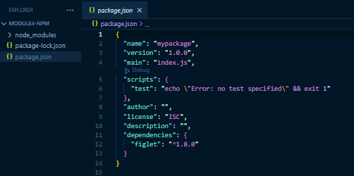

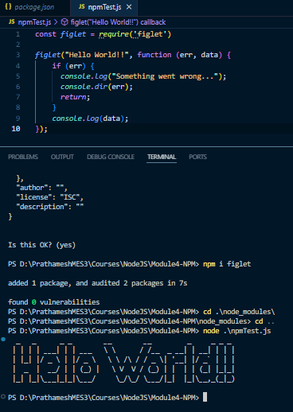

M4.3: gitignore
A .gitignore file in Git specifies intentionally untracked files to ignore. It’s used to prevent certain files or directories from being tracked in a Git repository, which can help keep the repository clean and protect sensitive information, large files, and files that change frequently (like log files).

Common .gitignore Patterns
- Single Files and Folders
  - To ignore a single file, add its name:
Copy code
secret.txt
  - To ignore an entire directory, add the directory name followed by a slash:
Copy code
node_modules/
- File Types
  - To ignore all files of a specific type (e.g., .log files):
bash
Copy code
*.log
  - To ignore multiple file types:
bash
Copy code
*.log
*.tmp
- Specific Files in a Folder
  - You can specify files within subdirectories:
bash
Copy code
src/temp/
build/
- Ignoring All Files in a Directory but Allowing Certain Files
  - Add an asterisk to ignore everything and then add exceptions:
diff
Copy code
docs/*
!docs/README.md
- Negating Patterns
  - Use an exclamation mark (!) to negate a pattern and include a file previously ignored:
c
Copy code
*.log
!important.log

M4.4: Semantic versioning
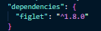
1.8.0
1 : Major release
8 : Minor release
0 : Patch release

M4.5: Publish your own NPM
- Create Package
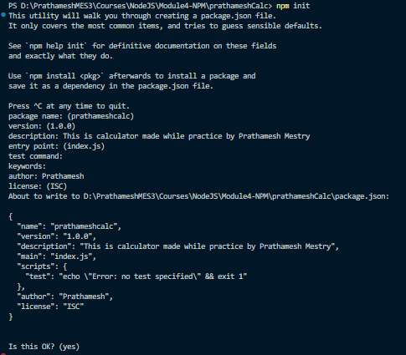
- Create NPM account
- Add user
Command: > npm login
- Publish package
Command: > npm publish

MODULE5: Getting Started with Express
M5.1: Introduction to Express
- Client Server Architecture
- Request response cycle.

- Express
Express is a minimal and flexible Node.js web application framework that provides a robust set of features for building web and mobile applications on the server side. It simplifies the process of handling HTTP requests and responses, defining routes, managing middleware, and working with templates.
Key features of Express on the server side include:
- Routing: Express allows you to define routes for different HTTP methods (GET, POST, PUT, DELETE, etc.) and map them to specific functions or middleware.

- Middleware: Express uses middleware to handle requests, such as logging, authentication, error handling, and parsing request bodies. Middleware functions are executed in sequence for each request.

- Templating: Express supports various templating engines (like EJS, Pug, and Handlebars) to generate dynamic HTML pages.

- Request Handling: Express provides a simple API to work with HTTP requests (such as reading query parameters, handling form data, and managing request headers).

- Error Handling: Express allows you to define error-handling middleware to capture and respond to errors in your application.

- Static Files: Express can serve static files, like images, CSS, and JavaScript, with ease.

- Integration with Databases: You can integrate Express with databases (such as MongoDB, MySQL, PostgreSQL) to perform operations like creating, reading, updating, and deleting data.

M5.2: Installation of Express
- Go to the following link and copy the npm command for downloading express.
LINK: https://www.npmjs.com/package/express
Command: npm install express
M5.3: Lets use Express
- Require the express as it is third-party package.
- Express have so many methods which are like get, put, post, delete and so on.
- You need to listen on some port so that is mandatory.
- Run the server again to reflect changes.
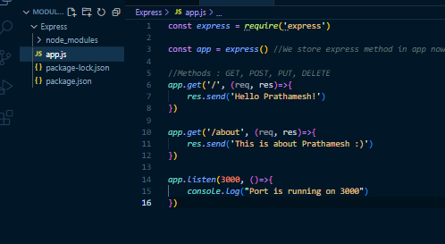

M5.4: Nodemon
- We have to again and again start the server so nodemon help to avoid this.
- Nodemon is a utility that helps develop Node.js applications by automatically restarting the server whenever file changes in the directory are detected.
- Install the nodemon using following command
COMMAND: npm install nodemon
- I got error while running file using nodemon because system was not recognizing the nodemon so I used following command to resolve.
COMMAND: npm install -g nodemon
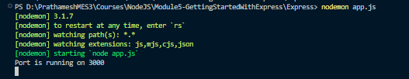

M5.5: Environment variable and PORT
- So when we running on production environment there we can’t specify 3000 port statically. There we need to use process object and dynamically set the port of production environment.
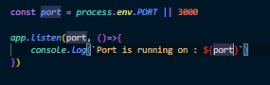

M5.6: Route parameters
// Route parameters
app.get('/courses/:id', (req, res)=>{
res.send(req.params.id) // Req parameter give the id
})

- Here you can see we have set id in route which will be dynamically taken from params.
- We see in url values are changing according to clicks.

M5.7: Handling multiple routes
- For handling multiple routes we can use object in javascript. We can define id for each entity and we can show result as per search.
- We can use route parameters to get an id or whatever.
- const courses = [
- {id:1, name:'Javascript'},
- {id:2, name:'NodeJS'},
- {id:3, name:'ReactJS'}
- ];

app.get('/courses/:id', (req, res)=>{
let course = courses.find(course => course.id === parseInt(req.params.id))

if(!course) res.status(404).send("Course you are looking for is not exist")
res.send(course)
})

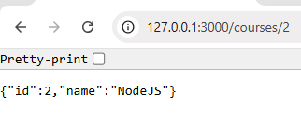
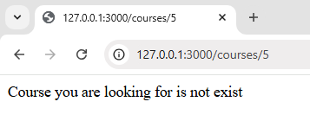
M5.8: Postman
- Postman is your single platform for collaborative API development.

M5.9: HTTP post method
- We need to use POST method but before that we have to use middleware that is express.json() to get req.body data.

app.use(express.json())

app.post('/courses', (req, res)=>{
const course = {
id:courses.length+1,
name: req.body.name
}
courses.push(course)
res.send(course)
})
- Above we are adding data into courses object which we have created earlier.
- So now in post man we have to change method from GET to POST by default it will be GET.
- Then we have to put url which is using and then we have to go to Body then select raw and then change Text to JSON see below.
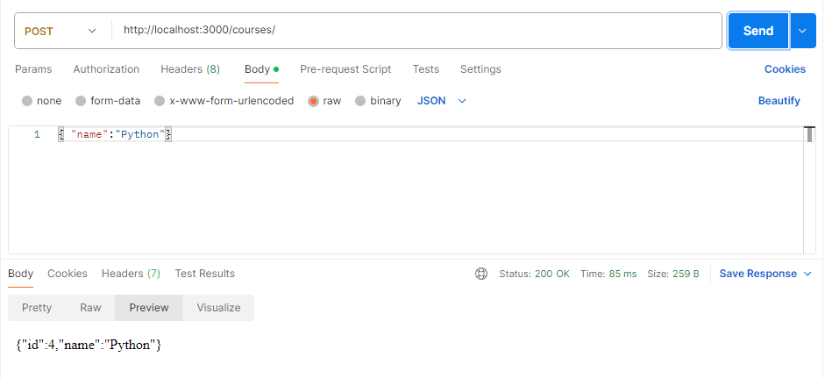
- In the body you can pass object which will be taken in server side and it will add that data into object array. Below you can see response.

M5.9: HTTP put method
- Update something.
app.put("/courses/:id", (req, res)=>{
let course = courses.find(course => course.id === parseInt(req.params.id))
if(!course) res.status(404).send("Course you are looking for is not exist")
course.name = req.body.name
res.send(course)
})

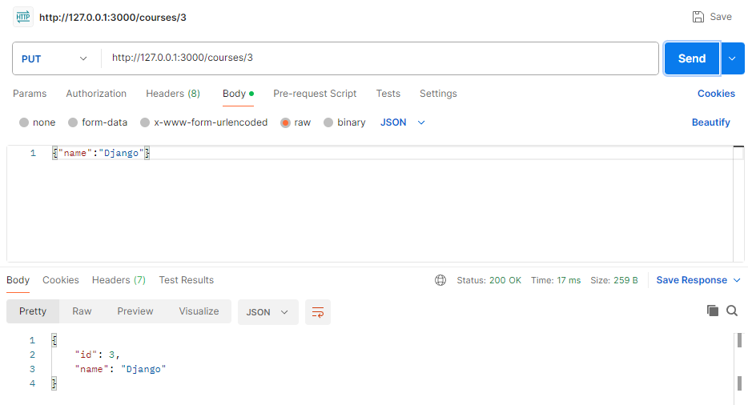

M5.10: HTTP delete method
- Delete something.
app.delete("/courses/:id", (req, res)=>{
let course = courses.find(course => course.id === parseInt(req.params.id))
if(!course) res.status(404).send("The course you are looking for is not found")
let newCourses = courses.filter(crse=> crse.id !== course.id)
res.send(newCourses)
})
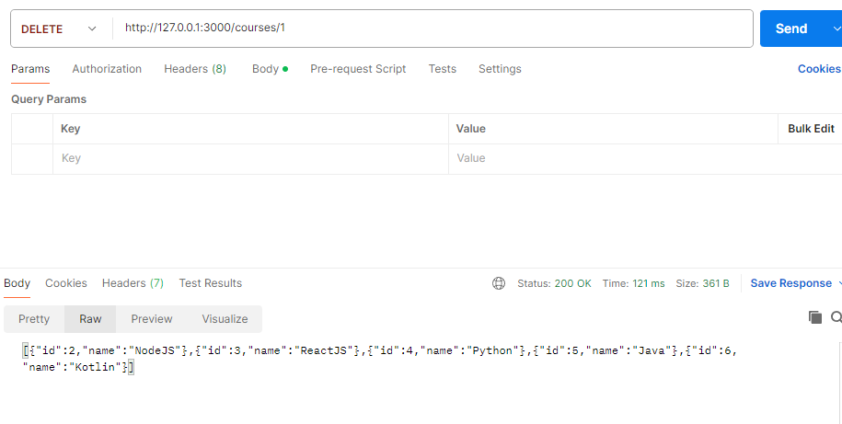

MODULE6: Middlewares in Express

M6.1: What are middlewares?
- In Express, middleware functions are functions that execute during the request-response cycle. They can manipulate the request object (req), response object (res), or pass control to the next middleware in the stack using next(). Middleware functions are essential for tasks like logging, authentication, request parsing, and more.

- Types of Middleware in Express
- Application-Level Middleware
  - Defined directly on the Express app instance.
  - Used across the application or on specific routes.
javascript
Copy code
const express = require('express');
const app = express();

// Application-level middleware
app.use((req, res, next) => {
console.log('Request received at:', new Date().toISOString());
next(); // Passes control to the next middleware
});
- Router-Level Middleware
  - Defined on an express.Router instance to apply middleware to a specific router.
javascript
Copy code
const router = express.Router();

// Router-level middleware
router.use((req, res, next) => {
console.log('Router-level middleware activated');
next();
});

router.get('/courses', (req, res) => {
res.send('List of courses');
});

app.use('/api', router);
- Built-in Middleware
  - Express provides some built-in middleware like:
    - express.json() for parsing JSON payloads.
    - express.urlencoded() for parsing URL-encoded data.
javascript
Copy code
app.use(express.json()); // To parse JSON bodies
- Third-Party Middleware
  - Libraries that provide additional functionality, like morgan for logging or cookie-parser for parsing cookies.
javascript
Copy code
const morgan = require('morgan');
app.use(morgan('tiny')); // Using third-party middleware for logging
- Error-Handling Middleware
  - A middleware function specifically for error handling.
  - Defined with four parameters: (err, req, res, next)
javascript
Copy code
app.use((err, req, res, next) => {
console.error(err.stack);
res.status(500).send('Something went wrong!');
});
- How Middleware Works
When a request is made, Express will:
- Execute the middleware in the order they are defined.
- If a middleware calls next(), Express moves to the next middleware in line.
- If next() is not called, the request-response cycle stops, and the response can be sent directly.
M6.2: Custom middlewares?
- Custom middleware are made by developers.
- Custom middleware has to use next() as it hold the request and it doesn’t allow to send the response.
- If you have written two custom middleware both will be executed simultenously.
const myMiddleware = require("./middlewares/middle.js")
const middleware2 = require('./middlewares/middle2.js')

const app = express()

app.use(myMiddleware)
app.use(middleware2)

- Declared middleware function in another directory
function myMiddleware(req, res, next){
console.log("This is custom middleware")
next()
}

module.exports = myMiddleware

- It executing while request and next method pass control to another middleware in stack and finally send the response.
Restarting 'app.js'
Port is running on : 3000
This is custom middleware
This is second middleware

M6.3: Third-Party middlewares?
- We install middleware from external resources.
Command: npm –i morgan
const morgan = require('morgan')
app.use(morgan('tiny'))

MODULE7: Asynchronous programming

M7.1: Introduction to asynchronous programming
- What is synchronous behavior?
Synchronous means it will use a single thread so only one operation or program will run at time. Sync is blocking it will only send one request to server and it will wait until it get response from the server.

- What is asynchronous behavior?
Async is non-blocking. It will send multiple request to the server at the time.

M7.2: Reading file Synchronously
- So in nodejs fs module help to read file. It has readFileSync() method which is taking file path to which it will read.
- This method runs synchronously that is it will halt further execution.

const fs = require('fs')

const app = express()

app.use(express())

console.log("First line")

//------------------readFileSync() read the file synchronously-----------------------------------------
let data = fs.readFileSync('f1.txt')
console.log(data.toString())
//----------------------------------------------------------------------------------------------------

M7.3: Reading file Asynchronously
- Now there is another method fs.readFile() which require path, text-formatting like (UTF-8) and callback function which will handle error and data.
- This method run asynchronously it don’t disturb execution flow.

const fs = require('fs')
//------------------readFile() read the file asynchronously-----------------------------------------
fs.readFile('f1.txt', "UTF-8", function cb1(err, data){
if(err){
console.log(err)
}
console.log(data)
})

M7.4: The event loop and everything
- There is call stack, node API space and callback queue.
- Firstly in program all synchronous code will executed in call stack till that whatever asyn code waits in Node API space.
- Then in event loop there it will check whether call stack is empty or not then it will execute functions from callback queue.

M7.5: Serial execution of async code
- Callback queue execute function concurrently. It is parallel execution flow.
- We can make serial execution using promises or by calling another callback into parent callback.

fs.readFile('f1.txt', "UTF-8", function cb1(err, data) {
if (err) {
console.log(err);
} else {
console.log(`File1 data -->> ${data}`);

fs.readFile('f2.txt', "UTF-8", function cb2(err, data) {
if (err) {
console.log(err);
} else {
console.log(`File2 data -->> ${data}`);

fs.readFile('f3.txt', "UTF-8", function cb3(err, data) {
if (err) {
console.log(err);
} else {
console.log(`File3 data -->> ${data}`);

fs.readFile('f4.txt', "UTF-8", function cb4(err, data) {
if (err) {
console.log(err);
} else {
console.log(`File4 data -->> ${data}`);
}
});
}
});
}
});
}
});

M7.6: Promises in Javascript
- A promise in JavaScript is an object that represents the eventual completion or failure of an asynchronous operation.
- Promise is default in pending state. Then fulfilled state, reject state and end settled state.
Example: My mother telling me that I don’t do work in home. So I Promise her that I will bring groceries tomorrow.
- Now Today my promise is in Pending state.
- Now next day I brought groceries now my promise is in Fulfilled state.
- Exceptional : I could not bring groceries today due to some reasons, now promise is in Rejected state.
- Now I didn’t get lunch at home and my promise has been settled .

let myPromise = new Promise(function(resolve, reject){
const a = 5
const b = 5

setTimeout(()=>{
if(a===b){
resolve("The values are equal")
}else{
reject("The values are not equal")
}
}, 2000)
})

//Pending state
// console.log(myPromise)

myPromise.then((res)=>{
console.log(res)
})
.catch((err)=>{
console.log(err)
})

M7.7: Promises and Async Await
- Using async/await in Promises makes handling asynchronous code more readable and easier to manage. It allows you to write asynchronous code in a synchronous-like manner. Here's how you can convert your existing promise-based code to use async/await.
- await can only be used inside async functions.

function placeOrder(order){
return new Promise((resolve, reject)=>{
if(order==="coffee"){
resolve(order)
}else{
reject("We are not serving other orders than Coffee :(")
}
})
}

function proccessOrder(order){
return new Promise((resolve)=>{
console.log("Your coffee is being ready...")
setTimeout(()=>{
resolve(`YaY!!!!!...your ${order} is waiting for you to taste :)`)
}, 3000)
})
}

//Async Await keyword
async function serveOrder(){
try{
let orderPlaced = await placeOrder('tea')
console.log(`Your order for ${orderPlaced} has been received..`)
let proccessedOrder = await proccessOrder(orderPlaced)
console.log(proccessedOrder)
}catch(err){
console.log(err)
}
}
serveOrder()

MODULE8: CRUD with mongoose and mongodb
M8.1: Getting started with mongoDB
- It follows No-SQL.

M8.2: Installation and configuration of mongoDB
- Install community server.
Link: https://www.mongodb.com/try/download/community
- After installation complete, go to C drive program files there find mongodb. Go to bin and then copy the path.
- Now go to system variables and then add the path.
- Now in command prompt you can type mongod and check.
- There you will see error":"NonExistentPath: so for this you have to create the path until and unless you create the path you cant connect to the db.
Command: md c:\data\db
- Now we have to install mongoose. It is bridge between express and mongodb.
Command: npm i mongoose
- Now we can connect using mongoose.connect()
const mongoose = require('mongoose')

mongoose.connect('mongodb://127.0.0.1/testDB')
.then(()=>{
console.log("DB is connected successfully")
})
.catch((err)=>{
console.log(err)
})

M8.3: Schemas and models
- A schema in Mongoose (and in databases generally) is a blueprint or structure that defines the shape of documents within a collection. In MongoDB, collections are made up of documents, and each document is a set of key-value pairs.
//Schema
const courseSchema = mongoose.Schema({
name: String,
creator: String,
publishedDate: {type: Date, default: Date.now},
isPublished: Boolean
})

- Model in mongoose is nothing but collection in mongodb.
//Models
const Course = mongoose.model('Course', courseSchema)

async function createCourse(params) {
const course = new Course({ //This is model
name: 'Javascript',
creator: 'Prathamesh',
isPublished: true
})

const result = await course.save()
console.log(result)
}

createCourse()

M8.4: How to query for documents?

async function getCourses(params) { //Get the course
// const courses = await Course.find({creator: 'Madhuri'}) // Give me specific course of which creator: Madhuri
const courses = await Course.find({creator: 'Madhuri'}).select({name: 1}) // Give me specific course of which creator: Madhuri
console.log(courses)
}

getCourses()

M8.5: Comparison query operator
//Comparison Op (gt, eq, gte, lte, lt, in, not in)

async function getCourses(params) { //Get the course
// const courses = await Course.find({creator: 'Madhuri'}) // Give me specific course of which creator: Madhuri
const courses = await Course.find({rating: {$in: [3, 4.5]}}).select({name: 1}) // Give me specific course of which creator: Madhuri
console.log(courses)
}

getCourses()

M8.6: Logical query operator
//Logical operator (and, or)

async function getCourses(params) { //Get the course
// const courses = await Course.find({creator: 'Madhuri'}) // Give me specific course of which creator: Madhuri
const courses = await Course.find({rating: {$in: [3, 4.5, 4.0]}}).select({name: 1}) // Give me specific course of which creator: Madhuri
.and([{creator: "Prathamesh"}, {rating: 2.5}])
console.log(courses)
}

getCourses()

M8.7: How to update a document?
//Upate the document
async function updateCourse(id) {
let course = await Course.findById(id)
if(!course) return;
course.name = "React"
course.creator = "Steve"
const updatedCourse = await course.save()
console.log(updatedCourse)
}

updateCourse('673333ae23b8cdfae825c7f7')

M8.8: How to delete a document?
async function deleteCourse(id) {
let course = await Course.findByIdAndDelete(id)
console.log(course)
}
deleteCourse('673333ae23b8cdfae825c7f7')

MODULE9: Data validation in MongoDB
M9.1: Data validation in MongoDB
- Data validation ensure data is correct or satisfy requirement parameter or not.
- Here required: true is used.
//Schema
const courseSchema = mongoose.Schema({
name: {type:String, required: true},
creator: String,
publishedDate: {type: Date, default: Date.now},
isPublished: Boolean,
rating: Number
})

M9.2: Inbuilt data validator

1. Data Type Validators
Mongoose validates data types automatically when you define the type in your schema. Examples:
- String, Number, Date, Buffer, Boolean, ObjectId, etc.
javascript
Copy code
const userSchema = new mongoose.Schema({
name: String,
age: Number,
createdAt: Date,
isActive: Boolean
});

2. Required
Use required: true to make a field mandatory.
javascript
Copy code
const userSchema = new mongoose.Schema({
name: { type: String, required: true }
});

3. Default
Use default to set a default value if none is provided.
javascript
Copy code
const userSchema = new mongoose.Schema({
isActive: { type: Boolean, default: true }
});

4. String Validators
- minlength / maxlength: Define the minimum or maximum length of a string.
- match: Use a regular expression to enforce a pattern.
javascript
Copy code
const userSchema = new mongoose.Schema({
username: { type: String, minlength: 5, maxlength: 20 },
email: { type: String, match: /.+\@.+\..+/ }
});

5. Number Validators
- min / max: Set minimum and maximum values.
javascript
Copy code
const productSchema = new mongoose.Schema({
price: { type: Number, min: 0, max: 1000 }
});

6. Enum
Use enum to restrict a field to specific values.
javascript
Copy code
const userSchema = new mongoose.Schema({
role: { type: String, enum: ['admin', 'user', 'guest'] }
});

7. Custom Validators
You can also create custom validators using a function.
javascript
Copy code
const userSchema = new mongoose.Schema({
age: {
type: Number,
validate: {
validator: function(value) {
return value >= 18;
},
message: "Age must be at least 18."
}
}
});

