Siri Shortcut: Peak Brainrot Sound Effects
iPhone Only
This guide only applies to Siri Shortcuts on iPhone.
Turn any brainrot sound effect into a Siri Shortcut you can trigger with a tap, a voice command, or your Action Button. Five steps, no extra apps required.

Download a Sound Effect
Go to soundbuttonsworld.com and browse for the brainrot sound effect you want.
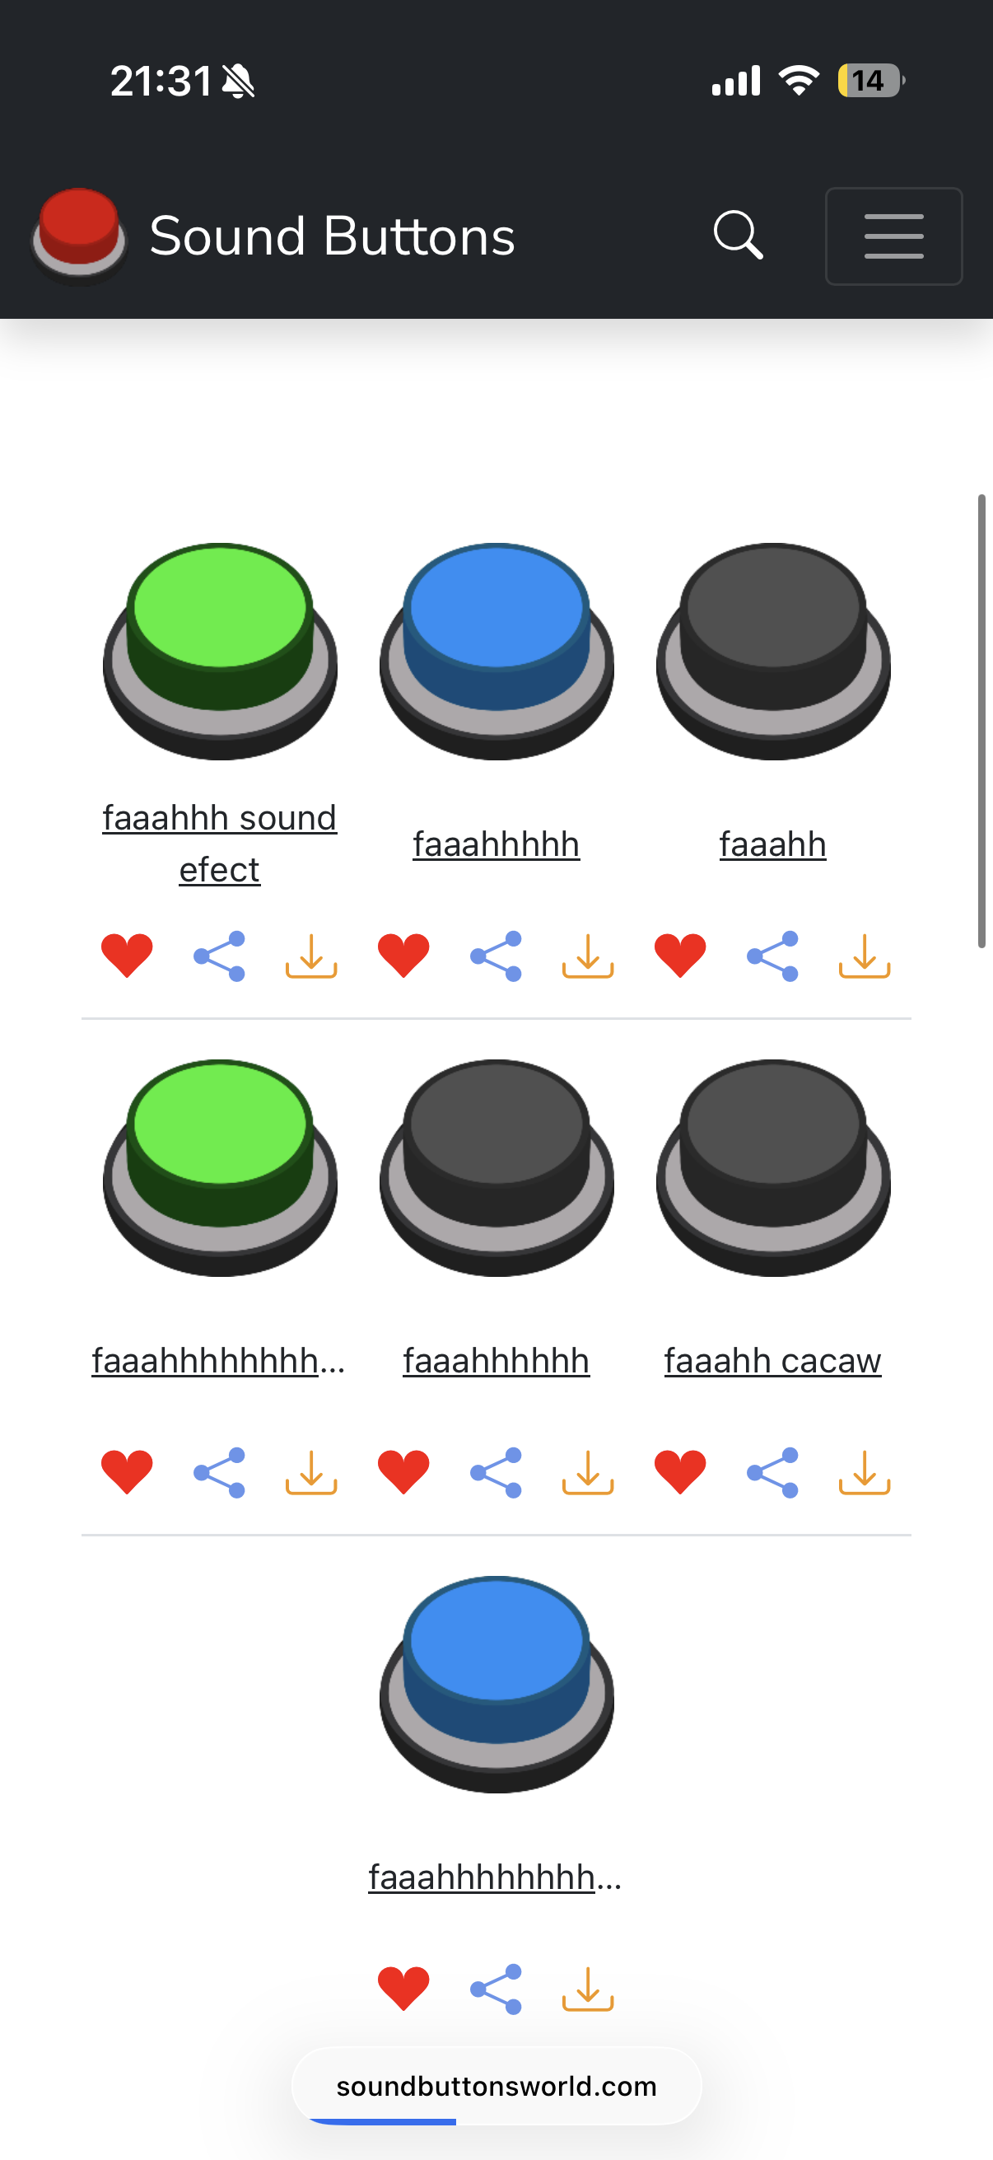
Browse the sound board and tap the download icon on your chosen effect.
When the download prompt appears, tap Download to save the MP3 file to your iPhone.
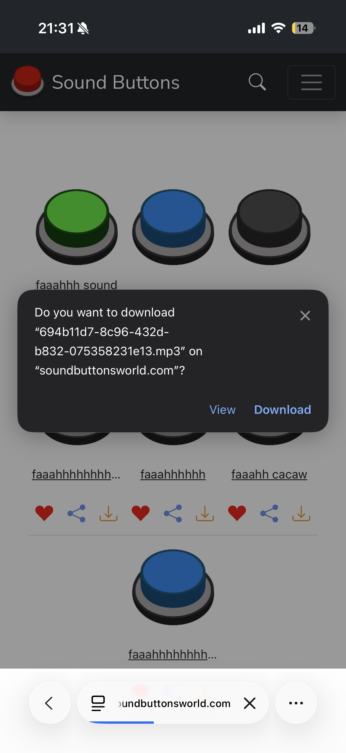
Tap Download to save the MP3 to your device.

Encode the MP3 to Base64
Open a Base64 encoder in your browser. A good free option is codebeautify.org/mp3-to-base64-converter. Upload the MP3 file you just downloaded.
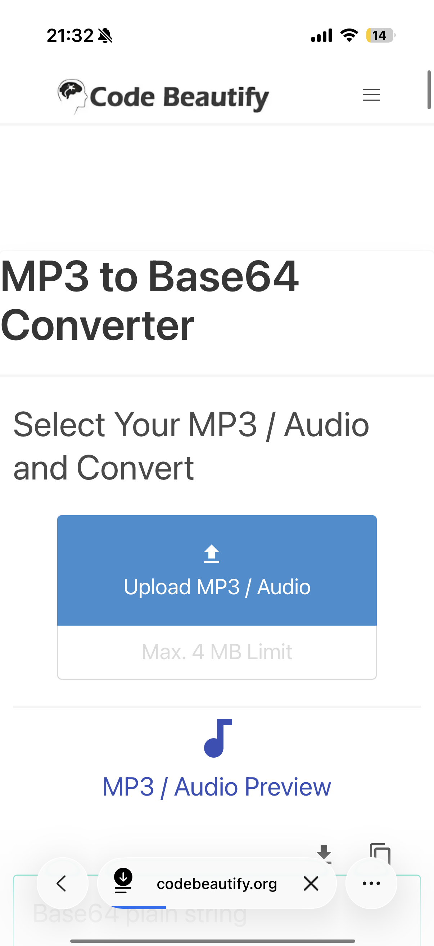
Upload your MP3 file on Code Beautify.
Once the file is processed, copy the entire Base64-encoded text output. Use the copy button next to the output for convenience.
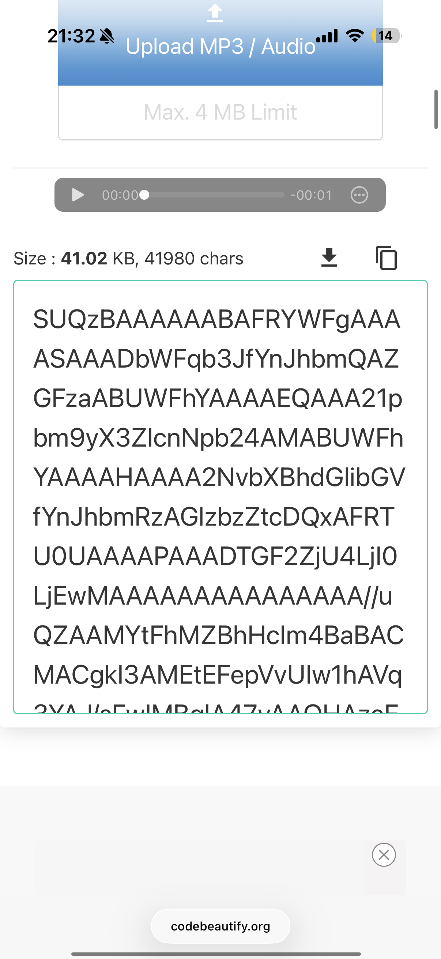
Copy the full Base64 string — make sure nothing is truncated.
Tip: The encoded text will be very long. Make sure you copy the full string with no truncation.

Create the Shortcut & Add a Text Action
Open the Shortcuts app on your iPhone and tap + to create a new shortcut. You’ll see the action search bar at the bottom.
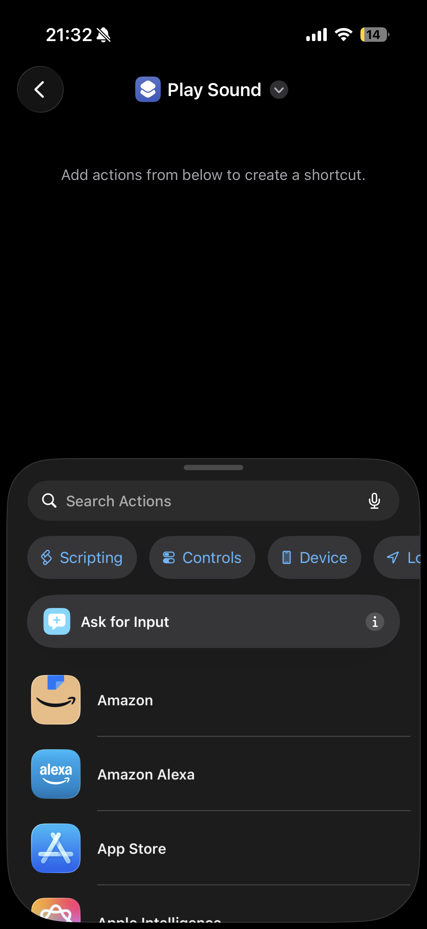
A fresh shortcut — use the Search Actions bar at the bottom.
Search for Text in the actions search bar and tap the Text action (the one with the yellow icon) to add it.
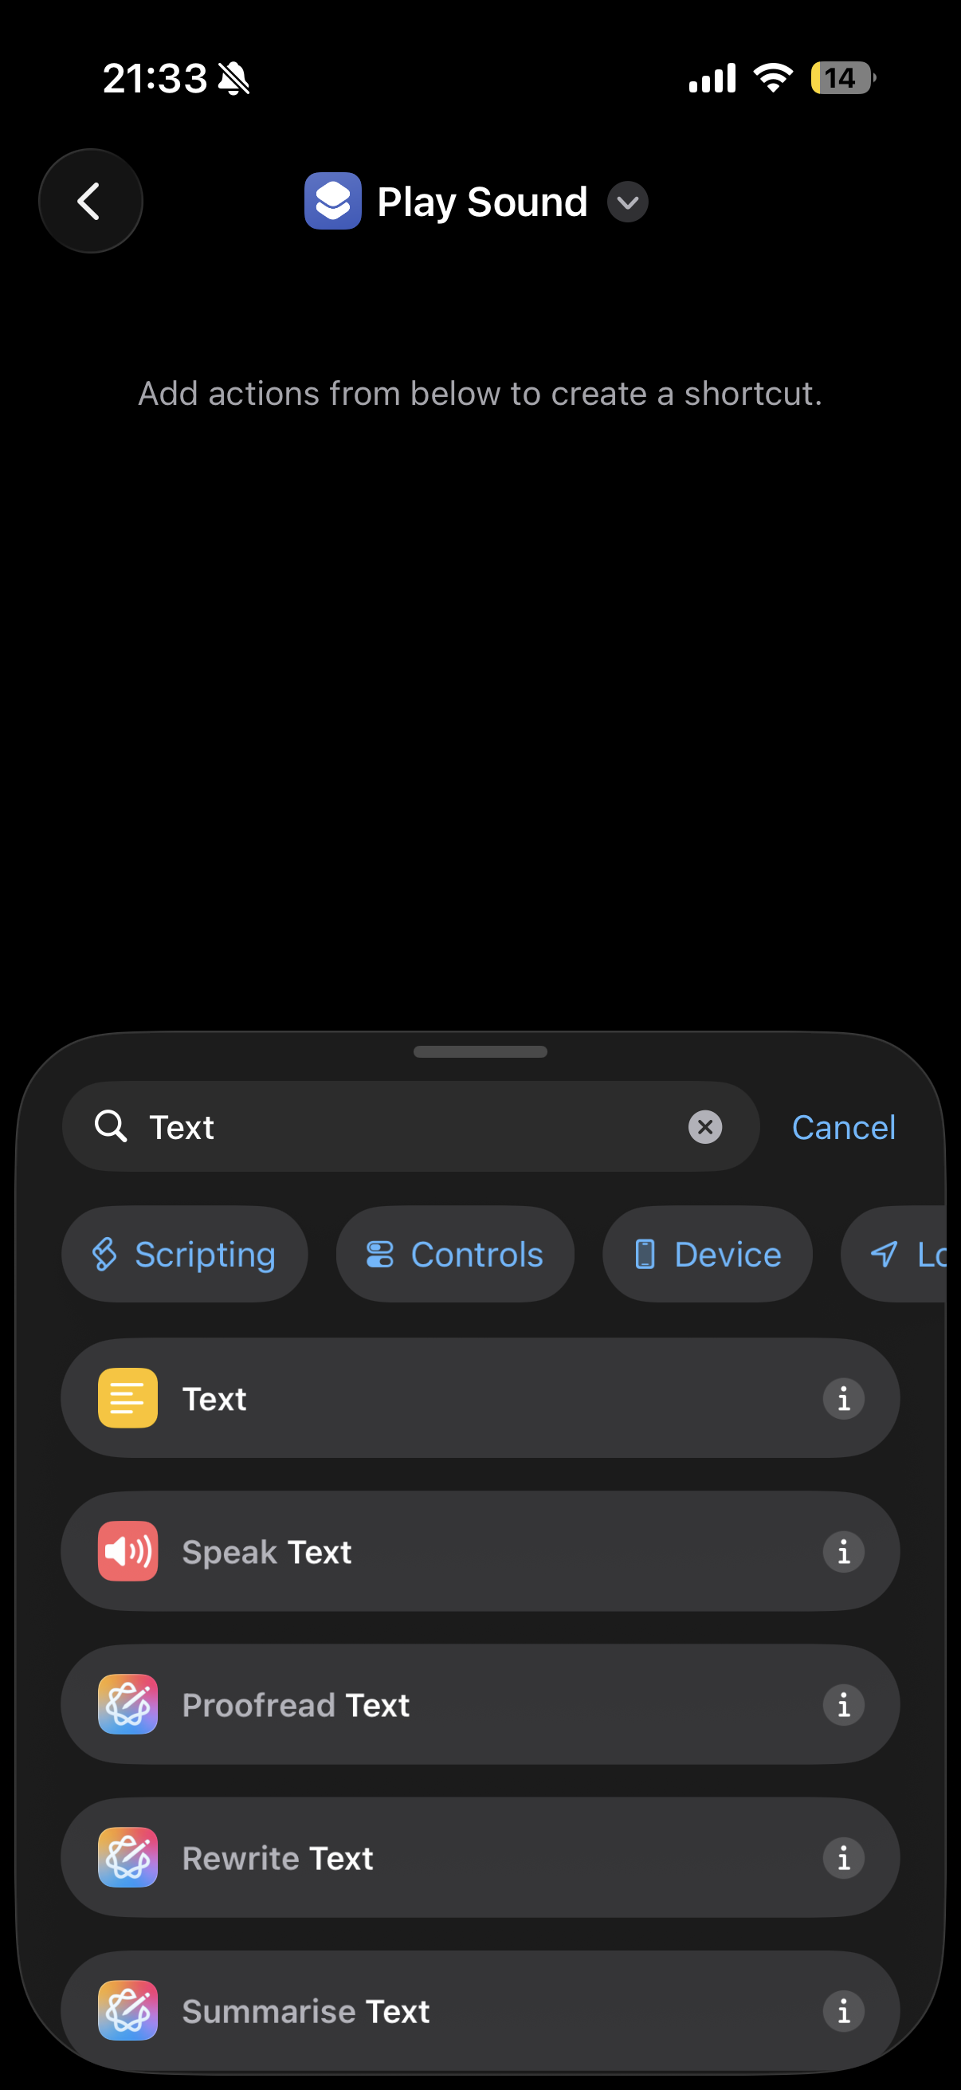
Search for “Text” and tap the first result.
Tap the text field inside the action and paste your Base64-encoded text.
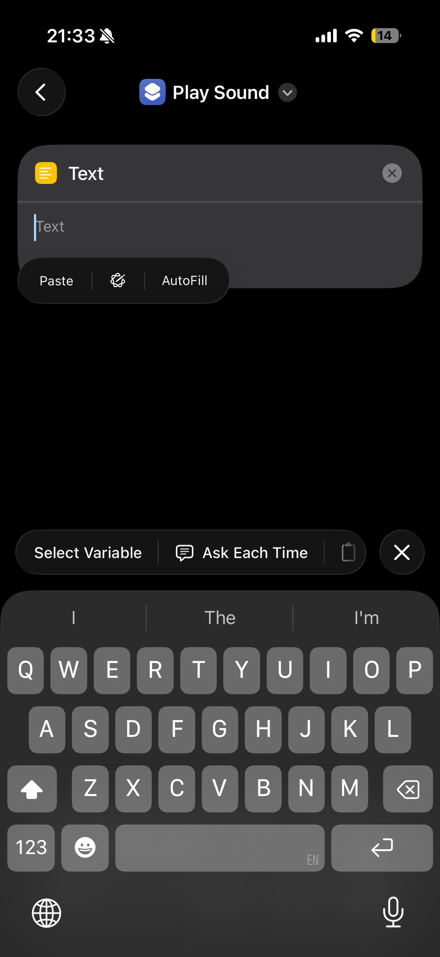
Paste the full Base64 string into the Text field.

Add the Base64 Decode Action
Search for Base64 in the actions search bar and add the Encode/Decode Base64 action below the Text action.
Important: Switch it to Decode. The default is Encode, which is the opposite of what you need.
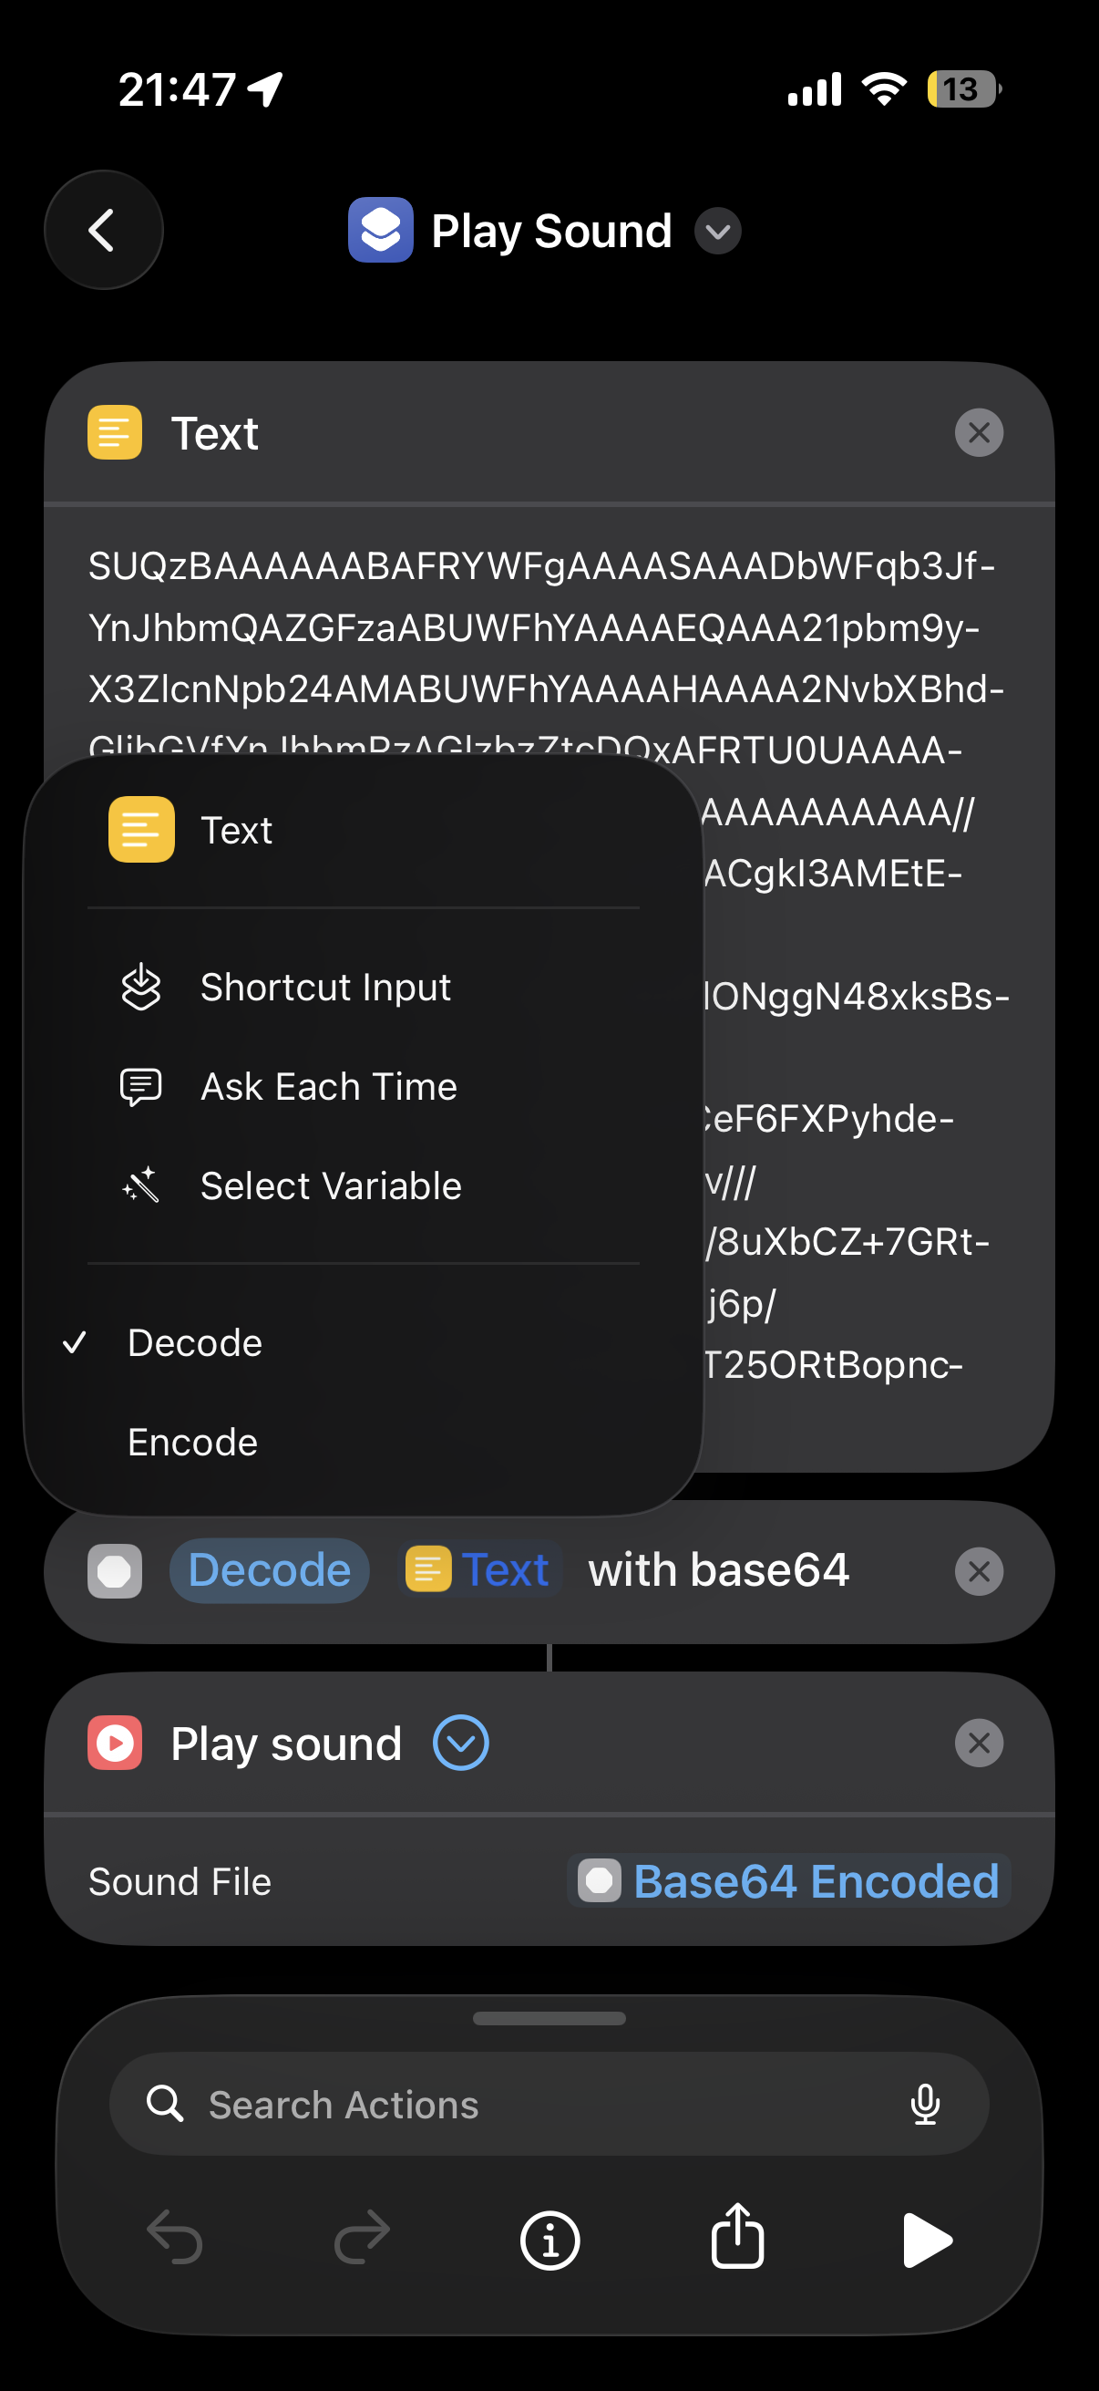
Make sure Decode is selected (not Encode) — you can see the full shortcut taking shape.

Add the Play Sound Action
Search for Play Sound and add it as the last action. When prompted for the sound file, tap the field and choose Base64 Encoded from the variable picker.
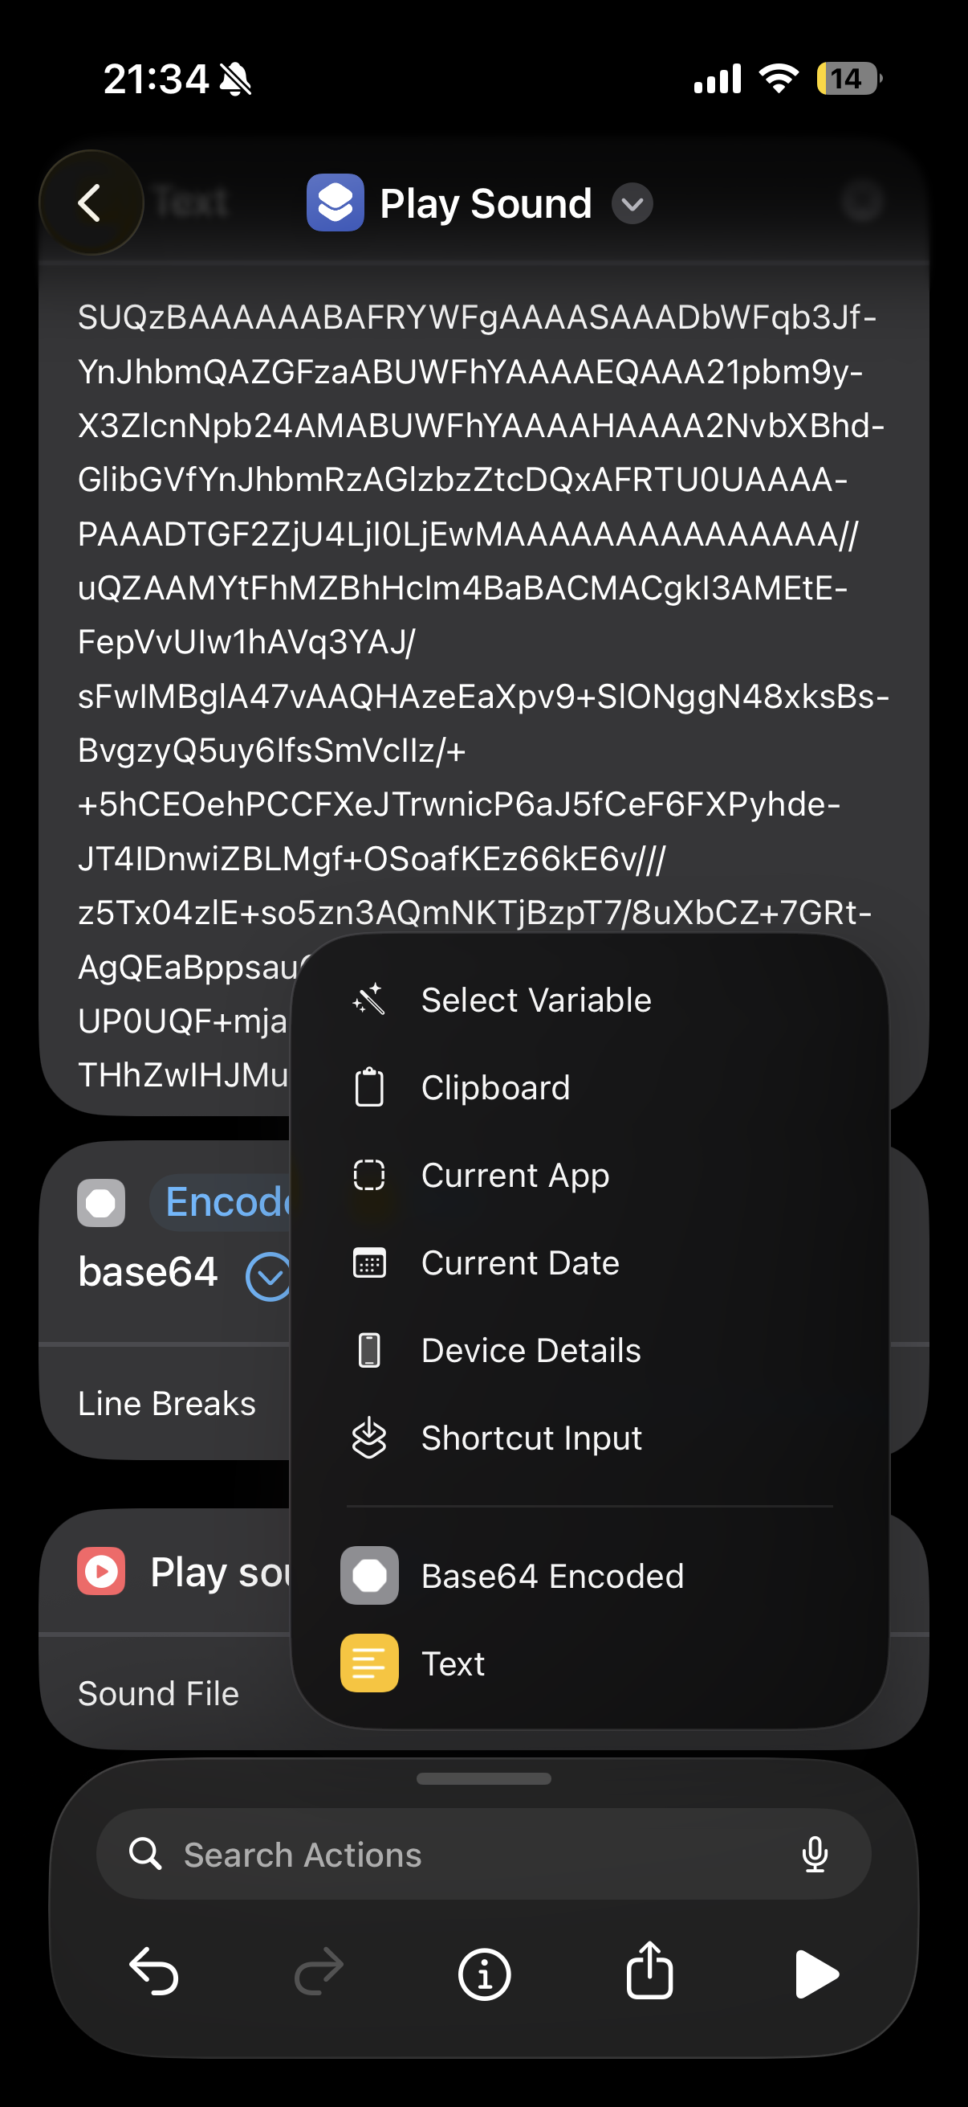
Select “Base64 Encoded” as the sound file source.
Your shortcut is now ready! Tap the play button at the bottom right to test it.

Bonus: Set It as Your Action Button
If your iPhone has an Action Button (iPhone 15 Pro and later), go to Settings → Action Button, select Shortcut, and pick the one you just created.
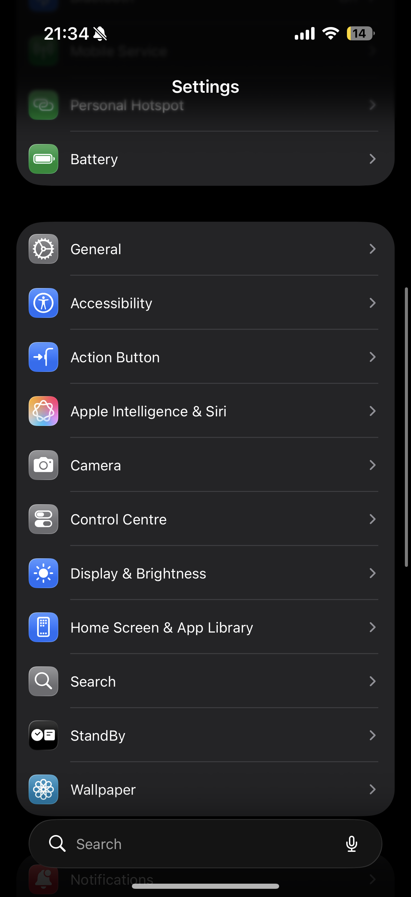
Find Action Button in Settings.
Select Shortcut and pick the one you just created. Now you can fire off your brainrot sound effect with a single press of the Action Button.
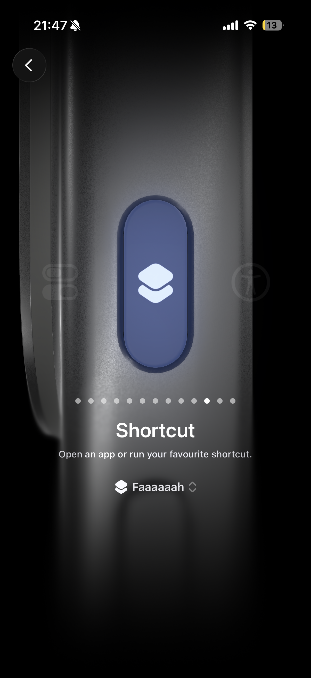
Action Button assigned to your brainrot shortcut — one press and it plays.
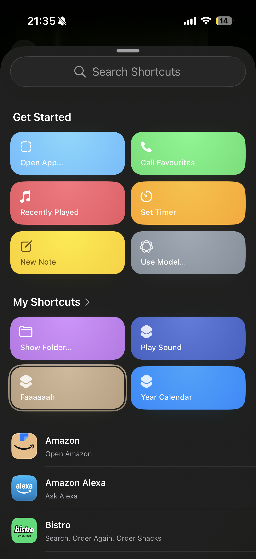
Your brainrot shortcuts, ready to deploy.
You can also trigger it via Siri voice command, add it to your Home Screen, or run it from the Shortcuts widget.

