Software Requirements Specification (SRS)

Enterprise Knowledge Platform (Working Draft)

Contents
Software Requirements Specification (SRS) 1
Enterprise Knowledge Platform (Working Draft) 1
1. Introduction 2
2. Business Problem 2
3. Product Vision 2
4. Main Features 2
4.1 Frameworks 3
5. Workflow 3
6. Domain Model 5
7. Business Logic 9
7.1 Entity Resolution 9
7.2 Coreference Resolution 9
7.3 Triple Normalization 10
7.4 Predicate Canonicalization 10
7.5 Duplicate Triple Removal 11
7.6 Confidence Scoring 11
7.7 Provenance Tracking 12
7.8 Ontology Mapping 12
7.9 Knowledge Graph Construction 13
8. GraphRAG 13
9. Enterprise Integrations 13
10. Architecture 14
11. Non-functional Requirements 14
12. Future Work 14

1. Introduction
Purpose
This document defines the first complete specification for an Enterprise Knowledge Platform. The platform transforms unstructured enterprise documents into a reusable Knowledge Graph that can be searched, explored and queried using GraphRAG.
Scope: The project is intended as:
• Integrated Systems course project
• Bachelor's thesis foundation
• Portfolio-quality enterprise application
Goals
• Automate knowledge extraction from documents.
• Build a reusable Knowledge Graph.
• Enable semantic search and GraphRAG.
• Expose secure REST APIs.
• Demonstrate enterprise integration patterns.

2. Business Problem
Organizations store thousands of PDFs, contracts, manuals and reports. Valuable knowledge is locked inside these files. Employees manually search documents and repeatedly extract the same information.
The platform converts isolated documents into structured organizational knowledge that can be reused by people and software.

3. Product Vision
The system is an Enterprise Knowledge Platform rather than a simple AI extractor.
Input: enterprise documents.
Output: a continuously growing Knowledge Graph that supports search, analytics, GraphRAG and external integrations.

4. Main Features
- User Management – Manage users and their access to the platform.
- Document Management – Upload, organize, and manage enterprise documents.
- Knowledge Extraction – Extract structured triples from unstructured documents using the NLP pipeline.
- Knowledge Graph Construction – Build a connected Knowledge Graph from extracted information.
- Graph Visualization – Explore entities and relationships through an interactive graph.
- GraphRAG Retrieval (Optional / Stretch Goal) – Use the Knowledge Graph to improve AI-generated answers. Feasibility and implementation difficulty will be validated early; falls back to standard flat-text RAG if graph-based retrieval proves too complex to implement well in the available time.
- REST API – Allow external systems to access the platform. JWT authentication for platform users (web frontend); API Key authentication for external system integrations; per-client rate limiting on all external-facing endpoints.
- Email Notifications – Notify users about processing events, sent via MailKit (async SMTP).
- Excel Import/Export – Import and export graph data and reports.

4.1 Frameworks
- Itext2KG - https://github.com/AuvaLab/itext2kg
The platform uses the iText2KG STAR framework as the foundation for document processing and Knowledge Graph extraction. The framework is responsible for performing NLP preprocessing, semantic block generation, and LLM-based triple extraction. The extracted triples are subsequently refined by the platform through schema validation, normalization, entity resolution, duplicate removal, confidence scoring, provenance tracking, and Knowledge Graph construction
- .NET Core 10
- React
- FastAPI for Python Service orchestration
- Queue: database-backed status column (Pending / Processing / Completed / Failed) polled by a Quartz.NET job on an interval (e.g. every 30s) — durable, survives app restarts, matches the pattern taught in the course exercises. RabbitMQ considered but not used in v1; listed under Future Work for when the platform needs push-based, cross-instance queuing.

5. Workflow
Upload Document
→ ProcessingJob created
→ Queue
→ Python processing service
→ Triple extraction
→ Entity resolution
→ Graph update
→ Graph indexing
→ Ready for search and GraphRAG
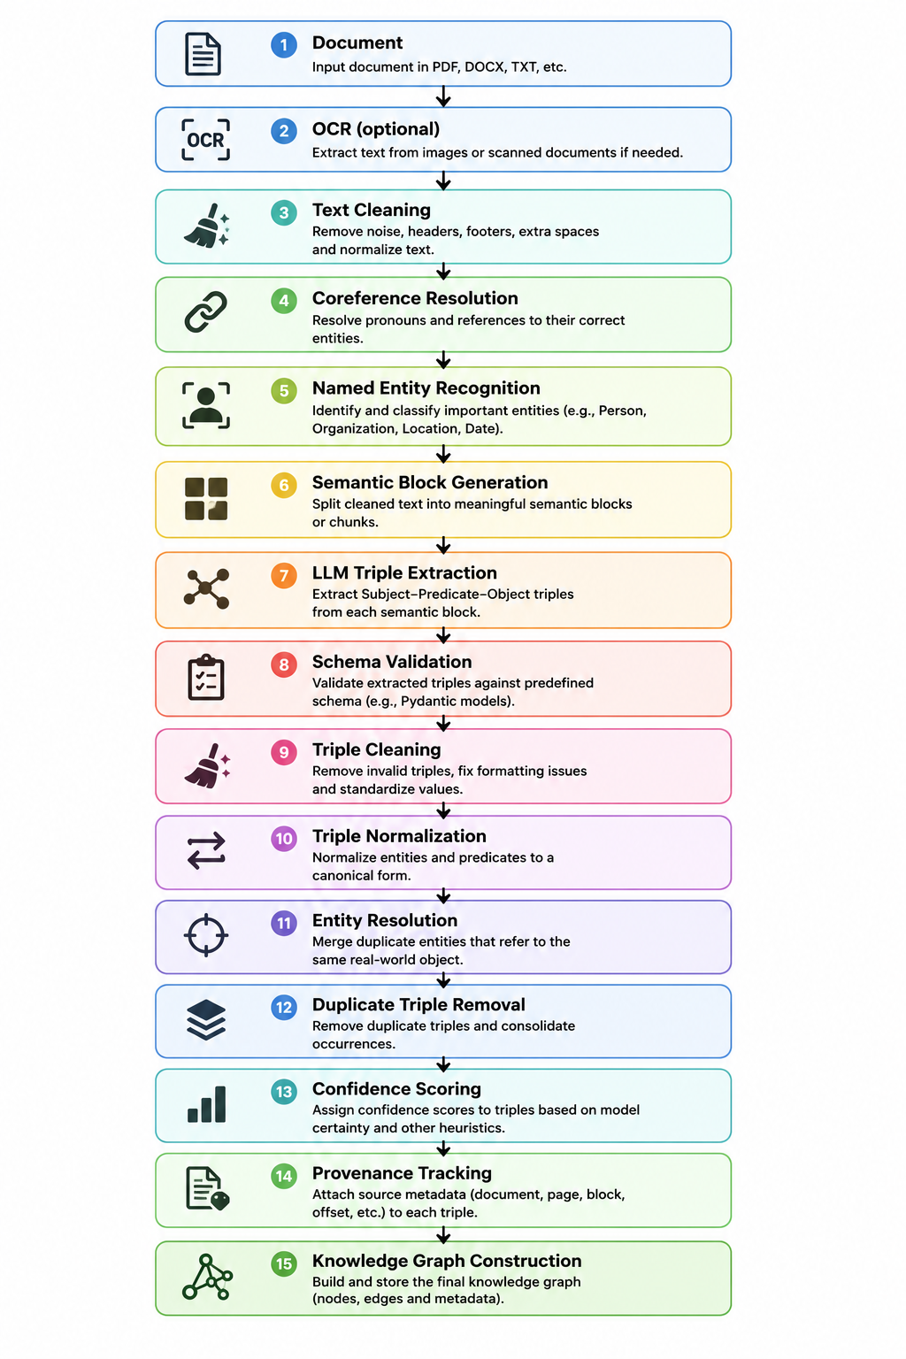

6. Domain Model
Entities:
User: Id ,Name, Email, Role, CreatedAt,UpdatedAt
Document: Id ,Name, FilePath, FileType, UploadDate, Status OwnerId, CreatedAt,UpdatedAt
ProcessingJob: Id, DocumentId, Status, StartedAt, FinishedAt, ErrorMessage, CreatedAt,UpdatedAt
SemanticBlock: Id ,DocumentId, Text, BlockIndex ,Page, CreatedAt,UpdatedAt
GraphEntity: Id, Name, Type, CanonicalName, CreatedAt,UpdatedAt
GraphRelationship: Id ,SourceEntityId, TargetEntityId, Predicate Confidence,CreatedAt,UpdatedAt
Triple: Id, Subject, Predicate, Object, Confidence ,Status,CreatedAt,UpdatedAt
TripleProvenance: TripleId, DocumentId, SemanticBlockId,CreatedAt, UpdatedAt
Notification: Id, UserId, Title, Message, SentAt,CreatedAt,UpdatedAt
EntityType: Id,Name(Person,Organization,Location)
ApiKey: Id, UserId, KeyHash, Label, CreatedAt, ExpiresAt, IsActive
Ternary Relation:
TripleProvenance (Triple, Document, SemanticBlock)
Stores in which semantic block of which document a specific triple was extracted, enabling provenance and traceability of every fact in the Knowledge Graph..

Explanation of Enteties:
1. User
Purpose:
Represents a person using the platform.
Responsibilities:
- Uploads documents.
- Starts document processing.
- Views the extracted Knowledge Graph.
- Receives notifications.

2. Document
Purpose:
Represents an uploaded file (PDF, DOCX, TXT, etc.).
Responsibilities:
- Stores document metadata.
- Is the source of extracted knowledge.
- Contains multiple semantic blocks.

3. ProcessingJob
Purpose:
Tracks the processing status of a document.
Responsibilities:
- Stores whether processing is queued, running, completed or failed.
- Records processing start/end times.
- Stores error information if processing fails.

4. SemanticBlock
Purpose:
Represents a meaningful section of a document.
Responsibilities:
- Stores a chunk of cleaned text.
- Serves as the input for triple extraction.
- Links extracted triples back to a specific part of the document.

5. Triple
Purpose:
Represents one extracted fact in Subject–Predicate–Object format.
Example:
Microsoft -> acquired -> GitHub
Responsibilities:
- Stores the extracted fact.
- Stores its confidence score.
- Serves as the intermediate representation before graph construction.

6. GraphEntity
Purpose:
Represents a unique real-world object in the Knowledge Graph.
Examples:
- Microsoft
- GitHub
- John Smith
- London
Responsibilities:
- Stores the canonical version of an entity.
- Acts as a node in the Knowledge Graph.
- Is created after entity resolution.

7. GraphRelationship
Purpose:
Represents a connection between two entities.
Responsibilities:
- Connects two graph nodes.
- Stores the relationship type (predicate).
- Forms the edges of the Knowledge Graph.

8. TripleProvenance
Purpose:
Stores where an extracted triple originated.
Responsibilities:
- Links a Triple to its Document.
- Links a Triple to its Semantic Block.
- Provides provenance and traceability.
Example:
Triple 15 was extracted from Semantic Block 8 of Document 3.

9. Notification
Purpose:
Represents a notification sent to a user.
Responsibilities:
- Notifies users when processing finishes or fails.
- Stores the notification message and timestamp.

10. EntityType
Purpose:
Represents the category of an entity.
Examples:
- Person
- Organization
- Location
- Event
- Product
Responsibilities:
- Classifies entities.
- Ensures consistent entity types across the Knowledge Graph.

11. ApiKey
Purpose:
- Represents a credential issued to an external system for programmatic access to the platform's REST API.
Responsibilities:
- Authenticates external/inbound API requests (as an alternative to JWT, which is used for platform users).
- Can be revoked or expired independently of a user's login session.
- Is checked against per-client rate limits on every inbound request.

7. Business Logic

7.1 Entity Resolution
Description:
The system automatically detects entities that refer to the same real-world object and merges them into a single canonical entity to eliminate duplicate nodes in the Knowledge Graph.

Example:
Apple
Apple Inc.
APPLE
↓
Apple Inc.
All relationships now point to the canonical entity Apple Inc.

7.2 Coreference Resolution
Description:
The system resolves pronouns and textual references before triple extraction to ensure that relationships correctly identify the referenced entities.
Example:
Microsoft acquired GitHub.
It paid $7.5 billion.
↓
(Microsoft, acquired, GitHub)
(Microsoft, paid, $7.5 billion)
instead of
(It, paid, $7.5 billion)

7.3 Triple Normalization
Description:
The system normalizes extracted triples by standardizing entity names and relationship predicates into a consistent format.
Example:
(Microsoft, works at, OpenAI)
(Microsoft, employed by, OpenAI)
↓
(Microsoft, works_for, OpenAI)

7.4 Predicate Canonicalization
Description:
The system maps semantically equivalent predicates to a predefined canonical predicate to improve graph consistency.
Example:
works at
employed by
employee of
↓
works_for

7.5 Duplicate Triple Removal
Description:
The system identifies identical triples extracted from multiple documents and stores only one relationship while preserving all source references.
Example:
Document A
Microsoft acquired GitHub.
Document B
Microsoft acquired GitHub.
↓
Knowledge Graph
Microsoft ── acquired ──► GitHub
The relationship exists only once, but provenance records show it came from both documents.

7.6 Confidence Scoring
Description:
The system assigns a confidence score to every extracted triple. Confidence can be used to filter unreliable information or prioritize human review.
Example:
(Microsoft, acquired, GitHub)

Confidence = 98%
(Apple, founded, Bill Gates)

Confidence = 24%
The second triple may be rejected or flagged for review.

7.7 Provenance Tracking
Description:
The system records the origin of every extracted triple by linking it to the source document and semantic block from which it was extracted.
Example:
Triple
↓
Document: AnnualReport.pdf
↓
Page: 12
↓
Semantic Block: 7
Users can trace every fact back to its original source.

7.8 Ontology Mapping
Description:
The system maps extracted entities and relationships to predefined ontology classes to ensure semantic consistency throughout the Knowledge Graph.
Example:
Microsoft
↓
Organization
John Smith
↓
Person
This allows the graph to distinguish between different types of entities.

7.9 Knowledge Graph Construction
Description:
After validation and refinement, the system transforms extracted triples into graph nodes and relationships, creating a connected Knowledge Graph.
Example:
Extracted Triples:
(Microsoft, acquired, GitHub)
(GitHub, created_by, Tom Preston-Werner)
Knowledge Graph:
Microsoft -> acquired -> GitHub -> created_by -> Tom Preston-Werner

8. GraphRAG
GraphRAG is used after the Knowledge Graph is built.
Question
→ Detect entities
→ Retrieve related graph nodes/triples
→ Build context
→ LLM generates answer
The graph improves retrieval by supplying connected knowledge instead of isolated text chunks.

9. Enterprise Integrations
ETL:
Extract document
Transform into triples
Load into Knowledge Graph
External API:
LLM provider (Groq/OpenAI)
Queue:
DB-backed status + Quartz.NET polling job (see Workflow and section 4.1)
Email:
Processing completed/failed
Excel:
Export graph data and reports.

9.1 Inbound vs Outbound
Outbound (platform calling others): calls to the LLM provider (Groq/OpenAI) for triple extraction and, if implemented, GraphRAG answer generation; calls to the Python processing service for local NLP tasks (cleaning, coreference resolution, NER pre-tagging, embeddings).
Inbound (others calling the platform): external systems consuming the platform's REST API to submit documents or query the Knowledge Graph, authenticated via API Key, subject to per-client rate limiting.

10. Architecture
Onion Architecture:
Presentation
Application
Domain
Infrastructure
Python extraction service communicates through REST.
BackgroundService processes queued jobs.
Repositories isolate persistence.
Cost-optimization split: the Python service performs all processing that does not require an LLM call — text cleaning, chunking into semantic blocks, coreference resolution, and NER pre-tagging. Only chunks likely to contain extractable facts (based on NER pre-tagging) are sent to the LLM for triple extraction, minimizing token usage and cost. Embeddings used for retrieval are also computed locally in the Python service, so retrieval itself costs no LLM tokens — the LLM is only called for final extraction and, if implemented, answer generation.
Async processing: implemented as a database-backed queue (status column on ProcessingJob/InboundEventEntry-style tables) polled by a Quartz.NET scheduled job, rather than an in-memory queue — ensures no job is lost on an app restart or crash. Email notifications are sent via MailKit (async SMTP client).

11. Non-functional Requirements
Maintainable code
Clean architecture
Scalable processing
Secure JWT authentication (platform users) and API Key authentication + per-client rate limiting (external integrations)
Logging
Error handling
API documentation
Dependency Injection
Docker
OCR

12. Future Work
Neo4j
Graph Analytics
RabbitMQ (push-based, cross-instance queuing at higher scale)
Vector database
Multiple LLM providers
Kubernetes
CI/CD
RBAC
Audit logs
Multi-tenancy

