The formula (given in formula book):  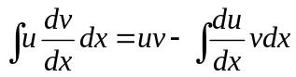  One part is differentiated  The other part is integrated. |  | Integration by parts is used to integrate a product. One part of the product (u) should be easy to differentiate (and will usually simplify when differentiated). The other part 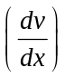 should be easy to integrate and should not become too much harder when integrated.
Example 1: Find 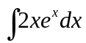.  This is a suitable candidate for integration by parts with 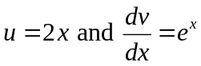:  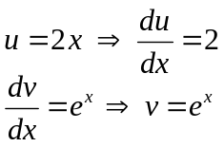  Substitute these into the formula:  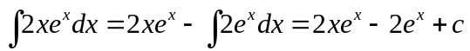  Example 2: Find 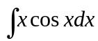.  Here we take 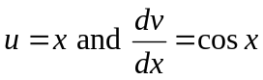:  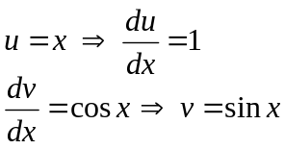  Substitute these into the formula:  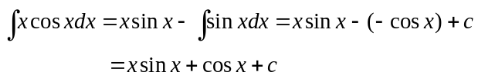  Note: Sometimes it is necessary to use the integration by parts formula twice (e.g. with 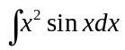). | Common examination questions  Example 1: Find 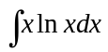.  This can be found using integration by parts if we take 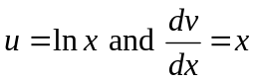.  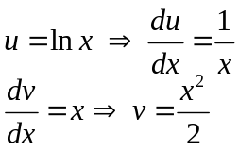  Substitute these into the formula:  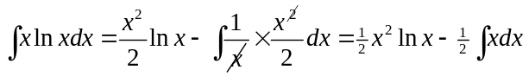  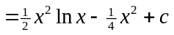  Example 2: Find 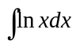.  This can be thought of as 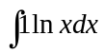 and so can be integrated by parts with 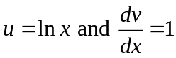  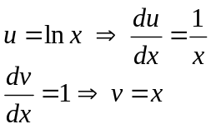  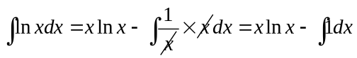  = 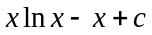 | Definite integrals (using by parts)  Example: a) Find the points where the graph of 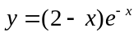 cuts the x and y axes.  b) Sketch the graph of .  c) Find the area of the region between the axes and the graph of .  a) Graph cuts y-axis when x = 0, i.e. at y = 2  Graph cuts the x-axis when y = 0, i.e. when x = 2..  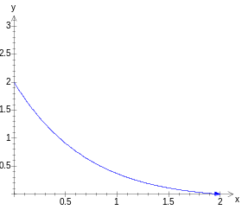  b) The graph looks like:  c) Area is 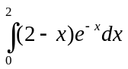.  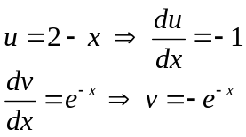  So 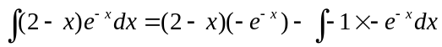  = 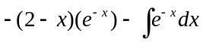  = 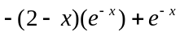  Now that we’ve integrated, we substitute in our limits:  