Integration

Rule: Increase the power by 1 and divide by the new power.

y = | 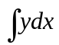 =
 | 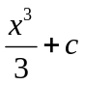
12x | 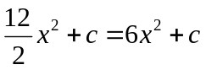
 | 9x + c
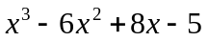 | 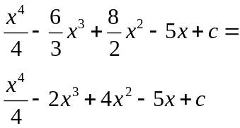

Integration is the reverse of differentiation.

Example:
Find y if 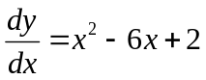 and y = 4 when x = 3.

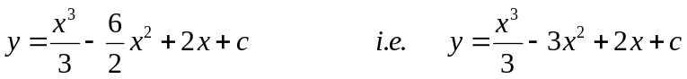.
When x = 3, y = 4. So 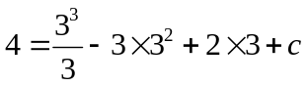
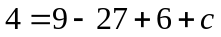
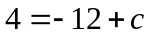
c = 16
So, 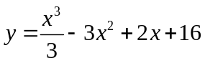

Definite Integration

Example:
Find 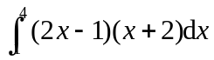.

First expand the brackets: 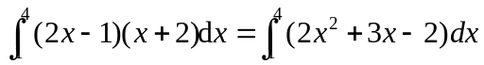
Integrate the expression: =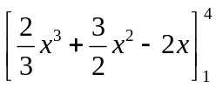
Substitute in the 2 limits and subtract: =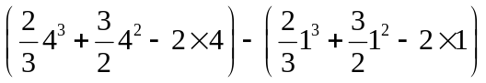
= 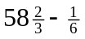
= 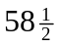

Finding areas

Integration can be used to find the area underneath a curve.

Example 1:
Find the area beneath the curve 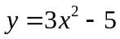 between the lines x = 2 and x = 4.

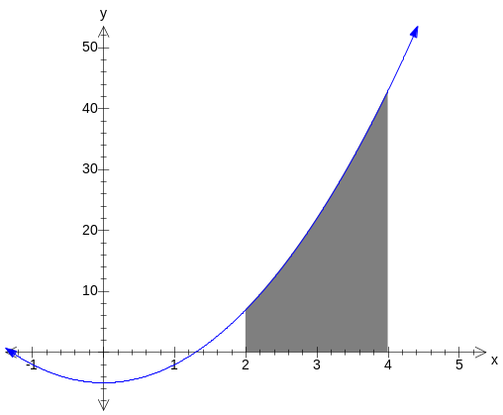
Area = 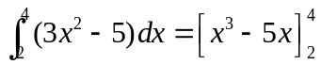
= 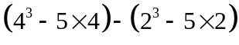
= 44 – (-2)
= 46

Areas beneath the x-axis are negative. You need to calculate areas above and below the axes separately.

Example 2:
The diagram shows the curve y = x(x – 3).
Find the shaded area.
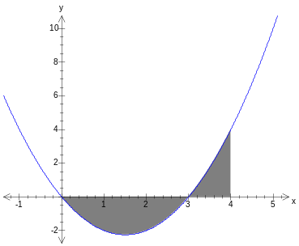
The curve crosses the x-axis at x = 3 (and at x = 0).

Area above the x-axis is
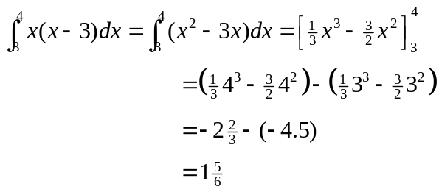
Area below the x-axis is
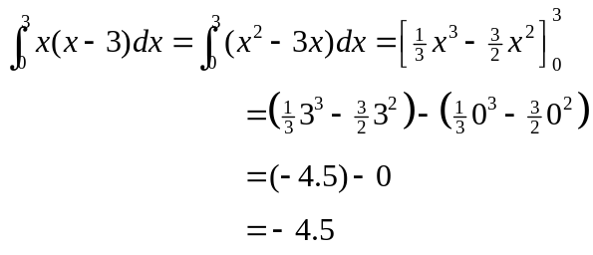
So total area is 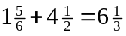.

Note:
To find the area between 2 curves use the formula:
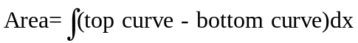

Questions:

1. (i) Integrate 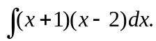
(ii) Evaluate 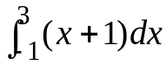.

2. Calculate the area completely enclosed by the curve 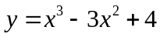, the x-axis and the lines
x = 1, x = 4.

3. Find the area of the finite region bounded by the curve 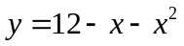

4. Carry out the following integrations:
(a) 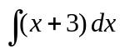 (b) 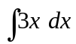 (c) 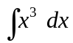.
and the x-axis.

5. Evaluate 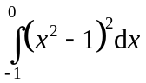.

6. Calculate 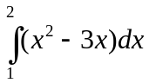. On a sketch graph shade an area corresponding to this integral.

7. Find the coordinates of the points where the line y = x + 11 meets the curve 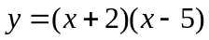 and sketch the two graphs on one diagram.
Evaluate 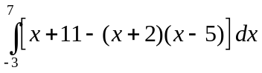.
On your diagram, shade the area represented by this integral.

8. 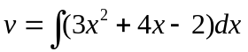.
- If v = 3 when x = 0, find v as a function of x.
(ii) Hence calculate the value of v when x = 1.

9. a) Find the coordinates of the points of intersection of the line y = 2x with the curve 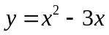.
b) Sketch the line and the curve for 0 ≤ x ≤ 6.
c) Calculate the area of the region enclosed between the line and the curve.

