Some key results (to learn):  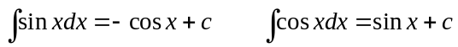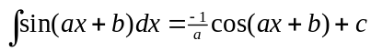  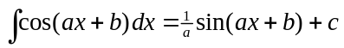  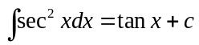 |  |  |  | You need to remember these trigonometric formulae- they are needed in some integration questions.  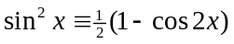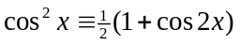  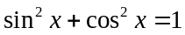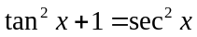  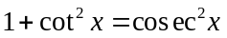
Integration by substitution  This column gives the calculations for changing the dx to du: |  | Methods of integration  The methods of integrating an expression are:  1) directly writing it down (either by memory or by looking in the formula book);  2) writing the expression in partial fractions;  3) using the method of integration by parts;  4) using a substitution;  5) using a trigonometric identity (such as 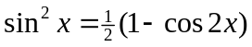 or 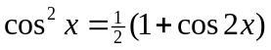 )  See my separate sheet on how to identify which method of integration is the appropriate one to use in any given situation. |  | Integration involving trigonometrical identities  Example: Using the identity given above  Example 2: Find 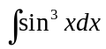  Solution: We use the fact that 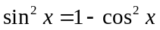  So,  = 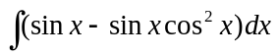  =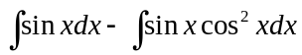  We now need to work out 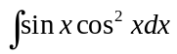  We use the substitution  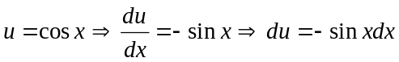  So, 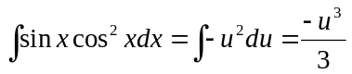  =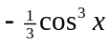  Therefore, 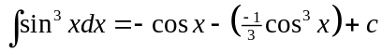  = 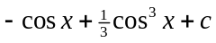
Example: 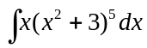.  Make the substitution 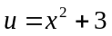  We get: 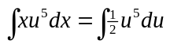  This gives: 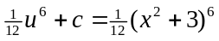 | 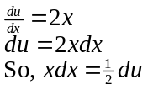
Example 2: Use the substitution 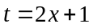 to find 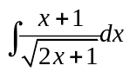.  Solution: 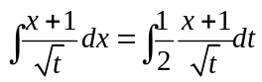  Since ,  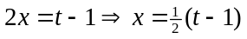  So we get 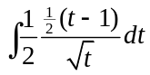 | 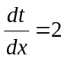  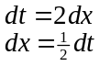
Definite integrals using a substitution
Find 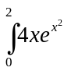.
 |  | Use the substitution 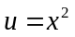.  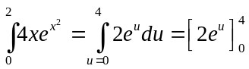  = 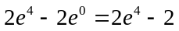 | 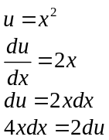  x = 0 → u = 0  x = 2 → u = 4
Take the multipliers outside the integral:
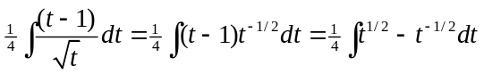
This gives: 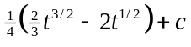
But , so 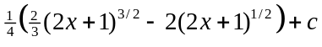.
This expands to give: 