**Packets : 81376**

**Filter Captured Packets by Protocol**

* Use the display filter bar to filter traffic by protocol:

HTTP: http

DNS: dns

TCP: tcp

ICMP (ping): icmp

UDP

**Identify Different Protocols**

*Hypertext Transfer Protocol* – An application-layer protocol used for transmitting hypermedia documents, such as HTML, between web browsers and servers. It’s the foundation of data communication on the World Wide Web.

*Domain Name System* – A protocol that translates human-readable domain names into IP addresses that computers use to identify each other on the network.

*Transmission Control Protocol* – A core transport-layer protocol that provides reliable, ordered, and error-checked delivery of data between applications over a network.

*Internet Control Message Protocol* – A network-layer protocol used for diagnostic and control purposes, such as determining if a host is reachable

*User Datagram Protocol* – A transport-layer protocol that sends datagrams without establishing a connection, offering low-latency communication but without guaranteed delivery, ordering, or error correction.

**Summarize Findings**

**During the 1-minute capture, 81376 packets were recorded.  
Detected protocols:**

*Domain Name System*:178

*Hypertext Transfer Protocol:32*

*Transmission Control Protocol:59274*

*Internet Control Message Protocol:43*

*User Datagram Protocol:22093*

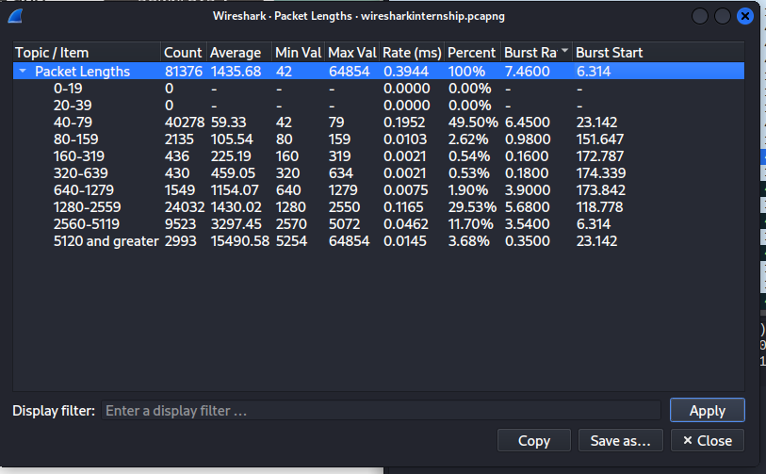

**Largest Packet or Smallest Packet**

* Go to **Statistics → Packet Lengths**.
* This will show:
  + Packet size distribution
  + **Max length or Min length** → largest or smallest packet captured (in bytes).
* You can also click a packet in the capture list and check **Frame Length** in the packet details pane

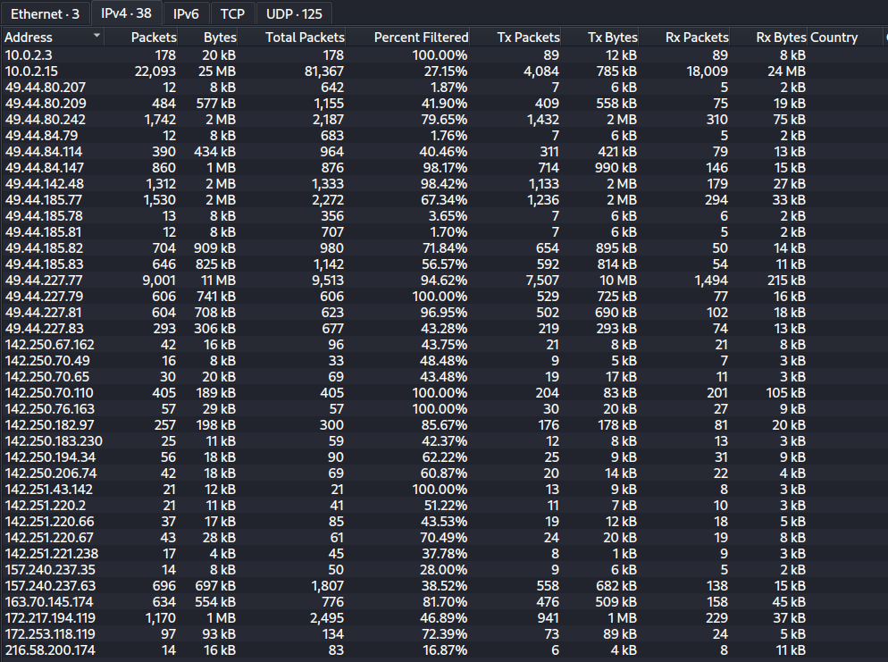

**Traffic Mostly Outbound**

* Go to **Statistics → Endpoints**.
* Select the **IPv4** or **IPv6** tab.
* Look at:
  + **Packets** (Tx / Rx columns)
  + **Bytes** (Tx / Rx columns)
* If Tx (sent) > Rx (received) for your machine’s IP address, traffic is mostly outbound.