NMAP

**What is Nmap?**

Nmap (Network Mapper) is a free and open-source tool for network discovery and security auditing.

**Why install Nmap?**

Useful for penetration testing, port scanning, and vulnerability detection.

**System Requirements**

* Supported OS: Linux, Windows, macOS
* Minimum RAM/CPU: 512MB RAM, basic CPU
* Internet connection (for package download)

Installing Nmap on Windows

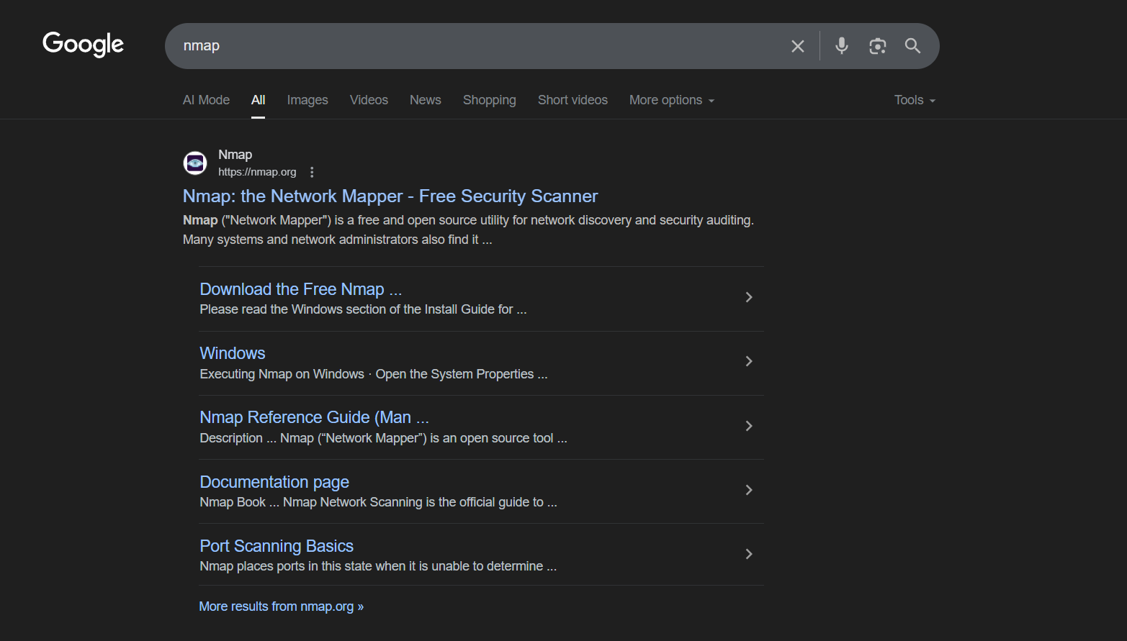

Visit the official Nmap website<https://nmap.org/download.html>

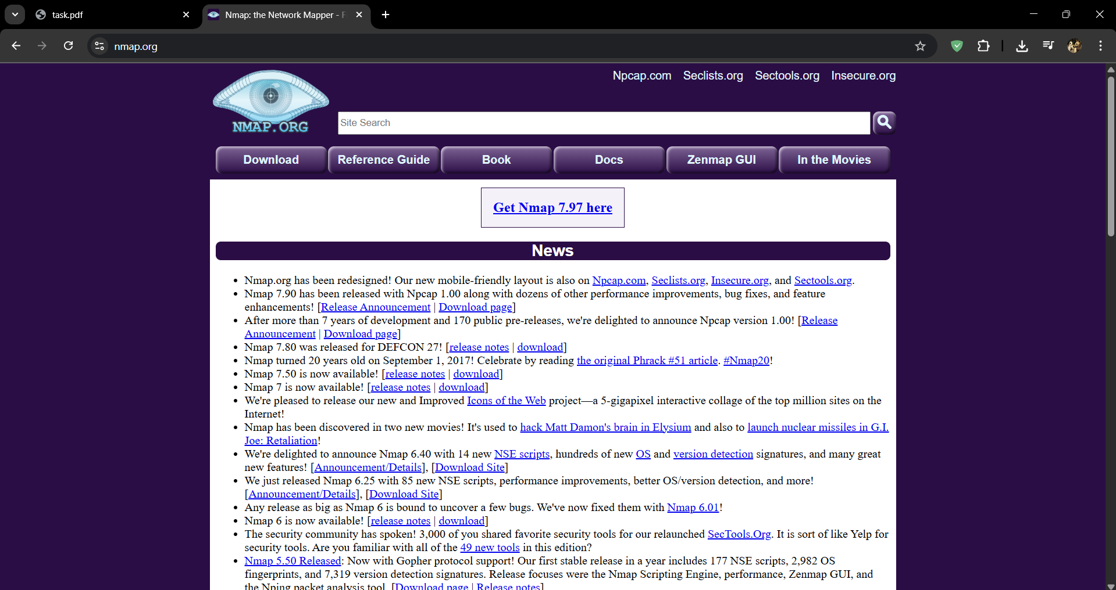

Click on **Download** section

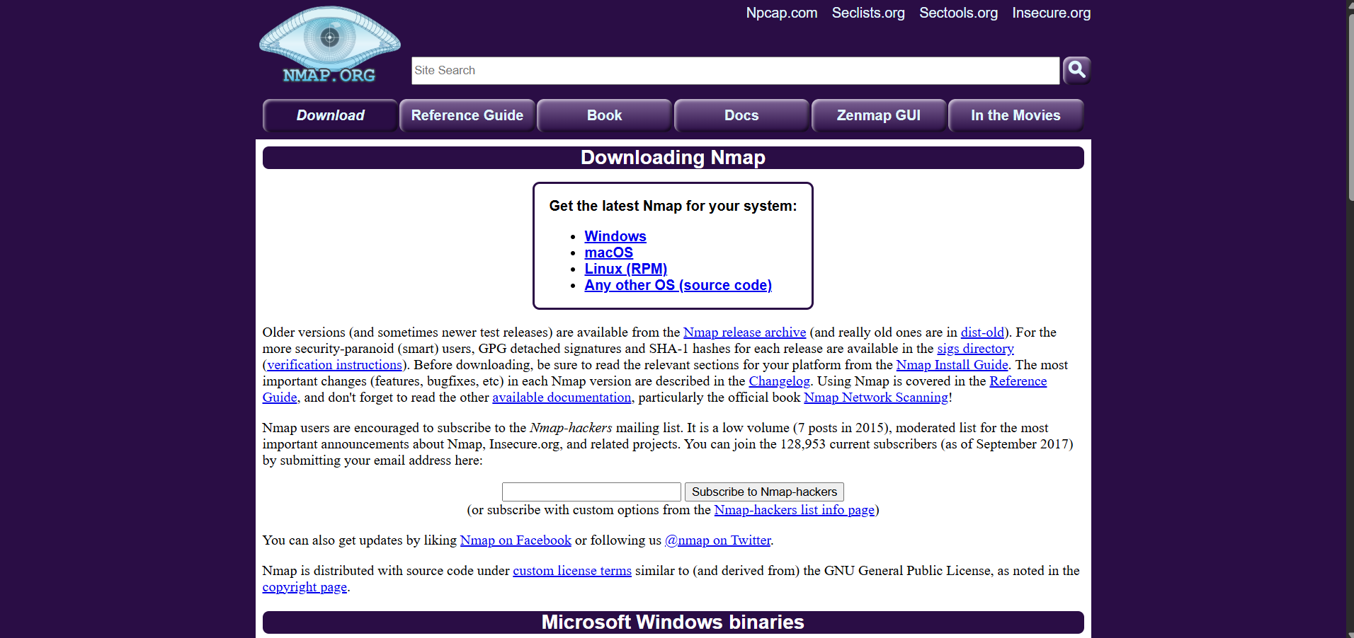

Scroll to the **Microsoft Windows binaries** section.

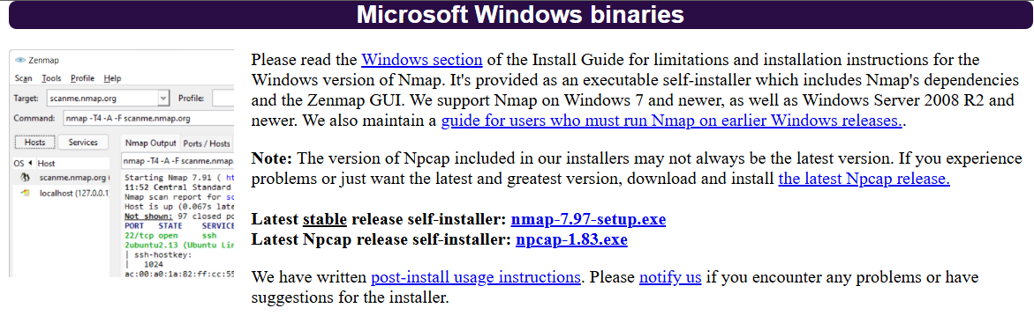

Locate the downloaded .exe file (e.g., nmap-7.94-setup.exe) in your Downloads folder.

**Double-click** the installer to launch the setup wizard.

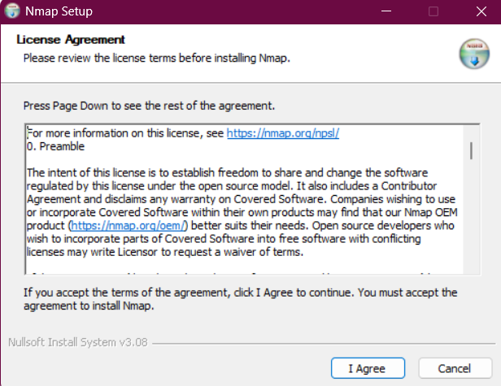

Click **"Next"** on the welcome screen to begin the installation process.

Read the license terms.

Select **"I Agree"** to continue.

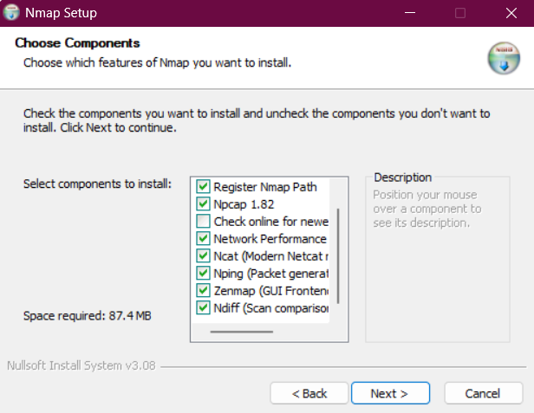

**Choose Components**

You can install:

* + Nmap
  + Zenmap (GUI frontend)
  + Npcap (required for packet capturing)

Leave all options selected unless you have a specific reason to exclude any.

Click **"Next"**.

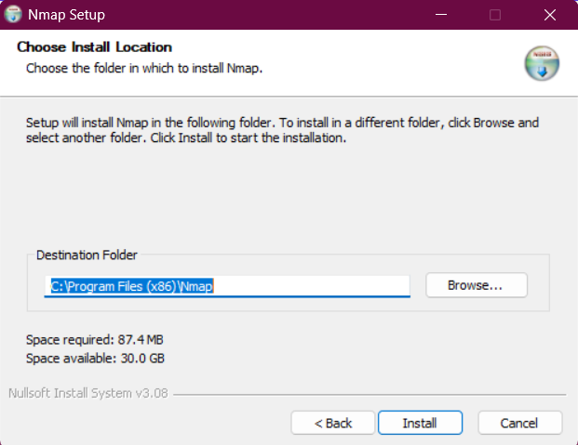

**Choose Install Location**

Choose the installation directory (default is usually fine).

Click **"Install"** to begin the installation.

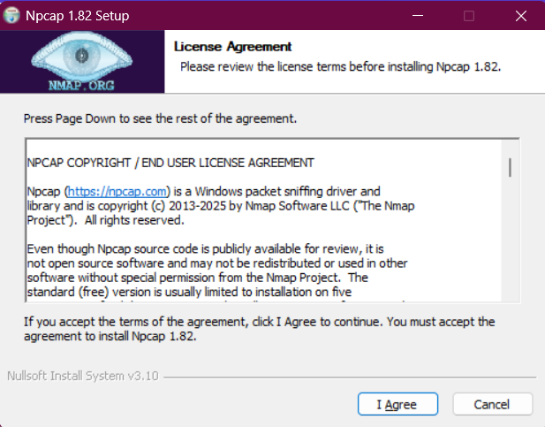

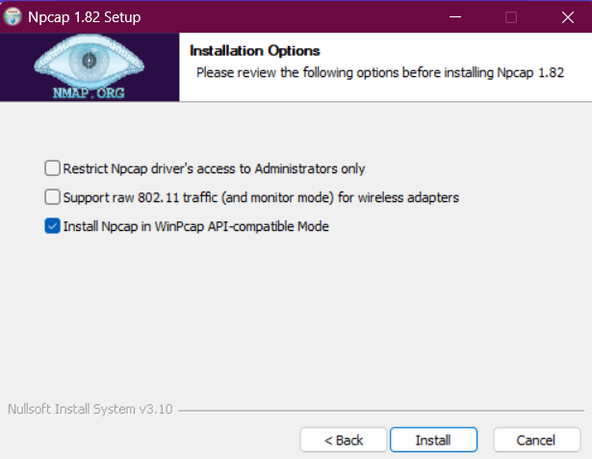

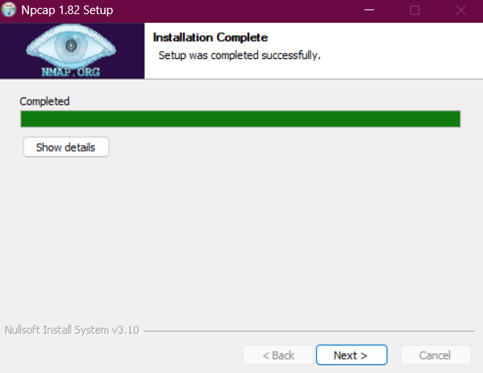

**Wait for Installation to Complete**

The setup will extract and install all necessary files.

This may take a minute or two.

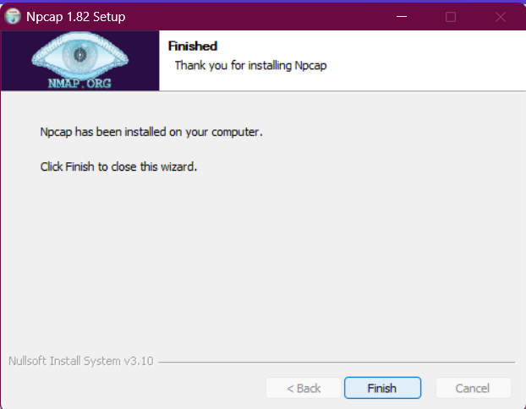

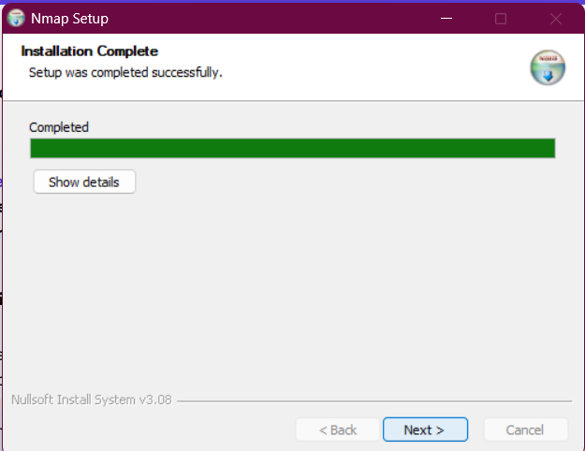

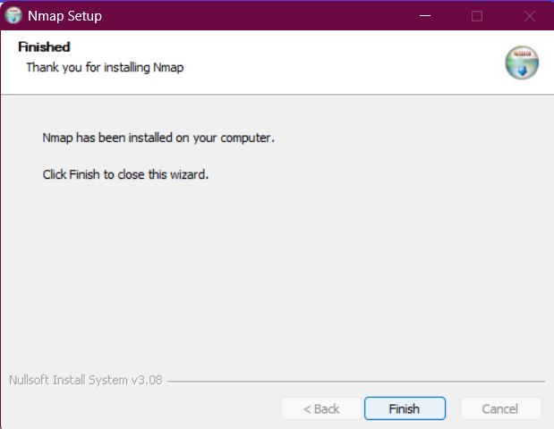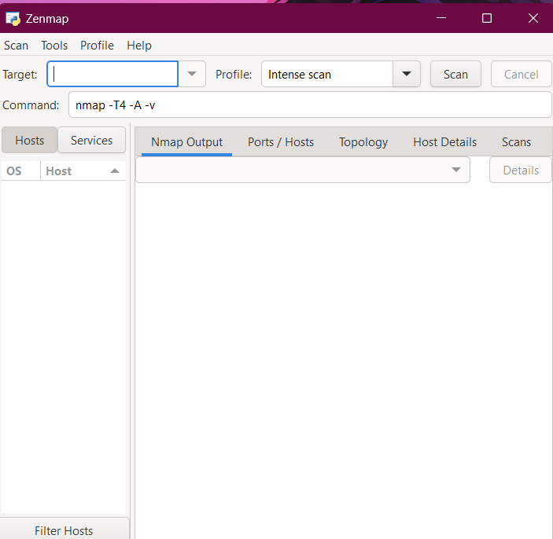

Installing Nmap on Linux

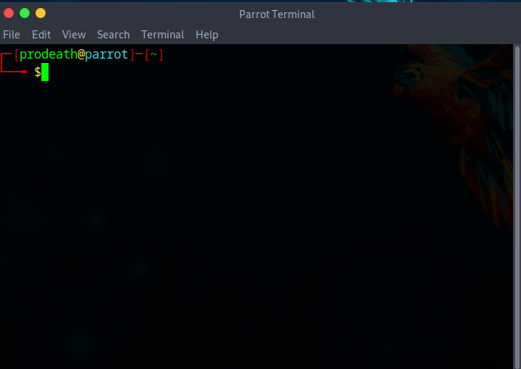

**Open the Terminal**

Use **Ctrl + Alt + T** to open the terminal on your Linux system.

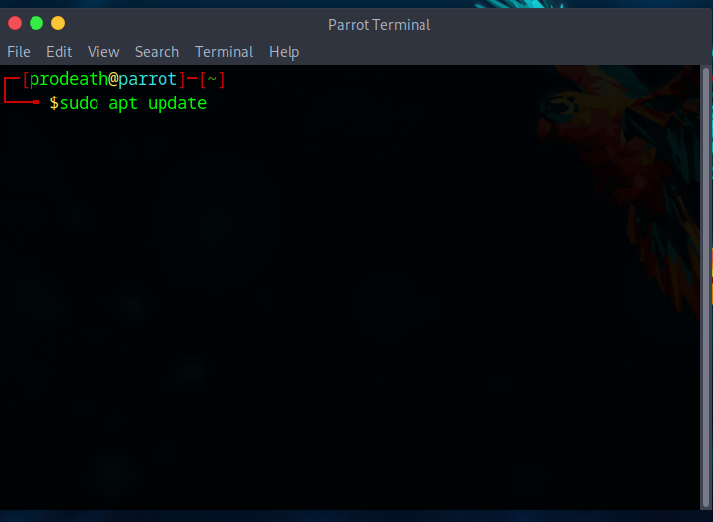

Before installing, update your local package index to ensure you get the latest version:

**sudo apt update**

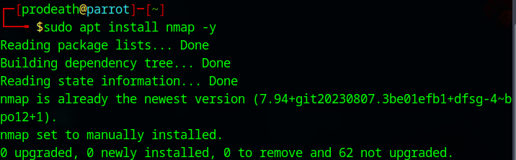

**Install Nmap**

Run the following command to install Nmap:

**sudo apt install nmap -y**

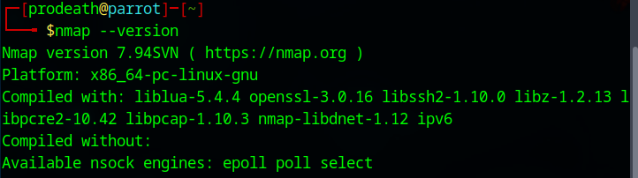

**Verify the Installation**

Check if Nmap was successfully installed by checking its version:

**nmap --version**