Major Project Report

On

**Extraction of Verb Expressions Implying Negative Opinions**

Submitted

For

Partial fulfillment for the award of the degree of

Bachelor of Technology

(Computer Science and Engineering)

|  |  |  |
| --- | --- | --- |
| **Guide:** | **Submitted by:** |  |
| Mrs. Nidhi Malik | Rohit Kumar Singh | 00110402713 |
|  | Deepak Bhandari | 00610402713 |
|  | Shreyas Srivastav | 02610402713 |
|  |  |  |

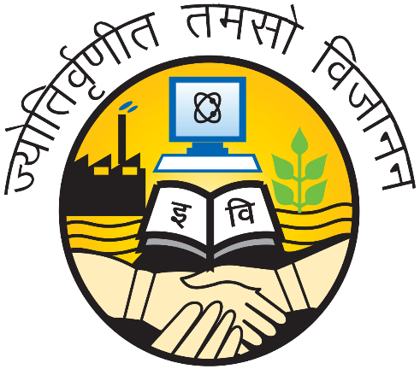

**Amity School of Engineering and Technology**

**(Affiliated to G.G.S.I.P University, Delhi)**

**(2013-2017)**