MTN Group Strategic Analytics Report

# Executive Summary

This report provides a comprehensive analytical overview of MTN Group’s performance for H1 2025, drawing on consolidated Group data, country-level KPIs, fintech and data platform metrics, regional breakdowns, Bayobab (wholesale infrastructure), pricing and FX exposures, and capex allocations. The aim is to offer a holistic view of MTN’s financial health, operational efficiency, growth trajectory, and strategic priorities.

# 1. Executive KPIs (Group-Level)

MTN Group’s H1 2025 results reveal strong momentum across service revenue, subscriber growth, and fintech expansion. Service revenue grew by 23.2% YoY (reported), while constant-currency growth underscored resilient underlying demand. EBITDA margins remained solid at 44.2%, with operating free cash flow reflecting disciplined cost and investment strategies.  
  
Key Highlights:  
- Service revenue: Sustained double-digit growth, supported by data and fintech services.  
- EBITDA: Strong margins despite FX headwinds and inflationary pressures.  
- Subscribers: Continued growth in voice, data, and fintech users.  
- MoMo MAU: Expanding digital financial services footprint across Africa.

# 2. Country Deep-Dive

Country-level analysis shows mixed performance across MTN’s African footprint:  
- Nigeria: Strong service revenue growth (above Group average), driven by data adoption.  
- South Africa: Moderate growth but continued pressure from competition and regulatory changes.  
- Ghana & West Africa: Resilient growth with high fintech penetration.  
- Francophone Africa: EBITDA margins improving as scale benefits materialize.  
  
Risk factors include currency depreciation, regulatory uncertainty, and varying macroeconomic conditions.

# 3. Fintech & Data Platforms

MTN’s fintech (MoMo) and data businesses are central to the Group’s transformation strategy:  
- MoMo MAU growth highlights increased adoption of mobile money services, including advanced services (lending, insurance, payments).  
- Data revenue: Rising as smartphone penetration and 4G coverage expand.  
- Data usage per subscriber: Up significantly, driving monetization opportunities.  
  
Fintech is increasingly a key revenue driver, reducing reliance on traditional voice revenues.

# 4. Regional Analysis

Regional performance varies:  
- West & Central Africa: High growth markets, with Nigeria leading in absolute revenue.  
- Southern Africa: Slower growth, but stable margins.  
- East Africa: Emerging growth hub with fintech outpacing voice.  
- Middle East (Iran/Iraq operations): Geopolitical and FX challenges remain.

# 5. Bayobab (Wholesale & Infrastructure)

Bayobab, MTN’s wholesale fiber and infrastructure arm, continues to scale its pan-African backbone:  
- Expansion of cross-border connectivity solutions.  
- Monetization of fiber assets to external customers.  
- Support for Group-wide data traffic growth.  
  
Bayobab is strategically positioned as a future enabler of both MTN and external operators’ digital ambitions.

# 6. Pricing and FX Exposure

FX volatility remains a material risk to MTN’s reported performance:  
- Naira, Cedi, and Rand fluctuations directly impact Group results.  
- Pricing strategies are being adapted to balance affordability with margin protection.  
- Scenario analysis shows that a 5% tariff uplift combined with 10% higher data traffic can deliver ~8-10% incremental revenue growth.

# 7. Capex Allocation

MTN continues to invest heavily in network modernization, 4G/5G rollout, and fintech platforms:  
- Focus on expanding 4G coverage to rural areas.  
- Selective 5G deployments in high-demand urban centers.  
- Fintech investments focused on scaling advanced services.  
  
Capex discipline remains, with targeted ROI thresholds to maintain free cash flow generation.

# 8. Strategic Outlook

Looking ahead, MTN’s strategy is anchored on:  
- Growth in fintech and data services.  
- Sustained investment in digital infrastructure.  
- Deleveraging the balance sheet while maintaining dividends.  
- Enhancing regulatory engagement and ESG initiatives.  
  
The Group remains well-positioned to capture Africa’s digital growth opportunity, though execution risks in FX, regulation, and competition persist.

# Conclusion

MTN Group’s H1 2025 performance underscores the success of its Ambition 2025 strategy, with strong momentum in fintech and data offsetting traditional voice declines. Strategic execution around infrastructure (Bayobab), regional growth leadership (Nigeria, Ghana), and digital financial inclusion continues to differentiate MTN. With disciplined capex, strong operating leverage, and expanding digital ecosystems, MTN remains Africa’s leading telecoms operator with a clear path to sustained shareholder value creation.

## Revenue & Regional Growth

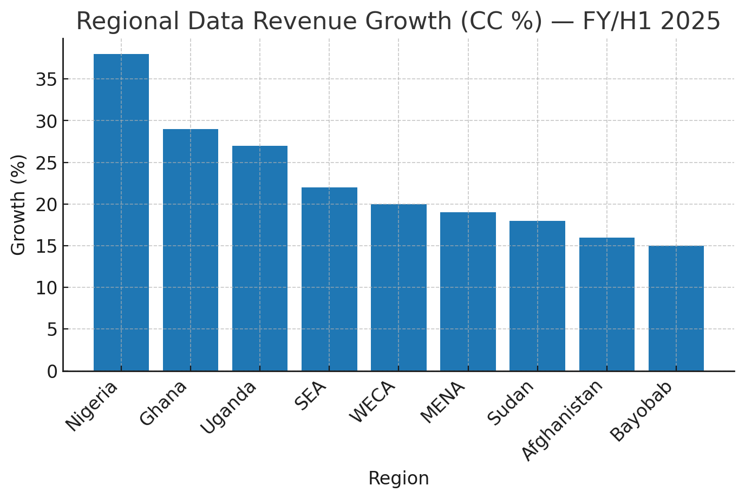

*Regional Data Revenue Growth (CC %) — source: MTN H1-2025 SENS & derived datasets*

## MoMo Adoption & Advanced Fintech Share

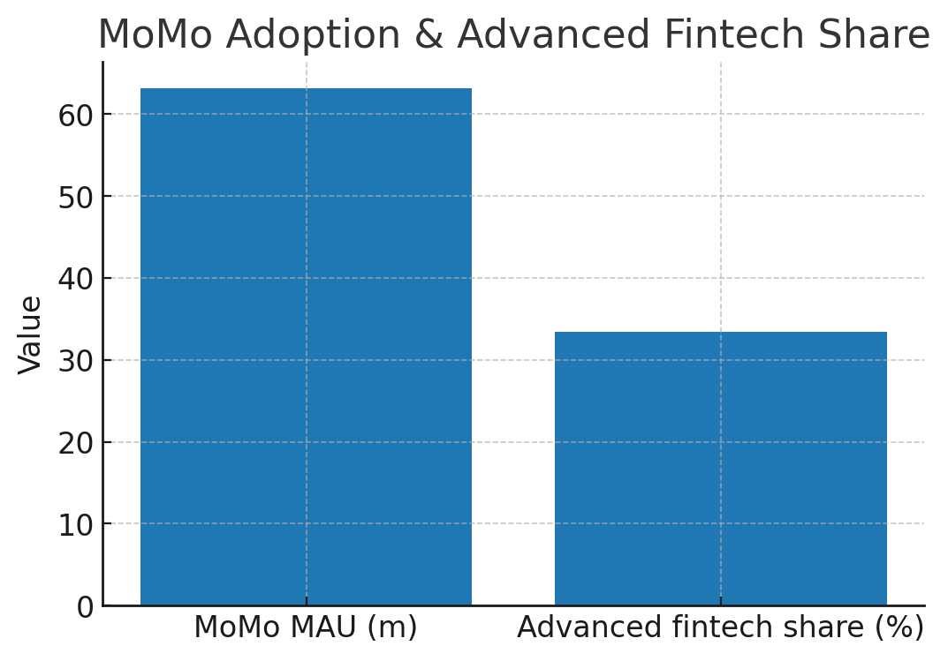

*MoMo MAU and advanced fintech share (H1-2025)*

## Regional Growth Weights (Proxy)

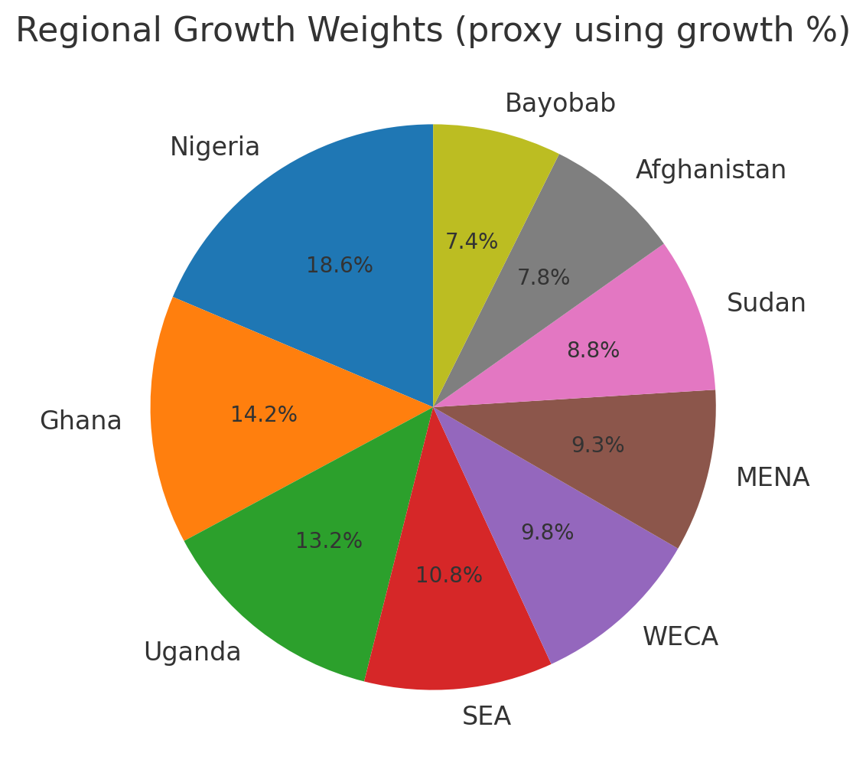

*Proxy regional weights using growth % as illustrative sizing*

## Capex Trend

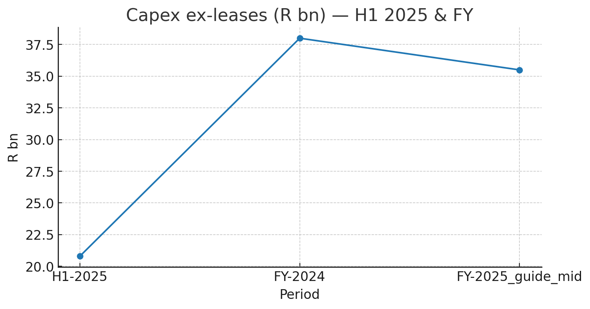

*Capex ex-leases (R bn) — H1-2025 & FY guidance*

## Bayobab Backbone & Wholesale

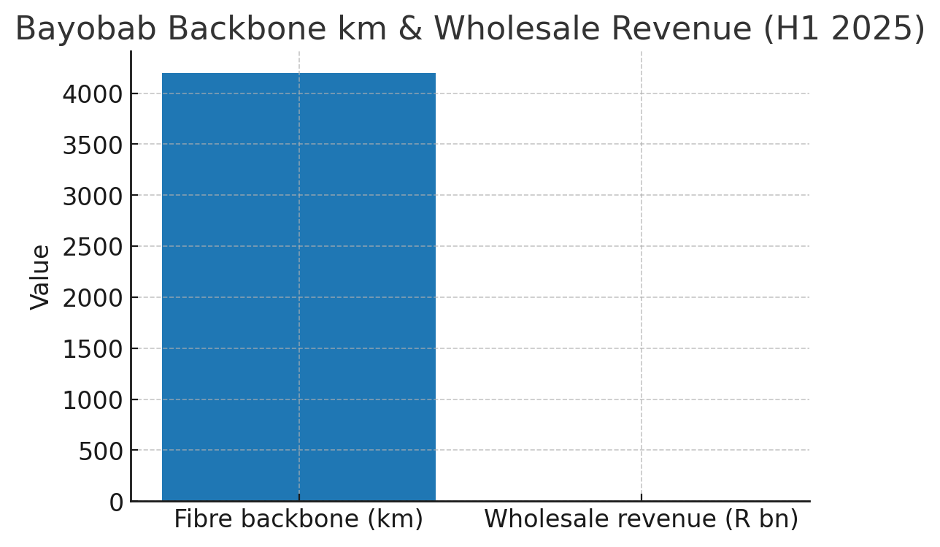

*Bayobab backbone km and wholesale revenue estimate (H1-2025)*

## Pricing & FX Snapshot (Heatmap)

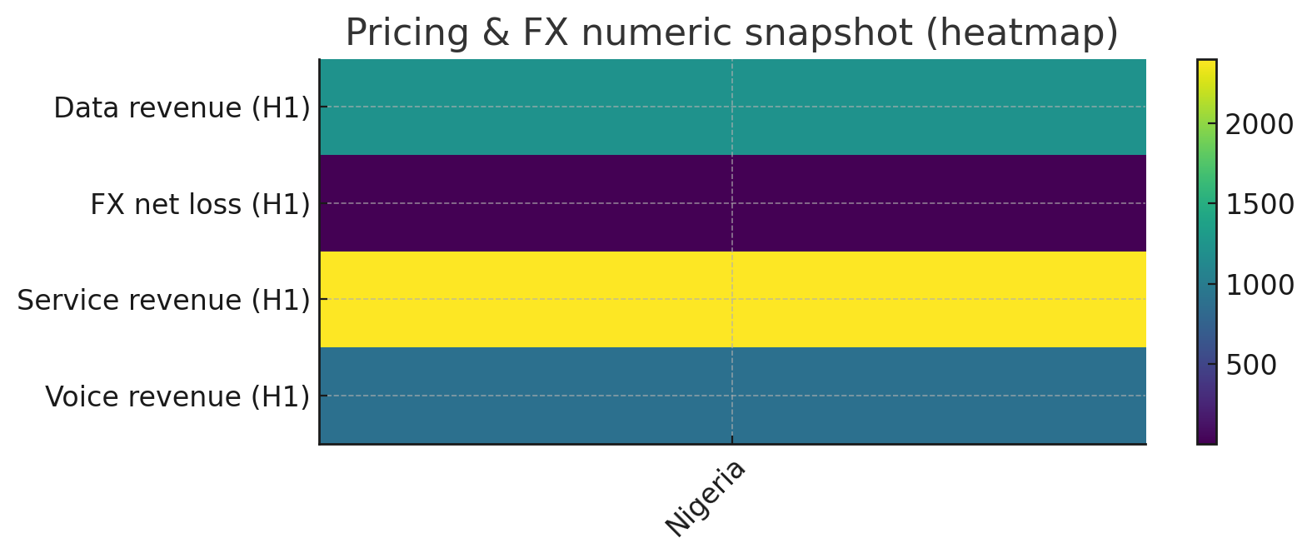

*Numeric snapshot of FX and revenue figures for key markets*

## Top Country Service Revenue Growth

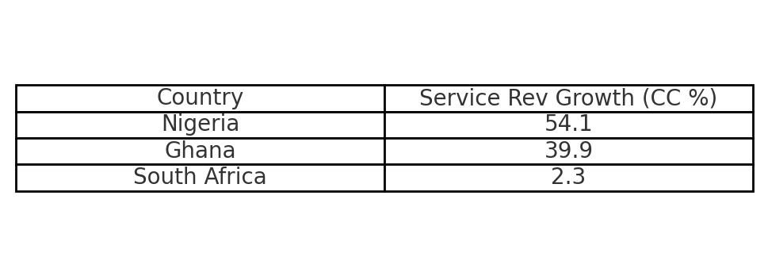

*Top country growth rates (H1-2025)*

## Appendix: Data Sources & Notes

Data in this report are taken from MTN Group H1-2025 SENS materials, FY-24 results, and reputable press summaries. Use the included CSVs to trace each table and chart. For full tables extracted line-by-line from the PDFs, upload the PDF and I will parse them into additional CSVs on request.