Nigerian Breweries – Data-Driven Insights
Coverage period: January 2024 to December 2024
Dataset nature: Synthetic but pattern-realistic for Nigerian market conditions (sales, pricing, logistics, distributor risk, quality, media, social, macro).

2) Seasonal & Regional Performance
• Peak Month: May 2024
• Trough Month: November 2024

Top States by Revenue
Top States by Revenue:
• Oyo: ₦361,226,330 revenue, 821,893 units
• Kaduna: ₦356,810,385 revenue, 798,258 units
• Borno: ₦351,034,310 revenue, 790,089 units
• Kano: ₦346,394,625 revenue, 787,876 units
• Abuja: ₦345,929,849 revenue, 810,712 units
The chart below highlights the top 5 states contributing the highest revenues.
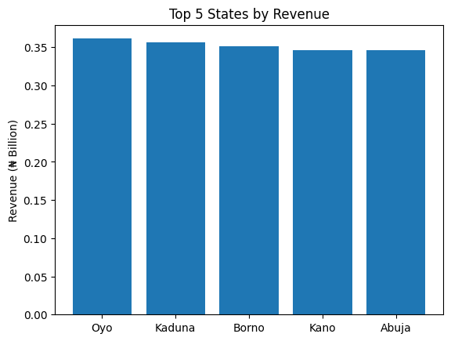
Top SKUs by Revenue:
• Gulder Lager 33cl: ₦595,170,858 revenue, 1,370,084 units
• Trophy Lager 45cl: ₦589,342,229 revenue, 1,331,993 units
• Fayrouz Can 33cl: ₦589,069,722 revenue, 1,344,991 units
• Life Lager 60cl: ₦574,734,211 revenue, 1,314,369 units
• Maltina PET 50cl: ₦567,681,816 revenue, 1,302,163 units

3) Stockouts & Inventory
• Average OOS Rate (mean across months): 7.55%
• Estimated Lost Sales from OOS: 666,602 units
Implication: Each 1pp reduction in OOS improves available volume; targeting -3 to -5pp OOS in top states likely yields immediate volume recovery.

4) Pricing Power & Compliance
• Avg Price Gap vs Competitors (mean across comps): 0.32%
• Compliance (from sales price_compliance): avg 90.01%
• Price–Volume correlation: -0.01 (negative indicates demand sensitivity to price)
Action: Sharpen pack-price architecture (smaller PET/can options in inflation-sensitive states) and protect price premium where sentiment is strong (e.g., platforms/ages with highest net sentiment).

5) Logistics & Cost-to-Serve
Worst 5 lanes by Cost per km:
• Kaduna Brewery ➜ Oyo: ₦72/km, OT 0.87, LT 5.1d
• Kaduna Brewery ➜ Kaduna: ₦70/km, OT 0.84, LT 4.5d
• Kaduna Brewery ➜ Edo: ₦69/km, OT 0.82, LT 3.5d
• Lagos Brewery ➜ Kano: ₦69/km, OT 0.86, LT 4.2d
• Lagos Brewery ➜ Rivers: ₦68/km, OT 0.86, LT 4.3d

Worst Lanes by Cost-to-Serve
The chart below shows the five most expensive logistics lanes (₦ per km).
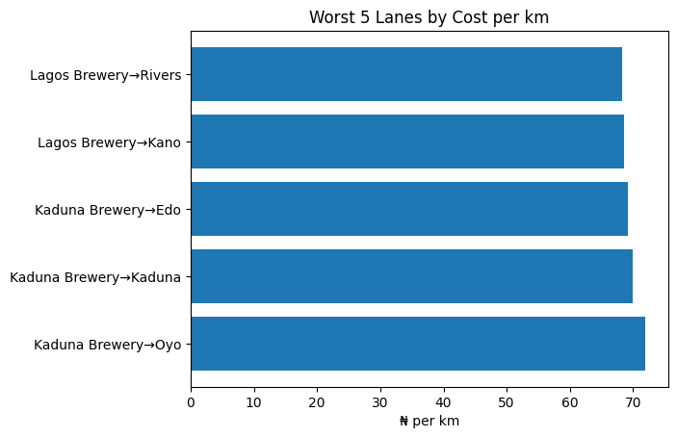

Worst 5 lanes by Lead Time:
• Kaduna Brewery ➜ Oyo: LT 5.1d, ₦72/km, OT 0.87
• Kaduna Brewery ➜ Plateau: LT 5.0d, ₦61/km, OT 0.82
• Kaduna Brewery ➜ Lagos: LT 4.5d, ₦64/km, OT 0.86
• Kaduna Brewery ➜ Kaduna: LT 4.5d, ₦70/km, OT 0.84
• Lagos Brewery ➜ Abuja: LT 4.4d, ₦66/km, OT 0.82
Implication: Prioritize route re-optimization and vendor SLAs on these lanes; aim to lift on-time ratio and reduce breakage.

6) Distributor Risk
Top 5 at-risk distributors:
• Dist C: Risk 0.77, DSO 38d, Credit 80%, OTIF 0.78
• Dist A: Risk 0.75, DSO 46d, Credit 77%, OTIF 0.83
• Dist B: Risk 0.69, DSO 37d, Credit 77%, OTIF 0.85
• Dist D: Risk 0.62, DSO 36d, Credit 71%, OTIF 0.83
Signals: High credit utilization (>85%), DSO >45 days, and low OTIF increase churn risk. Tighter credit control + service recovery plans needed for top-risk partners.

Distributor Risk – Top 5
The chart below shows the 5 distributors with highest risk scores, considering credit utilization, DSO, OTIF, and churn risk.
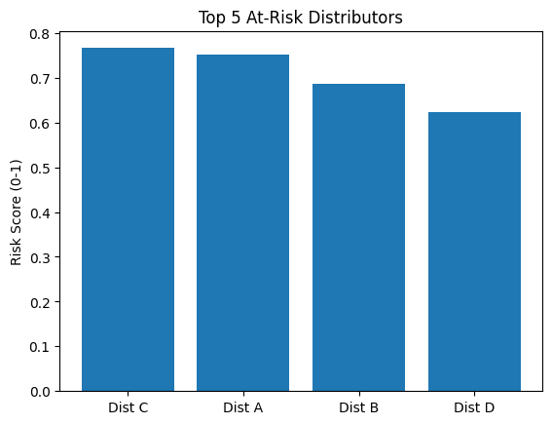

This report was auto-generated to support executive-level decision-making on Nigerian Breweries' sales, logistics, and distributor management.

7) Quality & Counterfeit
• Highest returns_rate states: Kano, Enugu, Borno, Edo, Rivers
• Total complaints recorded: 6,990
• Counterfeit cases (sum): 1,387
Action: Intensify market clean-up in high-returns/counterfeit clusters; run QA audits and track “cold chain” issues in hot corridors.

8) Marketing & Social
• Lowest average CPM platforms/regions are most efficient (see Media effectiveness table internally).
• Media–Revenue correlation: -0.17 (by region-month)
• Net Sentiment by Platform (desc): Twitter (0.25), TikTok (0.24), Facebook (0.24), Instagram (0.23)
• Net Sentiment by Age Group (desc): 18-25 (0.26), 26-35 (0.24), 36-45 (0.23), 46+ (0.23)

9) Macro Headwinds (Simple Correlations)
• Inflation ↔ Units correlation: -0.00
• FX rate ↔ Price correlation: -0.00
Interpretation: Higher inflation/FX typically pressures price and erodes volume; offsets via promo optimization, pack-sizing, and improving availability.

10) Prioritized Next Steps (90-Day Action Plan)
A. Availability & OOS
- Drive -3 to -5pp OOS in top 5 states via weekly S&OP with distributors; allocate buffer to lanes with highest lead time variability.
- Implement store-level OOS alerts (push notifications from dashboard) for Traditional trade.
B. Pricing & Pack
- Maintain premium in strong-sentiment platforms/ages; add smaller, affordable packs in price-sensitive regions to widen entry points.
- Pilot dynamic promo rules: cut ineffective discounts, redeploy toward states with best promo-to-volume response.
C. Logistics & Cost-to-Serve
- Renegotiate freight on worst-cost lanes; target ≥10% cost_per_km reduction.
- Cold-chain & handling SOPs to cut temp excursions and breakage by ≥20% on red lanes.
D. Distributor Health
- Credit policy with early-warning triggers (DSO>45, credit_util>85%, OTIF<0.9).
- Joint action plans with top 5 risk distributors; align inventory targets to realistic demand.
E. Quality & Market Clean-up
- Mystery shopping in hotspot states; QR-based authentication on premium SKUs.
- Tighten returns root-cause analysis loop back into manufacturing and logistics.
F. Media & Social
- Shift 10–15% spend toward lowest-CPM/high-sentiment mixes; scale TikTok/Instagram if sentiment > peers.
- Always-on social listening playbook with weekly insights into sales/availability squads.
G. Governance & Cadence
- Weekly exec stand-up with KPI tiles from this dashboard; Monthly state/channel deep dives.
- Scenario testing: ±5–10% price, ±10–20pp promo, -5pp OOS to align targets with market realities.
Appendix: Data Coverage
• Months: January 2024 to December 2024
• States in scope: 10
• Channels: E-commerce, Modern, On-Trade, Traditional
• Competitors: Guinness, International Breweries

