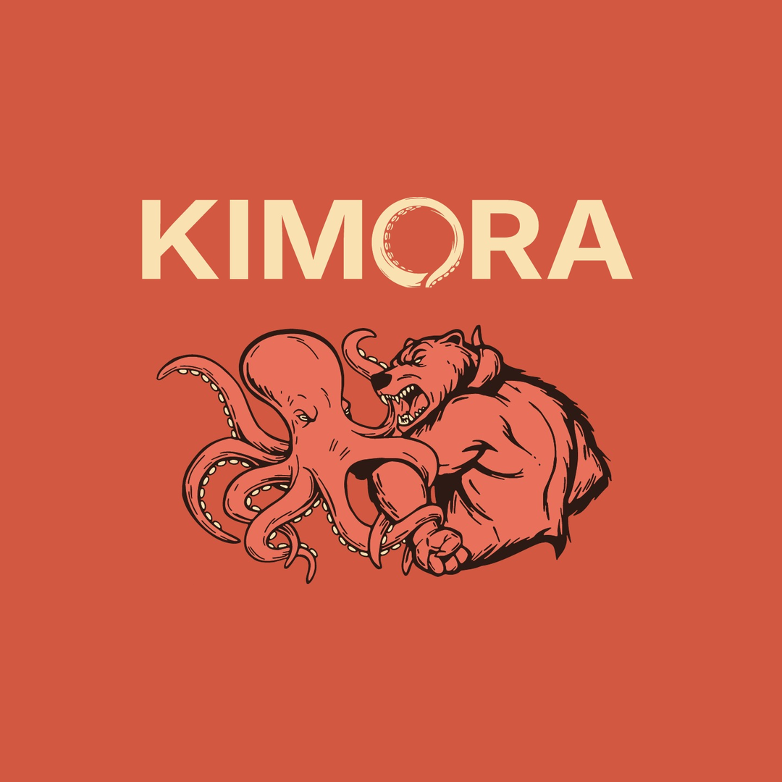
Gym Counter Display — Fabrication Spec & Request for Quote
Kimora Co. · Single-serve creatine stick “grab station” · Initial run: 50 units
Prepared June 30, 2026 · alex@kimoraco.com · kimoraco.com · Sedona, AZ

1. What we’re producing
A countertop point-of-purchase (POP) display — a “grab station” — for jiu-jitsu / BJJ gym front desks. It has three integrated zones:
- Header placard — printed brand card with the wordmark + bear-octopus crest, the $49.99 bag price, and a scannable QR to kimoraco.com.
- Stick tray — open tiered holder presenting single-serve creatine sticks face-out so the full stick is visible; restocked from the top.
- Cash honor box — a locked box with a coin/bill slot for $2 single-stick sales (honor system).
Purpose: drive first-time product trial at the point of training. We are seeding 50 partner gyms.

2. Quantity, timeline & budget
Initial order | 50 units. Please also quote 100 and 250 for volume comparison.
Sample first | 1 prototype/sample required for sign-off before the full run.
Timeline | Vendor selection + prototype now; full production timed to product launch (~Dec 2026).
Target unit cost | ~$50/unit goal. We will pay more for the custom-acrylic build if the quality justifies it.
Ship to | Kimora Co., PO Box 20024, Sedona, AZ 86341 (street address available for freight).

3. Two build options — please quote both

Option A — Assembled kit (target ~$50/unit)
- Off-the-shelf locking acrylic donation/ballot box with coin slot + cam lock and 2 keys.
- Acrylic tiered bin / pack dispenser for the sticks (face-out).
- Rigid printed header (3–5 mm PVC or styrene) seated above/behind the tray.
- Full-color vinyl decal wrap on the cash box (bear-octopus crest + “Grab a stick — $2”).

Option C — Custom-fabricated acrylic unit (premium — quote actual)
- Single integrated laser-cut / bonded acrylic unit (3–5 mm), matching the approved concept render.
- Direct-print or applied graphics on the header; integrated lockable coin slot in the base.
- Cleanest look and most durable; expected higher unit cost at 50 pcs — we want the real number.

4. Specifications
Overall footprint | ~10 in H × 6 in W × 4 in D (confirm / propose)
Header placard | ~6 in W × 4 in H, full-color (CMYK + white)
Stick capacity | 24–36 single-serve sticks, face-out, ~2 tiers; top restock
Single stick (approx.) | ~120 × 30 × 10 mm — exact dieline provided on award
Cash box | Integrated, lockable (cam lock + 2 keys), coin + bill slot
Material — Option A | Off-the-shelf acrylic box + PVC/styrene header + vinyl
Material — Option C | Cast/extruded acrylic, 3–5 mm, bonded
Print / finish | CMYK + white; UV-print or vinyl; scannable QR embedded as vector
Brand colors | Cream #F4EFE3 · Charcoal #16140F · Coral #D8532E

5. Art & files (provided on award)
- Print-ready vector files (.ai / .eps / .pdf) for wordmark, stick and pouch — from our designer.
- Bear-octopus crest (the logo illustration). It MUST be reproduced exactly — the full octopus head (left) and snarling bear (right). No substitutions or AI redraws.
- Scannable QR to kimoraco.com, supplied as vector for the header.
- Approved concept render attached separately for visual reference (not production art).

6. What we need back from you
- Unit price at 50 / 100 / 250 units.
- One-time fees (tooling, setup, plates, die).
- Sample / prototype cost and lead time.
- Production lead time after art approval + deposit.
- Minimum order quantity (MOQ).
- Materials & thickness used; lock type and security.
- Freight cost to Sedona, AZ 86341, plus packed carton dimensions and weight.
- Payment terms.
- Print method, and confirmation the QR + fine crest detail hold at print size.

7. Vendor shortlist
Vendor / path | Best for | Where
ShopPOPdisplays (US) | Custom acrylic, faster turnaround | shoppopdisplays.com
Alibaba acrylic POP suppliers | Custom acrylic, lowest unit cost at MOQ | alibaba.com — search “acrylic counter display”
Local acrylic / laser shop | One-off prototype, fast iteration | Search “acrylic fabrication Phoenix/Sedona AZ”
Displays2Go | Off-the-shelf locking boxes + bins | displays2go.com
Source One Displays | Locking donation/ballot boxes | sourceone.org
Uline / Amazon | Acrylic bins, locking boxes, fast | uline.com / amazon.com
Local print shop | Rigid header + vinyl decal (Option A) | Search “sign shop / large-format print AZ”

8. Outreach email template
Subject: Custom countertop retail display — quote request (50 units, repeatable)
Hi [Vendor],

I’m sourcing a custom countertop point-of-purchase display for a creatine + electrolytes brand (Kimora Co.). It’s a small “grab station” for gym front desks: a printed header placard, a tiered tray that holds single-serve drink-mix sticks face-out, and a small locked cash box with a coin slot.

Initial run is 50 units, with more to follow if it performs — please quote 50 / 100 / 250. I’ve attached a spec sheet and a concept render. Approx. footprint ~10″H × 6″W × 4″D; full-color header; integrated lock.

Could you send: unit price at each quantity, any one-time/tooling fees, sample cost + lead time, production lead time, MOQ, materials, and freight to Sedona, AZ 86341? Print-ready vector art is ready on award.

Thanks,
Alexzander Estrada
Founder, Kimora Co.
alex@kimoraco.com · kimoraco.com

— Kimora Co. · PO Box 20024, Sedona, AZ 86341 · alex@kimoraco.com · kimoraco.com · Grow Stronger. Think Sharper.

