Gym Counter Display — Fabrication Spec & Quote Request
Kimora Co. · Custom acrylic countertop POP display · Initial run: 50 units
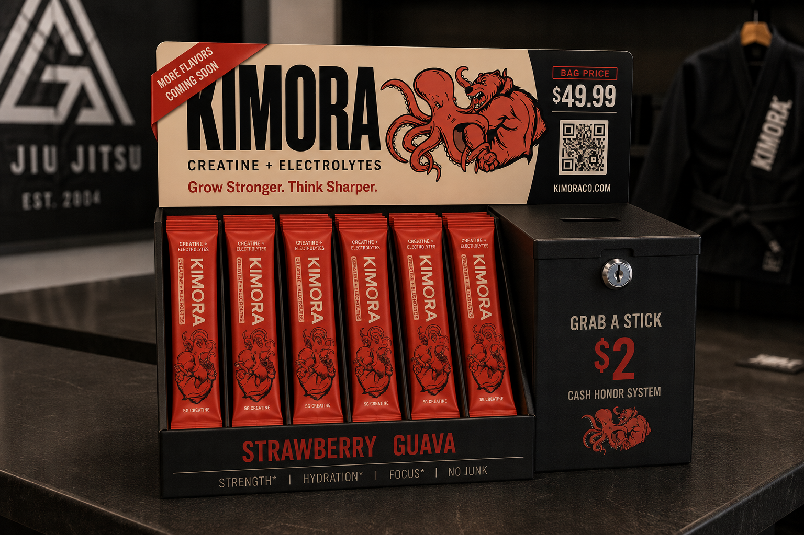
Approved design reference. Build to match this render.

1. Overview
A countertop point-of-purchase display for jiu-jitsu / BJJ gym front desks, built to match the render above. It is TWO pieces that sit side by side:
- Module A — Header + stick tray: an open-front tray that presents single-serve creatine sticks standing upright and face-out, with a tall printed header panel rising behind it.
- Module B — Locking cash box: a separate closed box with a coin/bill slot and a keyed lock, for honor-system $2 single-stick sales.
Purpose: first-time product trial at the point of training. Seeding 50 partner gyms.

2. Module A — Header + stick tray
- Open-front tray, matte black, with internal vertical channels that hold sticks upright, face-out. Render shows 6 facings; each channel holds several sticks deep (front-restock or top-restock).
- Header panel rises behind/above the tray at a slight backward angle. Cream background on the left ~2/3; charcoal panel on the right ~1/3 (behind the price + QR).
- Header graphics: KIMORA wordmark, the bear-octopus crest, “CREATINE + ELECTROLYTES,” the “Grow Stronger. Think Sharper.” tagline, a red diagonal “MORE FLAVORS COMING SOON” corner banner (top-left), a red “BAG PRICE $49.99” tag (top-right), a QR code, and “KIMORACO.COM.”
- Tray front rail printed: “STRAWBERRY GUAVA” (large, coral) with “STRENGTH* | HYDRATION* | FOCUS* | NO JUNK” beneath.

3. Module B — Locking cash box
- Separate closed box, matte black, roughly cube-shaped, slightly shorter than the header.
- Coin/bill slot on the top face; keyed cam lock (with 2 keys) on the upper-front face.
- Front graphics: “GRAB A STICK” / “$2” (large, coral) / “CASH HONOR SYSTEM,” with the bear-octopus emblem in coral at the bottom.
- Must be secure enough to deter casual tampering (locked rear or bottom access for cash retrieval).

4. Specifications (approximate — please confirm / optimize)
Module A footprint | ~8 in W × ~6 in H (tray) with header rising to ~11 in overall · ~4–5 in D
Header panel | ~8 in W × ~4.5 in H, full-color
Stick facings / capacity | 6 facings, face-out; ~24–36 sticks total (multiple deep per channel)
Single stick size | ~120 × 30 × 10 mm (≈4.7 × 1.2 × 0.4 in) — flat stick packet, not a bottle
Module B (cash box) | ~5 in W × ~6 in H × ~5 in D · coin/bill slot + keyed cam lock + 2 keys
Material | Combination black + clear/printed acrylic, ~1/8 in (3 mm) — economical option confirmed by fabricator
Print / finish | UV-printed graphics (header, tray rail, cash box); scannable QR embedded as vector
Brand colors | Cream #F4EFE3 · Charcoal #16140F · Coral #D8532E

5. Graphics & files (provided on award)
- Print-ready vector files (.ai / .eps / .pdf) for the wordmark, crest, stick and pouch — from our designer.
- The bear-octopus crest MUST be reproduced exactly — full octopus head (left) and snarling bear (right). No substitutions.
- Scannable QR to kimoraco.com, supplied as vector for the header.
- This render is the design reference for layout, proportion, and finish (not production art).

6. Quantity, timeline & budget
Initial order | 50 units. Please also quote 100 and 250.
Sample first | 1 prototype/sample for sign-off before the full run.
Timeline | Vendor + prototype now; full production timed to product launch (~Dec 2026).
Target unit cost | ~$50/unit goal; flexible upward if the build quality justifies it.
Ship to | Kimora Co., Sedona, AZ 86341 (street address for freight on request).

7. What we need quoted
- Unit price at 50 / 100 / 250 (Module A + Module B together).
- One-time fees (tooling, setup, print plates).
- Prototype / sample cost and lead time.
- Production lead time after art approval + deposit.
- Material & thickness used; lock type and cash-box security detail.
- Freight to Sedona, AZ 86341, with packed carton dimensions and weight.
- Payment terms; confirmation the QR and fine crest detail hold at print size.

— Kimora Co. · alex@kimoraco.com · kimoraco.com · Sedona, Arizona · Grow Stronger. Think Sharper.

