Dhapakhel , Lalitpur

pradip.ezyro.com

+977 9818057213

Raip2424@gmail.com

**Trannings**

**CONTACT**

**PROFILE**

**Pradip Rai**

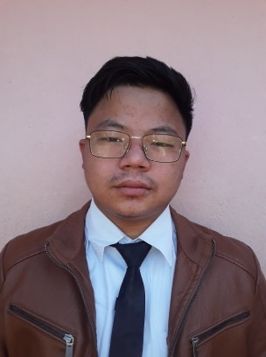

CURRICULUM VITAE

**EDUCATION**

**Shree Krishna Higher Secondary School**

**Dhapakhel lalitpur**

A Highly Motivated BBs Third Year Student looking for a Job within Related Field. Through my education I have high level of motivation for my work. I have ability to tackle any kind of problems and always eager to learn new things

**Nims College**

**Kumaripati Lalitpur**

+2 Passed with Second division (58.30) in 2074

SLC Passed with first division (70.25) in2071

**Nirvana College**

**Kumaripati Lalitpur**

Bachelor running (Third Year) with the subject BBS

391-mail4.png

067-phone.png

**EXPERIENCE**

001-home.png

**Nabil Bank**

**Kyc Department**

**Kumaripati Lalitpur**

202-sphere.png

I work there as kyc updater from 2019 Nov 10 to 2020 Nov 13

**AptechComputerEducation**

**Jawalakhel Lalitpur**

**Skills**



Computer Basis skill, Simple Web Design, Video Editing , Photo Editing

Three Month Training in Web Design and Hosting