Question: https://leetcode.com/problems/rotate-image/

So we need to create the rotated image of a matrix, now it is quite a simple problem if we use an extra space, but the condition is that we don’t we use any extra space.

So if you are aware of matrix and different forms of the matrix then by trying out few transformation we can come to an conclusion that we need to Transpose the matrix, i.e., the first row is transformed to first column and second row to second column….

Now once we are done with transposing we need to horizontally flip the matrix and we are done with the 90deg rotation.

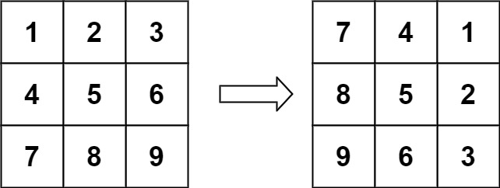

Code:  
class Solution {

public void rotate(int[][] matrix) {

//transverse

for(int i=0; i<matrix.length; i++){

for(int j=i; j<matrix.length; j++){

swap(matrix, i, j);

}

}

//horizontal flip

for(int i=0; i<matrix.length; i++){

matrix[i]=reverse(matrix[i]);

}

}

public void swap(int[][] matrix, int i, int j){

int temp = matrix[i][j];

matrix[i][j]=matrix[j][i];

matrix[j][i]=temp;

return;

}

public int[] reverse(int arr[]){

int i=0, j=arr.length-1;

while(i<j){

int temp=arr[i];

arr[i]=arr[j];

arr[j]=temp;

i++;

j--;

}

return arr;

}

}

Github Link :<https://lnkd.in/ecwtJeaz>