Question: https://leetcode.com/problems/k-diff-pairs-in-an-array/

It is a simple backtracking problem where we take decision of either including or not including a element at each level of the decision tree.

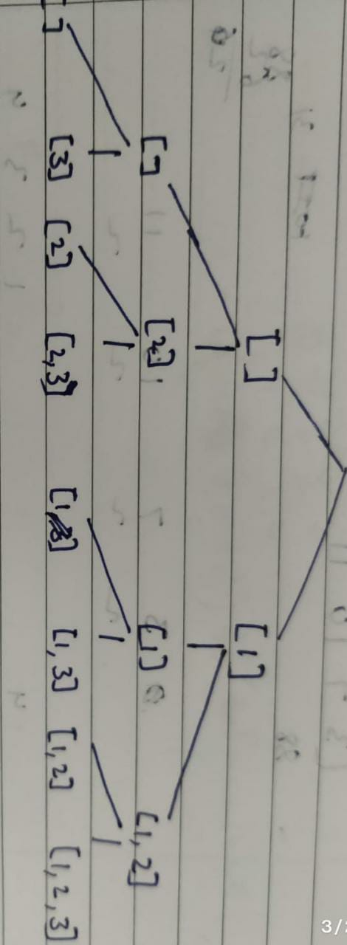

Code:  
class Solution {

public int findPairs(int[] nums, int k) {

int n = nums.length, count=0;

Arrays.sort(nums);

for(int i=0; i<n; i++){

int z=i+1, target=nums[i]+k;

while(z<n){

if(nums[z]==target){

count++;

break;

}else if(nums[z]>target){

break;

}

z++;

}

if(i<n-1 && nums[i]==nums[i+1])

while(i<n-1 && nums[i]==nums[i+1]){

i++;

}

}

return count;

}

}

Github Link :<https://lnkd.in/ecwtJeaz>