Full title: HIUSA: AN AI - INTEGRATED STUDENT GOVERNANCE AND FINANCIAL MANAGEMENT SYSTEM
Agendas:
- HIUSA’s Features in total
  - Financial Management Module
    - Automated Digital Ledger - Records all transactions in real-time, ensuring transparency and auditability
      - Who can access
        - Admin
          - Full access
    - Auto-Generated Financial Reports - Generates income statements, expense summaries, and audit logs, Exportable in PDF/Excel format.
      - Powered by Groq LLM, to be specified in the RRL. Summaries of everything, taken from OLS.
      - Records of all transactions, e mention.
      - Can generate reports per event as well.
      - Who can access
        - Admin
          - Full access
    - Digital Receipt System - Automatically issues receipts for every transaction, Accessible anytime by students and officers.
      - If a student has paid and its approved, there is a validation that this is the receipt that he/she will receive, so the officer can double-check the order confirmation.
      - Different column name for receipt no; it's not the primary ID because there is a different receipt no. for every event. If there’s a new event, the receipt no column starts back to 1.
    - Budget Allocation Manager - Allows admin to assign budgets per project/event, and tracks remaining funds dynamically
      - Admins
        - They are the ones to set the budget for events
      - Department Head
        - Approves or rejects budget allocation for the event
      - SBO Officers
        - They can only see how much budget was assigned to the event.
    - Transaction History Dashboard - Displays complete financial logs with filters and search
      - Summary and statistics.
        - Who can access
          - Admin
            - FULL CRUD
          - SBO Officer
            - View and search only
          - Department head
            - View and search only
    - Financial Forecasting - Predicts future budget availability based on historical transactions and suggests safe spending limits to avoid deficits
      - OLS, with a formula nga naa sa RRL, e specify lang jud nako ug maayo after.
      - Uses Python.
      - Who can access
        - SBO Officer
          - Can use the feature to determine.
        - Admin
          - Can use the feature to determine.
    - Budget Advisory System - Recommends optimal fund allocation per event/project, Flags overspending risks in real time
      - Uses OLS to check spending or how u budget.
  - Event Management Module
    - Event Planner - Create, edit, and manage events with budget and task tracking, including vendor deadlines and logistics checklist.
      - Who can access
        - Admin
          - Full access to this
        - Department Head
          - Admin will propose event alongside the budget if budget is applicable. If its good, department head will approve of it.
        - SBO Officer
          - Will only be able to see the tasks assigned to them.
    - Activity Calendar - Centralized calendar for all SBO events; syncs with student view in real time
      - Who can use
        - All users
    - Event Budget Monitoring - Tracks spending vs allocated budget per event
      - Who can use
        - Admin
          - Can use this.
        - SBO Officer
          - Can use this.
    - Event Notification - Sends reminders and updates to students and officers
      - Everytime an event is made, e notify diritso sa students nga naay new event.
      - Also notify students if events are close.
      - Everyone can manage notifications.
      - Who can use
        - Admin
          - Will be able to send a reminder once a announcement has been created.
        - SBO officer
          - Same with admin, but requires approval of Admin before successfully posting.
        - Department Head
          - Only receives notifications
        - Student
          - Only receives notifications.
    - Attendance Tracking System - Records student participation in events (preferably biometric)
      - We are gonna use DigitalPersona 4500.
      - Repo for attaching digitalPersona : https://github.com/Marcellinus123/Biometrics-Capture-and-Verification-with-Digital-Persona-U.are.U-4500-in-PHP-and-MySQL
      - Who will use
        - SBO Officer
          - Will use his/her dashboard to track attendance of every event and set up the biometrics ONLY IF they have it; if not, they will use the digital monitoring.
        - Other roles
          - Will also register their biometric details.
    - Event Planning Assistant - Suggests timelines, required resources, and checklist items, and predicts potential delays or conflicts
      - Powered by LLM, groq
      - Officer/Admin must press a button to trigger the event planning assistant.
      - Who will use
        - Admin
          - Can make use of this totally
        - SBO Officer
          - Can only see the results the admin has requested.
  - Merchandise Module
    - Tokenized Queue System - A fulfillment mechanism within the Merchandise module of Hiusa in which the system issues a unique alphanumeric claim token to a student after completing a merchandise reservation, and the student later presents the token to an officer for validation and merchandise release.
      - 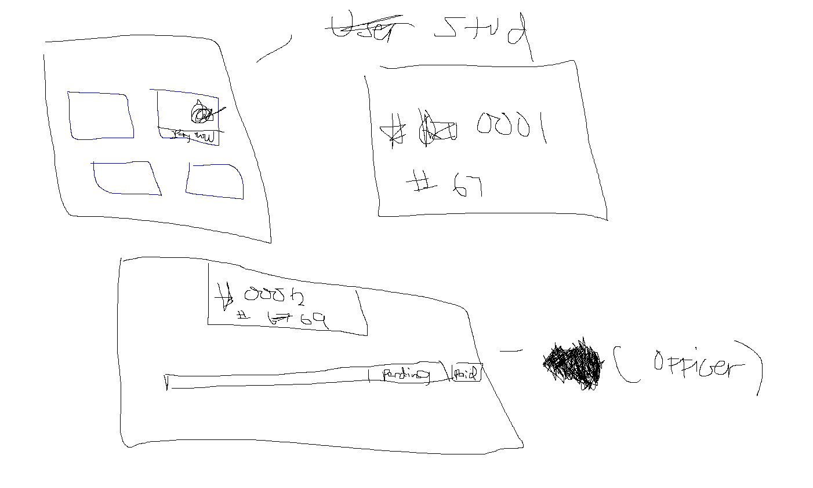
    - Inventory - Displays current stock levels of items
      - Cloudflare R2 bucket will be used for all images
      - Who can use
        - Admin
          - FULL CRUD
        - SBO OFFICER
          - View only
    - Order Tracking - Students can monitor order status (pending, paid, claimed)
    - Fulfillment Verification - Officers validate claim tokens before releasing items
    - Who can use
      - Admin and SBO Officer
        - Make total use of this
      - ALL users
        - Can make reservation purchases, receive token, track order, browse merchandise, and pay online via gcash, but requires approval of SBO Officer and admin if it was sent to their account.
  - Voting Module
    - Secure Online Voting - One student, one vote enforcement
      - Accessible during election periods only
      - Who can use
        - ALL
          - Can vote and see results
    - Candidate Management
      - Include partylist as well.
      - Images as well, Cloudflare R2 bucket
      - Who can use
        - Admin
          - registers and manages official candidates, full crud
        - SBO officer
          - registers and manages official candidates, full crud
    - Real-Time Vote Counting - Automatic tallying with live updates
      - Everyone can view the results.
    - Tamper-Proof Election Mechanism - Prevents duplicate voting and manipulation
    - Election Results Dashboard - Displays results instantly after voting closes
      - Who can use
        - Everyone can see results
    - Partylist management
      - Who can use
        - Admin
          - Can manage partylists fully.
    - Election management
      - Who can use
        - Admin
          - Manage elections fully,. Full crud, but requires approval of department head for creating an election.
        - Department head
          - Approves or disapproves creation of an election.
  - Tasks Module
    - Task Delegation - Assigns tasks based on officer roles, workload, and past performance, and suggests best-fit team members for activities
      - Uses Rule-based weight scoring algorithm for this, and a LLm using groq for explaining the results.
      - Who can use
        - Admin
          - Makes full use of the feature of task delegation.
        - SBO Officer
          - Can only view their assigned tasks and tracks progress
      - FinalScore = (RoleWeight × RoleScore) + (WorkloadWeight × WorkloadScore) + (PerformanceWeight × PerformanceScore), where RoleWeight, WorkloadWeight, and PerformanceWeight represent the relative importance assigned to each decision criterion, while RoleScore, WorkloadScore, and PerformanceScore represent an officer's suitability based on their role compatibility, current workload, and historical task performance, respectively.
    - Workflow Automation - Auto-generates workflows for events and operations, Tracks task completion and deadlines
      - Auto creates workflows, what to do for the event. Also tracks completion.
      - Who can use
        - Admin
          - Full creation of this feature.
        - SBO Officer
          - Can track task completion and deadlines, basically be able to see their to do’s. The tasks will automatically be seen in the task module.
      - It also uses the task delegation since it will assign tasks to officers, depending on who will fit this task.
  - Announcements module
    - Who can use
      - Admin
        - Has the ability to approve and create announcements, and to manage them.
      - SBO officer
        - Can create announcements, but requires approval of Admin.

  - Users
    - MVP functionalities
      - Admin
        - Treasurer, president, SBO Adviser, Secretary, Auditor, Chief of Developer (If applicable to other orgs)
        - Can add users basically, adds sbo members, department head, and students.
        - Able to manage merchandise and inventory, manage gcash payment option by putting their qr code, use the AI features mentioned above.
        - Task delegate sbo members and utilize creation of event workflows by using the workflow automation feature.
        - Can also use the task delegation itself without using the event workflow feature.
        - Approve announcements drafted or sent by sbo members
        - manage the financial part, and utilize its ai features.
        - Can manage sbo member role like PIO, vice president internal, vp external, and many more, and set as sbo member
        - Can create an election which requires approval of depeartment head, manage candidates, manage partylists, and supervise voting
        - Can vote
        - Can use biometrics for attendance for events
        - Can take attendance for everyone in the event by letting them use biometrics or just manual checking.
        - Able to export reports and utilize the AI for exporting.
        - see calendar of events.
        - Can receive notifications.
      - SBO member
        - All other sbo members except those in admin
        - Can process payment for the token queue thing in the merchandise module, since they will deal with the labor.
        - Can post announcements, but requires approval of admin
        - Can view tasks assigned to them, mark it as done as well.
        - Can view events.
        - Can vote.
        - Can view inventory, but not add.
        - Can view financial per event or overall status.
        - Can use biometrics for attendance for events
        - Can take attendance for everyone in the event by letting them use biometrics or just manual checking.
        - Can browse merchandise and purchase.
        - They can voting results
        - see calendar of events.
      - Department Head
        - Dean, chairperson, etc.
        - Does most approvals, like approval of creation of event, and approval of election.
        - Able to get an overview of financial situation of everything, events, and etc.
        - They can voting results
        - see calendar of events.
      - Students
        - Can browse merchandise, vote, see calendar of events.
        - They can voting results
- Tasks to do for the Manuscript
  - AYNMIN DEV'S TO DO
- Strategy for workflow
  - Hatag rako instructions for business use case and system use case.
- Link for new files
  - New final paper
    - HIUSA - FINAL

