SOFTWARE DESIGN DESCRIPTION

E Commerce Code Challenge
  - Laravel React MySQL and Docker architecture
Purpose
Provide a complete design baseline for personal review before implementation begins
Document field | Value
Version | 0.1
Status | Proposed for review
Date | 1 October 2026
Scope | Product management search CSV import and simulated purchasing

Design conclusion
The proposed solution is a split monorepo with independently packaged React and Laravel applications, a MySQL InnoDB database, and a Docker Compose runtime. Product imports accept valid rows and produce a downloadable rejection file. Purchases reserve stock before payment and finalize through explicit, idempotent state transitions.

Contents
- 1 Purpose and design status
- 2 Product scope and requirements
- 3 Architecture drivers
- 4 System architecture
- 5 Technology and packaging decisions
- 6 Domain model
- 7 Product catalog design
- 8 CSV import design
- 9 Purchase and payment design
- 10 API design
- 11 Frontend experience and design system
- 12 Security and privacy
- 13 Reliability and observability
- 14 Container operation and configuration
- 15 Continuous integration
- 16 Verification strategy
- 17 Alternatives and tradeoffs
- 18 Risks assumptions and open questions
- 19 Implementation sequence
- 20 Acceptance criteria
- 21 References

Document conventions
Confirmed decisions were explicitly agreed during design review. Recommended defaults complete the design where the challenge is silent. Open questions do not block implementation unless they materially change the product behavior described here.

1 Purpose and design status
This document defines the proposed software design for the e-commerce code challenge. It is intended for review before code is created. It connects each challenge requirement to an implementation choice, records the alternatives considered, and defines the behavior that tests must verify.
The design favors a production-minded modular application without introducing services that the challenge does not need. Laravel owns business behavior and persistence. React owns the user experience. MySQL is the source of truth for products, imports, inventory reservations, orders, payments, idempotency records, and outbox messages.

Design status
Area | Status | Position
Backend | Confirmed | PHP and Laravel REST API
Frontend | Confirmed | React TypeScript and Tailwind
Database | Confirmed | MySQL with InnoDB
Packaging | Confirmed | Separate frontend and backend images
CSV import | Confirmed | Partial success with downloadable rejected rows
Purchase | Confirmed | Reserve pay and finalize
Design system | Confirmed | ShopVibe light theme with accessibility adaptations
Remaining defaults | Recommended | Product lifecycle search API conventions and retention

2 Product scope and requirements

Product objective
The application lets a trusted operator manage a product catalog and import products from CSV. A shopper can search the catalog and purchase a quantity of one product using a simulated payment provider. The application must start locally through Docker and must preserve correct inventory under concurrent requests.

Requirements traceability
Requirement | Design response | Primary verification
Local database | MySQL InnoDB in Docker Compose | Migration and smoke tests
Product CRUD | Versioned Laravel endpoints and React management screens | Feature and browser tests
CSV import | Validated partial import with persisted results | Fixture driven import tests
Example CSV | Repository fixture with download date 2026-10-01 | README review
Product search | Paginated case-insensitive API and catalog UI | API and browser tests
Purchase products | Reservation payment and finalization workflow | Concurrency and state tests
User interface | React storefront and management workspace | Responsive Playwright flow
Docker runtime | Frontend backend scheduler and MySQL services | Clean Compose startup
Decision record | README and design decision section | Documentation review
Local instructions | Environment and one-command startup instructions | Fresh-clone verification
GitHub delivery | Single split-monorepo with CI | Repository review

Out of scope
- Authentication user accounts and administrative roles
- A shopping cart or multi-product checkout
- Shipping tax discounts refunds and multiple currencies
- Real payment credentials or a live payment provider
- Product images and media management
- Redis Kafka Elasticsearch Kubernetes AWS deployment and Infrastructure as Code
- Dark mode

3 Architecture drivers
Driver | Design implication
Reviewer setup | A fresh clone must start with Docker Compose and no host PHP Node or MySQL installation.
Data quality | The supplied CSV is adversarial and requires explicit validation duplicate handling and error reporting.
Inventory correctness | Reservations must be atomic and repeatable without overselling or double release.
Payment realism | The database reservation commits before the payment call and finalization runs in a second transaction.
Retry safety | Client and provider operations use different idempotency keys.
Operational recovery | A scheduler expires abandoned reservations reconciles uncertain payments and processes outbox records.
API ownership | React communicates through a versioned REST contract rather than Laravel page responses.
Scope control | The design exposes production boundaries without adding an external broker or cache.

4 System architecture
The runtime contains three persistent application services and one database. The scheduler reuses the backend image, so the project produces two application images rather than three. A short-lived migration service also uses the backend image during startup.
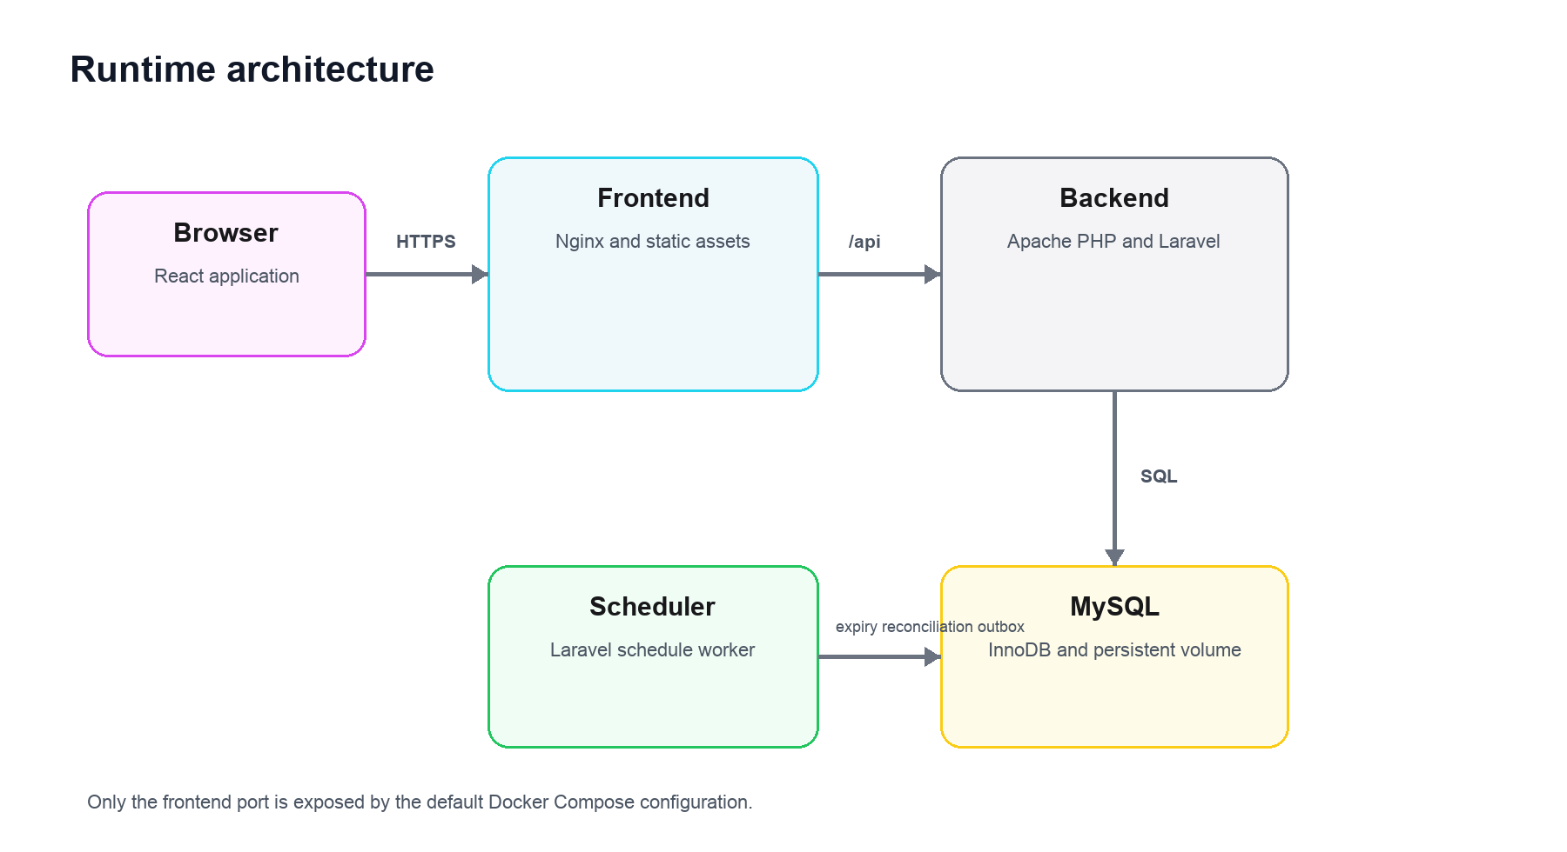
Figure 1 Runtime architecture

Component responsibilities
Component | Responsibilities | Public exposure
Frontend | Serve React assets proxy API requests and provide the health entry point | Host port 8080
Backend | Validate requests execute domain behavior expose REST resources and health endpoints | Compose network only
Scheduler | Expire reservations reconcile payments and process outbox messages | None
MySQL | Persist transactional and operational state using InnoDB | Compose network only

Repository organization
/
|-- backend/
| |-- app/Catalog/
| |-- app/Importing/
| |-- app/Ordering/
| |-- database/
| |-- routes/
| `-- tests/
|-- frontend/
| |-- src/api/
| |-- src/features/
| |-- src/components/
| `-- tests/
|-- docker/
|-- docs/
|-- compose.yaml
`-- README.md

5 Technology and packaging decisions
Concern | Selected technology | Reason
Backend | PHP and Laravel | Matches the interview context and provides mature validation transactions migrations scheduling and testing.
Frontend | React and TypeScript | Creates a clear API consumer and supports component testing.
Database | MySQL InnoDB | Provides transactions row locks foreign keys and familiar PHP operations.
Styling | Tailwind and CSS variables | Maps ShopVibe tokens to local accessible components without a large visual framework.
HTTP entry point | Nginx frontend image | Serves static assets and proxies API traffic under one browser origin.
PHP runtime | Apache PHP image | Keeps the backend independently deployable without a second backend web-server container.
Orchestration | Docker Compose | Provides a reproducible local environment and explicit service health checks.
CI | GitHub Actions | Verifies both applications their images and the integrated runtime.

Packaging behavior
The frontend and backend are independently buildable and deployable. The frontend Nginx image proxies /api to the backend over the Compose network. The browser therefore uses one origin, while the API remains a separate artifact with its own dependencies and tests.

6 Domain model
Aggregate or record | Purpose | Key invariants
Product | Sellable catalog entry | Unique SKU nonnegative price and stock archived products cannot be purchased
Product import | One CSV processing attempt | Counts agree with persisted rejections and inserted rows
Import rejection | Original rejected row and validation reasons | Source values remain unchanged in storage
Order | Purchase intention and outcome | State changes are monotonic and totals do not change after creation
Order item | Snapshot of purchased product | Name SKU unit price quantity and line total remain immutable
Inventory reservation | Units removed from sellable stock | One terminal transition restores or consumes stock exactly once
Payment attempt | Provider interaction | Provider key is unique and retries do not create another charge
Idempotency record | HTTP request replay result | Same key with a different request hash is rejected
Outbox message | Event committed with domain state | Successful order finalization creates one OrderPlaced event

Product data
Field | Type | Rule
id | BIGINT UNSIGNED | Internal primary key
sku | VARCHAR 64 | Required normalized to uppercase and unique for the product lifetime
name | VARCHAR 255 | Required after trimming
description | TEXT | Required string
category | VARCHAR 100 | Required free text
price | DECIMAL 12 2 | USD zero or greater
stock | INT UNSIGNED | Currently sellable units
weight_kg | DECIMAL 10 3 | Required and zero or greater
deleted_at | TIMESTAMP nullable | Soft deletion marker
created_at updated_at | TIMESTAMP | Stored in UTC

7 Product catalog design

Product lifecycle
- Create and update requests validate every field on the server.
- SKU uniqueness is enforced by MySQL and translated into a conflict response.
- Deletion archives the product rather than removing the database row.
- Archived products do not appear in the shopper catalog and cannot be purchased.
- A previously used SKU cannot be assigned to a different product.
- Order items keep snapshots so later catalog changes do not alter receipts.

Search behavior
Search matches SKU name description and category using case-insensitive MySQL collation. Category and in-stock filters may narrow the results. The default page size is 20 and the maximum is 100. The API returns stable pagination metadata and applies a deterministic secondary sort by product ID.
Parameter | Default | Allowed behavior
q | Empty | Case-insensitive substring search
category | All | Exact category filter
availability | All | All in_stock or out_of_stock
sort | name | name price stock or created_at
direction | asc | asc or desc
page | 1 | Positive integer
per_page | 20 | 1 through 100

8 CSV import design

Processing contract
1. Reject files that exceed 5 MB or 10000 data rows.
2. Require UTF-8 CSV and the seven product columns exactly once.
3. Allow source_row and validation_errors only when a rejection file is re-uploaded.
4. Ignore completely blank rows and preserve the original source row number.
5. Parse with a CSV library so quoted commas quotes and Unicode are preserved.
6. Validate all rows before writing products.
7. Reject every row that shares a duplicate SKU within the same file.
8. Reject SKUs that already exist and never perform an implicit update.
9. Insert the accepted set in one transaction.
10. Persist the import summary and rejected rows for review and download.

Validation outcome
Input condition | Outcome
Malformed CSV or missing required header | Reject the file with 422 and import nothing
Invalid product row | Reject the row and continue evaluating the file
Duplicate SKU within file | Reject all rows containing that SKU
Existing SKU | Reject the row as a conflict
Unexpected database error | Roll back the accepted set and return an operational error
Valid file with mixed results | Return 200 with imported and rejected counts

Rejected row download
The upload response includes a rejection CSV link when at least one row failed. The generated file contains the original seven fields plus source_row and validation_errors. The importer accepts and ignores those two diagnostic columns, allowing the user to correct and re-upload the downloaded file.
name,sku,description,category,price,stock,weight_kg,source_row,validation_errors
Yoga Mat,YM-015,Premium non-slip yoga mat,Sports,free,200,1.2,7,price: must be a decimal

CSV export protects spreadsheet users by prefixing values that begin with formula control characters. The stored source value remains unchanged; protection is applied only while streaming the download.

9 Purchase and payment design
A purchase covers one product and quantity. The order model still uses order items so the persisted contract can support multi-product orders later without changing historical records.
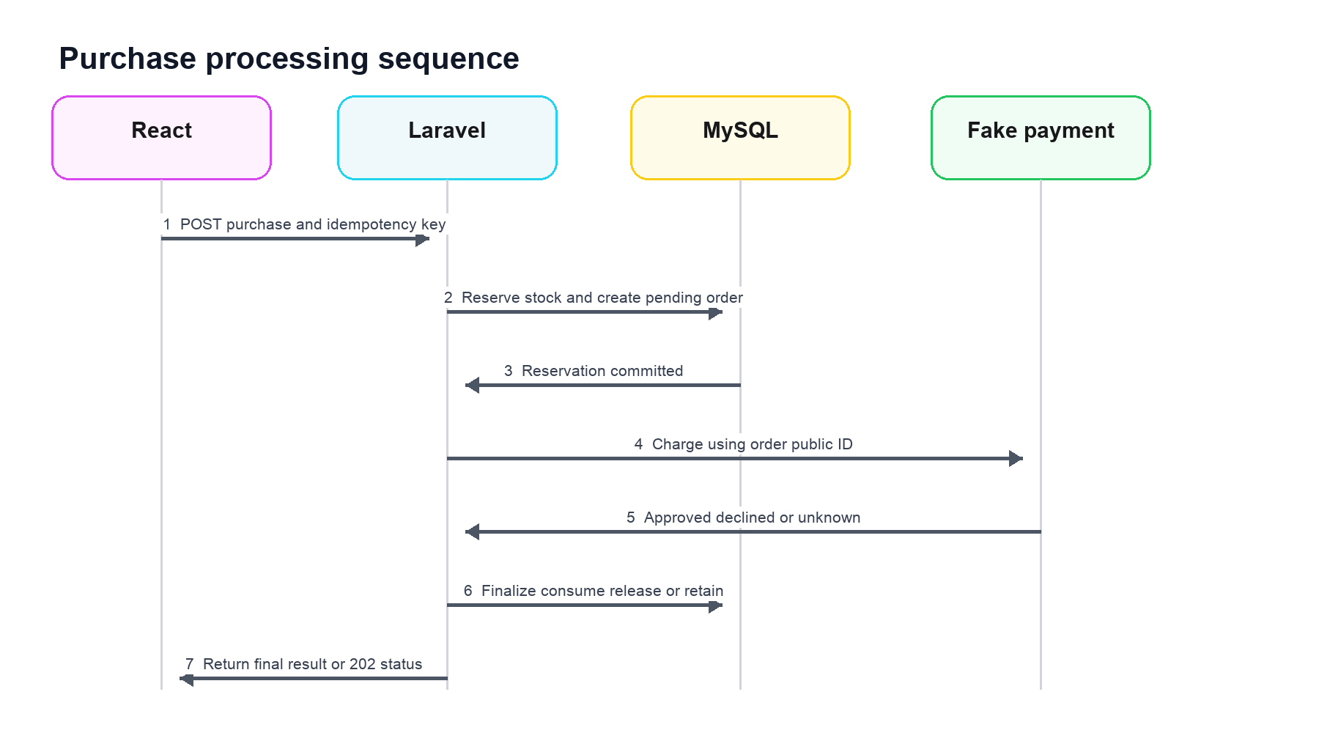
Figure 2 Purchase processing sequence

Reservation phase
The first InnoDB transaction claims the API idempotency key, atomically decrements sellable stock, creates a pending order and item snapshot, creates an active reservation, and records a pending payment attempt. The transaction commits before the gateway is called.

Payment phase
The fake payment gateway runs outside a database transaction. The order public ID is the provider idempotency key. The demonstration gateway approves deterministically. Tests inject declining and unavailable gateways without exposing test controls in the public API.

Finalization phase
Gateway result | Order transition | Reservation transition | Stock effect
Approved | pending_payment to paid | active to consumed | No second decrement
Declined | pending_payment to payment_failed | active to released | Quantity restored once
Unknown | pending_payment to payment_unknown | Remains active | Held for reconciliation
No payment before expiry | pending_payment to expired | active to expired | Quantity restored once

State transition rules
State owner | Initial state | Terminal or subsequent states
Order | pending_payment | paid payment_failed payment_unknown or expired
Order after uncertainty | payment_unknown | paid payment_failed or manual_review
Reservation | active | consumed released or expired
Payment | pending | approved declined or unknown
Payment after uncertainty | unknown | approved declined or manual_review

Reservation recovery
Reservations expire after a configurable ten-minute period. The scheduler locks an eligible reservation, rechecks its state and expiry, restores stock, and commits the terminal transition. Repeated runs are safe. A payment_unknown order is reconciled before inventory is released. If the provider remains uncertain, the order moves to manual_review and continues to hold the units.

Idempotency boundaries
Boundary | Key | Protection
Browser to API | Idempotency-Key header | Double clicks network retries and repeated HTTP requests
Backend to payment | Order public ID | Gateway retries timeout recovery and process restarts
Event processing | Outbox message ID | Repeated scheduler delivery

Transactional outbox
The paid transition and OrderPlaced outbox row commit in the same transaction. The scheduler processes the message and writes a structured event log. A production deployment could publish the same record to a queue without changing order finalization.

10 API design

Endpoints
Method | Path | Purpose
GET | /api/v1/products | Search filter sort and paginate products
POST | /api/v1/products | Create a product
GET | /api/v1/products/{id} | Read one product
PUT | /api/v1/products/{id} | Replace editable product fields
DELETE | /api/v1/products/{id} | Archive a product
POST | /api/v1/product-imports | Upload and process a CSV file
GET | /api/v1/product-imports/{id} | Read an import result
GET | /api/v1/product-imports/{id}/rejections.csv | Download rejected rows
POST | /api/v1/purchases | Reserve pay and finalize a purchase
GET | /api/v1/orders/{publicId} | Read order status or receipt
GET | /api/health/live | Report process liveness
GET | /api/health/ready | Report database readiness

Response conventions
- JSON resources use a top-level data member and pagination metadata where applicable.
- Errors follow a Problem Details shape with type title status detail request_id and field errors.
- Money is serialized as a decimal string with an explicit USD currency code.
- Timestamps use ISO 8601 in UTC.
- The API never accepts price total stock or payment status from the browser.
- An OpenAPI document describes the supported contract.

Purchase outcomes
Condition | Status | Behavior
Paid | 201 | Return receipt and location
Payment unknown | 202 | Return order URL for bounded polling
Missing idempotency key | 400 | No reservation created
Product not found | 404 | No reservation created
Archived or insufficient stock | 409 | No order side effect
Key reused with different body | 409 | Return idempotency conflict
Payment declined | 402 | Return safe decline response after stock release
Unexpected dependency failure | 503 | Return retry guidance without internal details

11 Frontend experience and design system
The frontend applies the ShopVibe light design system to two related workspaces. The storefront uses spacious cards and prominent purchase actions. The management workspace uses the same tokens with denser forms tables and import results. Dark mode is intentionally excluded.

Navigation and screens
Area | Screens | Primary tasks
Shop | Catalog product detail purchase drawer receipt | Search filter choose quantity and purchase
Manage | Product table create edit archive import result | Maintain catalog and correct rejected data

Frontend implementation
- React Router controls navigation.
- TanStack Query owns server state mutations retries and invalidation.
- React Hook Form and Zod provide immediate form feedback while Laravel remains authoritative.
- Tailwind consumes semantic CSS variables derived from ShopVibe.
- Locally owned components cover product cards tables forms dialogs toasts pagination file upload and import errors.
- The browser generates a purchase idempotency key with crypto.randomUUID and retains it for network retries.

Accessibility adaptations
The published fuchsia cyan and yellow colors are retained as brand accents but are not assumed to meet text contrast requirements. A darker fuchsia is used for small text and primary controls. Cyan and yellow use dark foreground text. Statuses include text or icons and never rely on color alone. Focus indicators keyboard operation semantic markup reduced-motion preferences and form error association are required.
The CSV does not contain image URLs, so cards use category treatments and typographic hierarchy rather than inventing a media field or loading third-party placeholders.

12 Security and privacy
Risk | Control
SQL injection | Eloquent parameter binding database constraints and no concatenated query input
Stored XSS | React text escaping and no unsafe HTML rendering of product fields
CSV parser abuse | File size row count header encoding and type limits
Spreadsheet formula injection | Escape formula-leading values only while exporting rejection CSV
Mass assignment | Explicit request objects and mapped writable fields
Price manipulation | Read price and currency from MySQL and ignore browser totals
Overselling | Conditional stock update and terminal reservation transitions
Replay | HTTP provider and event idempotency
Information disclosure | Safe public errors and request IDs instead of exception details
Secret exposure | Environment injection .env.example and no committed credentials
Dependency compromise | Lockfiles automated update review and pinned CI actions

Authentication is outside the challenge. The README must state that management routes are trusted demonstration interfaces and would require administrative authorization in a production system.

13 Reliability and observability

Reliability mechanisms
- Database constraints provide the final defense for uniqueness and referential integrity.
- Reservation creation decline release expiry and finalization are idempotent.
- State transitions use row locks and conditional status checks.
- Payment timeouts produce an unknown state rather than a false failure.
- Scheduler operations recheck state after acquiring locks.
- Outbox records preserve events across process failure.
- Container health checks separate liveness from readiness.

Logging
Laravel emits structured JSON logs with a request ID. Business events include order public ID product ID quantity state transition and payment provider status. Logs exclude full CSV rows request bodies secrets and stack traces from client responses.
Signal | Example use
request_id | Trace one browser request through proxy and backend
order_id | Trace reservation payment finalization and outbox delivery
import_id | Trace upload validation persistence and rejection download
event | Count order_placed payment_unknown reservation_expired and import_completed

14 Container operation and configuration
Service | Image | Command or role | Dependency
mysql | Official MySQL | InnoDB database and named volume | None
migrate | Backend image | php artisan migrate --force then exit | Healthy MySQL
backend | Project backend | Apache and Laravel API | Completed migrations
scheduler | Backend image | php artisan schedule:work | Completed migrations
frontend | Project frontend | Nginx static assets and API proxy | Healthy backend

Configuration
- Docker images pin supported runtime versions.
- The production-like Compose file uses no source-code bind mounts.
- A development override enables Vite hot reload and backend source mounts.
- MySQL data uses a named volume and is not exposed by default.
- Reservation lifetime and application logging are environment-configurable.
- The sample CSV is a repository fixture and is not imported automatically on startup.

15 Continuous integration
GitHub Actions runs on pull requests and pushes to the main branch. CI verifies source quality before building the two deployable images and starting the integrated system. It does not deploy to a cloud environment.
Job | Checks
Backend | Composer validation Laravel Pint Larastan migrations and unit feature concurrency tests against MySQL
Frontend | Dependency install ESLint TypeScript Vitest and production build
Backend image | Production Dockerfile build
Frontend image | Production Dockerfile build
System | Compose startup health checks migrations API smoke checks and Playwright critical path

Third-party actions should be pinned to commit identifiers. Composer and npm caches improve speed but must not contain secrets. Browser traces and screenshots are uploaded only when the system test fails.

16 Verification strategy
Layer | Representative coverage
Unit | CSV row validation state transitions money calculations fake gateway and export escaping
Backend feature | CRUD search import download idempotency reservation payment and health endpoints
Database concurrency | Competing reservations finalization replay release and expiry
Frontend component | Forms import results errors purchase states and accessibility behavior
Browser | Import search purchase receipt stock update and rejected-row download
Container smoke | Fresh build migration service readiness and proxy routing
Documentation | Fresh-clone commands example CSV date and decision explanations

Critical concurrency scenarios
- Two buyers request the final unit and only one reservation succeeds.
- Two requests use the same API idempotency key and create one order.
- A payment call retries with the same provider key and returns one charge reference.
- A decline and expiry attempt compete and stock is restored once.
- Approval and expiry compete and only one terminal reservation transition commits.
- Repeated outbox processing does not repeat the business effect.

17 Alternatives and tradeoffs
Decision | Selected | Alternative | Reason for selection
Database | MySQL InnoDB | PostgreSQL or SQLite | Matches PHP context and supports required transactions and locks
Frontend | React SPA | Vue Inertia or Blade | Makes the REST boundary visible and matches the chosen client stack
Packaging | Separate images | Combined image | Demonstrates independent artifacts and container networking
Payment | Reserve pay finalize | One transaction | Avoids holding database locks across provider calls
Reservations | MySQL records | Redis | MySQL is already authoritative and the scale does not justify another store
Events | Transactional outbox | Direct dispatch | Preserves OrderPlaced across process failure
CSV | Partial success | Reject whole file | Lets users recover valid data and review only rejected rows
Duplicates | Reject | Automatic upsert | Avoids unintended overwrites and makes import behavior explicit
Deletion | Archive | Hard delete | Preserves history and prevents broken order references
Search | MySQL | Elasticsearch | Dataset and requirements do not justify another service
Styling | Tailwind local components | MUI | Keeps ShopVibe control and avoids a generic component skin

18 Risks assumptions and open questions

Risks and mitigations
Risk | Impact | Mitigation
Payment remains unknown | Inventory may remain unavailable | Reconcile first and route persistent uncertainty to manual review
Scheduler stops | Reservations and outbox records remain pending | Health monitoring and idempotent catch-up processing
CSV error volume | Large response or browser slowdown | Persist errors paginate UI and stream the download
Import retry | Previously accepted rows now conflict | Rejected download contains only failed rows
Frontend proxy misconfiguration | UI works but API fails | System CI calls API through the public frontend endpoint
Scope expansion | Core behavior remains unfinished | Maintain explicit non-goals and milestone gates

Assumptions
- The challenge accepts Docker Compose even though its wording uses the singular term container.
- The application is a trusted demonstration and does not require authentication.
- All prices use USD and tax is outside scope.
- One purchase contains one product and quantity.
- The example CSV fields are required even when the sample intentionally omits or corrupts them.
- Product management and shopper functions can share one React application.

Questions for the evaluator
1. Should duplicate SKUs be rejected or interpreted as updates?
2. Should valid CSV rows import when other rows fail?
3. Are category and weight required fields?
4. Does purchasing require a cart or only an immediate product purchase?
5. Is authentication or an administrator role expected?
6. Is Docker Compose acceptable for the application and local database?

19 Implementation sequence
Milestone | Deliverable | Exit evidence
1 Foundation | Repository applications Compose CI baseline and health endpoints | Clean startup and empty test suites pass
2 Catalog | Migrations CRUD archive search and management UI | API and browser CRUD tests pass
3 Import | Upload validation persistence error UI and rejected CSV | Supplied fixture produces expected outcomes
4 Ordering | Reservations gateway finalization idempotency scheduler and outbox | Concurrency and recovery tests pass
5 Storefront | Catalog filters purchase drawer polling and receipt | Critical Playwright journey passes
6 Hardening | Security review logging accessibility and failure behavior | Static checks and targeted tests pass
7 Delivery | README decisions OpenAPI and clean-clone verification | Reviewer commands succeed without local tools

20 Acceptance criteria
- docker compose up --build reaches healthy status and exposes the application at one documented URL.
- The operator can create read update archive search and import products through React.
- The supplied CSV imports valid rows and identifies every rejected row with a reason.
- The operator can download rejected rows correct them and re-upload the same CSV structure.
- Suspicious product strings render as text and do not execute or change SQL behavior.
- A shopper can search for an available product and complete a simulated purchase.
- Concurrent purchase attempts cannot oversell inventory.
- Retries do not create duplicate orders charges releases or events.
- Declined expired and uncertain payment paths preserve inventory and order-state invariants.
- GitHub Actions verifies backend frontend Docker and the integrated browser flow.
- The README records 2026-10-01 as the sample CSV download date and explains decisions alternatives assumptions and commands.
- The repository contains no generated explanatory code comments retained from AI assistance.

21 References
- Code Challenge e-commerce Source PDF supplied with the challenge
- Gila Software Engineer role Gila role page
- ShopVibe design system ShopVibe design reference
- Unlock Commerce decision record /Users/tsb-uy-hw0034/source/unlock-commerce/DECISIONS.md
- Unlock Commerce order synchronization design /Users/tsb-uy-hw0034/source/unlock-commerce/exercise-4-order-sync/DESIGN.md

Review outcome
Approval of this document establishes the baseline for implementation. Changes that affect data invariants, public API behavior, payment state transitions, packaging, or explicit scope should be recorded as design decisions before implementation diverges.

