ERSS
Emergency Response Support System
For DCAS - Dubai Corporation for Ambulance Services
Functional and Feature Overview — command console, citizen app, paramedic app and wearable integration
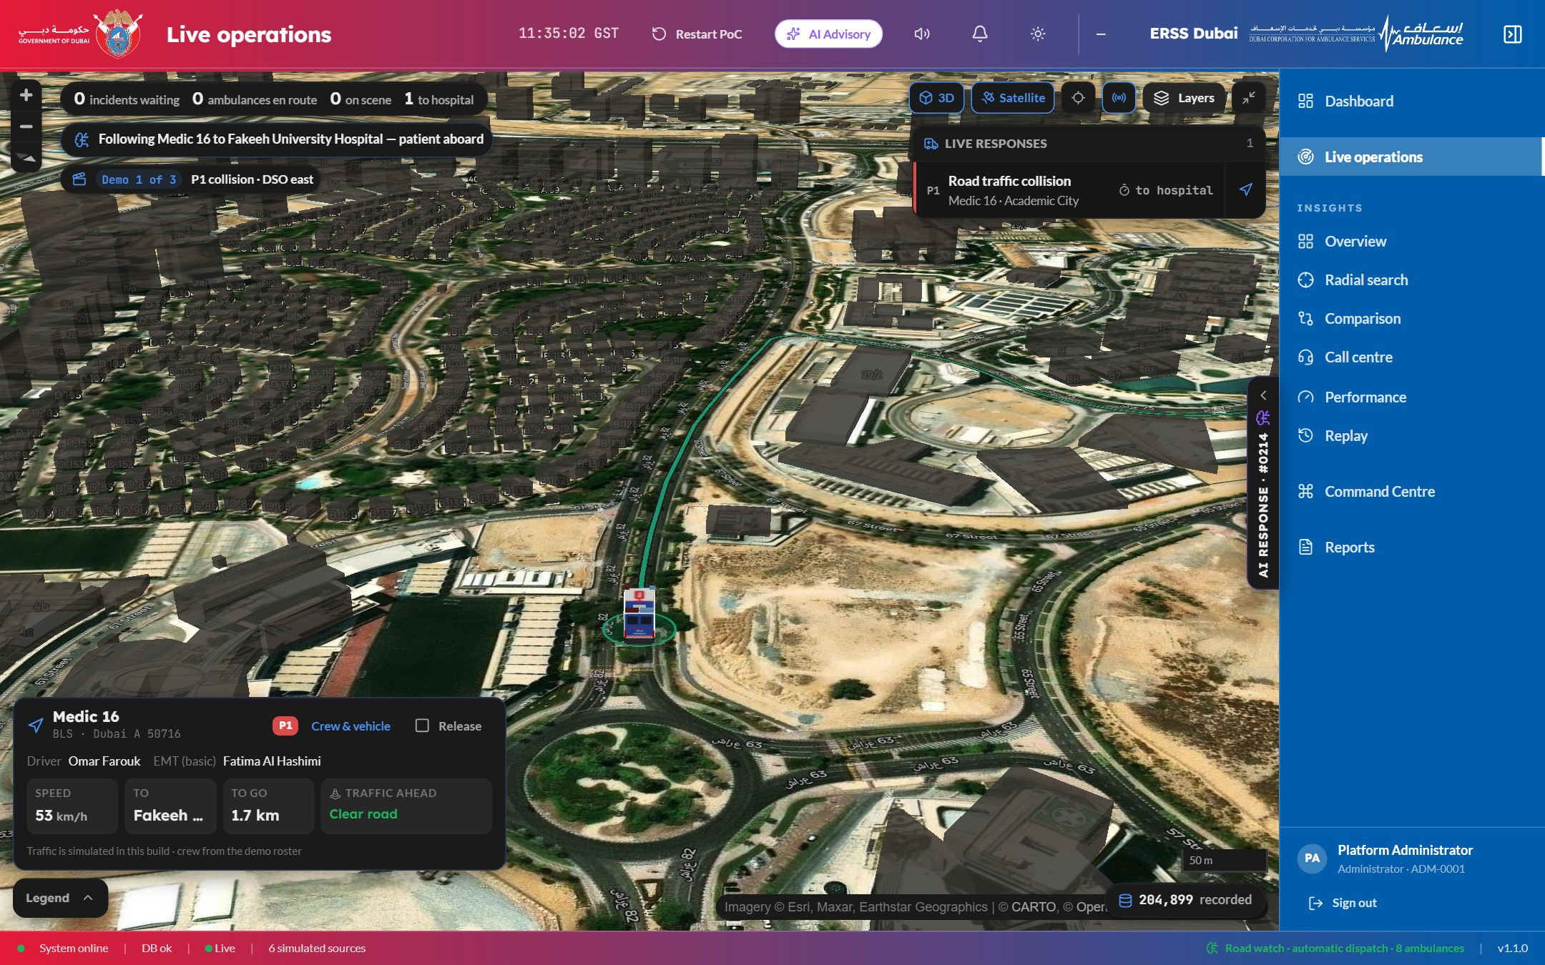

About this document
This document describes what ERSS does, screen by screen: the live command console used in the control room; the AI that detects an incident, dispatches an ambulance and explains every step it takes; the geospatial analytics and replay tools used to learn from every job; the reports; and the two mobile applications — one for the public, one for ambulance crews — including wearable heart-rate integration.
All screens are from the current trial build. In the trial, camera detections, traffic and wearable readings are simulated; every simulated source is labelled as such on screen.

1. The platform at a glance
ERSS is an interoperability and decision layer that sits above the command, dispatch and building systems already in service. It measures every response minute by minute at source, predicts where minutes will be lost, and turns each finding into a routed, tracked action with a timer against it. One platform serves three surfaces:
Surface | Who uses it | What it is for
Command console | Dispatchers, duty officers, service leads, administrators — on desktops and the video wall | The live picture, AI dispatch and its reasoning, the live 3D map, analytics, replay and reports
Citizen app | Members of the public, on their phones | One-slide SOS, live tracking of the ambulance, medical profile, wearable monitoring with automatic SOS
Paramedic app | Ambulance crews, on a phone in the vehicle | Full-screen job alerts, one-button job flow, map and route, AI co-pilot, hospital choice and handover

How a response flows
- Detect — a road camera, a citizen SOS or a wearable alarm raises the incident. No phone call is needed.
- Decide — the AI sets the priority, checks every ambulance, drives the real roads for the closest ones, scores them and chooses.
- Dispatch — the job reaches the crew’s phone, the crew acknowledges, and the receiving hospital is pre-alerted.
- Track — the console, the crew and the caller all follow the ambulance live, with the response clock running against its target.
- Learn — every job is kept: replay it, read the AI’s reasoning as it happened, review what went well, and download the report.

Sign-in and access
- Role-based access. Administrator, dispatcher, duty officer and service lead each see only the pages their role allows — the navigation is built from the user’s permissions.  - Government-standard layout. Government mark on the left, the service’s mark on the right, sidebar on the right.  - Dark and light themes, chosen at sign-in and carried into the console.  - One session per browser tab, so several roles can work side by side on one machine.  - Audit trail. Actions are recorded; records a person is accountable for are archived, never deleted. | 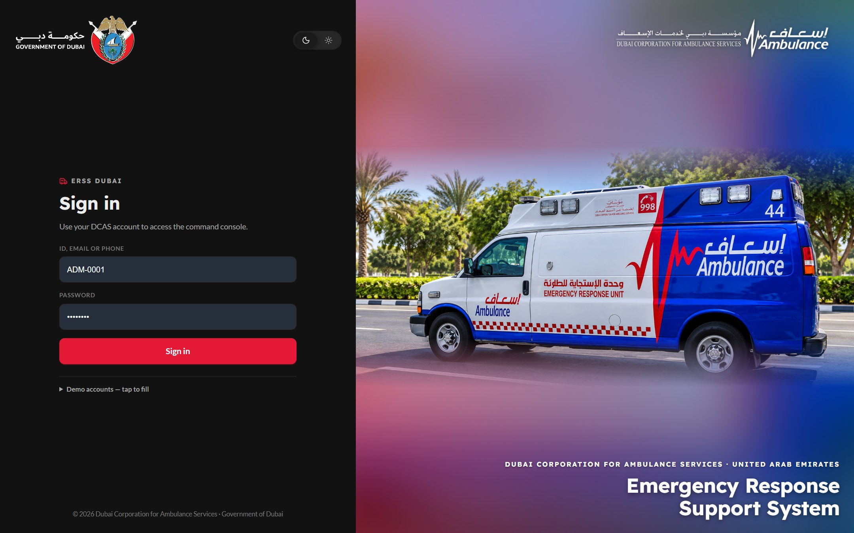  Figure 1 — Sign-in (dark theme)

2. Live dashboard
The landing page for the control room. Everything on it answers the two questions a duty officer holds in their head: which calls have nobody going to them, and where has each ambulance got to. Every figure carries its unit, and every card opens its detail in a slide-over panel without leaving the page.
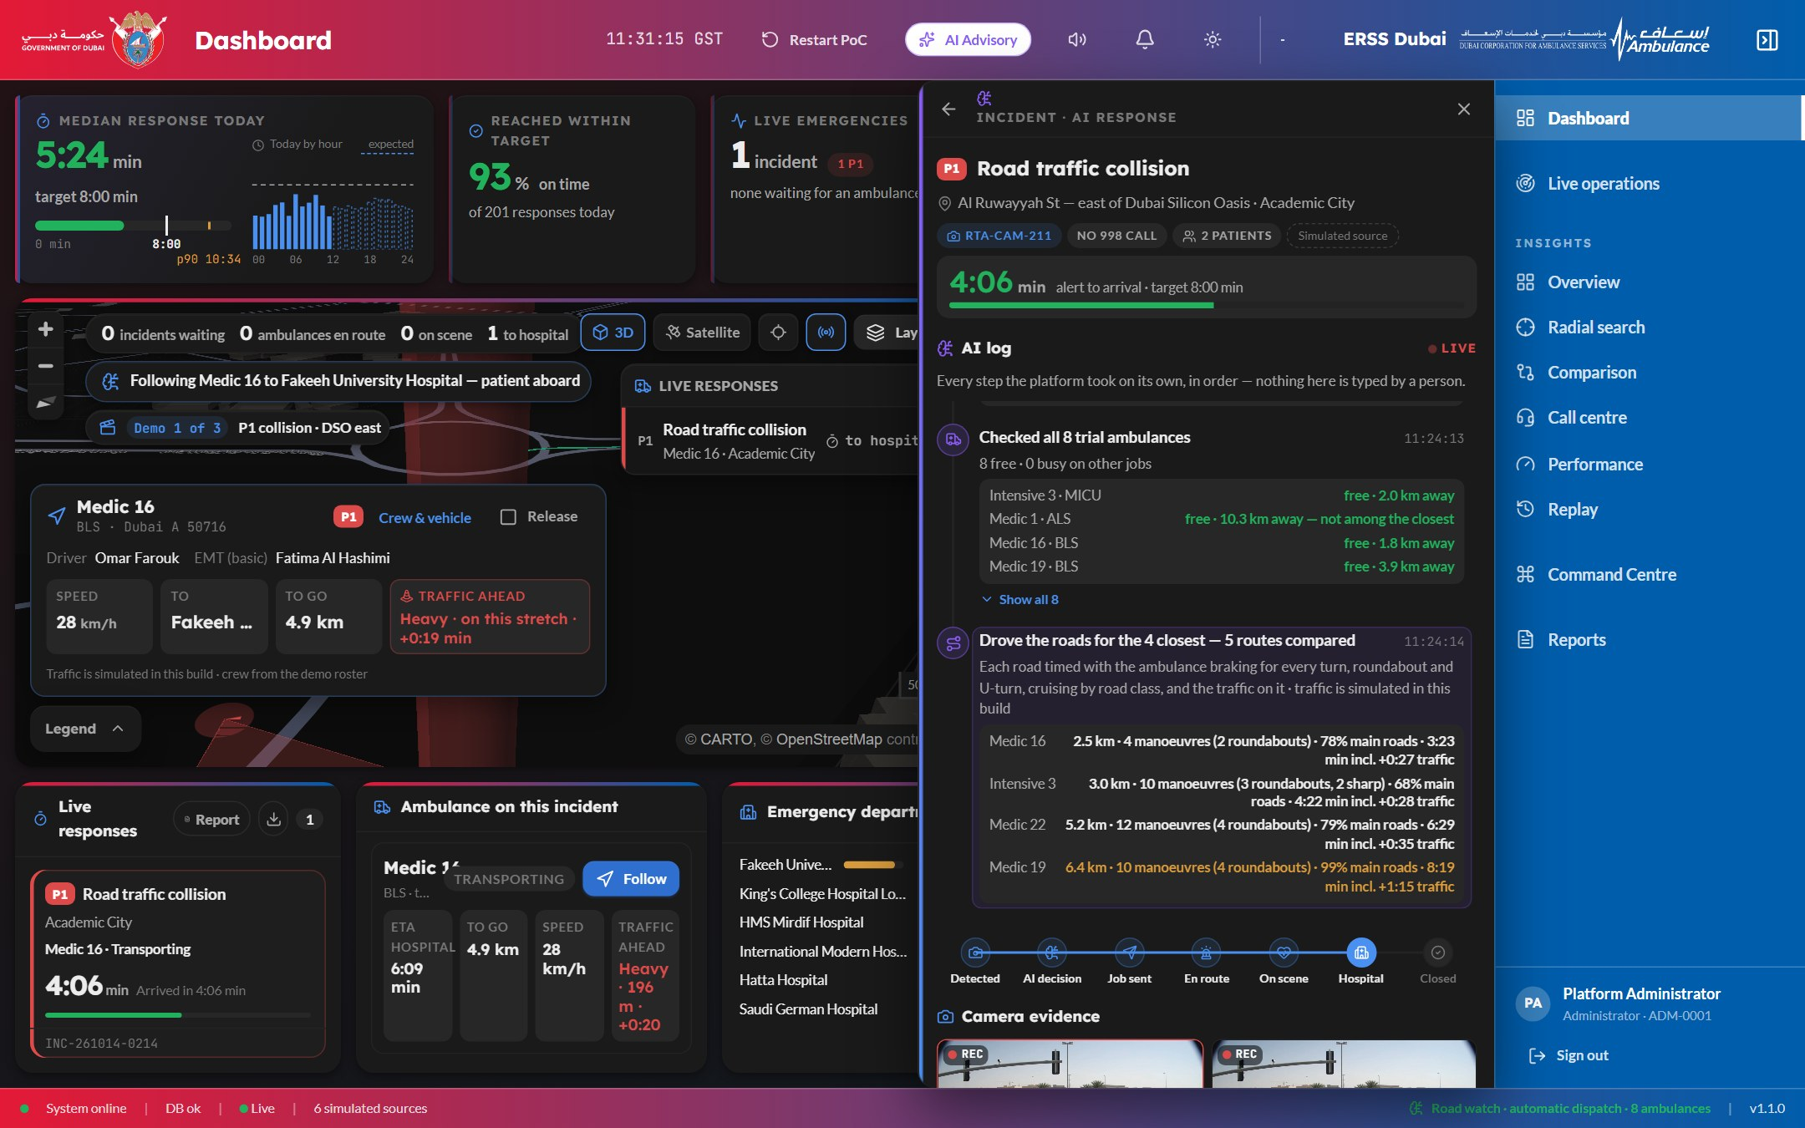
Figure 2 — Dashboard — response-time band, live 3D map, live responses and the AI response panel for a P1 road collision
- Response-time band — today’s median response against the 8-minute target, the 90th percentile, and an hour-by-hour profile against what is expected for that hour.
- Reached within target and live emergencies by priority, with how many are still waiting for an ambulance.
- Live map — ambulances at rest and on a job, the road still ahead of each one, incident markers and the cameras that raised them. The map follows each new incident by itself.
- Live responses with ticking clocks, the ambulance on this incident (speed, distance to go, ETA, traffic ahead) and emergency-department load at receiving hospitals.
- Status bar — system, database and live-connection health, and the count of simulated sources.

3. AI Response — from detection to dispatch, explained
The core of the platform. When a camera raises an incident, the AI handles the response end to end and writes down every step as it takes it. Nothing in the AI log is typed by a person: each line comes from the engine’s own output, with its time, its figures and its confidence. A person can step in during a short send window — send now, or hold

What the AI log shows, in order
- Detection — the sensor evidence, corroborated across more than one camera, the verdict with its confidence, and the fact that no 998 call had yet been received.
- Triage — priority, number of patients and what the crew needs (for example advanced life support, defibrillator).
- Fleet check — every ambulance’s status, distance and capability; who is ruled out and why.
- Road comparison — the closest candidates’ real routes, timed with every turn, roundabout and U-turn, main-road share and live traffic.
- Scoring and choice — arrival 55%, capability 20%, coverage left behind 15%, crew readiness 10%; the choice, the runner-up and the confidence.
- Job sent and acknowledged — the crew’s phone alerts, acknowledgement and wheels-rolling times are recorded.
- Hospital — destinations ranked; the receiving emergency department is pre-alerted automatically.
A progress strip tracks every job: Detected → AI decision → Job sent →
En route → On scene → Hospital → Closed.
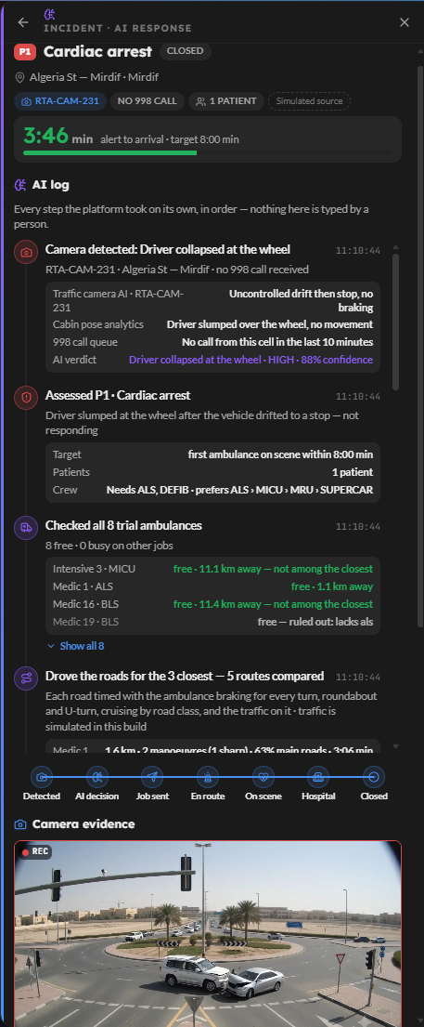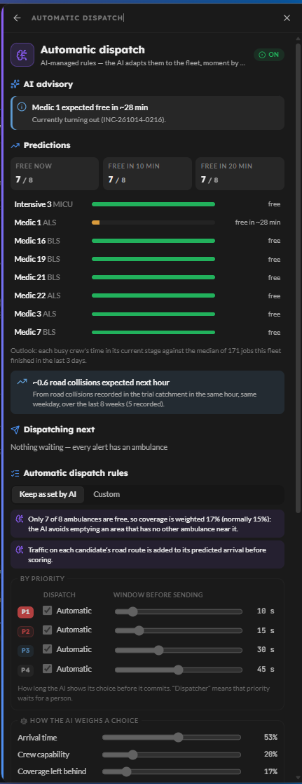

Figure 3 — The AI response panel and its live log & AI Automatic Dispatch Configuration

AI use cases across the platform
Use case | What the AI does | Where it appears
Incident detection | Corroborates camera evidence, rules out alternatives and raises the incident with a confidence — before anyone phones it in | Detection panel, AI log
Triage | Sets priority, patient count and the capability the crew needs | Incident panel
Automatic dispatch | Scores every free ambulance on road-timed arrival, capability, coverage and crew readiness | AI log, live map
Road-aware ETA | Times real routes with manoeuvres and traffic; predicts the arrival and is held to account for it | AI log, ride-along, Replay, Performance
Hospital ranking and pre-alert | Ranks destinations by capability and emergency-department load; pre-alerts the one chosen | Paramedic app, incident panel
Crew co-pilot | Briefing, road advice, scene safety and backup, a drafted handover — read aloud to the crew | Paramedic app, Replay
Wearable alarm | Detects sustained abnormal heart rate or blood oxygen and starts an SOS on its own | Citizen app, incident vitals
Advisories | Finds patterns that cost minutes — slow areas, coverage gaps, demand drift — with evidence, a recommendation and projected impact | AI Advisory panel, Command Centre
Forecasting | Predicts calls by hour, day and area, each with a confidence band and its measured error | Insights, Demand & coverage
After-action review | What went well, what to improve and what to change, for every job | Replay

Explainable by design. Every AI output carries its method, its inputs, the factors that weighed in it and its confidence. A recommendation that cannot show why it was made is not displayed.

4. Live operations map and geospatial view
The same live picture as the dashboard, given the whole screen — for the operations floor and the video wall. It is a true 3D city: buildings stand at their real heights, and tilting the view is what makes an alert column legible across the emirate.
Figure 4 — Live operations on satellite imagery with 3D buildings — an ambulance transporting to hospital, with its crew and traffic ahead
- Base maps — the standard map (follows the dark or light theme), a full-colour street map, or satellite imagery, one click from the toolbar. 3D buildings work on all three.
- Layers grouped as operational, analytical, agency and reference (stations, hospitals, zones, cameras, traffic signals, buildings), with a legend that can isolate any one category.
- Live ticker — calls waiting, ambulances en route, on scene and to hospital — and a response rail listing every live job.
- Director — the map flies to each new incident by itself and shows the camera feed that raised it while the AI decides.
- Ride-along — a chase camera behind any ambulance, with crew, speed, ETA, distance to go and the traffic ahead; congested stretches of its own route are drawn in red with the expected delay.

5. Insights — geospatial and performance analytics
Six analysis pages share one filter bar (time window, priority, area, forecast on or off). Every chart is also a filter — click a bar and every chart narrows to it — and every series carries a forecast with its confidence band and its back-tested error. Each page opens with AI findings: the few things in the data worth acting on, stated in a sentence.
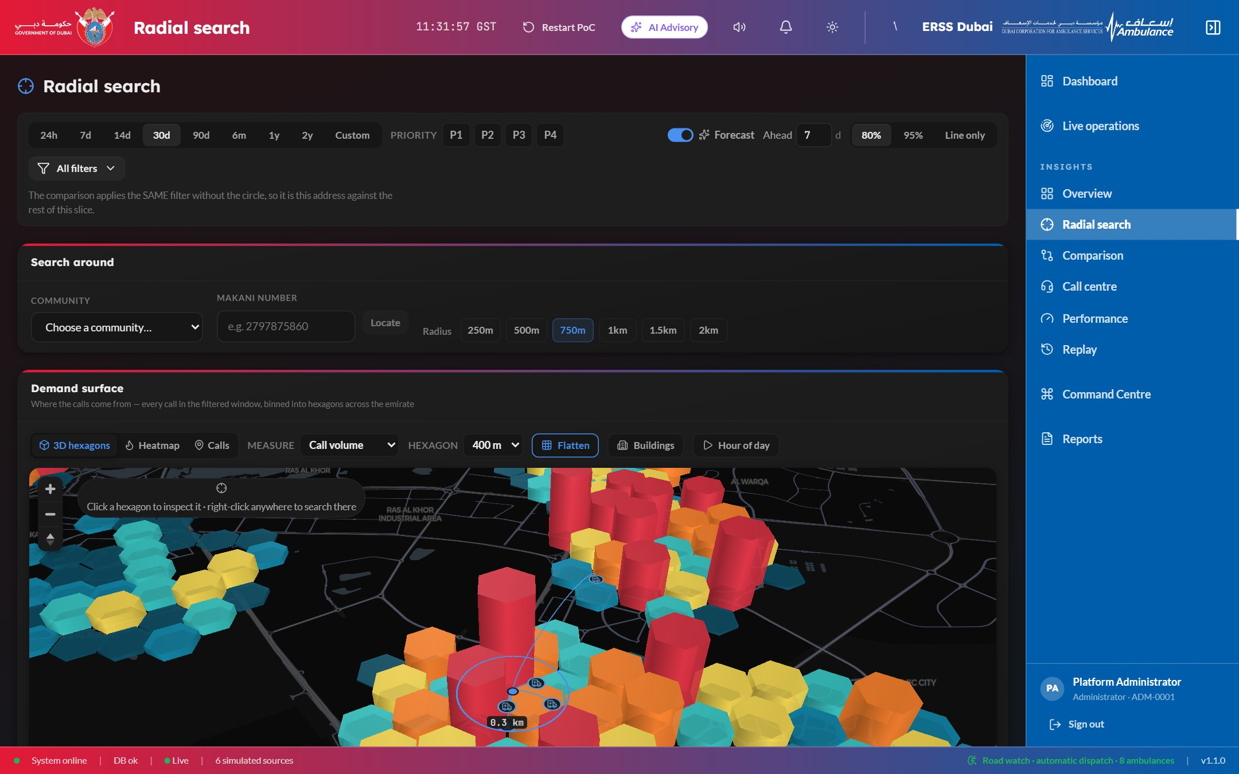
Figure 5 — Radial search and the 3D demand surface — two years of calls binned into hexagons over the city
Page | What it answers
Overview | The call mix; monthly and daily volumes against forecast; an hour × weekday almanac that flips between measured and forecast.
Radial search | Everything within a circle around a community, a Makani number or any point on the map, compared with the emirate. The demand surface shows 3D hexagons, a heatmap or individual calls, by volume, urgent share, mean response or share within target, at 150 m to 1.5 km cells, with a time-lapse through the day.
Comparison | This period against the previous one, and the next one extrapolated — which call types and areas are growing.
Call centre | 998 volume by hour against tomorrow’s forecast profile, where calls come from, how they resolved and the top complaints.
Performance | Every response stage measured; trends with the week ahead; breakdowns by zone, priority, unit type, hour and station; time recovered by signal pre-emption; and the accuracy of the arrival model.
Replay | One finished job, played back — see section 6.

6. Replay — after-action review
Pick any finished job and watch it happen again, on the real clock. A six-minute response takes six minutes at 1×, and under a minute at 8×, so what the replay shows can be compared directly with what the live map showed at the time.
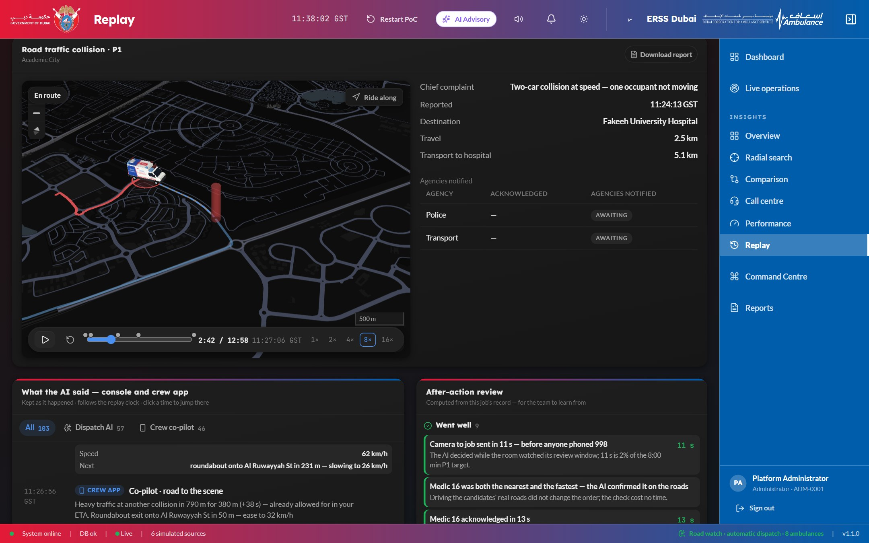
Figure 6 — Replay — the ambulance on its recorded route, the AI’s record following the scrubber, and the after-action review
- Proposed route against the road actually driven, with the ambulance moving at the speed the crew moved; speeds from 1× to 16×, and a ride-along view.
- Headline figures — response time, drive time, actual against proposed route, and arrival-prediction error.
- What the AI said — the dispatch AI and the crew co-pilot, line by line as they happened. Lines already said are full strength, the current one is highlighted, the rest are dimmed; click any line to jump the replay to that moment.
- After-action review — what went well, what to improve and what to change, computed from the job’s own record — plus the roads the AI compared, the timeline, partner agencies notified, and a one-click report.

7. Command Centre
The operational workbench and its supporting views, behind one tab strip. Each role sees only the tabs it is allowed.
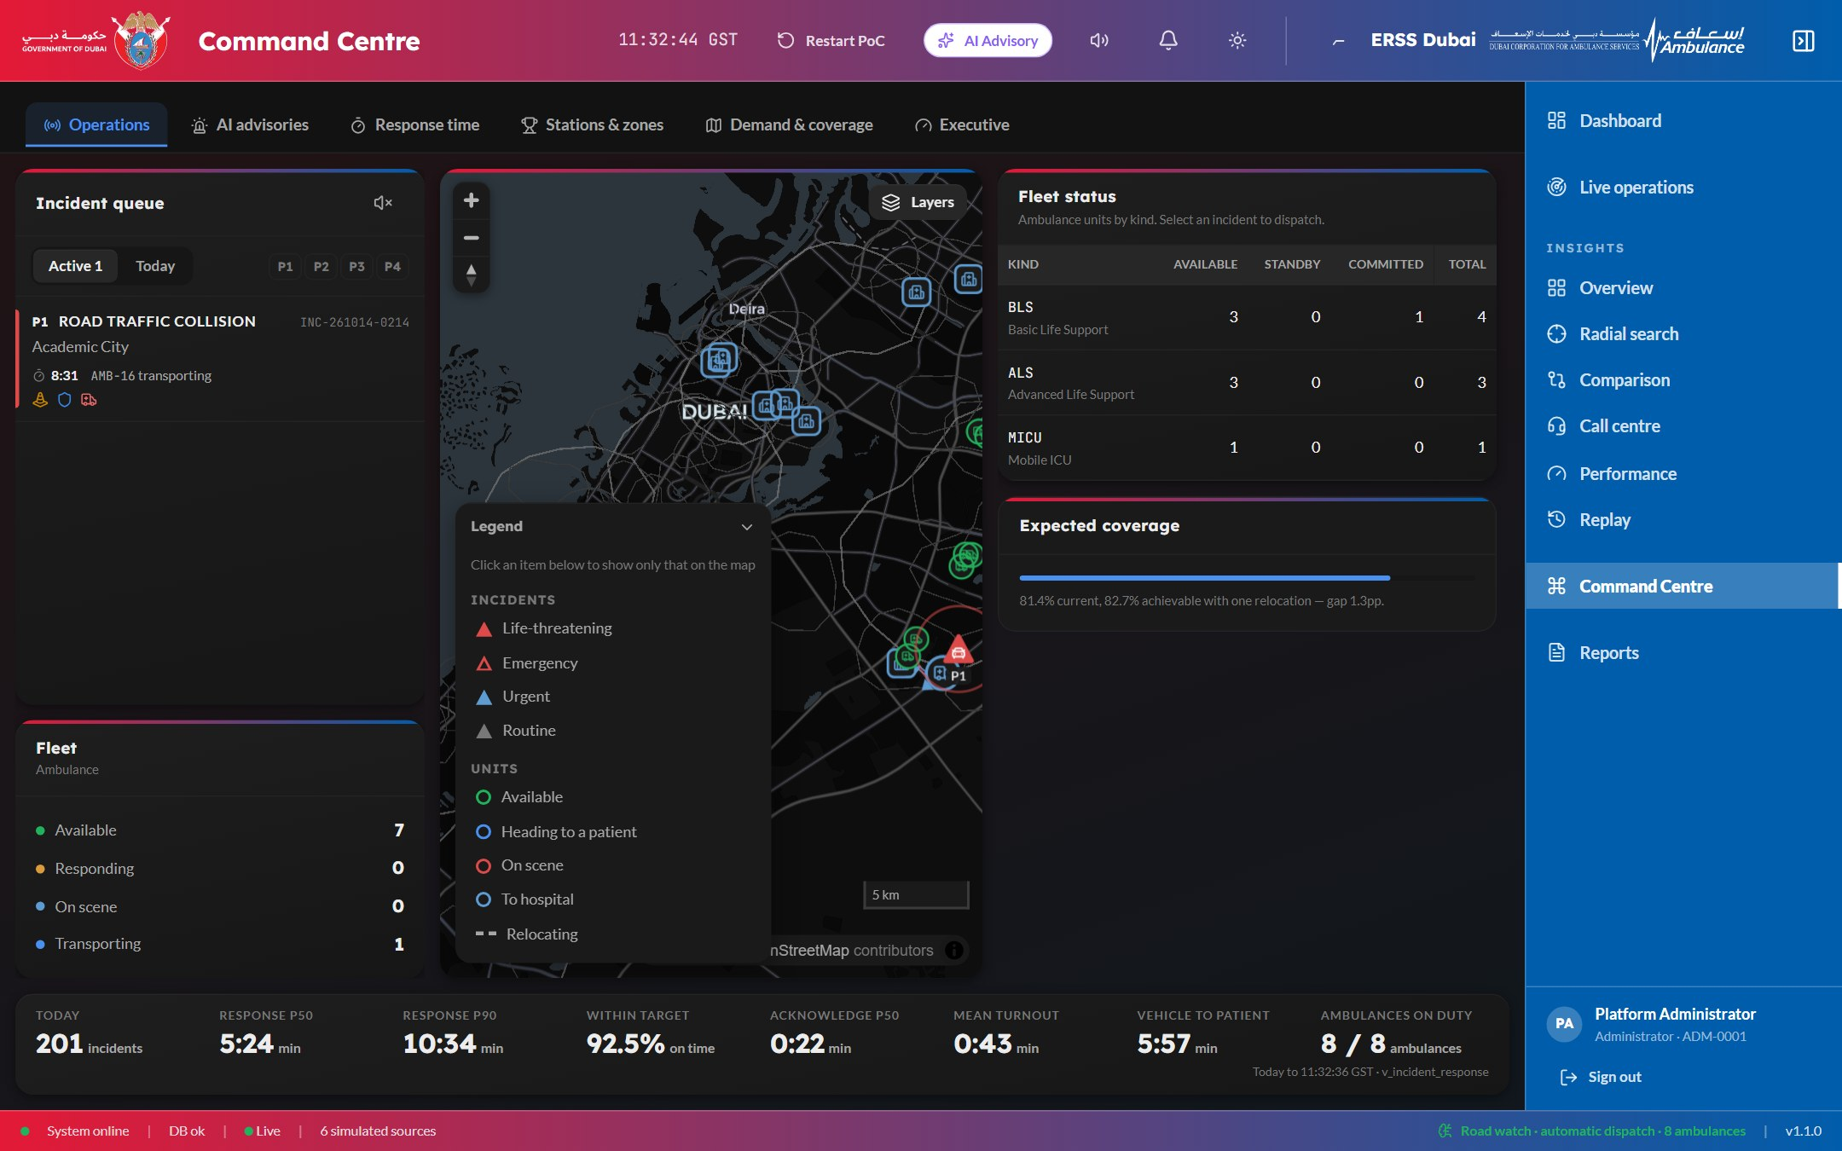  Figure 7 — Operations — the dispatch board |  | 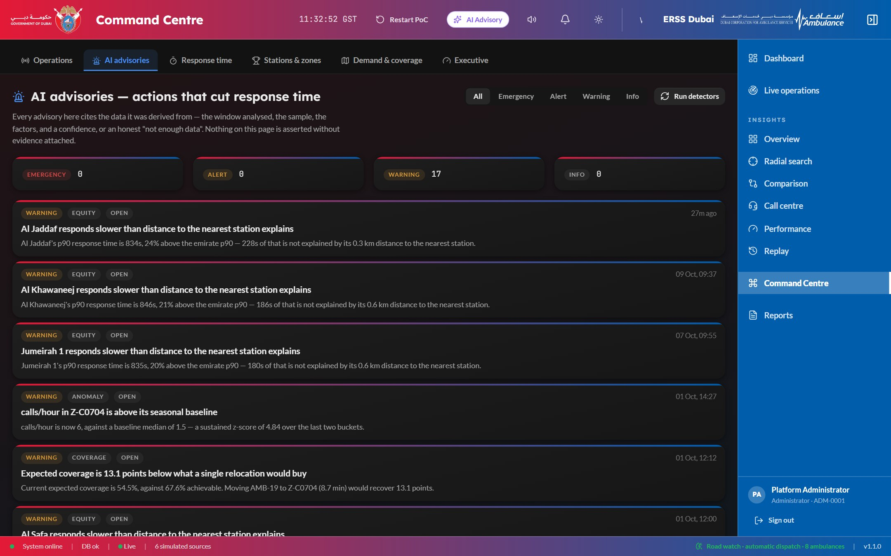  Figure 8 — AI advisories — actions that cut response time
Tab | What it is for
Operations | The dispatch board: incident queue, map, fleet status by state, expected coverage and the day’s headline figures.
AI advisories | Detector findings, each with its root cause, numbered evidence, a recommendation, the projected impact and an action.
Response time | Where the minutes go — each stage’s contribution to the 90th-percentile response, and the biggest contributors.
Stations & zones | A composite ranking of stations and zones: who is fastest, who is slipping.
Demand & coverage | Where the next calls will be — forecast demand by community and the coverage held against it.
Executive | One line per pillar: volumes, response, compliance and fleet, with trends and open advisories.

8. Reports
Every incident the platform handles is kept and reportable — from the cameras and from the citizen app, live and completed alike. The register filters by period (24 hours, 7 days, 30 days, all) and source, shows the headline figures for the period, and exports as a whole.
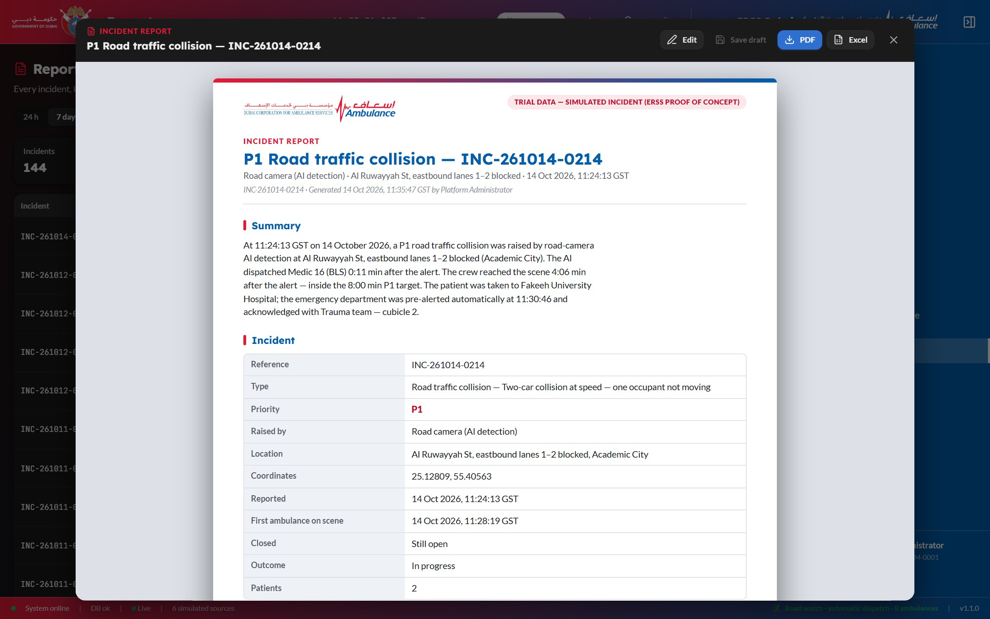
Figure 9 — The report studio — every download is previewed, can be edited, and is then taken as PDF or Excel
- See before you download. Every download in the product opens in the report studio first.
- Edit what a person should own — title, summary, clinical notes, recommendations, notes, and which sections to include — and save a draft to finish later.
- Download as a branded PDF or an Excel workbook.

9. Citizen app with wearable integration
The public SOS application. It is built for the worst moment of someone’s day: one deliberate gesture sends for help, and the app is never the only way to get it.
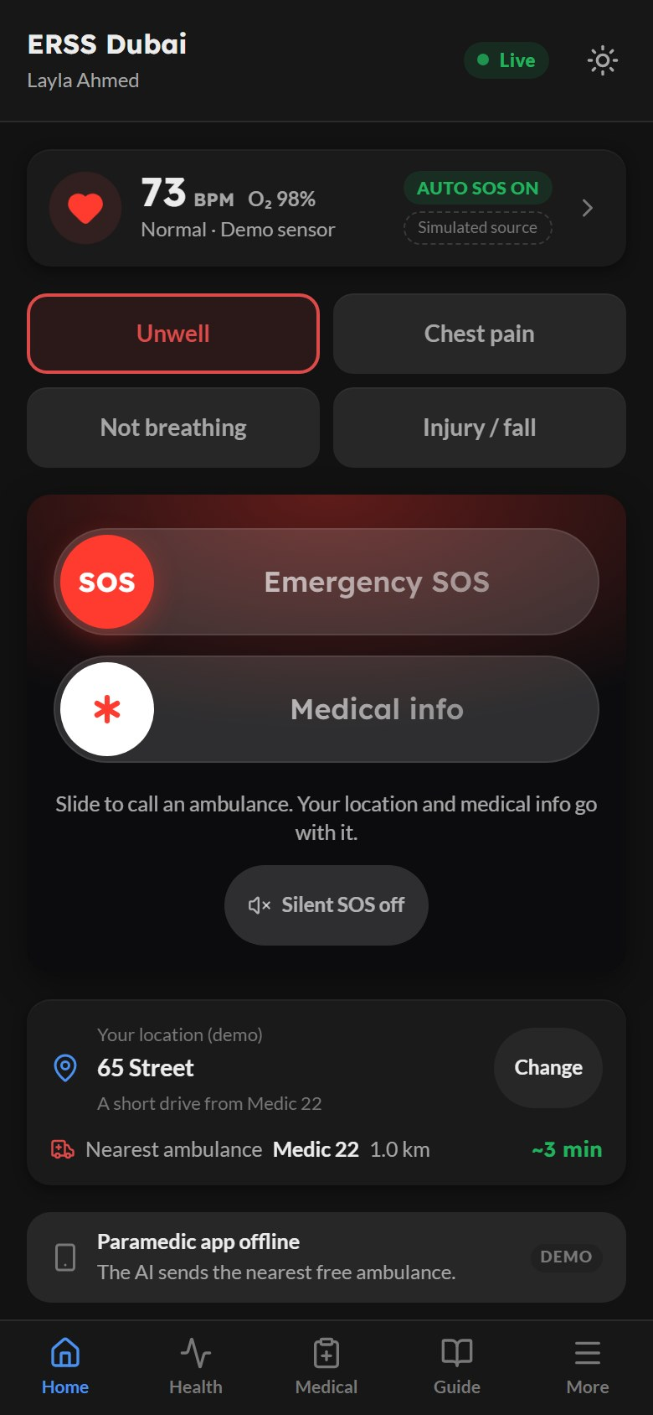  Figure 10 — Home — vitals, symptoms, slide to SOS | 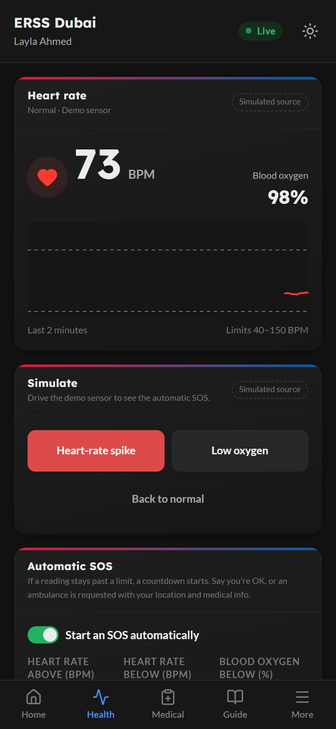  Figure 11 — Health — live heart rate and automatic SOS | 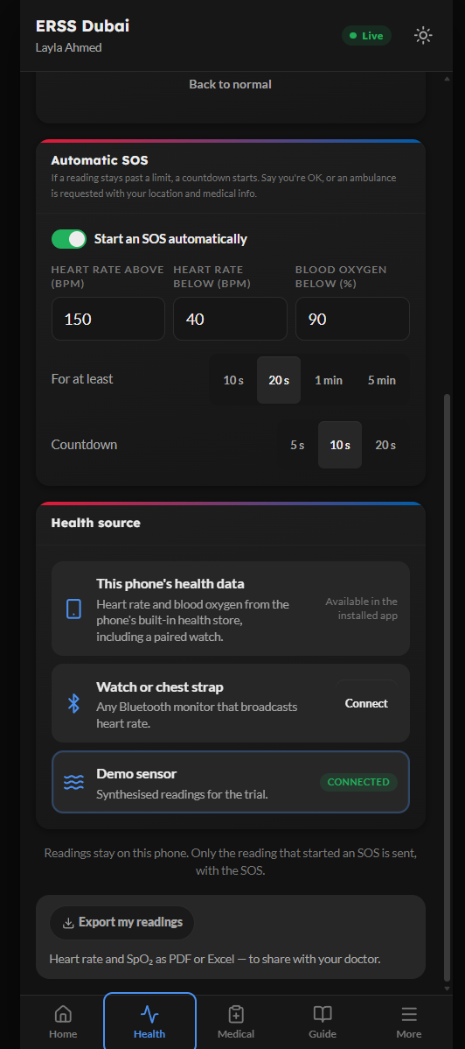  Figure 12 — Medical profile
- Slide to send SOS — sliding, not tapping, so a phone in a pocket cannot call an ambulance. Quick symptom choice (unwell, chest pain, not breathing, injury or fall), and a silent SOS option.
- Location and nearest ambulance with its estimated arrival; once sent, the caller watches the ambulance approach live, with each stage of the job.
- Direct dial to 998 Ambulance, 999 Police, 997 Civil Defence and 996 Coastguard — always present.
- Medical profile — blood group, allergies, conditions, medications and emergency contact — sent with an SOS and shown only to the responding crew.
- First-aid guide that works without a connection: CPR, choking, severe bleeding, stroke (F.A.S.T.) and heat illness.

Wearable integration and automatic SOS
- Live heart rate and blood oxygen from a connected watch, on the Home and Health tabs.
- Automatic SOS. If heart rate stays above 150 or below 40 beats per minute, or oxygen below 90%, for 20 seconds, a 10-second countdown takes the screen. “I’m OK” cancels it; silence sends it. The limits are adjustable.
- Vitals travel with the SOS. The readings that led to the alarm reach the console and the crew, and keep streaming while the ambulance is on its way — a crew that knows the oxygen has been falling for three minutes walks in with oxygen ready.
Wearable source | Status
Any watch or chest strap using the standard Bluetooth Heart Rate service | Available (Android)
The phone’s health store (Apple Health, Google Health Connect), including readings a paired watch writes there | Connection point in place; native module with the packaged app
Demo sensor — scripted normal, heart-rate spike and low-oxygen readings | Available; used in the trial and labelled “Simulated”

10. Paramedic app
The crew’s phone in the ambulance. The job screen is a map — where the ambulance is, where the patient is, and the road between them — with the response clock running against the priority’s target, and one large button that always shows the next step.
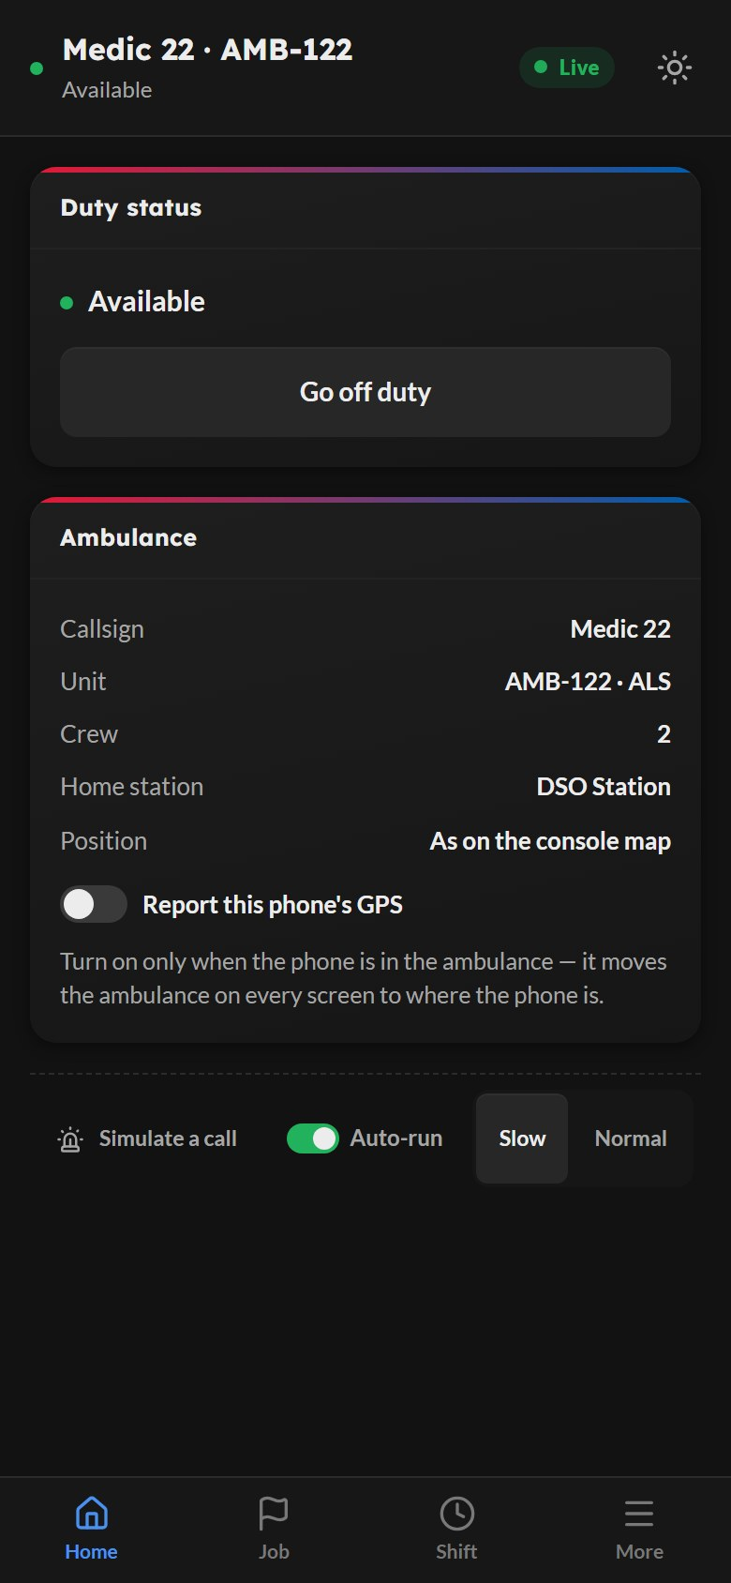  Figure 13 — Home — duty status and ambulance | 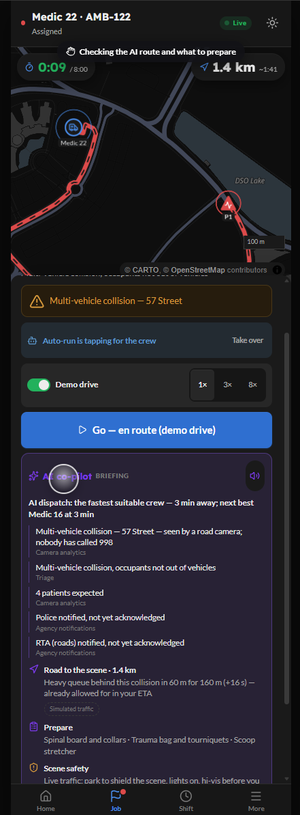  Figure 14 — Job — waiting for an assignment | 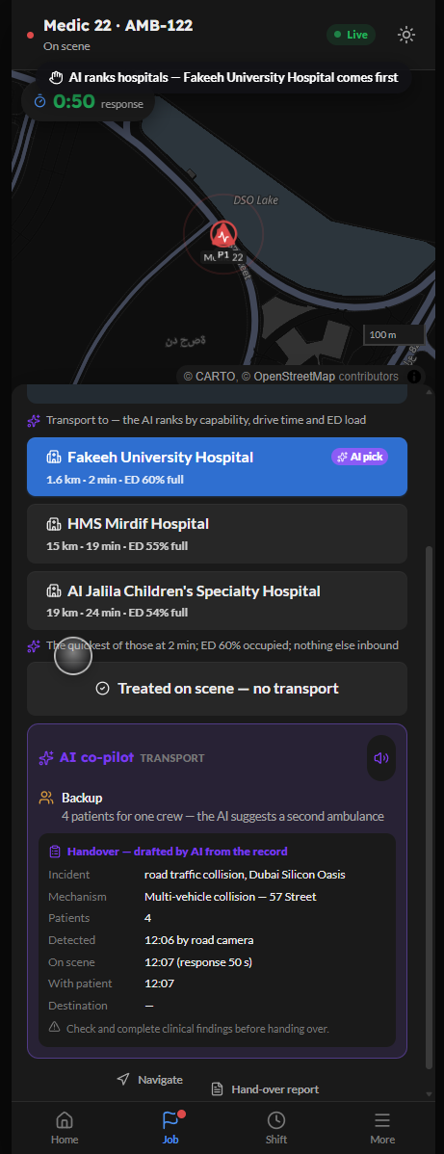  Figure 15 — Shift — jobs and handover reports
- Full-screen job alert with sound and vibration, to be acknowledged within 45 seconds.
- One button, the next step — go, arrived, with patient, transport, at hospital, clear — so a crew never hunts for a control in a moving vehicle. Every step updates the console and the caller at the same moment.
- AI co-pilot — the briefing when the job arrives (what happened, why this crew, what to prepare), road advice while driving, scene safety and backup on arrival, and a handover drafted on the way to hospital. Read aloud; every line carries its source.
- AI-ranked hospitals to choose the destination, and the patient’s wearable vitals live when the SOS came from the citizen app.
- Position from the phone’s GPS while on duty, accepted only inside Dubai.
- Shift view — the jobs this crew attended, each with its handover report to preview, complete and download.

11. Platform, security and trial scope
Area | What is in place
Access and audit | Role-based permissions on every page and action; an audit trail; accountable records archived, never deleted.
Screens | Desktop console, video-wall display density, and phones; dark and light themes.
Resilience | Every screen renders from the server alone; the live connection adds immediacy, so a dropped connection costs liveness, never correctness.
Deployment | Self-hosted fonts and configurable map, imagery and routing services — suitable for restricted networks.
Trial scope | Eight ambulances in one catchment; road incidents raised by cameras; automatic dispatch always on. Camera detections, traffic, crew roster and the wearable demo sensor are simulated and labelled on screen.

POWERED BY Astrikos AI — detection, dispatch and insight for every emergency response, explained at every step.

