LogiSync — AWS Architecture
Real-time delivery risk detection and proactive intervention
Proposed production architecture | Independent product case study

1. Architecture Diagram
The diagram presents a proposed AWS architecture for ingesting delivery events, detecting potential risks, enabling human-reviewed interventions, and measuring outcomes.
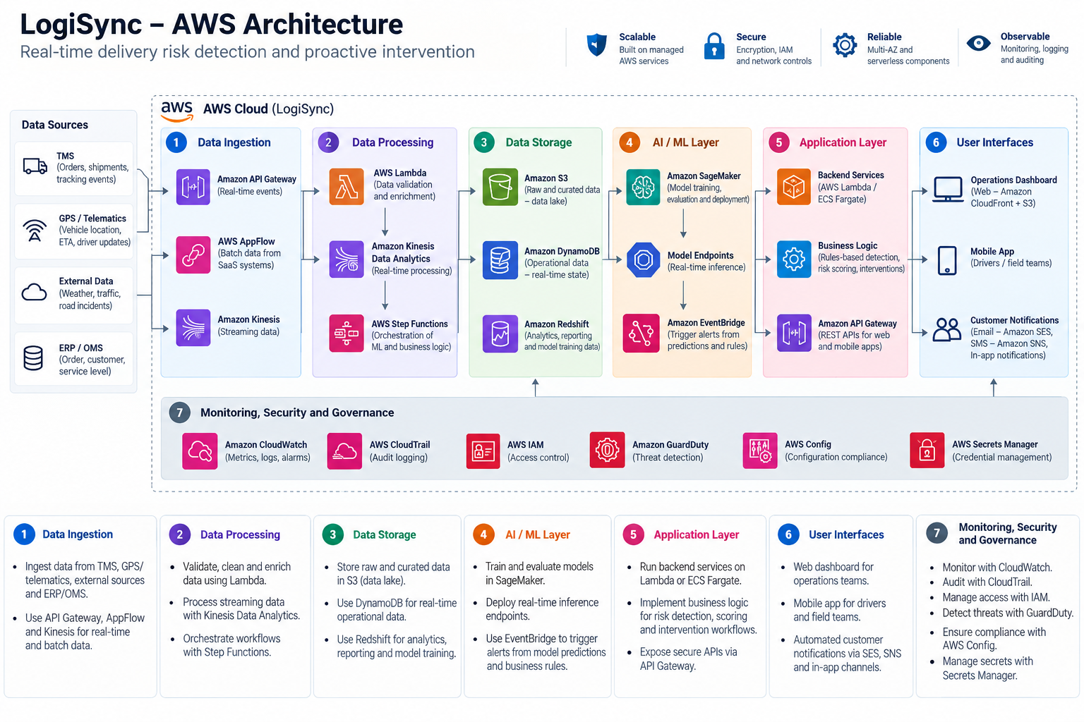

2. Architecture Overview
I recommend a serverless, event-driven architecture rather than starting with a large microservices platform. It supports the initial product hypothesis while keeping the first production iteration focused on reliable data ingestion, explainable risk detection, and human-approved actions.
Layer | Proposed AWS services | Responsibility
Web experience | Amazon S3, CloudFront, AWS WAF | Serve and protect the operations dashboard.
Identity and access | Amazon Cognito, AWS IAM | Authenticate users and enforce least-privilege access.
APIs and business logic | Amazon API Gateway, AWS Lambda | Receive events, validate requests and execute product logic.
Event processing | Amazon EventBridge, Amazon SQS, AWS Step Functions | Process events asynchronously, retry failures and orchestrate workflows.
Operational data | Amazon DynamoDB, Amazon S3 | Store current delivery/exception state and larger evidence artifacts.
Risk detection | Lambda-based rules engine | Flag potentially at-risk deliveries using transparent, testable rules.
Optional AI assistance | Amazon Bedrock; future ML evaluation | Support grounded summaries; evaluate ML only if it adds value over rules.
Notifications | Amazon SNS and/or Amazon SES | Deliver authorized alerts and customer communications through verified integrations.
Observability and security | Amazon CloudWatch, AWS CloudTrail, AWS KMS, AWS Secrets Manager | Monitor behavior, audit activity, encrypt data and protect credentials.

3. Proposed Event Flow
- Delivery systems, telematics and field reports provide delivery status, timestamps and exception signals.
- Amazon API Gateway and AWS Lambda validate incoming events and update operational records.
- Amazon EventBridge routes relevant events; Amazon SQS buffers processing and supports retries, with a dead-letter queue for persistent failures.
- AWS Step Functions coordinates multi-step workflows where needed.
- A transparent rules engine identifies potential risks and stores the evidence and alert reason.
- The operations dashboard presents alerts with source, timestamp, freshness and uncertainty.
- An authorized coordinator reviews the alert and approves any consequential intervention.
- The system records the action and delivery outcome for measurement and future evaluation.

4. Key Product and Architecture Decisions
Rules before ML: Start with explainable rules using available delivery-status signals. Compare any future ML model against this baseline and introduce it only if incremental value is demonstrated.
Human approval: A risk alert does not automatically reschedule a delivery or send an unverified customer commitment. Consequential actions require an authorized human decision.
Separate operational state from evidence: Use DynamoDB for operational state and S3 for suitable evidence artifacts, with retention and access rules defined before production.
Event-driven processing: Use asynchronous processing for event ingestion and workflow steps so transient downstream failures can be retried and isolated.
Grounded AI assistance: Amazon Bedrock is optional and should assist with summaries of approved evidence rather than independently decide operational outcomes.

5. Recommended MVP Scope
- Secure operations dashboard and defined user roles.
- Delivery-event ingestion through a controlled API or data import.
- Rules-based risk detection with visible reasons and supporting evidence.
- Exception queue with human review and recorded decisions.
- Human-approved intervention workflow and audit records.
- Basic monitoring, retries, error handling and shadow-mode evaluation.

6. Production Readiness Considerations
Data contracts: Define event schemas, identifiers, timestamps, duplicate handling, freshness and original delivery-commitment retention.
Security and privacy: Apply least-privilege IAM, appropriate authentication, encryption, data retention controls and auditability.
Reliability: Define retries, idempotency, dead-letter handling, alarms, recovery procedures and rollback.
AI governance: Maintain evaluation datasets, model/version records, grounding controls, human review and drift monitoring where applicable.
Cost: Estimate event volume, compute, storage, logs, notifications and optional AI inference before deployment.
Integrations: Validate supported TMS/OMS interfaces, credentials, external-system failure behavior and authorization.

7. Prototype vs. Production Boundary
LogiSync is currently an interactive prototype with some working flows; logistics data and integrations are mocked or simulated. This document describes a proposed production architecture. It does not claim that the AWS services, live integrations, security controls, reliability controls, ML capabilities or business outcomes have already been implemented or verified.

8. Summary
I designed LogiSync around a proposed serverless, event-driven AWS architecture for delivery-event ingestion, risk detection, exception review and human-approved interventions.
The proposed stack uses API Gateway and Lambda for APIs and business logic; EventBridge, SQS and Step Functions for asynchronous processing; DynamoDB for operational state; and S3 for evidence and reporting artifacts. Cognito supports authentication, while CloudWatch, CloudTrail, KMS and Secrets Manager address observability and security. The initial risk-detection approach is rules-based and explainable.
Bedrock is an optional extension for grounded exception summaries, while historical-data ML remains subject to data readiness and comparative evaluation. Live integrations, production controls and business impact remain subject to implementation and validation.

