LogiSync — Product Requirements Document
AI-assisted last-mile delivery exception management
Independent product case study | Proposed product and production direction
Document field | Value
Product | LogiSync
Category | B2B SaaS / Logistics Operations / AI-assisted decision support
Primary target user | Dispatch / Operations Coordinator (hypothesis to validate)
Proposed outcome owner | Head of Last-Mile Operations (hypothesis to validate)
Current status | Interactive prototype with some working flows; logistics data and integrations are mocked or simulated
Document status | Product requirements and validation plan; not a record of a production deployment

1. Executive Summary
LogiSync is an AI-assisted product concept for last-mile delivery exception management. It is designed to help operations teams identify potential delivery risks earlier, understand the evidence behind an alert, and coordinate an appropriate response before a committed delivery window is missed.
The product hypothesis emerged from qualitative customer interviews about furniture/ appliance deliveries. Interviewees described late deliveries, unexpected delivery-date changes, and planning their day around a delivery that did not arrive as expected. These interviews establish a customer-experience problem worth investigating, but they do not establish the internal operational root cause, preventability, market demand, or financial impact.
The initial product approach is deliberately rules-first: transparent detection using available delivery-status signals, a live exception dashboard, source and freshness indicators, human review, and approved interventions. Historical-data ML, multimodal reporting and an AI operations copilot are future options, subject to validation.
The current implementation is an interactive prototype with some working flows and mocked or simulated logistics data and integrations. This PRD defines the proposed product behavior and production direction; it does not claim that production integrations, predictive performance or business impact have been achieved.

2. Problem Statement
Last-mile delivery operations may struggle to identify, communicate and resolve delivery exceptions early enough to protect committed delivery dates. When deliveries are delayed or rescheduled at short notice, customers may rearrange their day or stay home to receive bulky items, only to discover that the delivery will not arrive as expected.

Customer evidence
- Multiple customer interviewees reported late furniture deliveries, including delays described as up to two days.
- Interviewees described delivery dates changing in the system and planning their day around expected deliveries.
- Some customers reported staying home for a delivery that did not happen as scheduled.

Evidence gaps
- Internal detection, escalation, ownership and rescheduling workflows have not been verified with operations staff.
- Delivery exception frequency, preventability, operational cost and financial impact are not quantified.
- Any relationship between these incidents and customer churn or low ratings remains unproven.

Product opportunity
Investigate whether earlier exception visibility, clear supporting evidence and human-approved coordination can reduce missed delivery commitments without creating excessive alert volume or additional operational burden.

3. Goals and Non-Goals
Goals | Non-goals for the initial release
Identify potentially at-risk deliveries earlier using available, validated signals. | Replace existing TMS, OMS, routing or fleet-management systems.
Give coordinators explainable alerts with source, timestamp and freshness. | Autonomously reschedule deliveries or make binding customer promises.
Support human review and approved intervention workflows. | Assume all delays are preventable.
Record original commitments, decisions, interventions and outcomes for evaluation. | Claim production impact from simulated data or modeled metrics.
Evaluate rules-based detection before considering ML. | Introduce ML, voice, photo AI or an AI copilot solely to increase feature count.

4. Users, Stakeholders and Jobs to Be Done

Primary persona hypothesis: Dispatch / Operations Coordinator
When a delivery may miss its committed window, I need to see the risk, understand why it is flagged, and know what can be done next so that I can prioritize my attention and coordinate an appropriate response.
- Goals: protect delivery commitments, prioritize exceptions, coordinate stakeholders and provide accurate updates.
- Potential pains: late signals, fragmented information, repeated follow-up, uncertain reports and limited time to investigate.
- Discovery needed: validate responsibilities, tools, decision rights, alert tolerance and actual intervention options with operations users.

Stakeholders
Role | Expected responsibility | Status
Head of Last-Mile Operations | Proposed outcome owner for delivery reliability and exception handling. | Hypothesis; confirm
Product sponsor | Champion pilot and coordinate participation. | To identify
Budget owner / economic buyer | Approve pilot or purchase funding. | Unknown
Dispatch / Operations Coordinator | Review alerts and coordinate approved actions. | Persona hypothesis
IT / Security / Data owners | Approve access, integrations, security and data handling. | To identify
Drivers / delivery partners | Provide operational status and exception reports where appropriate. | Workflow to validate

5. Current-State Workflow and Assumptions
The customer-facing sequence is supported by interviews: a delivery is expected, the customer plans around it, the delivery is delayed or does not occur as expected, and the delivery date may change. Notification experiences were mixed.
The internal sequence—driver identifies an issue, a system updates the date, and the customer is notified—is provisional. It must be confirmed through operations interviews, process mapping and event logs.

Discovery questions
- What is the earliest reliable signal that a delivery is at risk?
- Who first knows about an issue, and when does the coordinator receive the information?
- Which interventions can realistically change the delivery outcome?
- Who can approve an intervention or revised commitment?
- How are original commitments, revised commitments and actual delivery times recorded?
- What causes exceptions, and which are preventable?

6. Product Hypothesis and North Star
If dispatch and operations coordinators receive earlier, actionable visibility into delivery risks, supported by understandable evidence and human-approved interventions, they may be able to prevent some missed delivery commitments.

North Star metric
At-risk delivery commitment-miss rate = eligible at-risk deliveries that miss the defined original commitment ÷ all eligible at-risk deliveries × 100.
The original commitment must remain available even when a revised date is approved. Eligibility, commitment windows, and rules for approved rescheduling must be defined before measurement.

7. Scope and Prioritization

P0 — Earlier detection and explainable review
- Transparent rules using available delivery-status signals.
- Live exception dashboard with risk reason, source, timestamp and freshness.
- Original-commitment tracking and event history.
- Driver/coordinator reports with confidence and provenance indicators.
- Human review of uncertain, stale or conflicting information.
- Shadow-mode evaluation before operational intervention.

P1 — Contextual intelligence and validated ML
- Evaluate historical-data ML against the rules-based baseline.
- Incorporate reliable driver and coordinator reports.
- Investigate roadworks, traffic diversions, access restrictions and unloading constraints where data is available.
- Improve prioritization only when evaluation demonstrates a useful improvement.

P2 — Advanced assistance
- Voice-based driver reporting and photo-assisted issue identification.
- Grounded AI operations copilot for exception investigation.
- Broader contextual intelligence and closed-loop learning after validation.
Defer autonomous dispatch/rescheduling, automatic financial transactions, broad multi-city expansion and automatic model retraining until operational controls, data quality and measurable value are established. Any access-related payments must use authorized, documented business processes and financial controls.

8. Functional Requirements
ID | Requirement | Description | Priority
FR-01 | Ingest delivery events | Accept authorized delivery status and exception events through a defined API or controlled import. | P0
FR-02 | Validate event data | Validate required fields, identifiers and timestamps; detect duplicates, missing values and stale events. | P0
FR-03 | Preserve commitments | Store the original delivery commitment separately from revised commitments and actual outcomes. | P0
FR-04 | Detect potential risk | Apply documented rules to identify potentially at-risk deliveries; retain the rule and evidence that triggered each alert. | P0
FR-05 | Show exception dashboard | Display prioritized exceptions with status, reason, evidence source, timestamp, freshness and review state. | P0
FR-06 | Support human review | Allow authorized users to confirm, reject, defer or investigate an alert and record a reason. | P0
FR-07 | Record interventions | Record proposed action, approver, decision, timestamp and outcome. | P0
FR-08 | Control communications | Only permit approved customer updates based on confirmed information and verified integrations. | P1
FR-09 | Capture field reports | Capture driver/coordinator reports with source, timestamp and confidence; flag conflicting reports. | P0/P1
FR-10 | Evaluate outcomes | Report alert quality, detection lead time, commitment misses, intervention outcomes and workload. | P0
FR-11 | Optional AI assistance | Provide grounded summaries of approved evidence; do not independently authorize consequential actions. | P2
FR-12 | Optional ML scoring | Evaluate and deploy a model only if it demonstrates incremental value over rules and meets guardrails. | P1, gated

9. Key User Stories and Acceptance Criteria
As a coordinator, I want to see deliveries at risk so that I can prioritize investigation.
- Each alert has a unique delivery reference and a visible risk reason.
- The alert shows source, event timestamp and data freshness.
- The user can inspect supporting evidence.
- Alert status and review state are visible.
As a coordinator, I want to confirm or reject an alert so that operational decisions remain accountable.
- Only authorized users can change review status.
- A decision and timestamp are recorded.
- A rejection or override can include a reason.
- The system does not treat an override as automatically correct training data.
As an operations lead, I want to compare delivery outcomes so that I can decide whether the product should progress.
- Original commitments and actual outcomes are retained.
- Metric definitions and cohort eligibility are documented.
- Results distinguish observed outcomes from modeled estimates.
- Reports include guardrails and data-quality limitations.
As a product/AI owner, I want to compare ML with rules so that complexity is justified by evidence.
- Evaluation uses data available at the prediction time.
- Rules and ML use consistent eligibility definitions.
- False alerts, missed risks, lead time and operating cost are compared.
- No ML deployment occurs unless predefined acceptance criteria are met.

10. Non-Functional Requirements
Area | Requirement / decision to define
Security | Least-privilege IAM, authentication, authorization, encryption, secrets management and auditability.
Privacy | Define permitted data, retention, access, deletion and handling of driver/customer information.
Reliability | Retries, idempotency, dead-letter handling, external integration failure behavior, recovery and rollback.
Observability | Structured logs, service metrics, alarms, traceability from source event to alert and intervention.
Performance | Set API latency and event-processing objectives after expected volume and operational needs are measured.
Scalability | Use managed/serverless services initially; validate concurrency, throughput and cost at expected load.
Explainability | Expose alert reasons, evidence source, freshness and uncertainty; avoid unsupported confidence claims.
Audit | Record material alerts, decisions, interventions, commitment changes and access events.
Accessibility/usability | Test dashboard prioritization, readability and workflow efficiency with intended users.

11. Proposed AWS Architecture
The target design is serverless and event-driven. It is a proposed production architecture, not a claim that the current prototype is deployed on AWS.
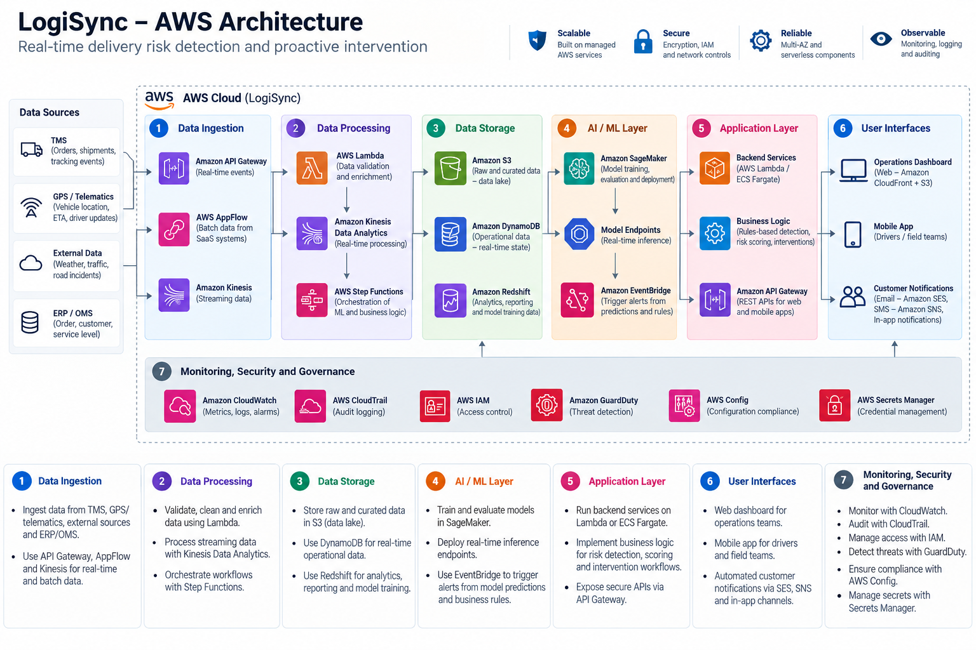
Layer | Proposed services | Rationale
Web and access | S3, CloudFront, WAF, Cognito | Serve dashboard, protect web entry and authenticate users.
API and logic | API Gateway, Lambda | Validate requests and run application/business logic.
Event processing | EventBridge, SQS, Step Functions | Route events, buffer work, retry failures and orchestrate workflows.
Operational data | DynamoDB, S3 | Store operational state separately from larger evidence artifacts.
Rules and optional AI | Lambda rules engine; optional Bedrock; future ML evaluation | Start explainably; add AI only when grounded and justified.
Monitoring and security | CloudWatch, CloudTrail, KMS, Secrets Manager, IAM | Monitor, audit, encrypt and protect credentials.
Notifications | SNS and/or SES where appropriate | Support authorized notifications through verified integrations.

12. AI Evaluation and Data Readiness

Data-readiness checks
- Coverage and consistency of event timestamps and original commitments.
- Reliable delivery identifiers, outcomes and exception labels.
- Freshness and completeness of delivery-status and field-report signals.
- Missing data, duplicate events, class imbalance and representativeness across delivery contexts.
- Authorized access, privacy, retention and sufficient sample size.
- Ability to reconstruct what was known at the time each prediction would have been made.

Evaluation sequence
- Document the rules-based baseline and intended operating conditions.
- Run shadow-mode evaluation without changing operational decisions.
- Measure precision, recall, false alerts, missed risks, detection lead time and alert burden.
- If data is sufficient, compare ML against rules using consistent eligibility definitions and time-separated evaluation.
- Evaluate operational outcomes in a controlled pilot; prediction quality alone does not prove business impact.
- Deploy ML only if it adds value and meets predefined quality, cost, data and safety guardrails.

13. Human-in-the-Loop and Safety
Stage | Automation | Human control
Signal collection | Validate required fields, duplicates and freshness. | Review consequential incomplete or conflicting reports.
Risk detection | Apply rules; optionally score risk after validation. | Inspect evidence and uncertainty; risk score is not proof.
Exception review | Present prioritized alert and supporting context. | Confirm, reject, defer or investigate; record override reason.
Intervention | Recommend possible next steps. | Authorized person approves consequential action.
Customer communication | Draft update from confirmed information where supported. | Verify status and commitment before sending.
Outcome learning | Calculate metrics and surface patterns. | Validate ambiguous outcomes; approve rule/model changes.

The product must not autonomously reschedule deliveries or turn an uncertain prediction into a customer promise. Rules and models should be versioned, changes tested, and rollback and incident-escalation procedures defined.

14. Metrics and Measurement
Metric type | Metric | Definition / use
North Star | At-risk commitment-miss rate | Eligible at-risk deliveries missing the defined original commitment ÷ all eligible at-risk deliveries.
Outcome | Overall commitment-miss rate | Track broader delivery reliability alongside the at-risk cohort.
Detection | Lead time | Time between a valid alert and the original commitment or defined risk deadline.
Detection | Precision / recall | Measure alert quality and missed eligible risks against verified evaluation labels.
Intervention | Intervention success | Evaluate outcomes using a suitable comparison; do not infer causality from simple correlation.
Operations | Handling time / alert burden | Check whether the product adds workload or creates excessive review.
Customer | Repeat-contact and complaint rates | Use consistent definitions and suitable comparison periods/cohorts.
Guardrails | Unsafe or inaccurate actions | Track unauthorized rescheduling, incorrect updates, safety incidents and data quality.

Baseline data, meaningful improvement thresholds, sample size, duration and stop conditions must be defined before the pilot. No numerical performance target is asserted here because baseline evidence is not available.

15. Rollout and Experiment Plan
Phase 0 — Readiness and discovery: Validate workflow, user roles, data access, baseline, integration/security requirements, owners and stop conditions.
Phase 1 — Shadow mode: Evaluate rules-based alerts without changing operations; investigate false alerts, missed risks, freshness and alert burden.
Phase 2 — Limited pilot: Introduce human-approved interventions to a defined cohort; train users and record decisions, outcomes and incidents.
Phase 3 — Outcome evaluation: Compare primary and guardrail metrics against baseline or suitable business-as-usual comparison; assess costs and limitations.
Phase 4 — Controlled expansion: Expand only when evidence supports it; monitor data quality, performance, workload, security and rollback readiness.
Use randomized assignment where feasible. If not, use a suitable matched comparison and document limitations. Each phase needs an explicit go/revise/stop decision; no rollout timeline is assumed.

16. Adoption Strategy
- Involve coordinators in discovery and workflow design.
- Begin in shadow mode so users can inspect alerts without changing their existing decisions.
- Pilot in a narrow scope and minimize duplicate data entry.
- Make alert evidence, freshness and uncertainty visible.
- Track activation, meaningful use, actionability, override reasons, handling time and user-reported usefulness.
- Expand only when users find the product useful and measured outcomes support it.

17. Risks, Dependencies and Open Questions
Risk / dependency | Mitigation or next action
Internal workflow is not validated | Interview operations users and map actual event/decision sequence.
Insufficient or poor-quality data | Perform data-readiness audit and prospective collection if needed.
False alerts reduce trust | Evaluate in shadow mode; tune rules and monitor alert burden.
Signals arrive too late | Measure detection lead time and identify earliest reliable event sources.
Ground reports are inaccurate or stale | Capture source, timestamp, confidence and review state.
Interventions cannot change outcomes | Validate intervention options and decision rights before pilot.
Integration and security complexity | Conduct architecture, security, privacy and access reviews before production.
Business case remains unproven | Measure baseline, attributable benefits, implementation cost and willingness to pay.
AI adds complexity without value | Retain rules unless ML or AI demonstrates incremental value.

Open questions
- Which operational system is the source of truth for delivery commitments and status?
- Which event signals are available, timely and permitted for use?
- Who can approve interventions and customer updates?
- How should approved rescheduling be represented in outcome metrics?
- What volume of eligible exceptions exists, and what is the baseline miss rate?
- What security, privacy, integration and procurement requirements apply to a pilot?

18. V2 Roadmap and Exit Criteria
Increment | Focus | Exit condition
V2.0 — Validate | Reliable data, confirmed workflow, explainable rules and dashboard; shadow-mode evaluation. | Data reliability and detection quality meet predefined pilot-entry criteria.
V2.1 — Intervene | Limited human-approved interventions, structured field reporting and measured outcomes. | Evidence of operational benefit without unacceptable workload, safety or communication impacts.
V2.2 — Predict | Compare historical-data ML and contextual signals against the rules baseline. | Incremental value and quality/operational guardrails are met.
V2.3+ — Expand | Explore voice/photo reporting, grounded copilot, more integrations and multi-site scale. | Each capability has validated need, reliable data, measurable value and acceptable risk.

Defer autonomous dispatch, automatic financial transactions, automatic retraining and broad multi-city rollout until the relevant data, authority, safety, economics and operational evidence are established.

Release Acceptance Checklist
- Problem and primary persona are validated with operational users.
- Original and revised delivery commitments are separately represented.
- Event schema, timestamps, freshness and duplicate handling are defined.
- Rules-based alerts show reason and supporting evidence.
- Human review, authorization and audit trail work as specified.
- Shadow-mode evaluation is completed against predefined criteria.
- Primary metric, guardrails, sample size and stop conditions are agreed before a pilot.
- Security, privacy, reliability, monitoring and rollback requirements are reviewed.
- ML is not deployed without demonstrated incremental value over rules.
- Prototype capabilities, proposed capabilities, modeled estimates and validated results are clearly distinguished.

Portfolio Integrity Statement
LogiSync is an independent product case study. The prototype has some working flows, while logistics data and integrations are mocked or simulated. The AWS architecture, rollout plan, ML evaluation and production controls in this PRD are proposed designs. The 80% review-volume reduction shown in the portfolio is a modeled illustration, not a production result. Financial savings, retention impact and operational performance remain unvalidated.

