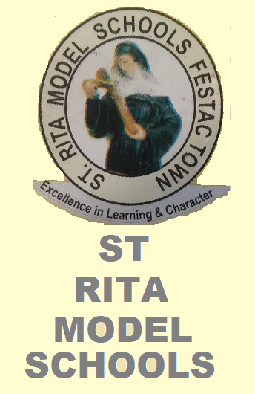 ST RITA MODEL SCHOOLS 
Address: House 32, A Close, 712 Road, Festac Town, Amuwo - Odofin L.G.A, Lagos, Tel:+2348033464520, Nigeria.
Email:StRitaModelSchFestac@gmail.com
 | CLASS |  |  |  | SESSION
 | AVG. CLASS AGE |  |  |  | NO. IN CLASS |  | POSITION IN CLASS
 | TOTAL SCORE |  |  |  | % AVG.  SCORE |  | CLASS AVG.  SCORE
 | 1ST CA  20 POINTS | 2ND CA  20 POINTS | EXAM  60POINTS | COMMU. SCORE  100POINTS | HIGHEST IN CLASS | LOWEST IN CLASS | SUBJECT POSITION | GRADE
MATHEMATICS
ENGLISH LANGUAGE
QUANTITATIVE REASONING
VERBAL REASONING
BASIC SCIENCE
SOCIAL SCIENCE
VOCATIONAL APTITUDE
C.R.K
HOME ECONOMICS
YORUBA / IGBO / HAUSA
AGRIC SCIENCE
COMPUTER SCIENCE
CREATIVE ART
SECURITY
PHY & HEALTH EDU.
DICTION
Teachers Remark |  | Guidance/Counselling Remark |  |  | Headmasters Remark

