Advanced Metrology Report

Author:
Abdelrahman Shehata
(Matrikelnummer: 6452887)

Professor:
Prof. Dr.-Ing. Philipp Huke

March 17, 2025

Table of Contents
1. Introduction 5
2. Data Description 6
2.1 Detector Specifications 6
2.2 Dataset Overview 6
3. Statistical Analysis of Dark Frames 7
3.1 Overall Bias and Noise Levels 7
3.2 Dark Frame Statistical Distributions 8
3.2.1 Mean Dark Frame Visualization 8
3.2.2 Histogram of Dark Frame Bias Values 10
3.2.3 Standard Deviation Dark Frame Noise Visualization 12
3.2.4 Histogram of Dark Frame Noise Values 14

Table of Figures
Figure 1: Mean dark frame visualization 9
Figure 2: Histogram of dark frame bias values 11
Figure 3: Standard deviation dark frame noise visualization 13
Figure 4: Histogram of dark frame noise values 15

Abbreviations | Description
CCD | Charge-Coupled Device
FPN | Fixed-Pattern Noise

1. Introduction
Spectroscopy is a fundamental tool in modern physics and astronomy, allowing precise measurement of light spectra to analyze the properties of materials and celestial objects. Among the various spectroscopic instruments, echelle spectrographs offer high-resolution spectral dispersion by using a combination of diffraction orders to separate and spread light into a detailed spectrum [1]. These spectrographs are widely used in astrophysical research and precision measurements in metrology due to their ability to achieve high spectral resolution over a broad wavelength range [2].
This report presents an in-depth analysis of spectral data obtained from an echelle spectrograph, focusing on data processing, statistical analysis, and wavelength calibration. The dataset consists of multiple frames, each serving a distinct purpose in characterizing the instrument's response and calibrating the observed spectrum:
- Dark Frames: Measure detector noise and bias levels, providing insights into sensor performance [3].
- Whitelamp Spectrum: A reference continuous light source used to assess the spectral response.
- Flat Frame: A measurement of the WhiteLamp spectrum through the spectrograph, showing the structured distribution of spectral orders.
- Calibration Lamp Spectrum: A set of known spectral features used to calibrate the wavelength scale.
- Calibration Frame: A measurement of the calibration lamp through the spectrograph, distributing spectral features across detector orders.
The primary objectives of this study are:
- Data Description – Provide details on detector specifications, including size, number of pixels, and any relevant information.
- Dark Frame Analysis – Compute bias and noise statistics for each pixel and summarize the results without displaying individual pixel distributions.
- Flat Frame Analysis – Fit the underlying function of the flat-field orders in the order-direction to characterize the spectral structure.
- Slit-Direction Fitting – Fit the intensity distribution along the slit (perpendicular to the spectral orders) to analyze the spatial structure.
- Pixel Sensitivity Estimation – Determine the relative sensitivity of each pixel using the flat field and Whitelamp spectrum, normalizing the strongest pixel to 1.
- Calibration Lamp Analysis – Identify spectral peaks in the CalibrationLamp spectrum using FindPeaks and improve accuracy via peak fitting.
- Wavelength Calibration – Locate and fit spectral peaks in the Calibration_Frame orders, then derive a wavelength solution for the detector and estimate the precision of individual pixel wavelengths.
This report details the methods applied, challenges encountered, and results obtained at each stage of the analysis. The findings contribute to improving the instrumental calibration of the spectrograph, ensuring more accurate spectral measurements in future applications.

2. Data Description
The dataset analyzed in this report was obtained from an echelle spectrograph with a detector size of 4096 × 4096 pixels, totaling 16,777,216 pixels. The detector records spectral data across multiple frames, each serving a distinct purpose in calibration and analysis.

2.1 Detector Specifications
- Detector Size: 4096 × 4096 pixels
- Total Number of Pixels: 16,777,216
- Pixel Type: CCD
- Bit Depth: Not known
- Wavelength Range: 425.27 - 783.62 nm
- Cooling Mechanism: Not known

2.2 Dataset Overview
The dataset consists of multiple frames designed for bias correction, flat-fielding, and wavelength calibration:
- Dark Frames (Darks_Shehata_Abdelrahmen.mat)
  - Variable Name: detector_darks
  - Dimensions: (10, 4096, 4096) (Frames × Height × Width)
  - Purpose: Measures the detector’s bias and noise characteristics in the absence of light.
- Flat Frame (Flat_FrameShehata_Abdelrahmen.mat)
  - Variable Name: flatfield
  - Dimensions: (4096, 4096)
  - Purpose: Captures the instrument's response to a uniform light source, revealing the structured distribution of spectral orders.
- Whitelamp Spectrum (Whitelamp_Shehata_Abdelrahmen.mat)
  - Variable Names:
    - white_spectrum: (1, 101) (Intensity)
    - white_wavelength: (1, 101) (Wavelength)
  - Purpose: Provides a continuous reference spectrum used to assess the detector's spectral sensitivity.
- Calibration Lamp Spectrum (CalibrationLamp_Shehata_Abdelrahmen.mat)
  - Variable Names:
    - calib_spectrum: (1, 86016) (Intensity)
    - calib_wavelength: (1, 86016) (Wavelength)
  - Purpose: Contains known spectral features essential for wavelength calibration.
- Calibration Frame (Calibration_FrameAbdelrahman_Shehata.mat)
  - Variable Name: calibration_frame
  - Dimensions: (2048, 2048)
  - Purpose: Captures the calibration lamp spectrum dispersed across spectral orders, allowing precise determination of the wavelength solution for the detector.
This dataset forms the foundation for subsequent analyses, including noise statistics, flat-field modeling, pixel sensitivity estimation, and wavelength calibration.

3. Statistical Analysis of Dark Frames
To evaluate the dark signal characteristics of the imaging system, we conducted a statistical analysis of the pixel values in the dark frames. This analysis provides insights into the inherent noise and bias levels present in the system. Below, we summarize the key statistical findings:

3.1 Overall Bias and Noise Levels
- Mean Bias Level (Overall Mean of Pixel Dark Level): 19.67 counts
- Overall Median of Pixel Dark Level: 19.70 counts
- Overall Standard Deviation of Pixel Dark Level: 11.35 counts
- Mean Noise Level (Standard Deviation Across Pixels): 0.47 counts
- Minimum and Maximum Bias Values: 0.00 / 39.90 counts
These values indicate that the imaging system exhibits a consistent bias level with moderate noise. The standard deviation across pixels (0.47 counts) suggests a low level of pixel-to-pixel variation in dark noise, which is desirable for maintaining uniformity in imaging.

3.2 Dark Frame Statistical Distributions
To further illustrate the pixel value distributions in the dark frames, we generated the following visualizations:

3.2.1 Mean Dark Frame Visualization
The Mean Dark Frame Visualization in Fig. 1 provides a spatial representation of the average pixel intensities across the sensor in the absence of light.
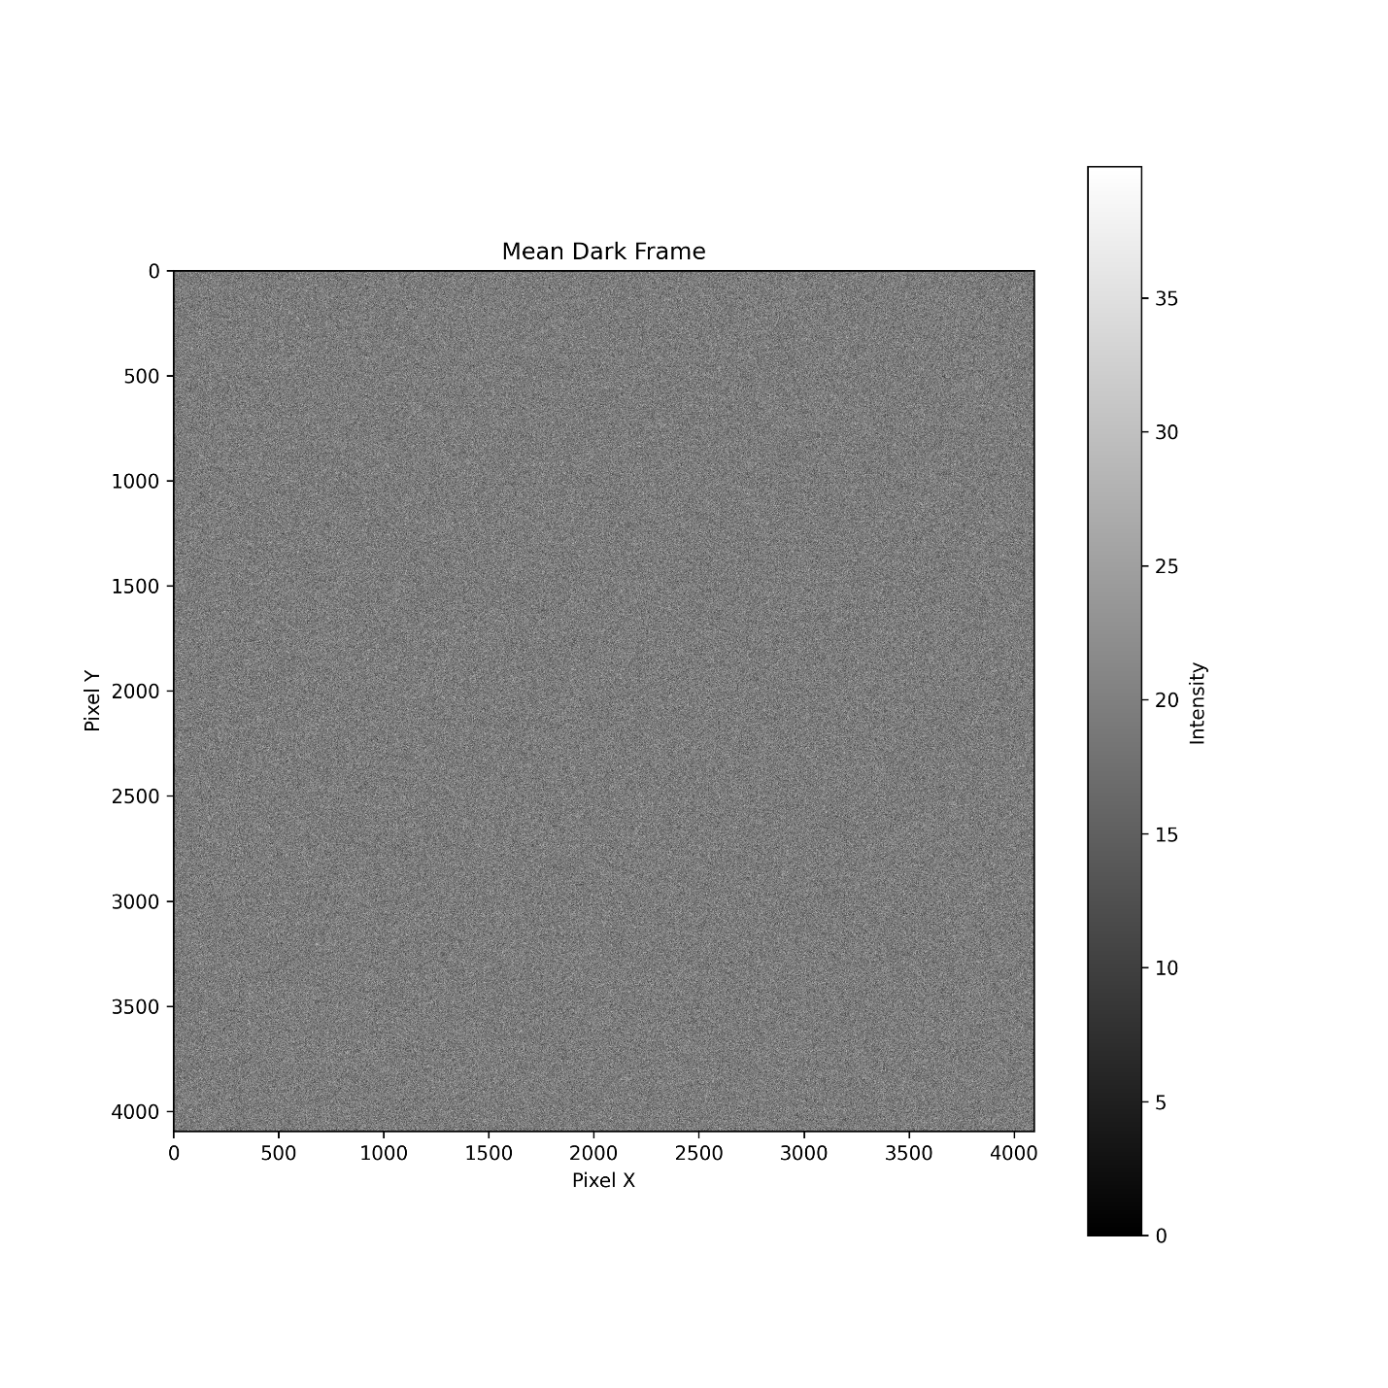
Figure 1: Mean dark frame visualization
Key Observations:
- Uniformity of the Mean Bias Level:
  - The image appears mostly uniform, suggesting that the sensor exhibits a relatively consistent baseline signal.
  - Any variations in intensity across the frame may indicate FPN due to pixel-to-pixel variations in dark current and readout noise.
- Intensity Scale Interpretation:
  - The grayscale color bar on the right represents the range of pixel intensity values.
  - A higher mean intensity in specific regions may suggest thermal noise accumulation or sensor non-uniformities.
- Potential Artifacts or Anomalies:
  - Small deviations from uniformity could indicate the presence of hot pixels, where certain sensor elements have an abnormally high response even in the absence of light.
  - If significant structure is visible, it may suggest readout artifacts from the sensor’s electronics.
- Use in Calibration and Bias Correction:
  - This plot is essential for identifying systematic biases in the sensor.
  - It serves as a reference for bias subtraction, ensuring that astrophotographic or scientific images are properly corrected for inherent sensor noise.

3.2.2 Histogram of Dark Frame Bias Values
The Histogram of Dark Frame Bias Values in Fig. 2 provides a statistical distribution of pixel intensity values recorded in the dark frame. This helps to analyze the spread and uniformity of sensor bias levels.
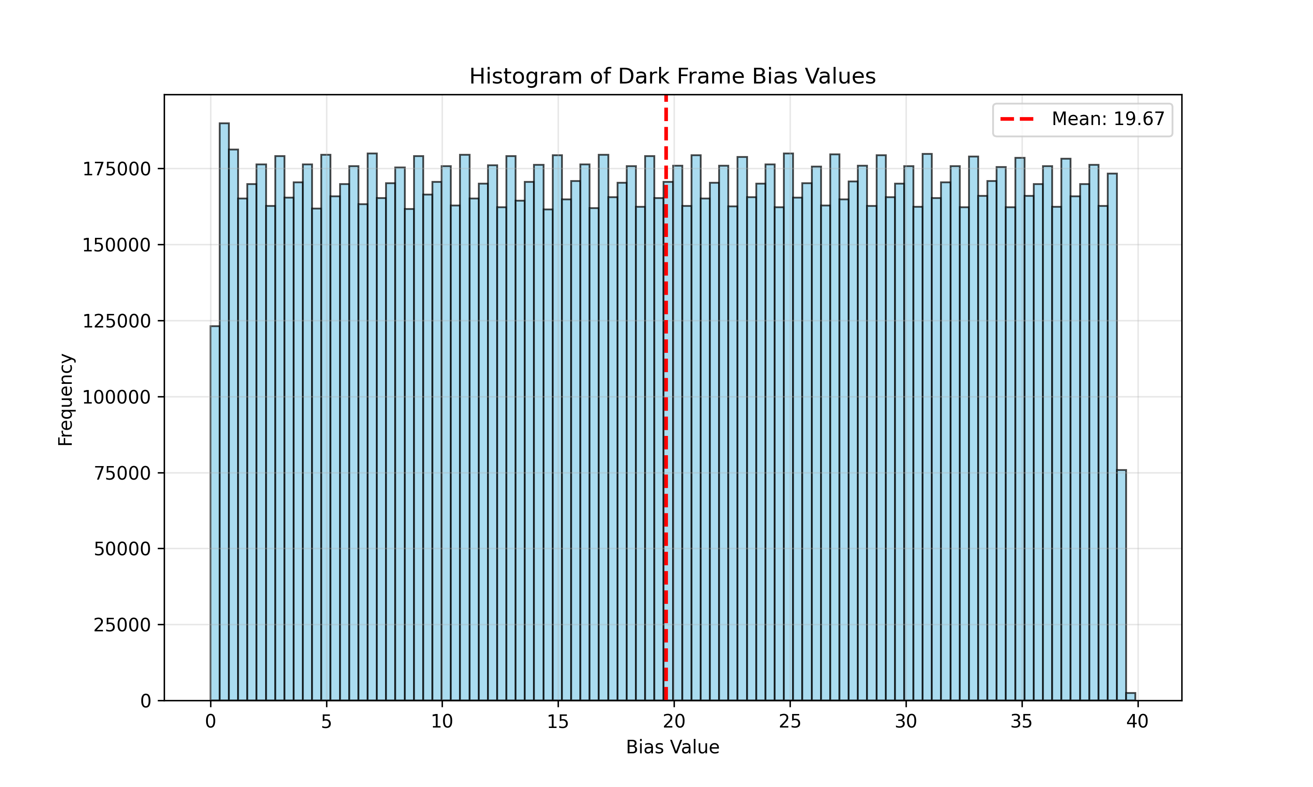
Figure 2: Histogram of dark frame bias values
Key Observations:
- Bias Value Distribution:
  - The histogram shows a relatively uniform distribution of pixel values ranging from 0 to 40.
  - The presence of a broad distribution suggests some variability in the sensor’s dark response, which could be influenced by electronic noise and dark current.
- Mean Bias Level (Red Dashed Line):
  - The mean bias level is approximately 19.67, indicating the central tendency of pixel intensities.
  - This value is a crucial reference for bias subtraction in scientific image correction, ensuring accurate removal of systematic offsets.
- Noise and Sensor Uniformity:
  - A perfectly uniform sensor would have a very narrow histogram centered around a single bias value.
  - The spread seen here suggests read noise, which introduces pixel-to-pixel variations even in the absence of light.
  - The relatively flat distribution may also indicate the presence of thermal noise or ADC quantization effects.
- Application in Image Calibration:
  - This distribution helps in modeling the FPN, allowing for statistical correction in later processing steps.
  - Understanding the bias value distribution ensures that scientific or astronomical images maintain accurate signal-to-noise ratios.

3.2.3 Standard Deviation Dark Frame Noise Visualization
This heatmap in Fig. 3 represents the standard deviation of pixel values in the dark frame across multiple exposures. The standard deviation is a key measure of sensor noise, revealing spatial variations in noise levels across the sensor.
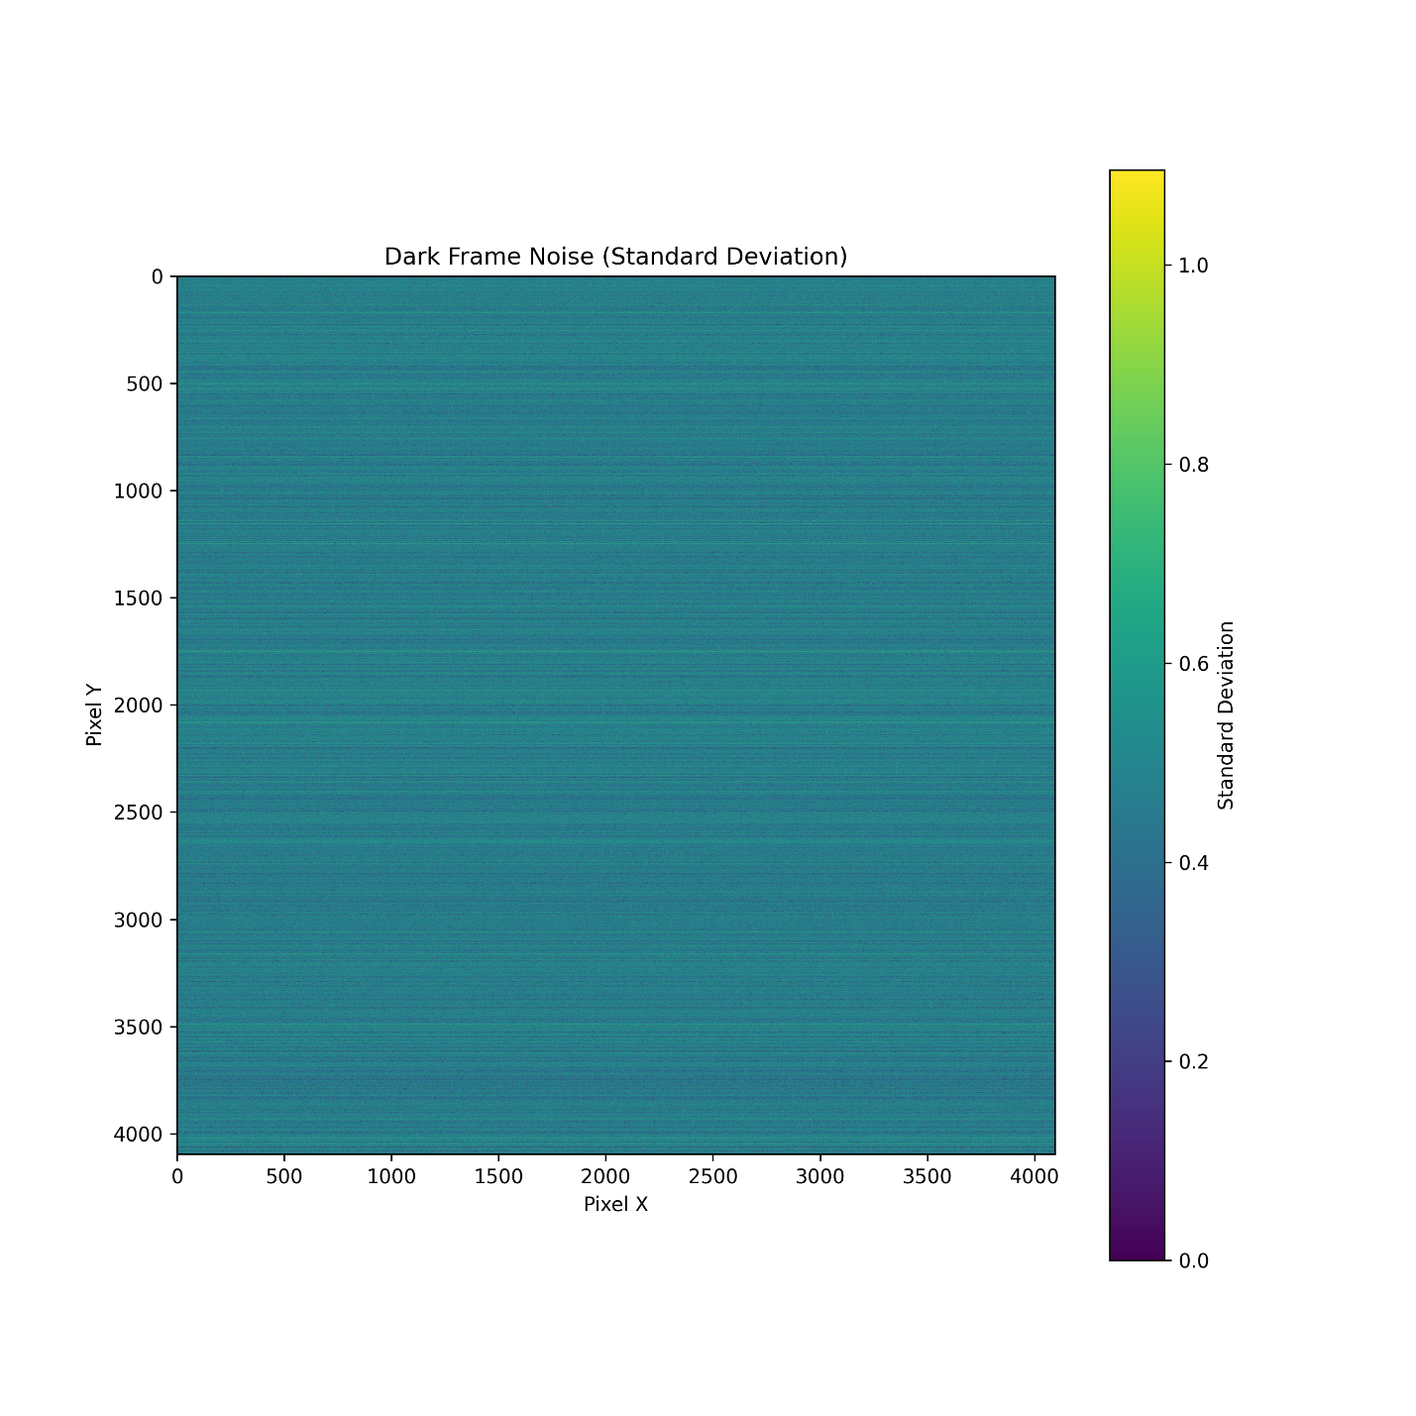
Figure 3: Standard deviation dark frame noise visualization
Key Observations:
- Noise Distribution Across Pixels:
  - The majority of the sensor exhibits low noise, as seen in the predominantly blue-green coloration (lower standard deviation values).
  - Some variations across the sensor indicate the presence of FPN and read noise contributions.
- Horizontal Striping Pattern:
  - The subtle horizontal banding suggests row-wise noise correlations, which may arise due to readout electronics, thermal effects, or amplifier variations.
  - This effect is commonly seen in CMOS sensors due to row-wise readout architecture.
- Magnitude of Noise Levels:
  - The color scale indicates that the noise level ranges from 0 to slightly above 1 (arbitrary intensity units), which suggests a relatively low variation in dark noise across the sensor.
  - The low standard deviation implies that the bias level is stable with minimal fluctuations, making the sensor suitable for precision imaging applications.
- Implications for Image Calibration:
  - Dark noise maps like this help in identifying regions with higher noise levels, allowing for better dark frame subtraction in later image processing.
  - The presence of non-uniform noise across the sensor suggests that calibration corrections should be applied on a pixel-by-pixel basis to ensure optimal image quality.

3.2.4 Histogram of Dark Frame Noise Values
This histogram in Fig. 4 provides a statistical distribution of dark frame noise values across all pixels, measured in terms of standard deviation. It represents the spread of pixel noise levels, helping to identify systematic noise components and outliers.
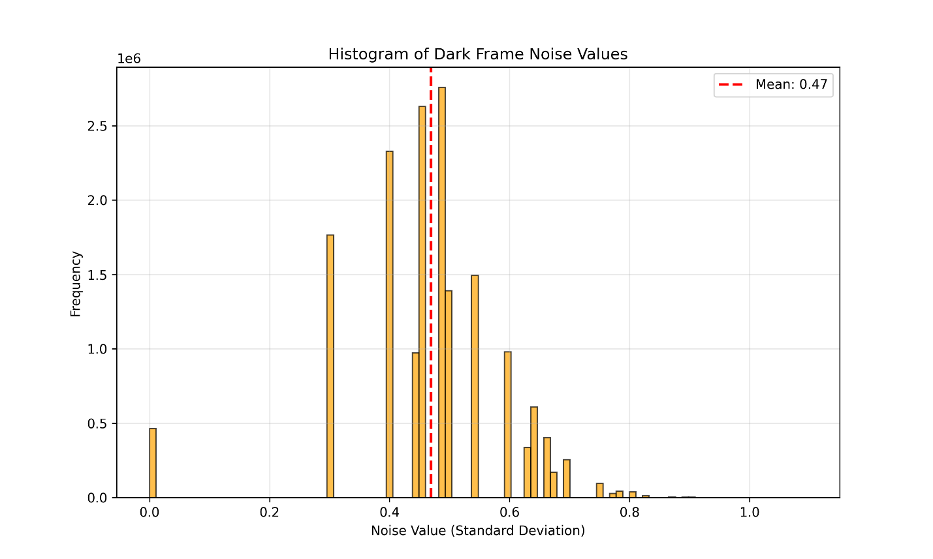
Figure 4: Histogram of dark frame noise values
Key Observations:
- Mean Noise Level (~0.47)
  - The red dashed line marks the mean standard deviation across all pixels, approximately 0.47.
  - This value represents the average noise floor of the sensor in dark conditions.
- Distribution Shape
  - The histogram exhibits a right-skewed distribution, where the majority of pixels cluster between 0.3 and 0.6 in standard deviation.
  - There are multiple peaks, suggesting the presence of different noise sources or variations across sensor regions.
  - A small number of pixels have higher noise levels (above 0.8), likely due to hot pixels or sensor defects.
- Presence of Low-Noise Pixels
  - The small peak near 0.0 suggests that some pixels exhibit extremely low noise.
  - These may correspond to inactive or masked pixels on the sensor.
- Implications for Image Processing
  - Understanding the distribution of noise values is crucial for developing effective dark frame subtraction techniques.
  - The presence of higher noise pixels suggests the need for adaptive noise reduction strategies in calibration.

References
- Schroeder, D. J. (2000). Astronomical Optics. Academic Press.
- Pepe, F., Mayor, M., Delabre, B., et al. (2000). "HARPS: a new high-resolution spectrograph for the search of extrasolar planets.", Proc. SPIE 4008, Optical and IR Telescope Instrumentation and Detectors.
- Howell, S. B. (2006). Handbook of CCD Astronomy. Cambridge University Press.
- Janesick, J. R. (2001). "Scientific Charge-Coupled Devices." SPIE Press.
- Holst, G. C., & Lomheim, T. S. (2011). "CMOS/CCD Sensors and Camera Systems." SPIE Press.

