IDM SPR 2026 QUIZ 4 (15 points) NAME __________________
You may use:
- your own IDM course notes
- your own IDM homework
- any materials in the IDM course repo
- any of the built-in help within Spyder (or Jupyter if you are using that)
You may not use any other sources. You may not collaborate with anyone else whatsoever.
- Assume the following problem is to be formulated in the same manner as the olive oil problem covered in class. Sketch the time-based network diagram that would result (not the simple structural network). (7 points)
  - Label each node with its proper label (letter or name for location, week).
  - Draw in all arcs including inventory arcs, if any, but if flow could not possibly go through or from a node or arc in a feasible solution, do not include that node or arc in the diagram.
  - You do not need to label arcs, costs, nor capacities.
DO NOT SOLVE the MPTP, just sketch the diagram.
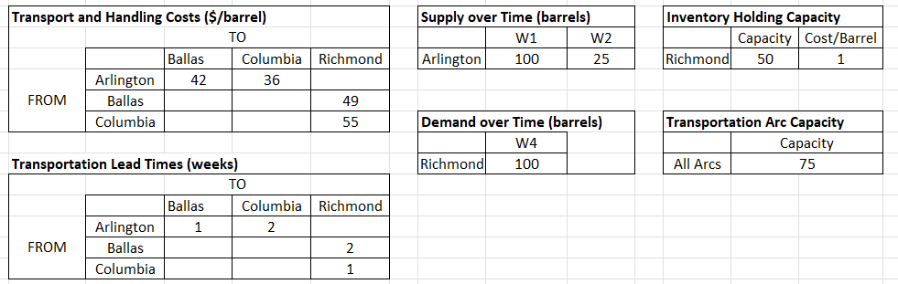
Week -- >
Location
↓

- This problem refers to the mp_transhsip.py code and associated data/ mptp_data_01.dat file from the course repo lecture multiperiod transshipment folder and reproduced for you in the quiz04-transshipment-problem folder. (8 points)

  - Run the code, which should result in an optimal solution, and report the following:

    - optimal values of the variables corresponding to the number of barrels of oil transported between:
      - KCI week 1 and NRF week 2 _____________

      - CHI week 2 and NRF week 4 _____________

      - SJU week 6 and SJU week 7 _____________

    - Did the flow reach maximum capacity on any transportation (not inventory) arc? If so, which one(s)?

  - In the dat file, change Panama’s week 4 demand from 100 to 125. Save the dat file, point the code to the revised dat file, re-run the code and answer the following:

    - optimal objective value _______________

    - optimal values of these variables:

      - x_CHI_1,HOU_3 _____________

      - x_CHI_2,HOU_4 _____________

      - x_PAN_6,PAN_7 _____________

There is no electronic submission for this quiz.

