The Stable Marriage Problem
- initially studied in 1962 by David Gale and Lloyd Shapley
- began a line of research about markets and efficient (polynomial time) algorithms in the fields of economics and operations research
- considered the seminal problem in a field of study broadly called matchings under preferences
- importance of work in this field recognized in 2012 when Alan Roth and Lloyd Shapley won the Nobel Prize for their work on an efficient algorithm for kidney-exchange programs
Problem statement: “Given n men and n women, where each person has ranked all members of the opposite sex in order of preference, marry the men and women together such that there are no two people of opposite sex who would both rather have each other than their current partners. When there are no such pairs of people, the set of marriages is deemed stable.” In this version of the problem, we are only considering heterosexual marriages.

Example
Below are the preference lists for a group of men and women:
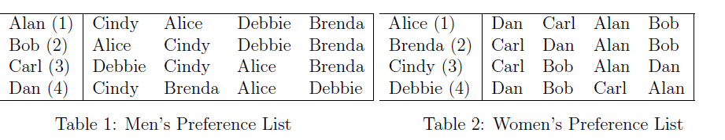
- Using trial and error, come up with a stable matching and an explanation about how there are no blocking pairs in the stable matching.
Going through men in order of their preferences yields:
Alan-Cindy Bob-Alice Carl-Debbie Dan-Brenda
Explanation of why it’s stable: Alan, Bob, and Carl all got their 1st choices, so are not in a blocking pair. While Dan prefers Cindy to his partner (Brenda), Cindy does not prefer Dan to her partner (Alan). So that’s not a blocking pair, so there are no blocking pairs.
- Going through the women in order of their preferences yields the matchings:
Alice-Dan Brenda-Carl Cindy-Bob Debbie-Alan
Demonstrate that this matching is unstable by finding a blocking pair.
Debbie prefers Dan, Bob, and Carl to her match (Alan). Carl prefers Debbie to his match (Brenda), so Debbie-Carl is a blocking pair, making this matching unstable.
- Using trial and error, come up with an unstable matching different from the one in the previous question and demonstrate that this matching is unstable by showing it has a blocking pair.
Matching by having men pick their lowest preferences yields:
Alan-Brenda Bob-Debbie Carl-Alice Dan-Cindy.
Cindy prefers Alan to Dan. Alan prefers Cindy to Brenda. So Cindy-Alan is a blocking pair.

Gale–Shapley Algorithm
Algorithm Gale–Shapley (Men Propose) O(n²)
Require: Preference Lists for n men and women
Ensure: A stable marriage
1: Initialize all men and women as free
2: while there exists a free man m who still has a woman to propose to do
3: w = m’s highest ranked woman to whom he has not yet proposed
4: if w is free then
5: (m, w) become engaged
6: else some pair (m′, w) already exists
7: if w prefers m to m′ then
8: (m, w) become engaged
9: m′ becomes free
10: else (m′, w) remain engaged

The Gale-Shapley algorithm is guaranteed to find a stable matching. It also has these interesting properties:
- Truthfulness for proposers. From the proposing side, the algorithm is strategy-proof: no proposer can obtain a better outcome by misrepresenting their preference list.
- Proposer-optimal stable matching. Among all stable matchings, the algorithm produces the matching that is best for all proposers and, correspondingly, worst for all recipients.
- Group strategy-proofness. No coalition of proposers can jointly misreport their preferences in a way that makes every proposer strictly better off than if each acted truthfully and independently.

Note that we can equivalently run the algorithm with women proposing instead and will reach a stable matching, though not necessarily the same one as with men proposing.

- Solve the example above using the Gale-Shapley algorithm with women proposing (preferences reproduced below):

Alice Dan Alan
Brenda Carl Dan
Cindy Carl
Debbie Bob
--
Carl is Cindy’s first choice and Carl prefers her to his current match Brenda, so Carl splits with Brenda.
After losing Carl, Brenda chooses Dan who prefers her to his current match of Alice, so Dan splits with
Alice.
Alice then matches with Alan.

And this is Stable.

