Information Systems – Fall 2026
HW 6 SOLUTIONS: SQL (25 points)
Due: TU 10/27/2026 at the beginning of class

Note: the due date is after the midterm exam. The material in Part I will be on the midterm exam. The solutions may be posted to the course repo before the exam. You are allowed to view them before completing the homework, but should try to do so only after you have completed the problems.

Objective: Increase familiarity with building SQL statements and integrating databases with Python.

Required Submission:
Submit the following electronically to the CANVAS hw06 assignment page:
- Part I: the Part I questions below followed by your answers in the form of:
  - your SQL statements, and
  - the screenshots of your output
.
- Part II: your completed Jupyter notebook with all cells executed and all output shown

Collaboration: You may collaborate on this assignment with students currently enrolled in this course. You may use your textbook, materials presented in class, or posted on the class website as examples. You may use the Internet as a resource. Direct copying from any source including the Internet (or anyone) is never allowed, and you must be able to cite and explain your own work. If in doubt, ask your instructor.

Part I – Write SQL statements for the Household Help Database
Preparation
A database file HouseholdHelp.accdb is posted in the course repo. Open this file in Access and familiarize yourself with its tables.

For the following questions:
- Write the SQL statement necessary to answer each question.
- Run the SQL statement in Access.
- In your HW submission, below each question fill in:
  - the SQL statement you wrote and
  - a screenshot of the output from Access.
- Do not design queries in “Query Design” view and then use the associated SQL statement.
  - The SQL statement should be written by you, not Access!
  - Later you will be tested on SQL statement writing without the aid of Access.

1. How many clients live in zip code 74102?
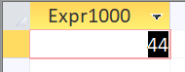
SELECT Count(Zip)
FROM Clients
WHERE Zip = '74102';

2. How many workers can complete each task? (list by task type)
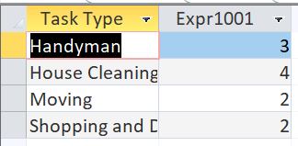
SELECT [Task Type], Count([Worker Skills].[Task ID])
FROM Tasks
INNER JOIN [Worker Skills]
ON Tasks.[Task ID] = [Worker Skills].[Task ID]
GROUP BY [Task Type], Tasks.[Task ID];

3. How many jobs has each worker completed? (list by worker’s first and last name)
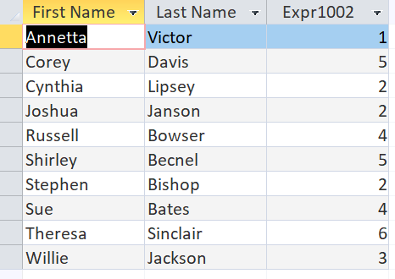
SELECT [First Name], [Last Name], Count([Job ID])
FROM Jobs
INNER JOIN [Workers]
ON Jobs.[Worker ID] = [Workers].[Worker ID]
GROUP BY [First Name], [Last Name], Jobs.[Worker ID];

4. What clients (first and last name) have used worker 551?
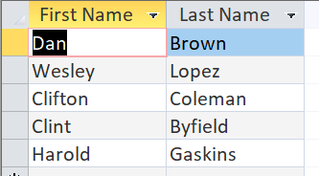
SELECT [First Name], [Last Name]
FROM Clients
INNER JOIN [Jobs]
ON Jobs.[Client ID] = [Clients].[Client ID]
WHERE [Worker ID] = '551';

5. How many clients have expired credit cards, as of March 1, 2019?
(Hint: https://stackoverflow.com/questions/4183180/select-query-with-date-condition)
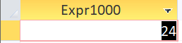
SELECT Count([Client ID])
FROM Clients
WHERE CCExpires < #03/01/2019#;

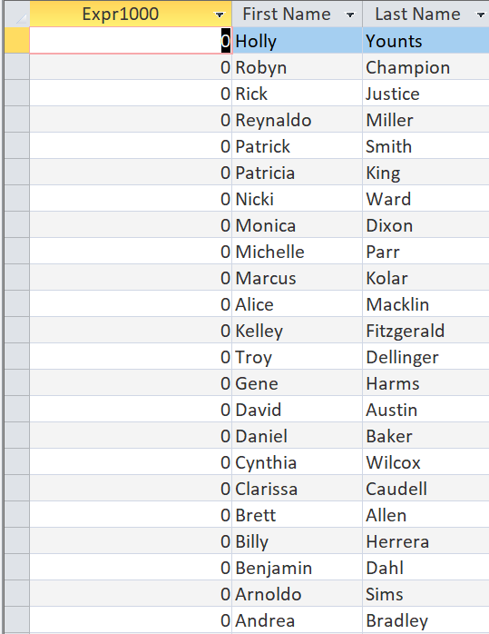
6. List the number of times each client has used services through this company. Your list should include even those clients who have never used services (i.e. think about which JOIN is appropriate to use for this question). List in ascending order.
SELECT Count([Job ID]), [First Name], [Last Name]
FROM Jobs
RIGHT JOIN Clients
ON Jobs.[Client ID] = Clients.[Client ID]
GROUP BY Jobs.[Client ID], [First Name], [Last Name]
ORDER BY Count([Job ID]) DESC;

