Information Systems – Fall 2026
HW1: Jupyter Notebooks (10 points)
Due: at the beginning of class on Thursday Aug 27, 2026

Introduction to Jupyter Notebooks
We will begin this course by introducing a new coding environment called Jupyter notebooks. Jupyter Notebooks are an “open-source web application that allows you to create and share documents that contain live code, equations, visualizations and narrative text”. This is a popular application used in industry because it lends itself to communicating in a report-like manner while embedding code.
OBJECTIVES: The objectives of this assignment are to (1) introduce you to Jupyter notebooks and (2) review some Python basics you learned in the Computer Modeling Languages course.
SUBMISSION: Submit two Jupyter Notebook .ipynb files – one for Part I and another for Part II - electronically to Canvas. The notebooks must have all the cells executed with output shown.
COLLABORATION: You may collaborate on this assignment with students currently enrolled in this course. You may use code presented in class or posted on the class website as examples. You may use the Internet as a resource for code documentation and ideas. Direct copying from the Internet (or anyone) is never allowed, and you must be able to cite and explain any code you have incorporated within your own program. If in doubt, ask your instructor.

Part I: Basics in Jupyter
If you do not have Jupyter installed, install the Anaconda suite (go to https://www.anaconda.com/download/success) then follow the instructions on Canvas : Announcements to create a Conda environment with Jupyter.
- Open Jupyter Lab (preferred) or Jupyter Notebook (more basic) to work in a directory of your choice. If you installed the infoSys conda environment, we suggest following this procedure:
- from the Windows start menu launch Anaconda prompt
- type “conda activate infoSys”
- change to the directory of your choice, suppose it’s “c:\Users\Iprog”, then type “cd c:\Users\Iprog”
- type “jupyter lab”
(Other options are Anaconda Navigator or the Windows start menu.)
A Jupyter Console will open (a black window with white text), followed by a Jupyter directory in your web browser, similar to what is shown below.
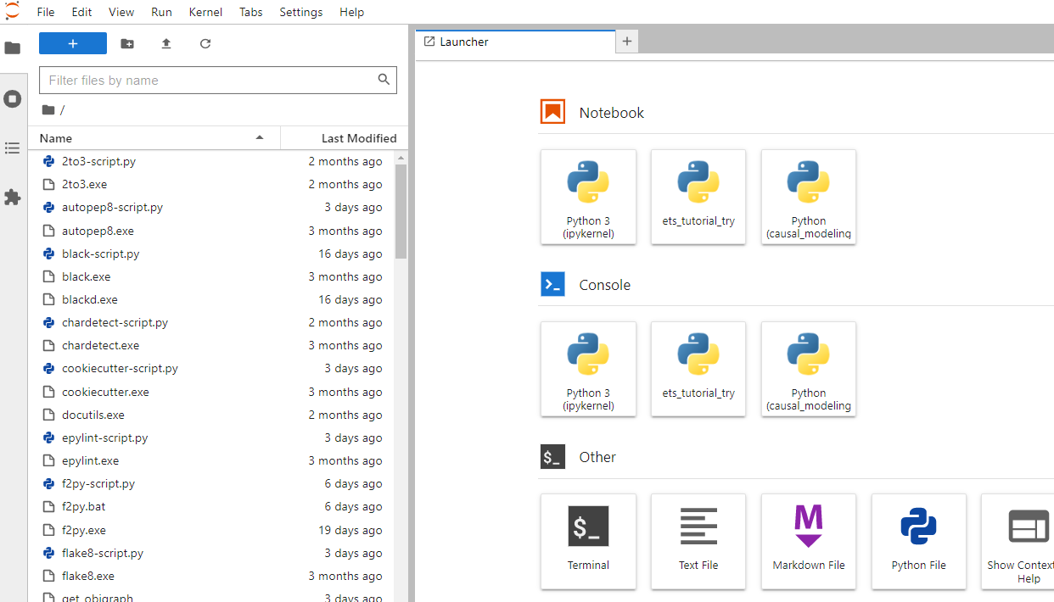

Note:
  - Do not close the Jupyter Console while you are working as this needs to be running in the background.
  - Even though Jupyter opens in web browser, you do not need to be connected to the Internet to use Jupyter.
  - Your Jupyter may start by creating a blank notebook and asking you which kernel you want to use. You can pick any one for now; we will come back to this.

- Familiarize yourself with the onscreen setup. You should see a file explorer panel on the left and a launcher window with buttons on the right or possibly a blank notebook file. Create a new folder to save all your Info Systems files by clicking on the “New Folder” button at the top of the file explorer (see circle at left of Figure 2 below). You can navigate to wherever you want this folder to be first by clicking on the folders in the file explorer.

- Next create a new Jupyter Notebook. To do so, in the Launcher window, click on a Python 3 button under the Notebook section.
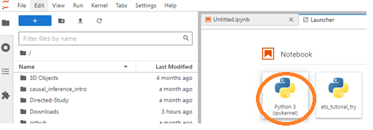
Figure 1

If you do not see the Launcher window, click the little plus sign shown in the circle towards the right of Figure 2.

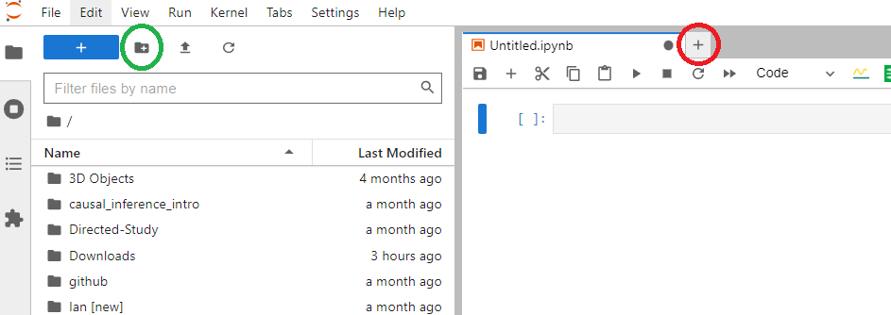
Figure 2
Your screen may look a little different than the ones shown.

- This will open a new Jupyter notebook or .ipynb file, as shown below. Right-click on the name, select Rename, and change the name of the .ipynb file to “LastName_JupyterIntro_Part1” with your last name.

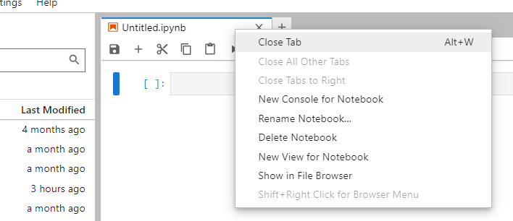
Figure 3

- Notice the highlighted blue box in the notebook – this is called a cell. More specifically, it’s a code cell, as indicated by the menu’s dropdown menu. Type the following Python code into the code cell and execute by clicking  or Ctrl + Enter or Shift + Enter:
x = 2
y = 4
x * y

Note: When you execute code with Shift + Enter, a new coding cell will appear. You can also manually add cells by clicking 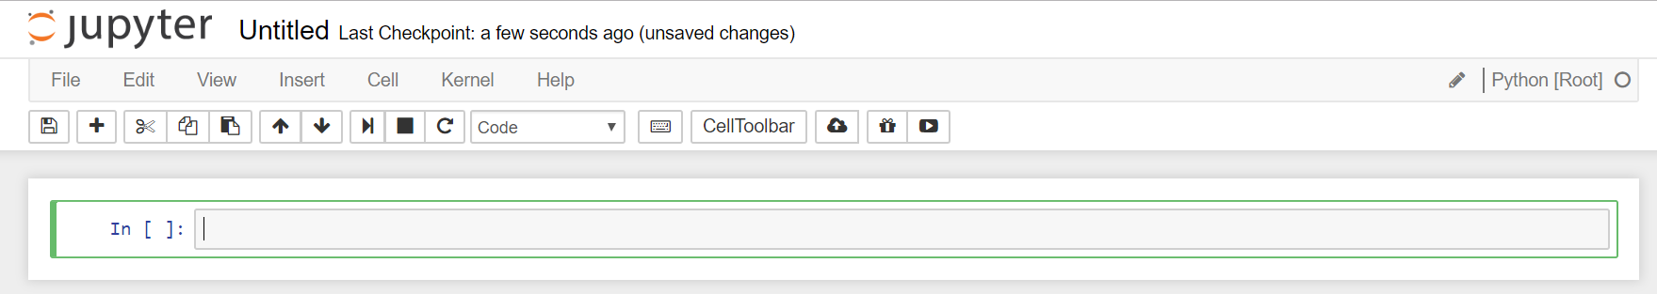.

- Move the empty code cell to the top by clicking toward the right of the cell. Type print(x) into this cell – what do you expect to happen?

- To restart the kernel, click . Try running the cell with print(x) again – what do you expect to happen? Type your answer to this question in a markdown cell in your Jupyter notebook, clearly labeling it with its question number (e.g. #7).

- Briefly explain the difference between what happened in step 6 and step 7 and how to avoid any errors in the future, while working with Jupyter notebooks. Type your answer to this question in a markdown cell in your Jupyter notebook clearly labeling it with its question number.

- Get familiar with the cut, copy, paste buttons , which work as you would probably expect them to.

- Make a new code cell, add code that would cause an infinite loop and execute. You’ll notice appears next to your code cell, indicating that it is running. Often, our code will run pretty quickly, but sometimes it will take a while to process (or in this case, infinitely). To stop your code cell click .

- Get in the habit of saving your notebook often by clicking . Nothing is worse than working on a coding assignment all night and then, Pow! it is gone because of a low battery, coffee spilled on the computer, etc.

Part II: Markdown Cells
Now that you are familiar with code cells, we will introduce markdown cells. With markdown cells, you can include text, formulas, etc. that will make your notebook in a readable format.
Here are a few examples of Jupyter Notebooks that use both markdown and code cells to explain a concept:
https://nbviewer.jupyter.org/github/ipython/ipython/blob/6.x/examples/IPython%20Kernel/SymPy.ipynb
https://nbviewer.jupyter.org/github/ipython/ipython/blob/6.x/examples/IPython%20Kernel/Trapezoid%20Rule.ipynb
https://nbviewer.jupyter.org/github/gestaltrevision/python_for_visres/blob/master/Part7/Part7_Image_Statistics.ipynb
- Add a new cell and convert it to a markdown cell by selecting “Markdown” from the dropdown menu.
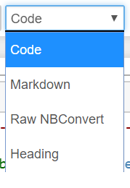
- Type anything and execute the cell. You’ll notice the text is embedded into your notebook. However, you are able to edit markdown cells by simply double-clicking on the text.

*** You can include headers, format text, include images, etc. using markdown cells. ***

- Use the reference given below to replicate the Jupyter notebook “HW1_JupyterIntro__Part2_Blank.pdf” posted on Canvas in the Assignments : HW 1 section. Save the file as “LastName_JupyterIntro_Part2.ipynb”. Anywhere you see ```YOUR CODE HERE``` is where you should enter in your own code in order to complete the task given.

Jupyter Markdown reference:

https://github.com/adam-p/markdown-here/wiki/Markdown-Cheatsheet. The following sections will be helpful: Headers, Lists, Code and Syntax Highlighting

https://www.markdownguide.org/

