Information Systems – Fall 2026
HW8: VBA (25 points)
Due: Tuesday Nov 17, 2026 at the beginning of class

Objectives:
- Practice with the following VBA skills:
  - Excel Range Objects
  - Dialog Boxes
  - Loops
  - Arrays

Submission:

Part | Hard copy | Electronic (to HW 8 CANVAS dropbox)
I | your code handwritten or typed in below questions | your completed HW8_Part1.xlsm file
II | N/A | your completed HW8_Part2.xlsm file
III | N/A | your completed HW8_Part3.xlsm file

Collaboration:
- You may:
  - collaborate on this assignment with students currently enrolled in this course
  - use your textbook, materials presented in class, or posted in the course repo as examples
  - use the Internet as a resource
- You must:
  - cite any people or sources that provided assistance
  - be able to explain your own work
- You may not:
  - directly copy from any source including the Internet (or anyone)
- If in doubt, ask your instructor.

Grading:
- Some portion of your work will be graded on the correctness of your answers.
- All of your submission will be graded on completeness and organization.

Part I – VBA: Working with Ranges
With the fictitious sales data in the Excel file “HW8_Part1.xlsm”, use the Range examples from class to complete the following in VBA, and write the code below and in the file:
- Create a sub named “Q1” that names the entire range of sales data “SalesData”.
code:

- Create a sub named “Q2” that makes the “SalesData” range bold with a red background
(hint: record a macro if you’re having trouble with the code to change the background).
code:

- Create a sub named “Q3” that does the following:
For each of the region columns within the data set, use the upper left cell (A1) with the .offset function to create a named range that corresponds to each of these columns. For example, the cells B2:B37 will be named “Region1” but you must use the .offset function from cell A1.
(Hint: see sub Range6() in the Ranges(essentials).xslm and the Offset Property Section in your textbook on pages 134-135)
code for one named range:

- Create a sub named “Q4” that creates a range object and sets the object equal to the contents in the first column of the “SalesData” (the first column pertains to the dates). Once this range object has been created, display a msgbox that displays the number of rows within this first column of data. You should determine the number of rows of this range by using the .Rows.Count property of the range object.

Part II – VBA: Lotto Tickets
Create a program in VBA that simulates getting ‘quick pick’ lotto tickets. A starter file is provided on CANVAS, “HW8_Part2.xlsm”. Your xlsm file should include the following:
- Ask the user how many lotto tickets they want
- Print the desired number of lotto tickets (5 #’s each)
- Create two buttons:
  - clear the contents
  - generate lotto tickets
For example, once you are completed, your Excel workbook may look like the following:
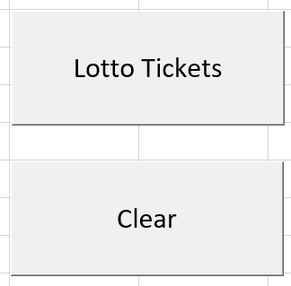
Clicking on the “Lotto Tickets” button would bring up the following input box:
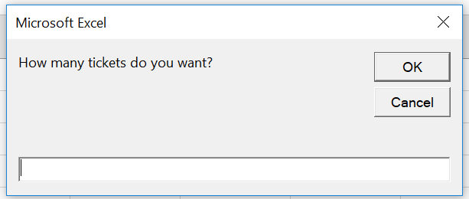
Entering 3 would result in three rows of 5 #’s each. Your numbers will look different as these are randomly generated numbers.
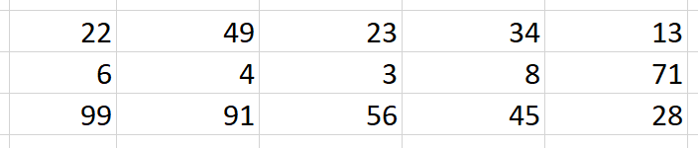
Clicking on the “Clear button would clear the worksheet.

Part III – Arrays
Write a program in VBA that does the following:

- Ask the user for n (# of rows) and m (# of columns)
- On Sheet 1, make an n x m table of random numbers between 1 and 100, starting at cell B2
- Make it so that the random numbers created in the previous step do not update when any changes to the spreadsheet are made. There are many ways to ensure this, one of which is by using the xlCalculationAutomatic property (see VBAPart2_Example1.xlsm).
- Name this range (i.e. the n x m table) “horzTable”
- Save the values of horzTable in a VBA array
- Transpose this table onto Sheet 2, starting at cell B2

For example, if the user inputs n = 3 and m = 10, Sheet 1 and Sheet 2 would look similar to the following:

Sheet1:
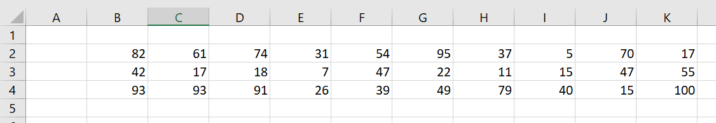

Sheet2:


