Information Systems
HW 5: Access (25 points)

SOLUTIONS
Objective: Increase familiarity with Access including:
- creating tables
- entering/importing data
- creating queries, forms, and reports

Submission: Submit a hardcopy consisting of:
Part I:
- your initials certifying that you completed Tutorial B
- screenshots for the “Making Seven Practice Queries” section of Tutorial B (pp 33-37)
- printout of the report requested in # 3 below (“Create a report that shows an employee’s…”)
Part II:
- printout of the portion of the report requested in #1
- written or typed response to question #2

Collaboration: You may collaborate on this assignment with students currently enrolled in this course and receive assistance from the instructor. You may use your textbook, materials presented in class, or posted on the class website as examples. You may use the Internet as a resource. Direct copying from any source including the Internet (or anyone) is never allowed, and you must be able to cite and explain your own work. If in doubt, ask your instructor.

Part I – Access Tutorial
Read and complete Tutorial B (pages 13-50). Answer the following questions.
- Initial here to indicate you completed Tutorial B: ____IDF_

- Complete the “Making Seven Practice Queries” on pages 33-37.
  - For queries 1 through 6, submit screen shots of the outputs.
  - For query 7 - the update query – submit a screenshot of your query set-up (but not the output).
To receive full credit, clearly label each screenshot with its number (1 through 7)

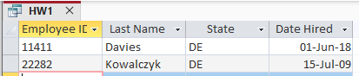
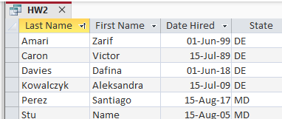
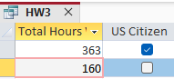
Answers to #s 4 and 5 depend on if you ran the queries before or after the raises. Solutions show when applied before the raises.
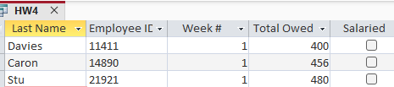
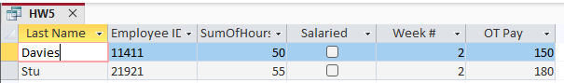
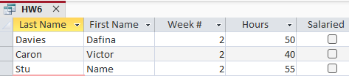

Query 7
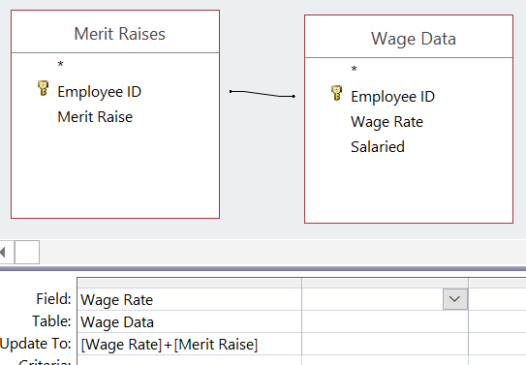

- Create a report that shows an employee’s:
- last name,
- first name,
- state,
- week number, and
- hours worked.
and is grouped by last name, and total the hours by person. Adjust your report so that there is no “staircase” look nor repeated data. Print this report and submit with your HW.

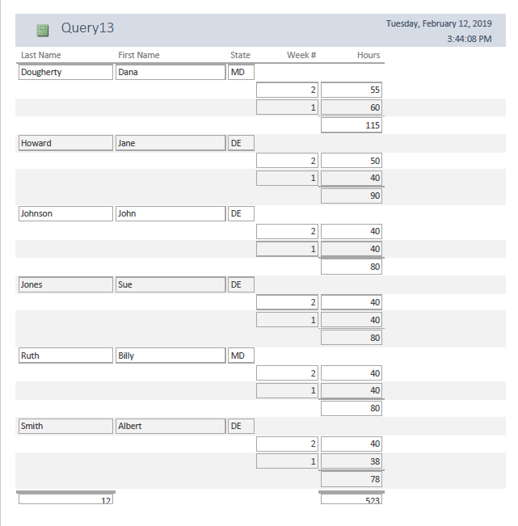

Part II – More Access Practice
- Recall the NFL data we scraped from nfl.com earlier this semester. Two Excel files in this homework’s course repo folder - passingDF.xls and teamDF.xls – contain some of the data we scraped then. Download these files and import them into Access as two tables. Using these tables in Access, reproduce the report shown below. Print out the first page of the report and submit it with your HW.
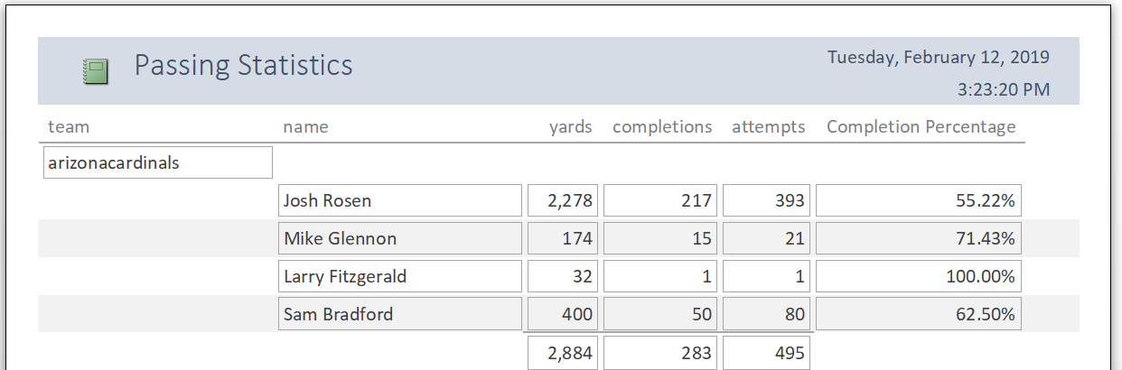

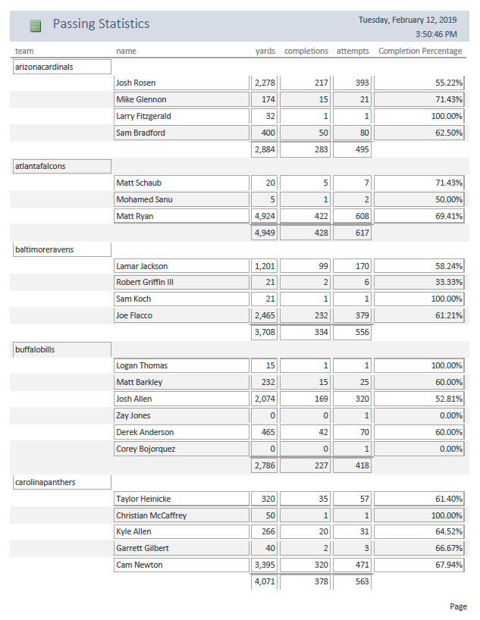
After importing the csv’s in as tables, create a query to get all passers’ fields needed in the report and add a new column for completion % like this Completion Percentage: [completions]/[attempts]
Note: not required but if you want to handle divide by 0, do something like this: Completion Percentage: IIf([attempts]=0,Null,[completions]/[attempts])

- In 1-3 sentences, explain any problems you see with using the completion percentage statistic to rank how “good” a player is.
There are some players that have low attempts/completions (probably due to their position). Therefore, these players may have higher completion percentages compared to players who contributed more overall (passing-wise) to the team. For example, Larry Fitzgerald has one attempt and one completion and therefore a 100% completion percentage.

