Pandas Worksheet
Purpose of this worksheet: increase your familiarity with pandas
We will be working with a data set of New York City 311 complaint calls (excerpt shown below).
Familiarize yourself with this file - “311_from_2011.csv” – before you begin to better answer the questions below.
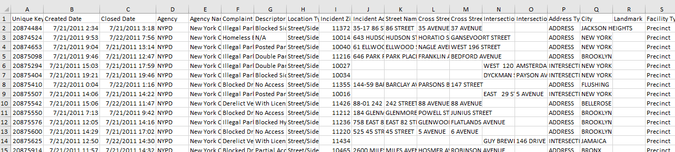

Terminology
(based on VanderPlas Python Data Science Handbook)
  - A Pandas Series is a one-dimensional array of indexed data.
e.g. 0 0.25
1 0.50
2 0.75
3 1.00
dtype: float64
  - A Pandas DataFrame is a two-dimensional array with both flexible row indices and flexible column names.
e.g. area population
California 423967 38332521
Florida 170312 19552860
Illinois 149995 12882135
New York 141297 19651127
Texas 695662 26448193
  - Python’s type() function – returns the type of the specified object, e.g. type(‘a’) = str, type(3) = int, etc.

Exercises
Being by typing: import pandas as pd

Loading Data
Command | What do you think it will do? | Were you correct? | What does it actually do  (if you weren’t correct)?
nyc_df = pd.read_csv('311_from_2011.csv')

What data type is nyc_df?

Extracting from a data frame

ß ** DO – Insert a title to describe the commands in this sub-part after you finish it
x = nyc_df['Complaint Type']
type(x)

z = nyc_df[ ['Complaint Type','Location Type'] ] type(z)

y = nyc_df[ ['Complaint Type'] ]
type(y)

list(nyc_df['Complaint Type'])
Note the single brackets here; conversion to list works on a series, which is already 1d, not on data frame. (pandas also has a .tolist method, which does the same thing)
set(nyc_df['Complaint Type'])

Note: this is useful if you have data with loads of columns but you only plan to work with a small number of them

ß ** DO – Insert a title to describe the commands in this sub-part after you finish it

nyc_df[7:9] and what is its data type?
nyc_df[7] and what is its data type?

nyc_df[7:8] and what is its data type?

nyc_df.iloc[7] and what is its data type?
(hint i stands for integer, loc for location)
nyc_df.head() and what is its data type?

In pandas, square brackets [] are normally used for column selection.
An exception is that slices, like [7:10] can be used to select rows.

Extracting subset of data frame (rows and columns)
nyc_df['Complaint Type'][5]
and what is its data type?
nyc_df['Complaint Type'][:5]
and what is its data type?
nyc_df[
['Complaint Type', 'Descriptor']][:3]
** please note the double square brackets again What is its data type?

Filtering
nyc_df['Latitude'] > 40.91

nyc_df[nyc_df['Latitude'] > 40.91] very useful, and what’s the data type?

Another way we might want to accomplish the above  is in 2 steps.  filter_1 = nyc_df['Latitude'] > 40.91  df_1 = nyc_df[filter_1] | N/A | N/A | N/A
len(nyc_df[nyc_df['Latitude'] > 40.91])

noise_res_df = nyc_df[
nyc_df['Complaint Type'] ==
'Noise - Residential']

** again, very useful; data type is what? **
How would you re-write it in 2 lines with a filter as above?
nyc_df[
nyc_df['Complaint Type'].isin(
['Squeegee','Urinating in Public']
)
]
noise_res_11221_df = nyc_df[
(nyc_df['Complaint Type'] == 'Noise - Residential') &
(nyc_df['Incident Zip'] == 11221)
]
above is very useful but these calls can get become cumbersome to read so you should break them up into multiple lines as above

What do these next lines do if called after the code in the previous row?

x = noise_res_11221_df.iloc[0]
What’s in x?
y = x[‘City’] What’s in y?

More, in general:
df.loc[df['column_name'].isin(some_values)]
df.loc[
(df['column_name'] >= A) &
(df['column_name'] <= B)
]

df.loc[df['column_name'] != some_value]
df.loc[~df['column_name'].isin(some_values)]

Sorting
nyc_df.sort_values(by='Created Date', ascending=True)
nyc_df.sort_values(by='Longitude')

So what are the things that can go after the “by=”?
And again, what data type is returned?

Type a command to access the first 30 rows from the previous result.

Other operations
nyc_df.info()

nyc_df['Complaint Type'].unique()

nyc_df[['Complaint Type']].unique()
nyc_df['Complaint Type'].value_counts()

– useful? I think so.

What’s the data type?
How would you get only the top 10?
Do it.

nyc_df['Complaint Type'].value_counts().plot()
If the plot doesn’t show up, try first typing %matplotlib inline
nyc_df[
'Complaint Type'].value_counts().plot(kind='bar')

Which plot is better? Remember this please.

New column from existing ones
nyc_df['Complaint'] = nyc_df['Complaint Type'] + nyc_df['Descriptor']

nyc_df['Short Key’] = nyc_df['Unique Key’] % 1000

nyc_df['Latitude'].min()

df['Incident Zip'].mode()
What’s the data type? (reason: mode can have ties)

Additional questions:
What’s the difference between a pandas Series and a pandas Data Frame? Illustrate the difference with an example.

Write out the general commands to and indicate what data type the result is for the following:
- extract a row by row number
- extract top several rows
- extract last several rows
- extract a column
- plot bar chart of counts of various features
Complete the 311 Jupyter notebook – “Class2_blank.ipynb”. Solutions to it will be available on D2L within a couple of days. Additional questions for it:
- Which borough has the most 311 calls? How would you answer this? Do it.

- How do you extract the borough name?

