MAT 336 - Information Systems - Quiz 4 NAME ___________________
This quiz is worth 15 points.
Materials Allowed
- your own Information Systems class notes and homeworks
- any of our Information Systems course materials
- internal help of Jupyter
No other materials are allowed. No collaboration is allowed.

Instructions
- Follow the instructions in the Jupyter notebook file in the quiz04 folder of the course repo.
- Use the two .csv files that are provided along with the quiz notebook file. The contents of the files are shown on the next page for your convenience.
- Upload your completed noteobok to the Quiz 4 Assignment page on Canvas.

- Answer these questions after completing the associated query in the code:

On question #5 (noise level of 8 or higher), the number of records returned is
______________.

On question #6 (signature snack, etc.) the value of Team for the last record is
_______________ .

Match day data
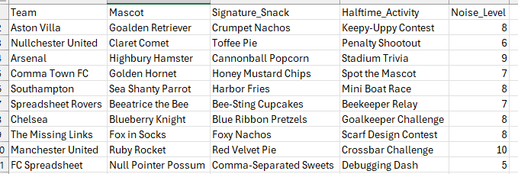
Player Data
