MAT 336 Information Systems Name ____________________

SOLUTIONS Midterm Exam Part 1: Written Portion (50 points)
- You may use 1 cheat sheet that is an 8.5” x 11” sheet of paper with notes on one-side only, hand-written or typed by you, no copying and pasting from others.
- You may not use a computer nor any other materials.
- No collaboration with anyone is allowed.

The following shows the first several rows of a pandas data frame on TED talks stored in the variable df. (Note its index has been cropped out.)
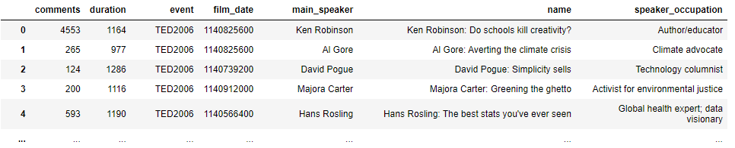
Select the best answer for each question. (2 points each)
- Which pandas command would return the name column?
A. df["name"]
B. df.name()
C. df.loc["name"]
D. df.iloc["name"]
- Without making any assumptions about the dataframe's index values, which pandas command would return the 2nd and 3rd rows of the dataframe?
A. df.iloc[2:3]
B. df.iloc[1:3]
C. df.loc[1:3]
D. df.iloc[[2,3]]
- Which pandas command would return the value of duration for the TED talk "David Pogue: Simplicity sells"?
A. df["duration"]
B. df.loc[df["main_speaker"]=="David Pogue"]["duration"]
C. df.loc[df["duration"]=="David Pogue", "name"]
D. df.iloc[3,1]
- Which pandas command would return the total number of talks in the dataframe?
A. len(df.rows)
B. len(df)
C. df.count()
D. len(df.columns)
- Which pandas command would return the number of different speaker occupations in the dataframe?
A. len(df[speaker_occupation].count())
B. df["speaker_occupation"].unique()
C. len(df["speaker_occupation"].unique())
D. len(df["speaker_occupation"])
- The full dataframe contains records corresponding to many different events (e.g., TED2006, TED2007, etc.). Which pandas code would calculate the total number of comments for each event?
A. event_groups = df.groupby("event")
event_groups[‘comments’].sum()
B. comments_by_event = df.groupby("comments")["event"]
comments_by_event.sum()
C. comments_by_event = df["comments"]
comments_by_event.sum()
D. event_groups = df.groupby("event")
event_groups[‘comments’].count()

The next multiple-choice questions do not pertain to the TED data set from the previous question. (2 points each)
- Which of the following deletes the column “times” from the data frame “df”:
- df.delete(“times”,axis=1,inplace = True)
- df.pop(“times”, axis=1,inplace=True)
- df.remove(“times”, axis=1,inplace = True)
- df.drop("times", axis=1, inplace = True)

- Primary keys:
  - can be foreign keys in other tables
  - ensure records in a table have no NULL values
  - always consist of one field
  - must be unique to the table, i.e. a key field in one table cannot be a field in another table

Free Response
Venue | Date | Performer | Weekend
Ballroom | 10/3/26 | Wendy K | True
Ballroom | 10/4/26 | The Warlocks | True
Oasis Room | 10/8/26 | Wendy K | False
Ballroom | 10/9/26 | JEV | False
Oasis Room | 10/9/26 | The Warlocks | False
- (11 points) Consider the following database table:

- Which normal form does this table violate?

2NF

- Why does it violate that normal form?

The non-key column Weekend is not fully dependent on the primary key, which is a compound primary key of Venue---Date. It only depends on part of it (Date).

- What correction can you make without losing data to remove the violation of that normal form?
Break this table up into two new tables:
venue/date/performer
and
date/weekend

- (17 points) A parks and recreation database (based on Case 2 from the textbook) contains the following tables:

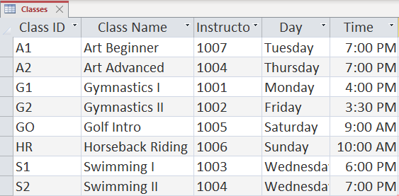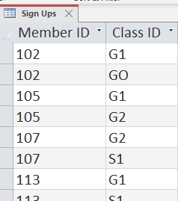
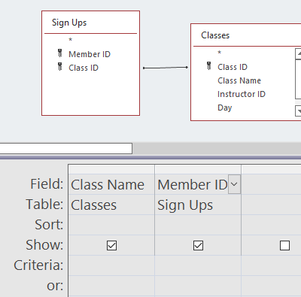
The next 3 questions refer to the query at right.
- What does the arrow between the boxes signify?

Those tables are linked by those fields. Also, those tables are joined by those fields in the query.

- What fields will be displayed in the output?

Class Name
Member ID

- Write out a few of the records that would appear in the query results (assume an inner join).
Gymnastics I 102
Gymnastics I 105
Gymnastics I 113
Gymnastics II 105
…
Answers may vary

- Write a SQL query that returns a list of classes that run on Tuesday or Thursday. Display columns for class name, day and time.

SELECT [Class Name], Day, Time
FROM Classes
WHERE Day = ‘Tuesday’ OR Day = ‘Thursday’;
- (6 points) Below are two tables from a database.
products prices
product_id | product_name
1 | Computer
2 | Printer
3 | Tablet
4 | Desk
5 | Chair
product_id | product_price
1 | 800
2 | 200
3 | 300
6 | 450
7 | 150

What is the output of the following query:

SELECT prices.product_id, product_name, product_price
FROM products
RIGHT JOIN prices
ON products.product_id = prices.product_id;

product_id product_name product_price
1 computer 800
2 printer 200
3 table 300
6 450
7 150

