VBA FORMS

Controls
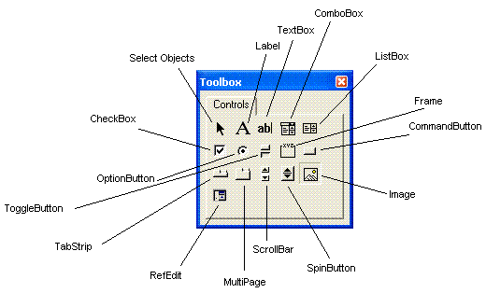Some important controls:
- CommandButton – click to run things
- Label – for information about items and output
- TextBox – for input
- ListBox, ComboBox – choose from item list
- Checkbox – check all items that apply
- OptionButton (radio button) – push to select just one of several items
- Frame – group of related controls, required around OptionButtons (it groups the option buttons so the user can only select one)
To add a control to a user form, drag/drop onto the user form

VBA Form Control Naming Conventions

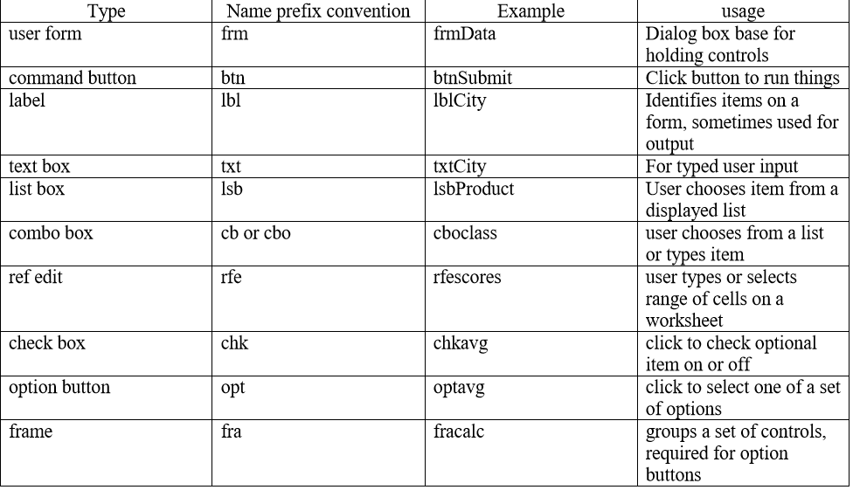

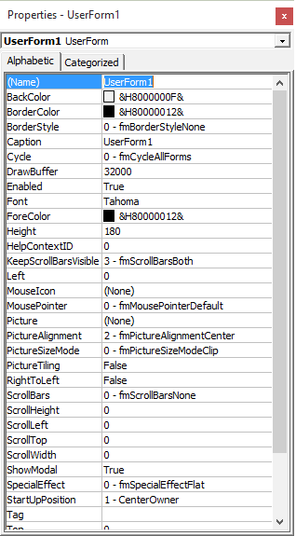
Properties Window

