Information Systems – Fall 2026
HW 3: Web Scraping (25 points)
Due: at the beginning of class on Tu Sep 15, 2026

Objectives:
- Review previously covered web scraping techniques and learn new ones by following a tutorial and by web scraping a music web site.
Submission:
- Submit 2 Jupyter notebooks (1 per part) to the Canvas assignment page by the due date and time
  - The notebooks must have all the cells executed (with output shown) and answers in markdown to any questions posed.
Collaboration:
You may collaborate on this assignment with students currently enrolled in this course. You may use code presented in class or posted on the class website as examples. You may use the Internet as a resource for code documentation and ideas. Direct copying from the Internet (or anyone) is never allowed, and you must be able to cite and explain any code you have incorporated within your own program. If in doubt, ask your instructor.
Grading:
In addition to correctness of your answers, you will be graded on completeness and organization of your notebook. Your code should be well-commented and include markdown cells to indicate what you are doing.

Part I – Web scraping tutorial including weather data web scraping
All instructions for this part are in the file “HW_3_Part_1_Blank.ipynb”.
You will:
- fill that file up with your work,
- change the file name to “HW_3_Part_1_LastName.ipynb”, and
- submit that Jupyter notebook as your response to Part I.
To properly view “HW_3_Part_1_Blank.ipynb” be sure to also download the file “weather2.png” and place it in the same folder or else refer to the graphic below:
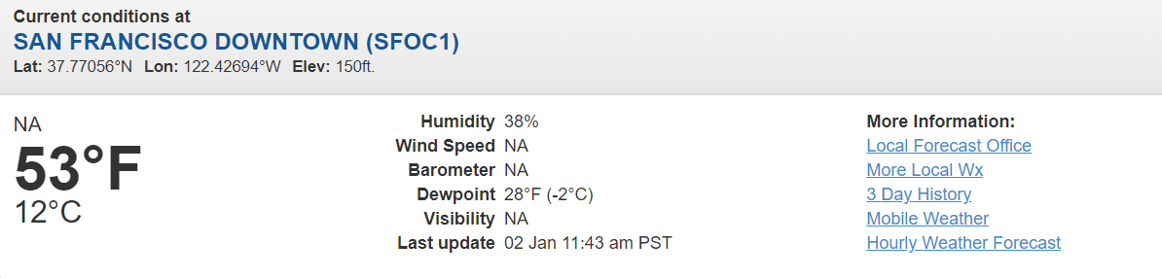

Part II – Billboard Music Web Scraping
All instructions for this part will be in the file “HW3_Part2_Blank.ipynb”.
You will:
- fill that file up with your work,
- change the file name to “HW3_Part2_LastName.ipynb”, and
- submit that Jupyter notebook as your response to Part 2.

