E5 Architecture: Horizon-Conditioned VAR-LiNGAM-PEM Graph with A3T-GCN
As of 2026-11-04. This document explains E5 only: every component, its equations, its inputs and outputs, and how the parts connect.

1. E5 in one page
E5 forecasts traffic flow with an unchanged A3T-GCN. The only thing that differs from the other experiments is the graph given to A3T-GCN. For E5, that graph is built from training data in four steps:
- A topology-aware VAR learns how each sensor's recent past predicts every other sensor.
- DirectLiNGAM estimates same-time-step causal effects between sensors (B0).
- PEM estimates how reliable each possible edge is (P).
- The VAR is turned into impulse responses at the forecast horizon h, corrected by P ⊙ B0, and each sensor keeps its 25 strongest sources.
This gives one graph per horizon (h = 1, 3, 6, 12, meaning 5, 15, 30 and 60 minutes). One A3T-GCN is trained per horizon, each with its own graph. The graphs are built once, offline, and never change during training: only A3T-GCN learns.

1.1 Notation
Symbol | Meaning | Shape
N | Number of sensors after the duplicate filter | 2,056
T | Training rows (5-minute steps) | 84,096
X | Training traffic flow, observed values only | T × N
R | Road adjacency among the kept sensors; R[i,j] ≠ 0 lets sensor j predict sensor i | N × N
p | VAR lag order | 3
A_{k} | VAR coefficients at lag k; A_{k}[i,j] = effect of sensor j at time t−k on sensor i | 3 × N × N
E | VAR residuals | T × N
B0 | Same-time causal effects from DirectLiNGAM | N × N
P | PEM edge-inclusion probability, symmetric, 0 to 1 | N × N
Ψ_{h}, Θ_{h} | Reduced-form and structural impulse responses at horizon h | N × N
G_{h} | Graph handed to A3T-GCN for horizon h | N × N

Every matrix is stored as [target, source]: entry [i,j] ≠ 0 means sensor j → sensor i.
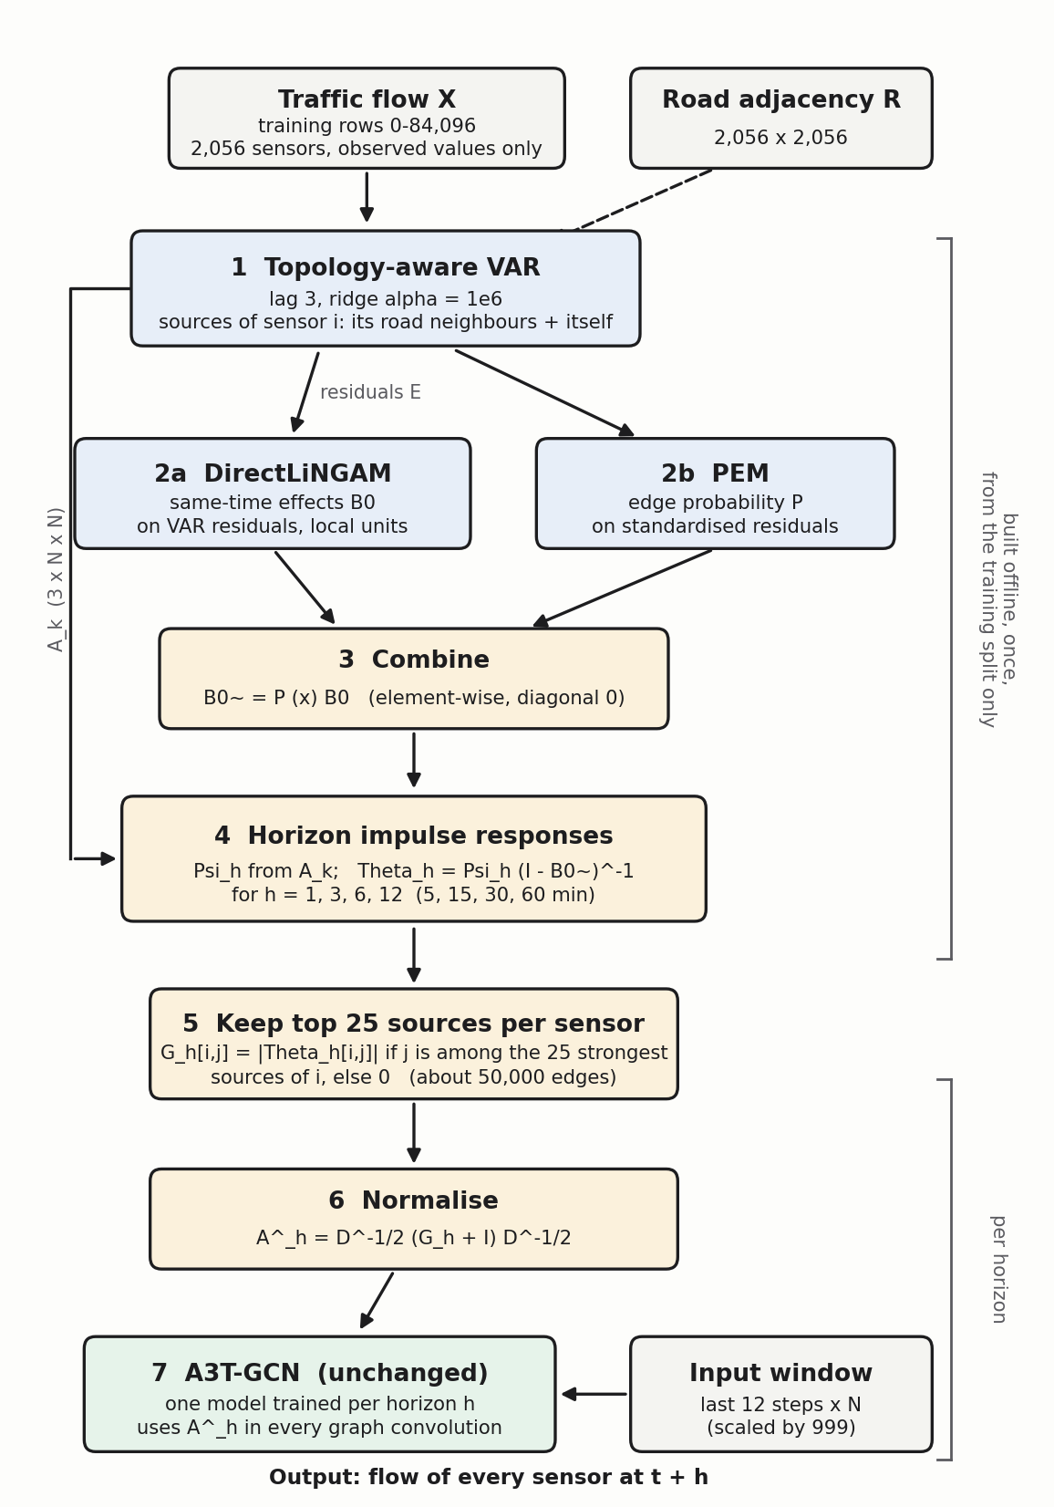
Figure 1. E5 block diagram: how the graph is built (blue and yellow) and used by A3T-GCN (green).

2. Component 1: data
What it does. Supplies the traffic flow and road network that every later step uses.
- Input: gba_his_raw_2021.h5 (105,120 × 2,352 flow values) and gba_rn_adj.npy (2,352 × 2,352 road matrix).
- Processing: chronological split (train 0–84,096, validation 84,096–94,608, test 94,608–105,120); duplicate sensors removed using training data only (296 sensors, leaving 2,056).
- Output: X (T × N) and R (N × N).
- Rule: the causal steps (VAR, LiNGAM, PEM) see only observed values and only training rows. Filled values are used only as A3T-GCN inputs.

3. Component 2: topology-aware VAR
What it does. Learns, for each sensor i, how the past of itself and of its road neighbours predicts its present flow. The road network restricts the candidate sources; it does not decide the weights.
xᵢ(t) = Σ_{k=1}³ Σ_{j ∈ 𝒩(i)} A_{k}[i,j] · xⱼ(t−k) + eᵢ(t)
𝒩(i) = { j : R[i,j] ≠ 0 } ∪ { i }
Each sensor is fitted separately with ridge regression:
β̂ᵢ = (Zᵢᵀ Zᵢ + α I)⁻¹ Zᵢᵀ yᵢ , α = 10⁶
Here yᵢ holds sensor i's flow, and the columns of Zᵢ hold the lagged flows of its allowed sources at lags 1, 2, 3. A row is used only when all values it needs were observed. The residual is the part the VAR cannot explain:
eᵢ(t) = xᵢ(t) − x̂ᵢ(t)
Item | Detail
Input | X (T × N) and R (N × N)
Output | A_{k} (3 × N × N) and residuals E (T × N, missing where not estimable)
Settings | lag 3, ridge α = 10⁶ (chosen on validation: grid over lag and α, best validation RMSE 26.45)
Saved as | coefficients.npy, residuals.npy, metadata.json under outputs/var_train/lag3_alpha1e+06/

E1 uses A_{k} alone. Its graph is W[i,j] = Σ_{k} |A_{k}[i,j]|. E5 starts from the same A_{k}.

4. Component 3: local units
DirectLiNGAM and PEM cannot run on all 2,056 residual columns at once, so both run on one small unit per sensor:
Uᵢ = { i } ∪ N_{in}(i) ∪ N_{out}(i)
Road units have on average about 32 sensors and at most 91. The road network is used only to choose which sensors are tested together; it does not set direction. Results from the units are merged into global N × N matrices (rules in sections 5 and 6).

5. Component 4: DirectLiNGAM → B0
What it does. Finds same-time-step causal effects between sensors. After the VAR, whatever is left in sensor i's residual at time t may still depend on its neighbours' residuals at the same time. LiNGAM models that:
e(t) = B0 · e(t) + n(t)
Here n(t) contains independent, non-Gaussian noise terms. If B0 can be ordered so that every sensor depends only on earlier ones (no loops), it can be identified from the data. DirectLiNGAM does this in two steps:
- Find a causal order: repeatedly pick the variable that is most independent of its regression residuals, treat it as the earliest, remove its effect from the others, and continue.
- Regress each variable on those that come earlier in the order (a sparse regression) to read off B0[i,j].
Item | Detail
Input | VAR residuals of each unit's sensors; complete rows only; up to 10,000 rows per unit
Merge rule | Row i of B0 (the effects into sensor i) comes from sensor i's own unit; entries for sources outside that unit are 0
Output | B0 (N × N, [target, source])
Settings | LINGAM_MAX_ROWS = 10,000; DirectLiNGAM defaults; seed 42
Saved as | lingam_result.npz under outputs/lingam/

Limits to keep in mind. LiNGAM assumes no feedback loops, but 98% of sensors lie on directed cycles of the road graph. A split-half check (the two halves of the training period) found B0 unstable: median support overlap 0.31 and sign agreement 0.86, below the required 0.80 and 0.95.

6. Component 5: PEM → P
What it does. Scores how reliable each pair relationship is. PEM estimates a precision matrix Ω (the inverse covariance) of the standardised residuals of a unit; a non-zero off-diagonal entry ω_jk means sensors j and k are directly dependent after accounting for the others.
Each off-diagonal entry gets a spike-and-slab prior: a narrow Laplace spike (no edge) mixed with a wide Laplace slab (edge), with prior edge probability η:
p(ω_{jk}) = (1 − η) · Lap(ω_{jk}; ν0) + η · Lap(ω_{jk}; ν1) , Lap(ω; ν) = (1 / 2ν) · e^{−|ω| / ν}
The estimate is the MAP solution (solved with L-BFGS-B, keeping Ω positive definite):
Ω̂ = argmin_{Ω ≻ 0} (n/2) [ tr(SΩ) − log det Ω ] + τ · tr(Ω) − Σ_{j<k} log p(ω_{jk})
where S is the sample covariance and n the number of rows. The posterior probability that an entry belongs to the slab is the inclusion probability:
P_{jk} = η · Lap(ω̂_{jk}; ν1) / [ η · Lap(ω̂_{jk}; ν1) + (1 − η) · Lap(ω̂_{jk}; ν0) ]
Item | Detail
Input | Standardised VAR residuals of each unit (per-sensor training mean and standard deviation); complete rows
Merge rule | P[j,k] is the maximum over all units that contain both sensors. PEM also gives directed edges D (combined by OR); E5 does not use D
Output | P (N × N, symmetric, values 0 to 1)
Settings | ν0 = 0.0017, ν1 = 1, τ = 0.01, η = 0.5 (uniform), threshold 0.5, L-BFGS-B
Saved as | pem_result.npz under outputs/pem/

Behaviour in practice. P is almost on/off: about 85% of its non-zero values are above 0.99.

7. Component 6: horizon conditioning
What it does. Turns the VAR and the corrected same-time effects into one effect matrix per forecast horizon h.
Step 1: combine B0 with P. PEM's probability scales each same-time effect, with self-links removed:
B̃0 = P ⊙ B0 , diag(B̃0) = 0
Step 2: reduced-form impulse responses. How much a one-unit change in sensor j at time t reaches sensor i after s steps, using only the VAR:
Ψ₀ = I , Ψ_{s} = Σ_{k=1}^{min(s,3)} A_{k} · Ψ_{s−k}
Step 3: structural impulse responses. The same-time effects are added on top:
Θ_{h} = Ψ_{h} · (I − B̃0)⁻¹
Θ_{h}[i,j] is the response of sensor i, h steps (5·h minutes) after a shock to sensor j. The effect matrix is its absolute value without the diagonal:
E_{h}[i,j] = |Θ_{h}[i,j]| , i ≠ j
For h = 1 this simplifies to Θ₁ = A₁ (I − B̃0)⁻¹.
Item | Detail
Input | A_{k} (from the VAR), B0 (LiNGAM), P (PEM), horizons 1, 3, 6, 12
Output | E_{h}, one dense N × N effect matrix per horizon (dense because effects spread through the network)
Code | causal/horizon.py (impulse responses), build_graph.py (combination)

8. Component 7: sparsification and normalisation
Top-25 sources. E_{h} is dense, so each target keeps only its strongest sources. The value 25 matches the average number of sources per sensor in the road graph, so the density is comparable:
G_{h}[i,j] = E_{h}[i,j] if j is among the 25 largest of E_{h}[i, ·] , otherwise 0
At h = 1 this leaves 50,555 edges. Each target has up to 25 incoming sources; ties go to the lower sensor index.
Normalisation. Inside A3T-GCN the graph is converted to a propagation matrix:
Â_{h} = D^{−1/2} (G_{h} + I) D^{−1/2} , D_{jj} = 1 + Σ_{i} G_{h}[i,j]
Â_{h}[i,j] weights how much sensor i takes from sensor j when it aggregates. The identity I adds each sensor's own signal. The diagonal Â_{h}[i,i] = 1 / D_ii is the share of own signal. Because D_jj grows with how strongly sensor j feeds others, a sensor with large outgoing weight keeps a smaller own-signal share.
Item | Detail
Input | E_{h} (N × N)
Output | G_{h} (N × N, [target, source]) and the normalised matrix Â_{h}
Saved as | E5__h{h}__lag3_alpha1e+06__rows10000__…_std.npz, one file per horizon

9. Component 8: A3T-GCN (unchanged)
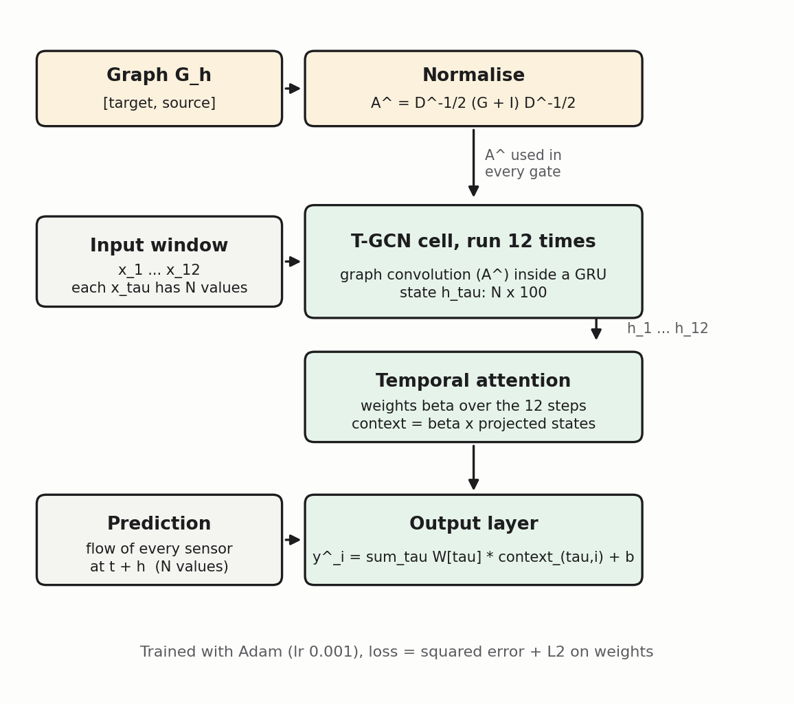
Figure 2. A3T-GCN: the graph enters only through the normalised matrix used inside the T-GCN cell.
Input. The last 12 steps x₁ … x₁₂ of all sensors (each a vector of N values), scaled by the training maximum 999. Target. The flow at t + h. A separate model with its own G_{h} is trained for h = 1, 6 and 12.
T-GCN cell (applied at every step τ = 1 … 12, hidden state h_{τ} of size N × 100). A graph convolution mixes each sensor's features with those of its sources, then a GRU updates the state:
[r_{τ}, u_{τ}] = σ( Â · [x_{τ}, h_{τ−1}] · W_{g} + b_{g} )
c_{τ} = tanh( Â · [x_{τ}, r_{τ} ⊙ h_{τ−1}] · W_{c} + b_{c} )
h_{τ} = u_{τ} ⊙ h_{τ−1} + (1 − u_{τ}) ⊙ c_{τ}
Here [x, h] joins the sensor's flow with its 100 hidden values (101 features), r and u are the reset and update gates, and σ is the sigmoid. The graph appears only as Â.
Temporal attention. The 12 hidden states are projected to one value per sensor, z_{τ} = h_{τ} w1 + b1. A scalar score is computed for each step and turned into weights over time:
a_{τ} = z_{τ} · w2 + b2 , s_{τ} = a_{τ}² , β = softmax_{τ}(s) , context_{τ} = β_{τ} · z_{τ}
Output layer. For each sensor i, the prediction is a learned weighted sum over the 12 steps:
ŷᵢ = Σ_{τ=1}¹² W_{out}[τ] · context_{τ,i} + b_{out}
Loss and training.
L = ½ Σ (ŷ − y)² + λ Σ_{w} ½ ‖w‖² , λ = 0.0015
Adam, learning rate 0.001, halved after 5 epochs without validation improvement (minimum 1e-5), gradient clipping at norm 5, batch size 8, 20 epochs, best validation epoch kept.
Item | Detail
Input | Window (12 × N) and Â_{h}
Output | Forecast of all N sensors at t + h, converted back to vehicles per 5 minutes
Trained parameters | Gate and candidate weights (W_{g}, W_{c}, b_{g}, b_{c}), attention (w1, w2, b1, b2) and output layer (W_{out}, b_{out}). The graph is not trained

10. Summary of inputs and outputs
Stage | Input | Output | Shape
1 Data | flow file, road matrix | X, R | T × N, N × N
2 VAR | X, R | A_{k}, E | 3 × N × N, T × N
3 DirectLiNGAM | E, local units | B0 | N × N
4 PEM | standardised E, local units | P | N × N
5 Horizon conditioning | A_{k}, B0, P | E_{h} for h = 1, 3, 6, 12 | N × N each
6 Top-25 and normalise | E_{h} | G_{h}, Â_{h} | N × N each
7 A3T-GCN | window, Â_{h} | forecast at t + h | N

11. Where LiNGAM and PEM act in E5
Both enter only through B̃0 = P ⊙ B0 inside (I − B̃0)⁻¹ in Θ_{h}. They never remove VAR edges. They rescale the VAR's impulse responses, which changes which sources land in each sensor's top 25. If B̃0 were zero, Θ_{h} = Ψ_{h} and E5 would be a horizon graph built from the VAR alone. This is why the choice of PEM prior changed the final graph by only 0.025% of its weight in E7.

12. Results so far (seed 42, test RMSE in vehicles per 5 minutes)
Horizon | E5 | E1 (VAR only) | NOGRAPH | HA
5 min (h = 1) | 28.17 | 28.10 | 27.58 | 54.92
30 min (h = 6) | 39.98 | 37.47 | 39.46 | 54.91
60 min (h = 12) | 48.97 | 47.41 | 43.87 | 54.89

E5 at seed 7 and 5 minutes gave 27.40. The 15-minute graph (h = 3) is built but no model has been trained on it yet.

