Horizon-Conditioned Probabilistic VAR-LiNGAM Causal Graph for Traffic Forecasting
Ablation study: architecture, results and inferences
Student: Sanjay Muraleedharan
Guide: Dr. B. A. Sabarish

Contents
1. Introduction 3
1.1 Problem and goal 3
1.2 Dataset and experimental setup 3
1.3 Metrics and statistical tests 3
2. Architecture 4
2.1 Framework block diagram 4
2.2 Forecasting model: A3T-GCN 5
2.3 Ablation map 5
3. Results of each experiment 6
3.1 Baseline: Historical Average (HA) 6
3.2 NOGRAPH: A3T-GCN without a graph 6
3.3 E0: A3T-GCN with the road-network graph 7
3.4 E1: VAR-learned graph 8
3.5 E2: VAR-LiNGAM graph 9
3.6 E3a: VAR + PEM, original form (P x D) 10
3.7 E3b: VAR weights on PEM edges (amended E3) 11
3.8 E4: VAR-LiNGAM + PEM 12
3.9 E5: horizon-specific causal graph at 5 min (full framework) 13
3.10 E5 at longer horizons (15, 30, 60 min) 14
3.11 E6: data-driven candidate links 15
3.12 E7: road prior in PEM 16
4. Comparison of all experiments 18
4.1 Summary table 18
4.2 Accuracy at 5 minutes 18
4.3 Error vs forecast horizon 19
4.4 Effect of the random seed 20
4.5 Own-signal share explains the extremes 20
4.6 Statistical significance 21
4.7 Error by time of day 22
4.8 Where on the network the VAR graph helps 23
4.9 Training stability 23
5. Conclusions 25
6. Limitations 25
7. Pending work 25

(Right-click the contents and choose Update Field if it is empty.)

1. Introduction

1.1 Problem and goal
Traffic forecasting predicts the flow at every road sensor a few minutes to an hour ahead. Graph neural networks such as A3T-GCN mix each sensor's history with that of its neighbours through a graph. The usual graph is the road network: two sensors are linked when they are close on the road.
This project asks whether a graph learned from the data with causal-discovery methods gives better forecasts than the road graph. The causal graph is built in steps (VAR, then VAR-LiNGAM, then PEM edge probabilities, then horizon-specific impulse responses). The ablation study adds one step at a time and keeps the forecasting model (A3T-GCN) unchanged, so any change in accuracy comes from the graph.

1.2 Dataset and experimental setup
Table 1. Setup shared by every experiment.
Item | Value
Dataset | LargeST-GBA 2021 (Greater Bay Area), traffic flow every 5 minutes, 105,120 time steps
Sensors | 2,352 in the file; 296 removed as copies of other sensors (same value on at least 90% of training rows, or correlation at least 0.999); 2,056 used
Split | Chronological: train 80%, validation 10%, test 10%
Missing values | Inputs: gaps filled by gap length (training data only). Targets: must be originally observed, never filled
Input / output | 12 past steps (1 hour) -> flow h steps ahead; h = 1, 3, 6, 12 (5, 15, 30, 60 min)
Model | A3T-GCN, 100 GRU units, unchanged for every experiment
Training | 20 epochs, batch 8, learning rate 0.001 (halved after 5 epochs without improvement), gradient clipping 5, L2 0.0015
Checkpoint | Epoch with the lowest validation RMSE
Seeds | 42 for every experiment; 7 for E0, E1, E5 at 5 min
Hardware | Kaggle T4 GPU (training); laptop CPU (VAR, LiNGAM, PEM, graphs)

1.3 Metrics and statistical tests
- RMSE and MAE in vehicles per 5 minutes, over all test sensors and windows. Masked MAPE only counts targets with flow of at least 10.
- % sensors better: share of the 2,056 sensors whose test MAE is lower for the first model of a pair. Wilcoxon signed-rank test on the per-sensor MAE.
- Diebold-Mariano (DM) test: compares the two models' MAE at each test time step (Newey-West lag 17). p < 0.05 means the difference is unlikely to be chance.
- Test windows: a window counts only if its target is observed at all 2,056 sensors, so 5,183 of 10,500 test windows are scored at 5 min (5,178 at 30 min, 5,172 at 60 min). Every model is scored on exactly the same targets.

2. Architecture

2.1 Framework block diagram
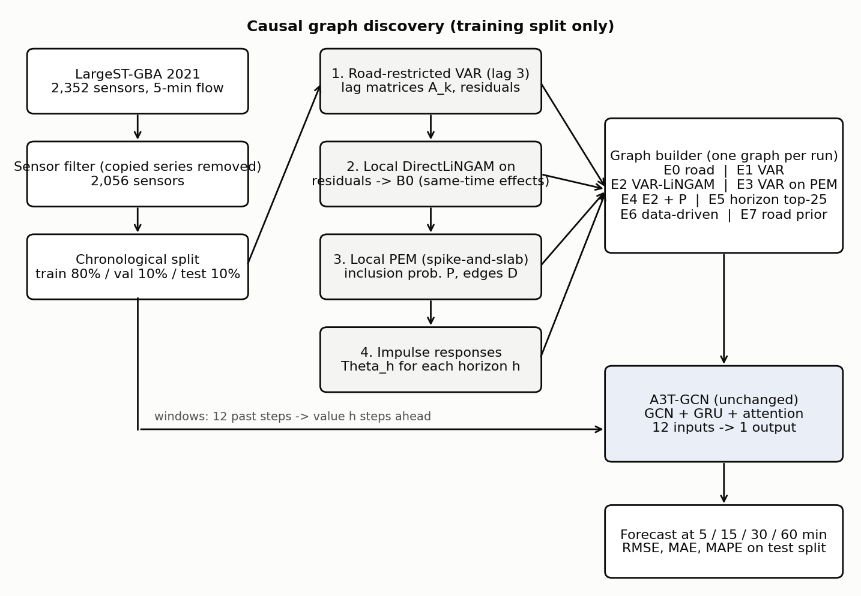
Figure 1. Proposed framework. Causal discovery runs on the training split only; the graph builder makes one graph per experiment; A3T-GCN is unchanged.
- Step 1, VAR: a ridge vector autoregression (lag 3, alpha 1e6) where each sensor is predicted from its own past and its road neighbours' past. It gives lag matrices A_1, A_2, A_3 and residuals.
- Step 2, VAR-LiNGAM: DirectLiNGAM on the VAR residuals (local units: a sensor and its road neighbours) gives B0, the same-time causal effects. Lagged structural effects are B_k = (I - B0) A_k.
- Step 3, PEM: a spike-and-slab model gives each candidate edge an inclusion probability P and a directed edge set D.
- Step 4, horizon conditioning: the structural impulse responses Theta_h measure the effect of each sensor on every other sensor h steps later; E5 keeps the 25 strongest sources per sensor for each horizon.

2.2 Forecasting model: A3T-GCN
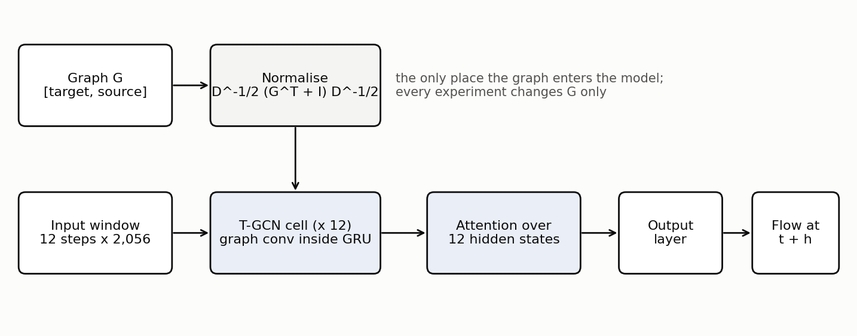
Figure 2. A3T-GCN. The graph enters only through the normalised operator used by the graph convolution inside the GRU.
The graph G is stored as G[target, source] and transposed once before normalisation, so each sensor reads from its sources. After normalisation, each sensor's own value keeps a weight (its own-signal share) and the rest goes to its neighbours. This share is used in Section 4 to explain the results.

2.3 Ablation map
Table 2. Experiments of the ablation study. Each experiment changes only the graph.
ID | Graph | Question it answers | Status
HA | No model: average of training values per weekday, 5-min slot and sensor | Lower bound every model must beat | Done (5, 30, 60 min)
NOGRAPH | A3T-GCN with an empty graph (each sensor sees only itself) | Does any graph help? | 5 min done; 30/60 min and seed 7 pending
E0 | Road network (original A3T-GCN) | Baseline graph | 5 min (2 seeds), 60 min done; 30 min pending
E1 | VAR: sum over lags of |A_k| | Do learned weights beat road weights? | 5 min (2 seeds), 30, 60 min done
E2 | VAR-LiNGAM: sum |B_k| + |B0| | Do same-time causal effects help? | 5 min done
E3 | E3a: P x D (original); E3b: VAR weights on PEM edges (amended) | Does PEM edge selection help? | Both done (5 min)
E4 | VAR-LiNGAM + PEM: sum |B_k| + P x |B0| | Does PEM weighting of B0 help? | Graph built; not trained (almost equal to E2)
E5 | Top-25 sources from impulse responses, one graph per horizon (full framework) | Do horizon-specific graphs help? | 5 min (2 seeds), 30, 60 min done
E6 | E4 on data-driven candidate links (top-25 correlated sensors) | Does the road restriction limit discovery? | Pending
E7 | E4 with a road prior in PEM (0.7 on road links, 0.3 elsewhere) | Does a road prior help PEM? | Pending

3. Results of each experiment

3.1 Baseline: Historical Average (HA)
What this experiment changes
No learning. The forecast for a sensor is the average of its training values at the same weekday and 5-minute slot. It does not use the last hour of data, so its error is the same at every horizon.
Block diagram: models used
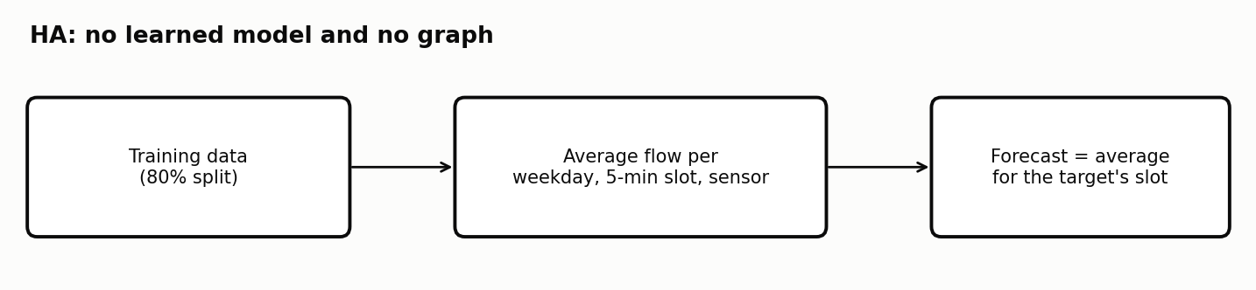
Figure 3. Steps of the HA baseline.
Graph facts
- No graph.
Results
Table 3. Baseline results (test split).
Run | Test RMSE | Test MAE | Masked MAPE (%) | Best epoch
HA, 5 min | 54.92 | 33.24 | 19.90 | -
HA, 15 min | [paste: results/HA_h3] | [paste] | [paste] | -
HA, 30 min | 54.91 | 33.23 | 19.90 | -
HA, 60 min | 54.89 | 33.21 | 19.91 | -
Inference
- Every trained model beats HA clearly at 5 and 30 min (about half the RMSE at 5 min).
- At 60 min HA is a strong baseline: only E1 has a significantly lower MAE (DM p = 0.016); E0 and E5 tie with it on MAE.
- HA is better than the models at night at 60 min because a one-hour input window cannot see the weekly pattern HA uses.

3.2 NOGRAPH: A3T-GCN without a graph
What this experiment changes
The graph is empty (A = 0), so the normalised operator is the identity. Each sensor uses only its own history; all sensors share the same GRU and attention weights.
Block diagram: models used
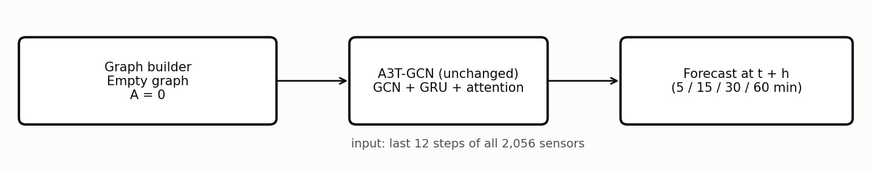
Figure 4. Models used in NOGRAPH. Solid boxes are used; dashed grey boxes are not used.
Graph facts
- 0 edges; own-signal share 100%.
Results
Table 4. NOGRAPH results (test split).
Run | Test RMSE | Test MAE | Masked MAPE (%) | Best epoch
NOGRAPH, 5 min, seed 42 | 27.58 | 16.87 | 11.19 | 20
NOGRAPH, 5 min, seed 7 | [paste: output_NOGRAPH_final_seed7] | [paste] | [paste] | [paste]
NOGRAPH, 30 min, seed 42 | [paste: output_NOGRAPH_h6_final] | [paste] | [paste] | [paste]
NOGRAPH, 60 min, seed 42 | [paste: output_NOGRAPH_h12_final] | [paste] | [paste] | [paste]
Inference
- At 5 min (seed 42) NOGRAPH beats every graph model: it is better than E1 on 82% of sensors, E0 on 88% and E5 on 74% (DM p < 0.001 for all three).
- The gain is largest in daytime and at busy sensors (MAE 21.8 vs 24.4 for E1 at the busiest quarter of sensors). Five minutes ahead, a sensor's next value mostly depends on its own recent flow; mixing in neighbours adds noise.
- Caution: one seed, and its best epoch is the last one with a noisy validation curve. E1 at seed 7 (26.71) is lower than NOGRAPH at seed 42.
- [paste after the pending runs: whether NOGRAPH still wins at 30 and 60 min. If E1 wins there, graphs help only at longer horizons.]

3.3 E0: A3T-GCN with the road-network graph
What this experiment changes
The original A3T-GCN setting: the road adjacency of the dataset, including self-loops.
Block diagram: models used
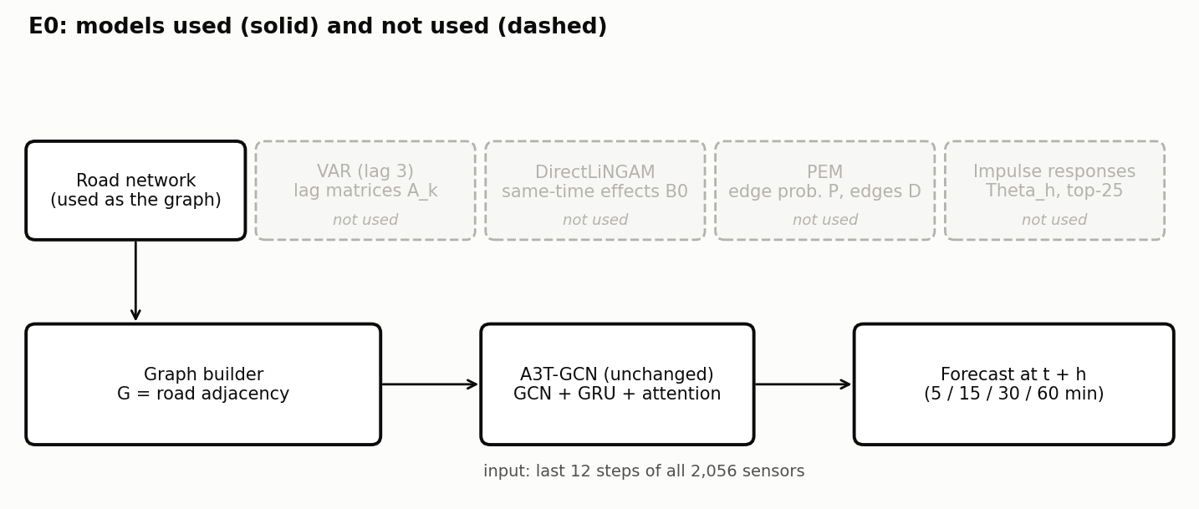
Figure 5. Models used in E0. Solid boxes are used; dashed grey boxes are not used.
Graph facts
- 51,686 directed edges between the 2,056 sensors, mean in-degree 25.1.
- Own-signal share 20% (median).
Results
Table 5. E0 results (test split).
Run | Test RMSE | Test MAE | Masked MAPE (%) | Best epoch
E0, 5 min, seed 42 | 29.76 | 19.34 | 11.89 | 15
E0, 5 min, seed 7 | 30.13 | 19.33 | 11.80 | 16
E0, 15 min, seed 42 | [paste: output_E0_h3_final] | [paste] | [paste] | [paste]
E0, 30 min, seed 42 | [paste: output_E0_h6_final] | [paste] | [paste] | [paste]
E0, 60 min, seed 42 | 49.87 | 33.19 | 20.41 | 15
Inference
- E0 is stable across seeds (29.76 vs 30.13), unlike E1 and E5.
- It is the weakest of the main graphs at every horizon tested: worse than E1 on both seeds and at 60 min, and worse than NOGRAPH at 5 min.
- At 60 min its MAE ties HA (DM p = 0.98).

3.4 E1: VAR-learned graph
What this experiment changes
G = |A_1| + |A_2| + |A_3| from the road-restricted VAR (lag 3, alpha 1e6), diagonal removed. Lag and alpha were chosen on validation one-step RMSE.
Block diagram: models used
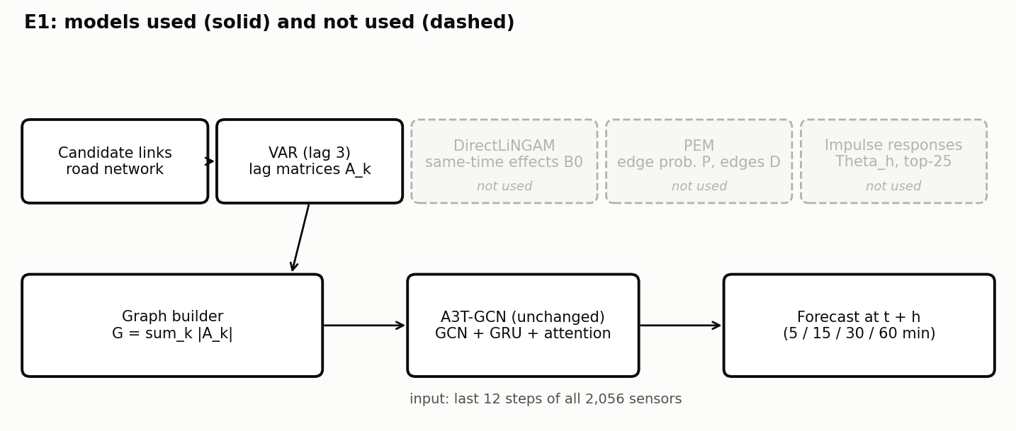
Figure 6. Models used in E1. Solid boxes are used; dashed grey boxes are not used.
Graph facts
- Same 51,686 edges as the road graph (the VAR is restricted to road neighbours); only the weights differ.
- Weight mean 0.075; own-signal share 39%.
Results
Table 6. E1 results (test split).
Run | Test RMSE | Test MAE | Masked MAPE (%) | Best epoch
E1, 5 min, seed 42 | 28.10 | 18.36 | 10.49 | 15
E1, 5 min, seed 7 | 26.71 | 16.90 | 9.97 | 20
E1, 15 min, seed 42 | - | - | - | -
E1, 30 min, seed 42 | 37.47 | 23.58 | 13.90 | 20
E1, 60 min, seed 42 | 47.41 | 31.32 | 19.67 | 19
Inference
- E1 is the best graph at every horizon and on both seeds. It beats E0 on 59% (seed 42) and 93% (seed 7) of sensors at 5 min and on 70% at 60 min (DM p < 0.001).
- The edges are the same as the road graph, so the gain comes only from the learned weights: VAR weights describe how strongly one sensor's past predicts another's.
- E1 is the only model whose MAE beats HA at 60 min (DM p = 0.016).
- Seed effect is large: 28.10 (seed 42) vs 26.71 (seed 7).

3.5 E2: VAR-LiNGAM graph
What this experiment changes
G = sum over k of |B_k| + |B0|, with B_k = (I - B0) A_k and B0 from DirectLiNGAM on 10,000 rows of VAR residuals per local unit. Adds same-time (contemporaneous) causal effects.
Block diagram: models used
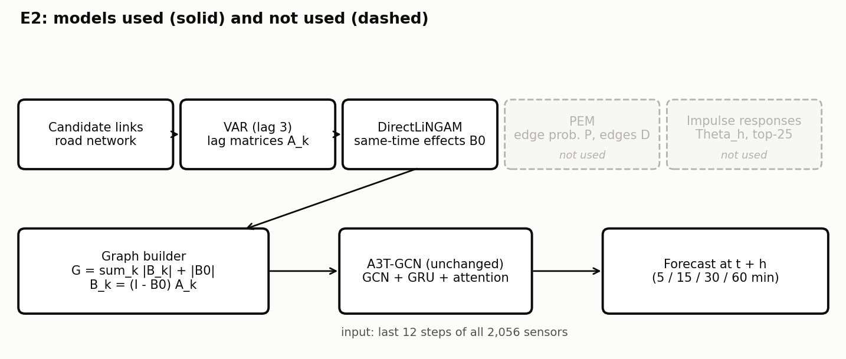
Figure 7. Models used in E2. Solid boxes are used; dashed grey boxes are not used.
Graph facts
- 101,685 edges (about twice E1), mean in-degree 49, maximum 160.
- Own-signal share 24%.
- B0 is unstable across the two halves of the training data (split-half Jaccard 0.31).
Results
Table 7. E2 results (test split).
Run | Test RMSE | Test MAE | Masked MAPE (%) | Best epoch
E2, 5 min, seed 42 | 32.38 | 21.88 | 12.83 | 14
Inference
- E2 is worse than both E0 and E1: E1 is better on 85% of sensors and E0 on 75% (DM p < 0.001).
- Adding B0 doubles the graph and lowers the own-signal share from 39% to 24%; each sensor's own signal is diluted by many weak, unstable links.
- Training was unstable (validation spikes at epochs 6, 8 and 15-19).

3.6 E3a: VAR + PEM, original form (P x D)
What this experiment changes
G = P x D: PEM inclusion probabilities on the PEM directed edges (the original design of E3).
Block diagram: models used
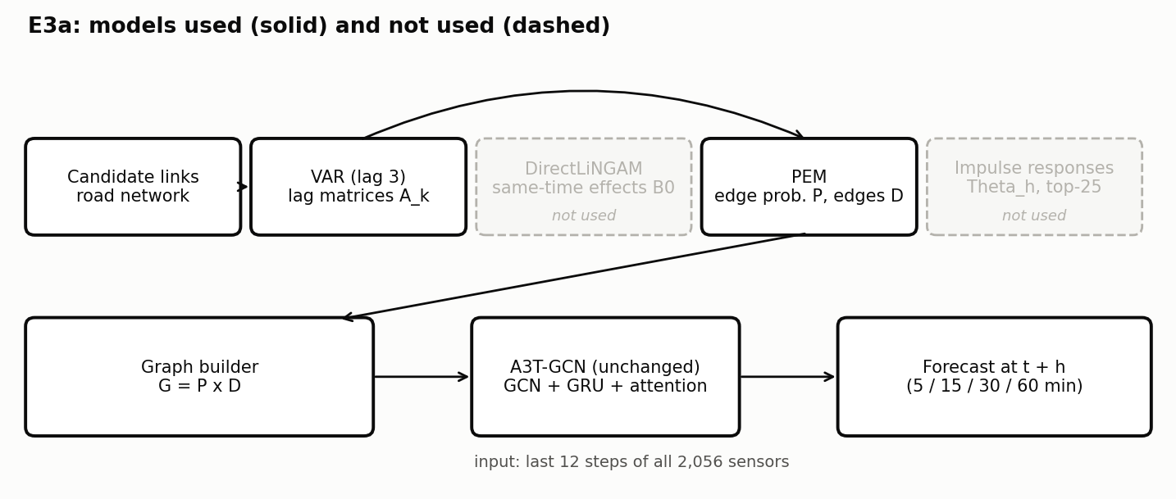
Figure 8. Models used in E3a. Solid boxes are used; dashed grey boxes are not used.
Graph facts
- 75,885 edges.
- P is almost binary: 85% of probabilities are above 0.99 and 87.5% of candidate links are kept, so the graph is effectively unweighted and dense.
- Own-signal share 3%.
Results
Table 8. E3a results (test split).
Run | Test RMSE | Test MAE | Masked MAPE (%) | Best epoch
E3a, 5 min, seed 42 | 57.17 | 39.66 | 26.60 | 18
Inference
- E3a is worse than HA. After normalisation each sensor keeps only 3% of its own signal, so the model cannot use a sensor's own history.
- PEM probabilities are not usable directly as edge weights. This led to the amended E3 (E3b), approved on 28 October 2026 and reported as a post-hoc change.

3.7 E3b: VAR weights on PEM edges (amended E3)
What this experiment changes
G = W x D: E1's VAR weights kept only where PEM keeps a directed edge. Tests PEM as an edge selector while keeping the weights of E1.
Block diagram: models used
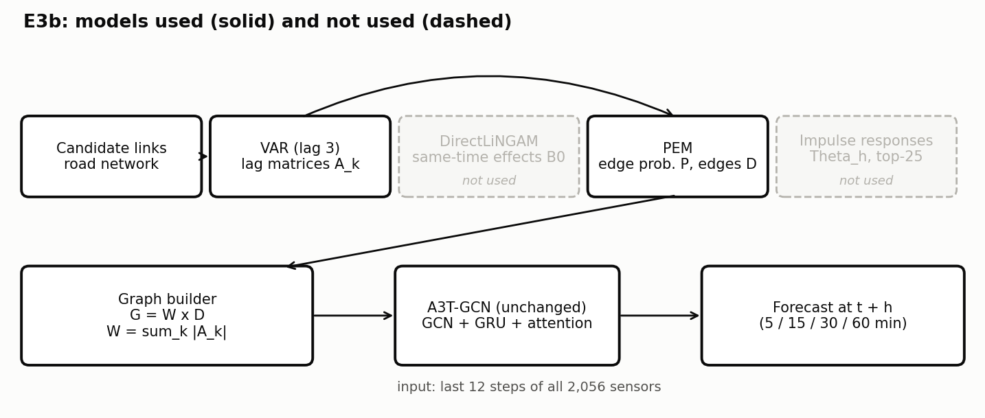
Figure 9. Models used in E3b. Solid boxes are used; dashed grey boxes are not used.
Graph facts
- 32,873 edges (64% of E1's).
- 44 sensors have no incoming edge.
- Own-signal share 50%.
Results
Table 9. E3b results (test split).
Run | Test RMSE | Test MAE | Masked MAPE (%) | Best epoch
E3b, 5 min, seed 42 | 28.30 | 19.62 | 15.89 | 7
Inference
- E3b is worse than E1 (E1 better on 84% of sensors, DM p = 1e-8) and ties E0 (DM p = 0.17).
- Removing a third of E1's edges with PEM does not help, even though the own-signal share rises to 50%.
- Validation was good up to epoch 7 and then collapsed; the high masked MAPE (15.9) shows larger errors at low flow.

3.8 E4: VAR-LiNGAM + PEM
What this experiment changes
G = sum over k of |B_k| + P x |B0|: PEM probabilities weight the same-time effects of E2.
Block diagram: models used
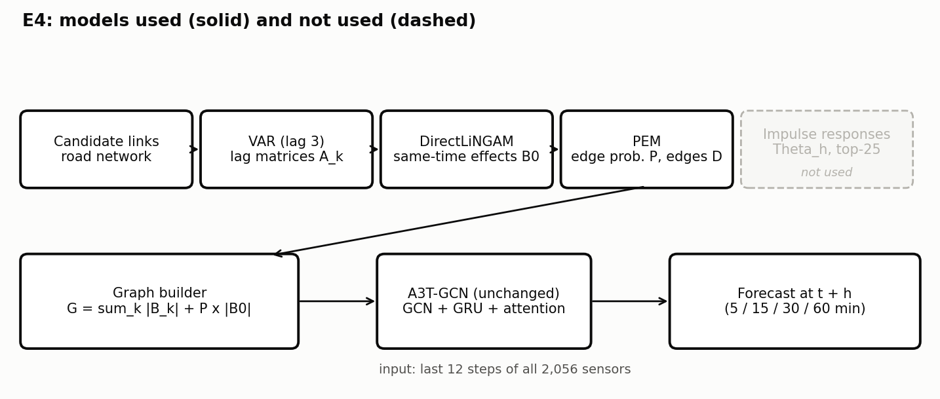
Figure 10. Models used in E4. Solid boxes are used; dashed grey boxes are not used.
Graph facts
- Graph built: 101,685 edges, own-signal share 24%.
- It differs from E2 in only 523 entries, because P is almost binary.
Results
Table 10. E4 results (test split).
Run | Test RMSE | Test MAE | Masked MAPE (%) | Best epoch
E4, 5 min, seed 42 | [paste if run: output_E4_final] | [paste] | [paste] | [paste]
Inference
- Not trained so far: the graph is almost identical to E2, so the result is expected to equal E2 (32.38).
- Recommendation: drop E4 and report the graph comparison instead. [paste the final decision here]

3.9 E5: horizon-specific causal graph at 5 min (full framework)
What this experiment changes
For each horizon h, the structural impulse responses Theta_h (from A_k, B0 and P) give the effect of every sensor on every other sensor h steps later. Each sensor keeps its 25 strongest sources (25 = mean road in-degree). One graph and one model per horizon.
Block diagram: models used
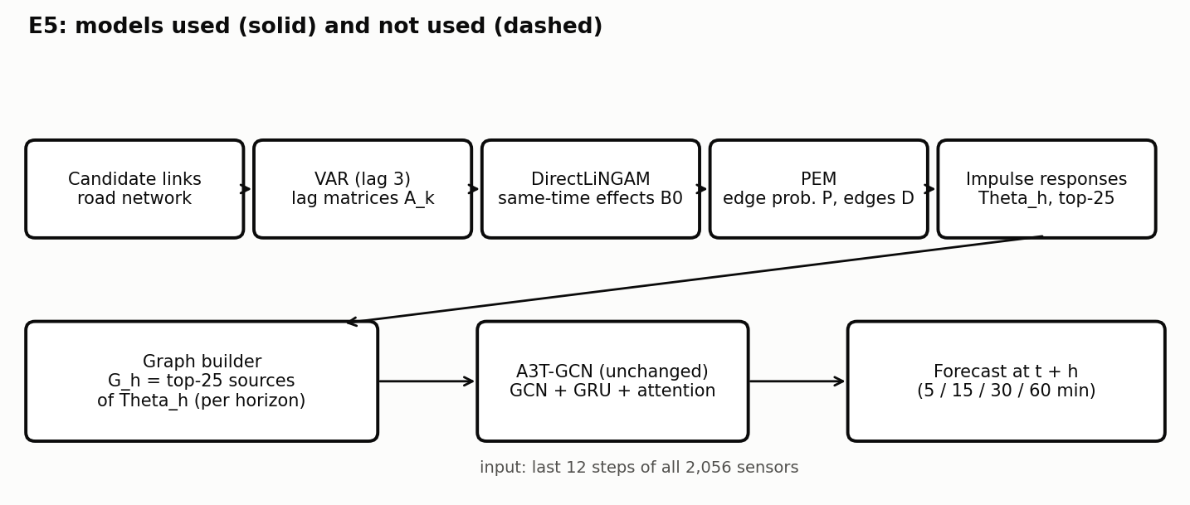
Figure 11. Models used in E5. Solid boxes are used; dashed grey boxes are not used.
Graph facts
- About 50,600 edges; in-degree exactly 25 for most sensors.
- Own-signal share 39%.
- Overlap with E1's edges (Jaccard) 0.43.
Results
Table 11. E5 results (test split).
Run | Test RMSE | Test MAE | Masked MAPE (%) | Best epoch
E5, 5 min, seed 42 | 28.17 | 18.47 | 11.41 | 4
E5, 5 min, seed 7 | 27.40 | 17.81 | 10.90 | 20
Inference
- E5 beats the road graph (E5 better than E0 on 62% of sensors, DM p < 0.001).
- It does not beat E1: a tie at seed 42 (DM p = 0.15) and worse at seed 7 (E1 better on 78% of sensors, DM p < 0.001). Two-seed means: E1 27.41, E5 27.78.
- The seed-42 run collapsed after epoch 4 (best epoch 4).

3.10 E5 at longer horizons (15, 30, 60 min)
What this experiment changes
Same method with the graph for h = 3, 6 and 12.
Block diagram: models used
Figure 12. Models used in E5. Solid boxes are used; dashed grey boxes are not used.
Graph facts
- About 50,900 edges per horizon; own-signal share 40% (30 min) and 41% (60 min).
- Overlap with E1's edges 0.34 at 60 min: the horizon graphs pick different sources.
Results
Table 12. E5 at longer horizons (15, 30, 60 min) results (test split).
Run | Test RMSE | Test MAE | Masked MAPE (%) | Best epoch
E5, 15 min, seed 42 | [paste: output_E5_h3_final] | [paste] | [paste] | [paste]
E5, 30 min, seed 42 | 39.98 | 25.82 | 14.90 | 15
E5, 60 min, seed 42 | 48.97 | 32.88 | 20.00 | 20
Inference
- E1 is better than E5 at 30 min (on 86% of sensors) and at 60 min (on 66%), DM p < 0.001 for both.
- At 60 min E5 ties HA on MAE (DM p = 0.67).
- So horizon-specific graphs do not improve on one VAR graph at any horizon tested.
- The 30-min run was very unstable (validation RMSE 108-179 at several epochs).

3.11 E6: data-driven candidate links
What this experiment changes
VAR, LiNGAM and PEM are run on candidate links from data (each sensor's 25 most correlated training sensors) instead of the road network; the graph uses E4's formula.
Block diagram: models used
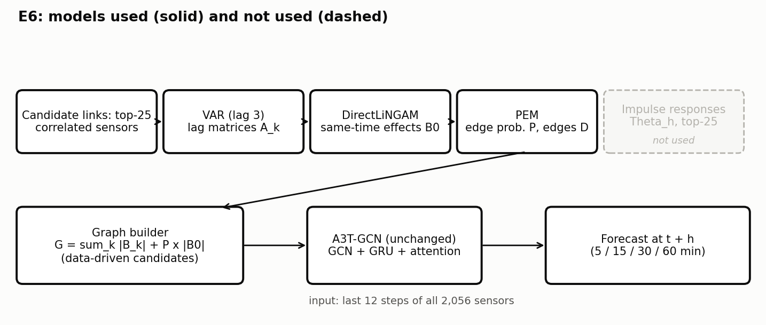
Figure 13. Models used in E6. Solid boxes are used; dashed grey boxes are not used.
Graph facts
- [paste: outputs/graphs/E6__...json: edges, nodes without incoming, own-signal share]
Results
Table 13. E6 results (test split).
Run | Test RMSE | Test MAE | Masked MAPE (%) | Best epoch
E6, 5 min, seed 42 | [paste: output_E6_final] | [paste] | [paste] | [paste]
Inference
- [paste: compare with E4/E2 (same formula, road candidates) and with E1]

3.12 E7: road prior in PEM
What this experiment changes
Same as E4, but PEM uses a prior inclusion probability of 0.7 on road links and 0.3 elsewhere instead of 0.5 everywhere.
Block diagram: models used
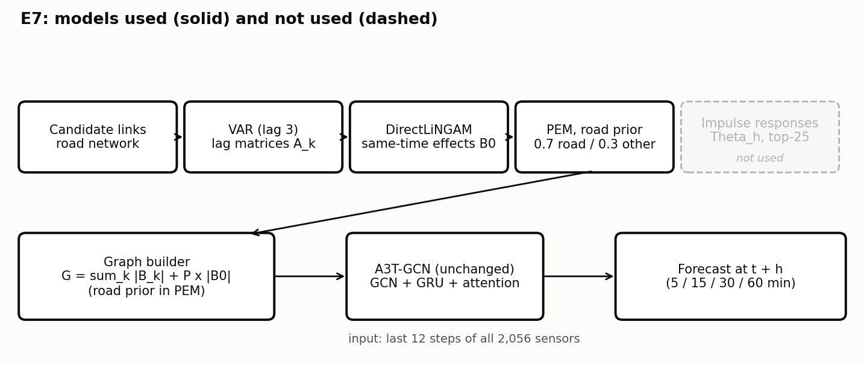
Figure 14. Models used in E7. Solid boxes are used; dashed grey boxes are not used.
Graph facts
- On the Stage A sample of 60 units the road prior changed about 3% of edges.
- [paste: outputs/graphs/E7__...json: edges, difference from E4]
Results
Table 14. E7 results (test split).
Run | Test RMSE | Test MAE | Masked MAPE (%) | Best epoch
E7, 5 min, seed 42 | [paste if run: output_E7_final] | [paste] | [paste] | [paste]
Inference
- [paste: if the E7 graph is almost equal to E4, report the graph comparison instead of training]

4. Comparison of all experiments

4.1 Summary table
Table 15. Test RMSE / MAE of every run. Seed 42 unless stated.
Experiment | 5 min, seed 42 | 5 min, seed 7 | 5 min, mean | 15 min | 30 min | 60 min
HA | 54.92 / 33.24 | - | - | [paste] | 54.91 / 33.23 | 54.89 / 33.21
NOGRAPH | 27.58 / 16.87 | [paste] | [paste] | [paste] | [paste] | [paste]
E0 road | 29.76 / 19.34 | 30.13 / 19.33 | 29.94 / 19.34 | [paste] | [paste] | 49.87 / 33.19
E1 VAR | 28.10 / 18.36 | 26.71 / 16.90 | 27.41 / 17.63 | [paste] | 37.47 / 23.58 | 47.41 / 31.32
E2 VAR-LiNGAM | 32.38 / 21.88 | - | - | - | - | -
E3a P x D | 57.17 / 39.66 | - | - | - | - | -
E3b VAR on PEM edges | 28.30 / 19.62 | - | - | - | - | -
E4 | [paste] | - | - | - | - | -
E5 horizon graphs | 28.17 / 18.47 | 27.40 / 17.81 | 27.78 / 18.14 | [paste] | 39.98 / 25.82 | 48.97 / 32.88
E6 | [paste] | - | - | - | - | -
E7 | [paste] | - | - | - | - | -
Inference: E1 has the lowest error among the graph models wherever it was run. NOGRAPH has the lowest error at 5 min on seed 42.

4.2 Accuracy at 5 minutes
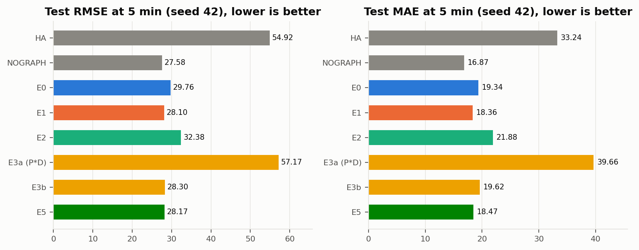
Figure 15. Test RMSE and MAE of every experiment at 5 min, seed 42.
- Order (RMSE): NOGRAPH 27.58 < E1 28.10 < E5 28.17 < E3b 28.30 < E0 29.76 < E2 32.38 < HA 54.92 < E3a 57.17.
- E1, E5 and E3b are within 0.2 RMSE of each other; the seed effect (up to 1.4 RMSE) is larger than that gap, so their order on one seed is not reliable. The significance tests in Section 4.6 settle it.
- The two dense graphs (E2, E3a) are clearly worse than the road graph.

4.3 Error vs forecast horizon
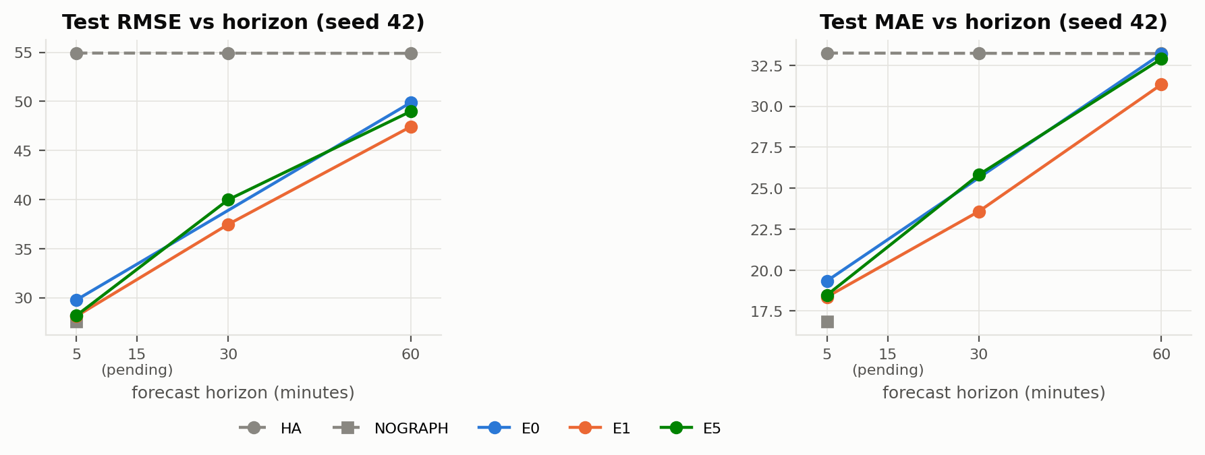
Figure 16. Test RMSE and MAE vs horizon. 15-min points, NOGRAPH at 30/60 min and E0 at 30 min are pending (the E0 line joins 5 and 60 min directly).
TO BE PASTED: updated version of this figure after the 15-min runs, NOGRAPH h6/h12 and E0 h6 (run: python presentation/collect.py, then python presentation/figures.py)

- Error grows almost linearly with the horizon for every trained model; HA stays flat.
- E1 stays the lowest graph model at 5, 30 and 60 min; the gap to E0 and E5 grows with the horizon in MAE.
- At 60 min the models' MAE approaches HA's; only E1 is significantly below it.
- [paste: where NOGRAPH lies at 30 and 60 min, and whether the graph models overtake it]

4.4 Effect of the random seed
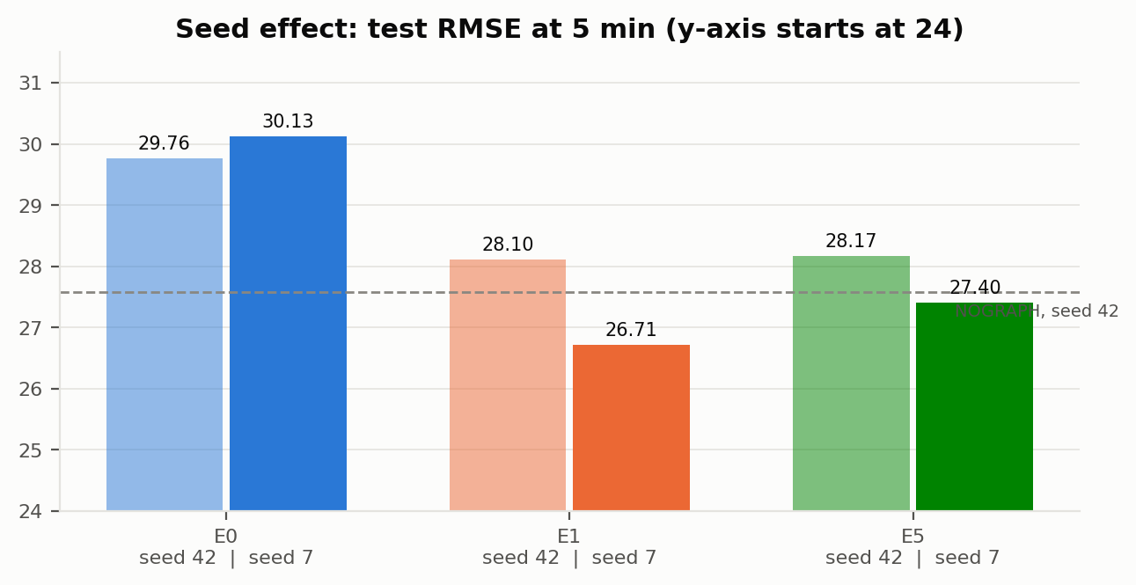
Figure 17. Test RMSE at 5 min for seed 42 and seed 7. The dashed line is NOGRAPH (seed 42).
- E1 improves by 1.39 RMSE and E5 by 0.76 from seed 42 to seed 7; E0 hardly changes (+0.37).
- The seed effect is as large as the differences between experiments, so a single-seed comparison can be misleading. E1 > E5 > E0 holds on both seeds.
- [paste: NOGRAPH seed 7, to check whether its 5-min win holds on a second seed]

4.5 Own-signal share explains the extremes
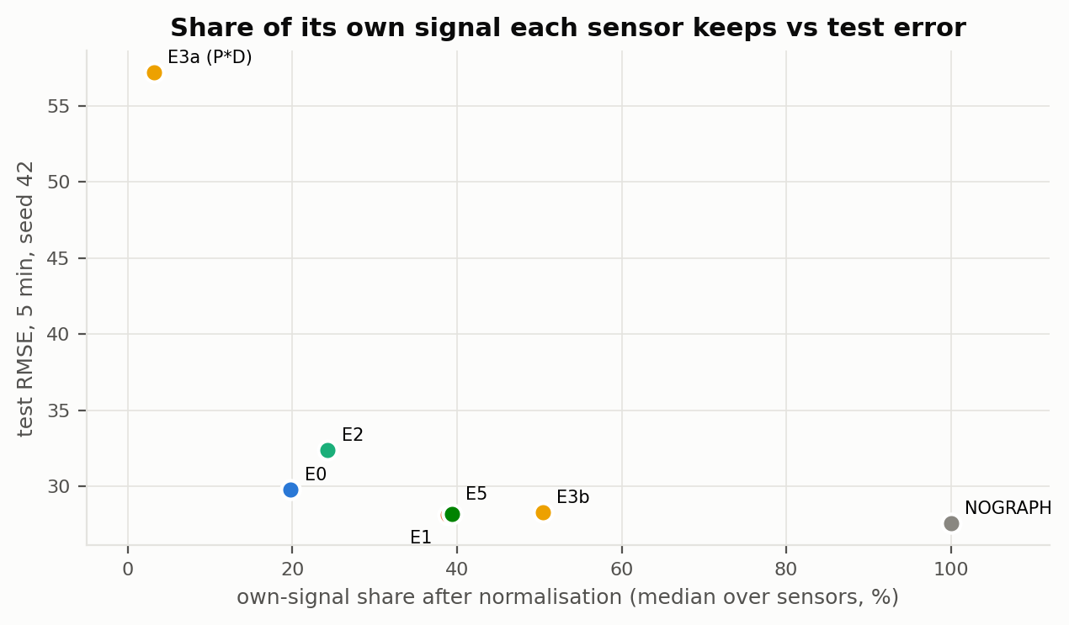
Figure 18. Median share of its own signal each sensor keeps after normalisation vs test RMSE (5 min, seed 42).
Table 16. Graph statistics.
Graph | Directed edges | Own-signal share (median) | Test RMSE 5 min
NOGRAPH | 0 | 100% | 27.58
E0 road | 51,686 | 20% | 29.76
E1 VAR | 51,686 | 39% | 28.10
E2 VAR-LiNGAM | 101,685 | 24% | 32.38
E3a P x D | 75,885 | 3% | 57.17
E3b VAR on PEM edges | 32,873 | 50% | 28.30
E4 | 101,685 | 24% | [paste]
E5 (5 / 30 / 60 min graphs) | 50,555 / 50,927 / 50,927 | 39% / 40% / 41% | 28.17
- The worst graphs keep the least own signal (E3a 3%, E0 20%, E2 24%); the best model keeps all of it (NOGRAPH 100%).
- The relation is not strict in the middle: E3b keeps 50% but is worse than E1 (39%), because it also removes useful edges and leaves 44 sensors with no neighbours.
- Dense graphs (E2, E3a, about 76,000-102,000 edges) train worse than graphs of about 50,000 edges.

4.6 Statistical significance
Table 17. Pairwise tests. "% sensors better" is for the first model of the pair; DM p from the per-timestep MAE.
Pair | Horizon, seed | % sensors better | DM p | Verdict
E1 vs E0 | 5 min, 42 | 59% | < 0.001 | E1 better
E1 vs E0 | 5 min, 7 | 93% | < 0.001 | E1 better
E1 vs E0 | 60 min, 42 | 70% | < 0.001 | E1 better
E5 vs E0 | 5 min, 42 | 62% | < 0.001 | E5 better
E5 vs E1 | 5 min, 42 | 56% | 0.15 | Tie
E5 vs E1 | 5 min, 7 | 22% | < 0.001 | E1 better
E5 vs E1 | 30 min, 42 | 14% | < 0.001 | E1 better
E5 vs E1 | 60 min, 42 | 34% | < 0.001 | E1 better
E2 vs E1 | 5 min, 42 | 15% | < 0.001 | E1 better
E2 vs E0 | 5 min, 42 | 25% | < 0.001 | E0 better
E3b vs E1 | 5 min, 42 | 16% | 1e-8 | E1 better
E3b vs E0 | 5 min, 42 | 30% | 0.17 | Tie
NOGRAPH vs E1 | 5 min, 42 | 82% | < 0.001 | NOGRAPH better
NOGRAPH vs E0 | 5 min, 42 | 88% | < 0.001 | NOGRAPH better
NOGRAPH vs E5 | 5 min, 42 | 74% | < 0.001 | NOGRAPH better
E1 vs HA (MAE) | 60 min | - | 0.016 | E1 better
E5 vs HA (MAE) | 60 min | - | 0.67 | Tie
E0 vs HA (MAE) | 60 min | - | 0.98 | Tie
NOGRAPH vs E1 | 30 min, 42 | [paste] | [paste] | [paste]
NOGRAPH vs E1 | 60 min, 42 | [paste] | [paste] | [paste]
- Every claim "E1 beats E0" and "E1 beats E5" is significant except E5 vs E1 at 5 min seed 42 (tie).
- No causal refinement (E2, E3b, E5) is significantly better than E1 anywhere.

4.7 Error by time of day
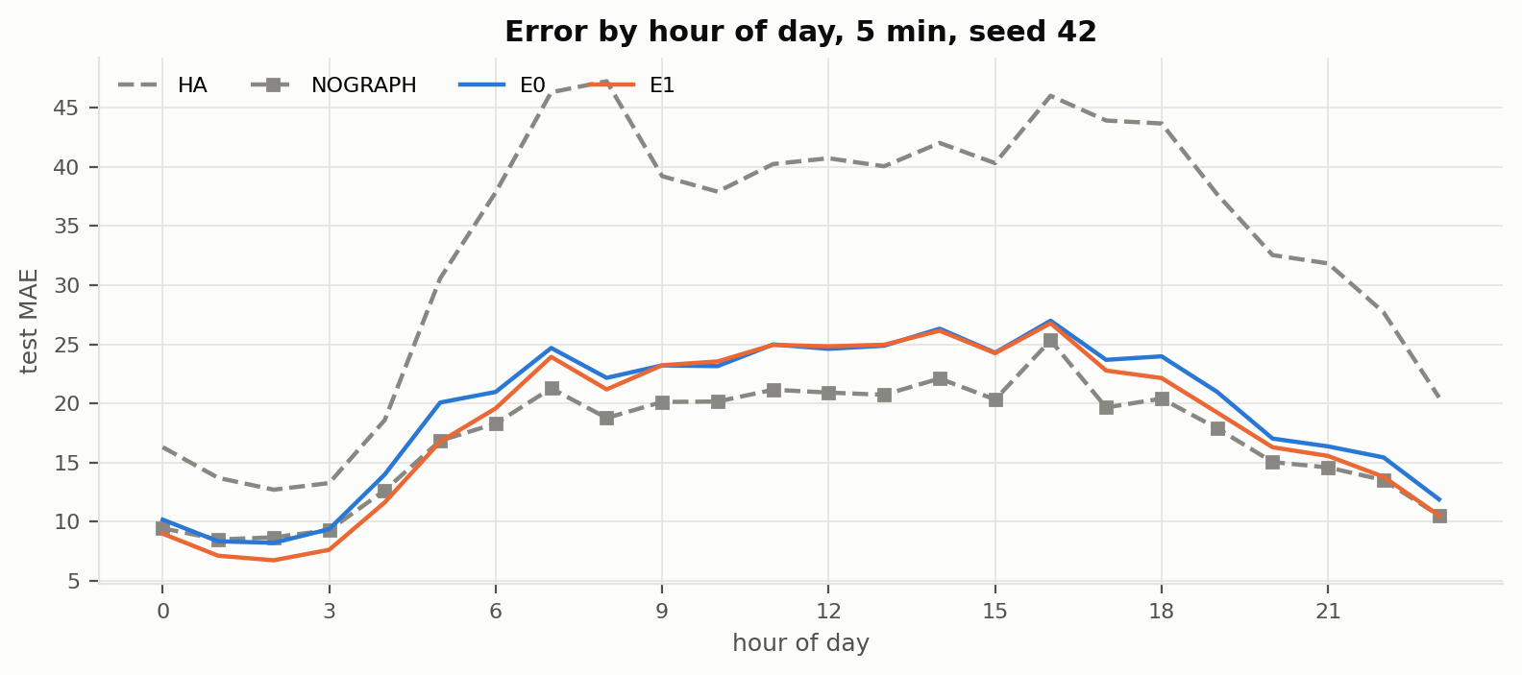
Figure 19. Test MAE per hour of day at 5 min, seed 42.
- All models are worst in the morning (7-8 h) and evening (16-18 h) peaks; HA is much worse than every model at all hours at 5 min.
- NOGRAPH has the lowest error from about 7 h to 22 h. E1 is the best between about 0 h and 4 h, when traffic is light and neighbours give useful information.
- E1 is lower than E0 at most hours, mainly in the evening (17-22 h).

4.8 Where on the network the VAR graph helps
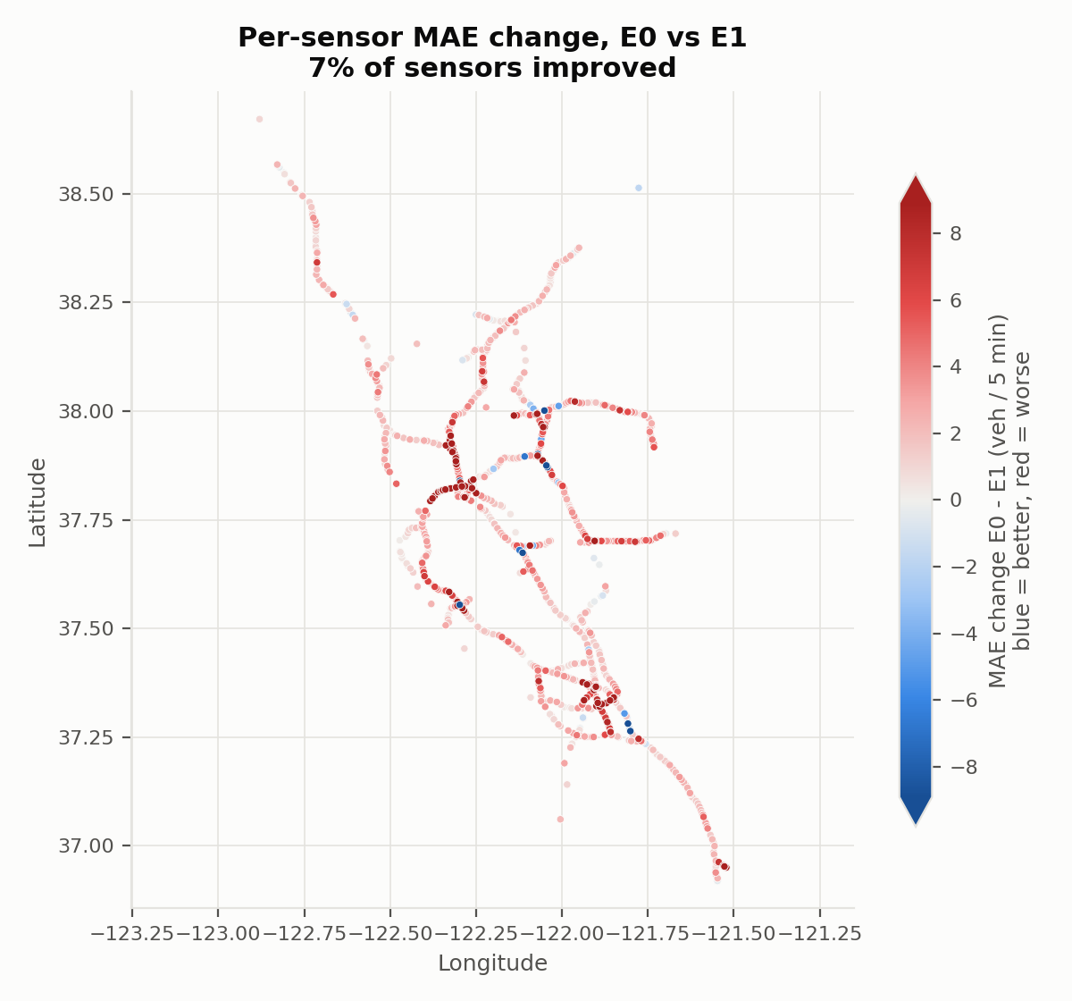
Figure 20. Per-sensor MAE change of E0 relative to E1 (5 min, seed 7). Red: E0 worse than E1; blue: E0 better.
- E1 is better than E0 almost everywhere (93% of sensors at seed 7), not only in one region.
- Many of the largest gains (dark red) are at freeway interchanges, where the road graph links many sensors and the VAR weights can favour the ones that matter.

4.9 Training stability
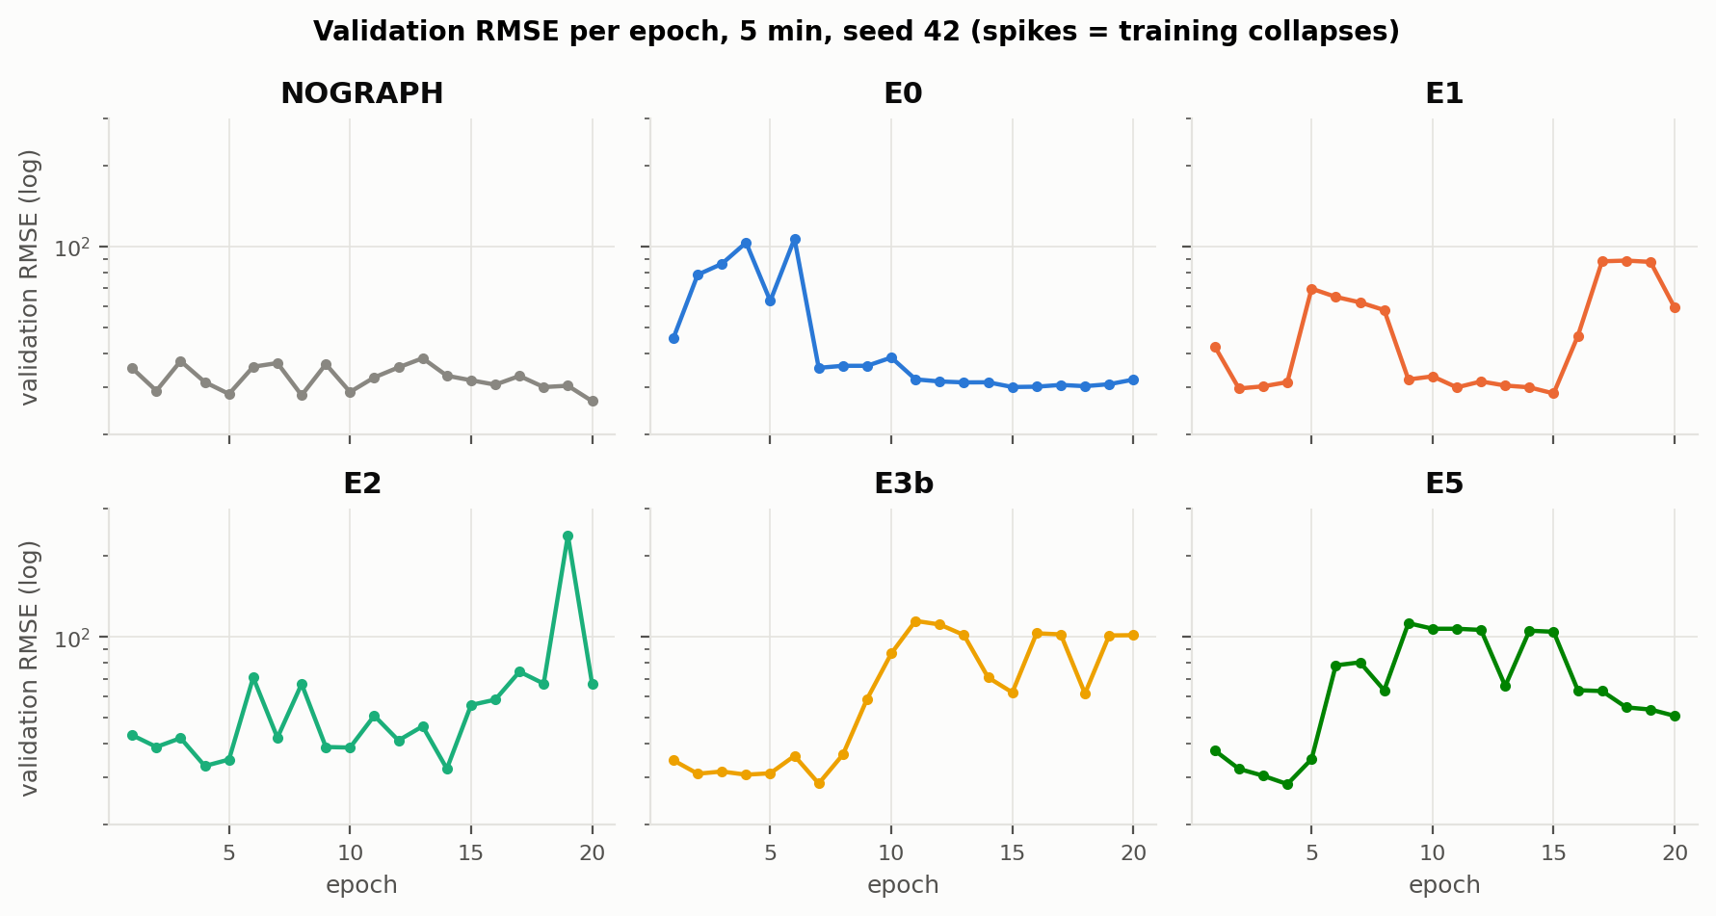
Figure 21. Validation RMSE per epoch (log scale), 5 min, seed 42.
- Every graph model had validation spikes (collapses) at the fixed learning rate 0.001: E0 at epochs 2-6, E1 at 5-8 and 16-19, E2 at 6, 8 and 15-19, E3b from epoch 9, E5 from epoch 5.
- NOGRAPH had the smoothest curve. Graph mixing makes training less stable.
- Because the best-validation checkpoint is used, the collapses mostly change the best epoch (E5: epoch 4, E3b: epoch 7) rather than the reported test error, but they add noise to single-seed comparisons.

5. Conclusions
- Learned VAR weights beat road weights. E1 uses exactly the road graph's edges with VAR weights and beats E0 on both seeds and at 5 and 60 min.
- The causal refinements do not add accuracy. Adding same-time LiNGAM effects (E2), PEM edge selection or weighting (E3a, E3b, E4) and horizon-specific impulse-response graphs (E5) never beat E1 significantly; several are worse than the road graph.
- Dense graphs hurt. Graphs that dilute each sensor's own signal (E3a 3%, E0 20%, E2 24%) give the highest errors.
- At 5 minutes a graph does not help A3T-GCN. NOGRAPH is the best model at 5 min (seed 42). [paste: conclusion for 30 and 60 min once NOGRAPH h6/h12 are done]
- At 60 minutes only E1 beats the historical average on MAE.

6. Limitations
- Most experiments have one seed; the seed effect (up to 1.4 RMSE) is as large as the differences between experiments.
- Training collapses occur at the fixed learning rate 0.001 in every graph model; the protocol was kept identical for all experiments rather than tuned per graph.
- 20 epochs for every run; E1 at 60 min reached its best at epoch 19 and may be under-trained.
- Only 49% of test windows (5,183 of 10,500) are scored, because a target must be observed at all 2,056 sensors.
- A3T-GCN sees one hour of input, so it cannot use the weekly pattern that makes HA strong at night.
- LiNGAM uses 10,000 residual rows per unit and runs on local units, not on all 2,056 sensors jointly; PEM settings were taken from the paper without a separate validation stage; E3 was amended after its first result (approved, reported as post-hoc).

7. Pending work
Table 18. Runs still to be done. Each fills the matching placeholders in this report.
Run | Where it is used | Status
NOGRAPH, 60 min, seed 42 | 3.2, 4.1, 4.3, 4.6, 5 | [paste status]
NOGRAPH, 30 min, seed 42 | 3.2, 4.1, 4.3, 4.6 | [paste status]
NOGRAPH, 5 min, seed 7 | 3.2, 4.1, 4.4 | [paste status]
E0, 30 min, seed 42 | 3.3, 4.1, 4.3 | [paste status]
HA, NOGRAPH, E0, E1, E5 at 15 min | 3.1-3.10, 4.1, 4.3 | [paste status]
E7 PEM run and graph (laptop), then training if it differs from E4 | 3.12, 4.1 | [paste status]
E6 VAR, LiNGAM, PEM on data-driven candidates, then training | 3.11, 4.1 | [paste status]
Third seed (123) for E0, E1, E5, NOGRAPH at 5 min | 4.4 | Optional

