E8: Horizon-Conditioned VAR-PEM Graph without LiNGAM
Workflow, components and equations (as implemented in the code)
Dataset: LargeST-GBA 2021, 5-minute traffic flow, 2,056 sensors after the duplicate filter. Forecaster: A3T-GCN, unchanged. Document date: 5 November 2026.

1. Purpose
E8 tests whether a graph built only from a VAR model and a probabilistic edge filter (PEM) can drive the unchanged A3T-GCN forecaster, without the LiNGAM contemporaneous structure used in E5. The edge filter is the part under study: PEM gives each candidate pair a probability of being a real edge, and that probability scales the VAR impulse response at each forecast horizon.
The motivating problem is that a road-network prior can suggest edges that carry no traffic (for example, a junction where vehicles only go down one road still gets edges to the empty roads). E8 therefore studies a data-driven prior, built from correlations of the VAR residuals, in place of the road prior.
E8 counts as a good approach only if the A3T-GCN trained on the E8 graph beats the A3T-GCN trained on E8V (the same graph with no PEM weighting) on validation and, once, on test. No such claim can be made before those runs.

2. Block diagram
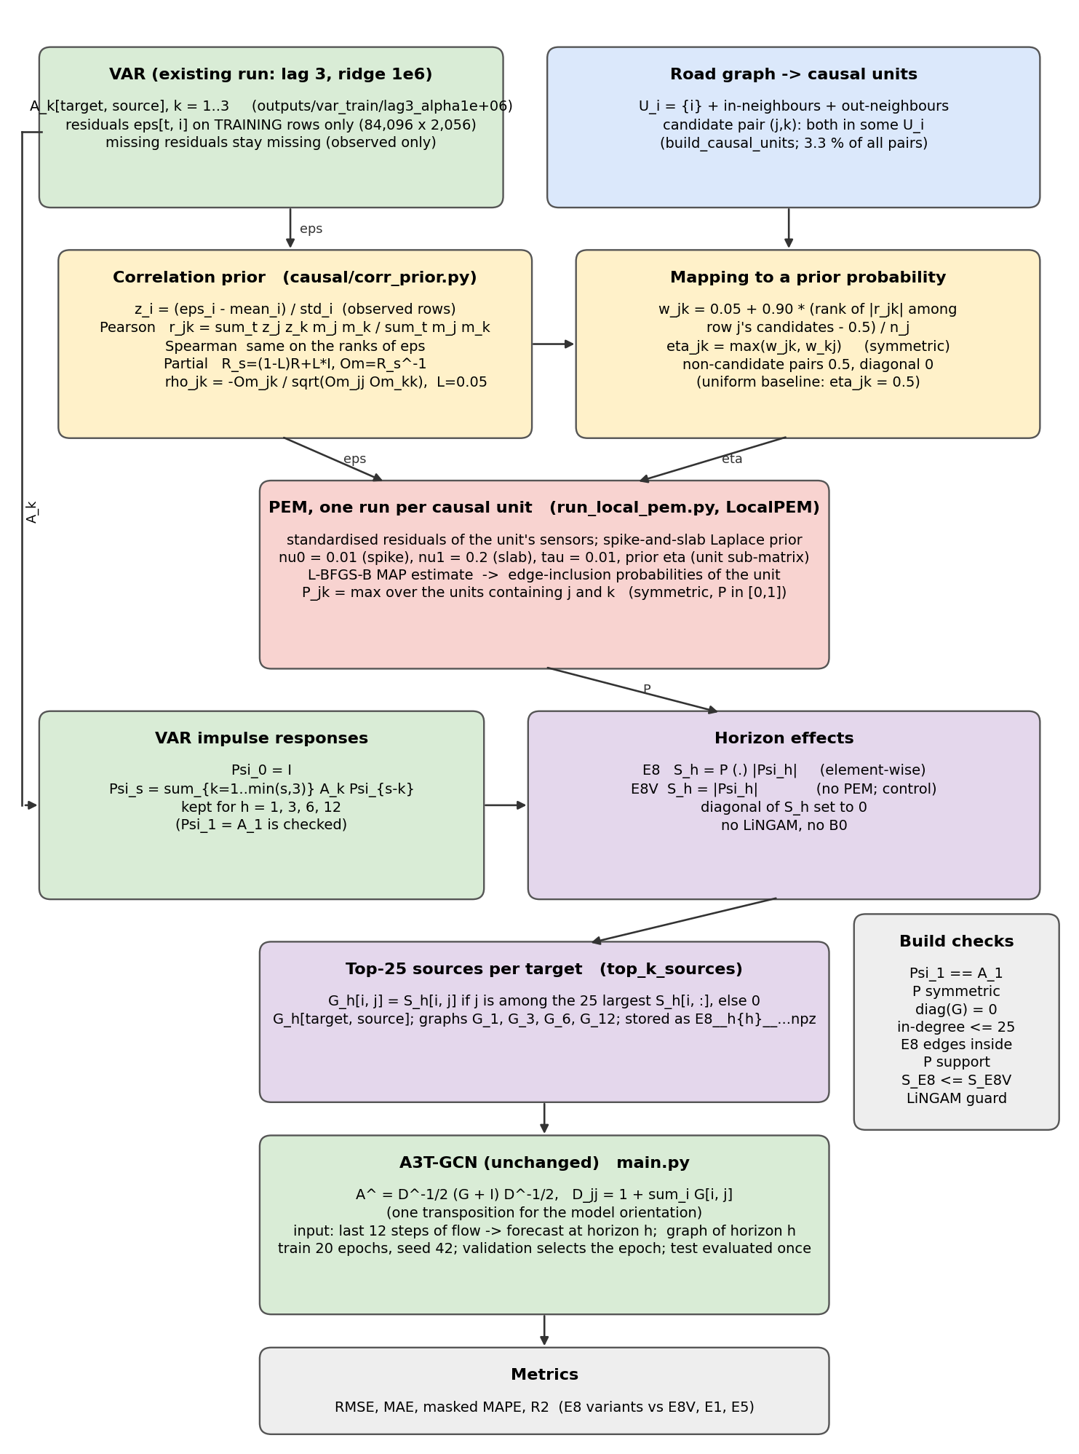
Figure 1. E8 pipeline: VAR and road-graph units, correlation prior, PEM, horizon effects, top-25 graph, A3T-GCN.

3. Components
Component | Code | Input | Output
VAR(3), ridge | var stage (existing run lag3_alpha1e+06) | Training rows of flow | A_k[target, source], k = 1..3; residuals ε
Causal units | build_causal_units, load_candidates | Road adjacency (gba_rn_adj.npy) | One unit per sensor; candidate pairs
Correlation prior | causal/corr_prior.py; build_corr_prior.py | Residuals ε; candidate pairs | η matrix saved as outputs/priors/corr_<method>.npz
PEM | run_local_pem.py (LocalPEM), --prior-file | Unit residuals; η sub-matrix | P: edge-inclusion probabilities, pem_result.npz
Impulse responses | causal/var_pem_horizon.py | A_1..A_3 | Ψ_h for h = 1, 3, 6, 12
Horizon effects | var_pem_horizon.py (weighted_effects) | P, Ψ_h | S_h
Top-k graph | var_pem_horizon.py; build_e8_graphs.py | S_h | G_h, files E8__h{h}__<run>__<variant>.npz
Forecaster | main.py (unchanged) | G_h; last 12 steps of flow | Forecast at horizon h; RMSE, MAE, MAPE, R²

4. Equations, step by step

Step 0. VAR and causal units
A VAR of lag 3 is fitted on training rows with ridge penalty α = 10⁶. Missing values stay missing (observed values only).
x_t = A₁ x_{t−1} + A₂ x_{t−2} + A₃ x_{t−3} + ε_t (1)
A_k[i, j] is the effect of source j on target i at lag k. The residuals ε are kept for training rows only (84,096 rows × 2,056 sensors, 99.5% coverage).
For sensor i, the causal unit is U_i = {i} ∪ N_in(i) ∪ N_out(i), where N_in and N_out are its incoming and outgoing road neighbours. A pair (j, k) is a candidate if both sensors lie in some unit; this is about 3.3% of all pairs.

Step 1. Correlation prior (causal/corr_prior.py)
Residuals are standardised per sensor on the rows where that sensor was observed.
z_i = (ε_i − mean_i) / std_i (2)
Pearson correlation uses only rows where both sensors were observed (m is the observed mask):
r_jk = Σ_t z_j z_k m_j m_k / Σ_t m_j m_k (3)
Spearman correlation is the same formula applied to the average ranks of ε. Partial correlation shrinks the correlation matrix R towards the identity, inverts it and rescales:
R_s = (1 − λ) R + λ I, Ω = R_s⁻¹, ρ_jk = −Ω_jk / √(Ω_jj Ω_kk), λ = 0.05 (4)
The code raises an error if the shrunk matrix is not positive definite.

Step 2. Mapping correlation to a prior probability
The absolute correlation is converted to a rank-based weight within each sensor's candidate list, so the prior spreads between 0.05 and 0.95 whatever the scale of the correlations:
w_jk = 0.05 + 0.90 · ( rank_avg(|r_jk|) − 0.5 ) / n_j (5)
η_jk = max( w_jk , w_kj ) (6)
Here rank_avg is the average rank of |r_jk| among the n_j candidates of row j. η is symmetric, non-candidate pairs get 0.5 and the diagonal is 0. The uniform baseline sets η_jk = 0.5 everywhere.

Step 3. PEM (run_local_pem.py, LocalPEM)
For each unit, PEM takes the standardised residuals of the unit's sensors and the unit's sub-matrix of η, and fits a spike-and-slab Laplace prior by MAP estimation (L-BFGS-B):
β_jk ~ (1 − γ_jk) Laplace(ν₀) + γ_jk Laplace(ν₁), P(γ_jk = 1) = η_jk (7)
P_jk = max over units U containing j and k of P^U_jk (8)
Settings: ν₀ = 0.01 (spike), ν₁ = 0.2 (slab), τ = 0.01, threshold 0.5. Equation 7 states the prior in words; the exact likelihood and penalty are those of LocalPEM, which is unchanged apart from the new --prior-file option. P is symmetric with values in [0, 1].
Why ν₀ = 0.01 and ν₁ = 0.2: with the earlier ν₀ = 0.0017 and ν₁ = 1, P is almost saturated (85% of entries above 0.99, 12% below 0.01), so no prior can change it. The new setting gives a graded P (about 40% of entries between 0.05 and 0.95 on a 60-unit slice). This is a post-hoc change made after seeing the saturation, and it is reported as such.

Step 4. VAR impulse responses
Ψ₀ = I, Ψ_s = Σ_{k=1}^{min(s,3)} A_k Ψ_{s−k} (9)
Ψ_h is kept for h = 1, 3, 6, 12. The build checks that Ψ₁ equals A₁.

Step 5. Horizon effects
E8: S_h = P ⊙ |Ψ_h| (10)
E8V: S_h = |Ψ_h| (11)
⊙ is the element-wise product, so each VAR effect is scaled by its probability of being a real edge. The diagonal of S_h is set to 0. There is no LiNGAM term and no B0. For comparison, E5 uses Θ_h = Ψ_h (I − P ⊙ B0)⁻¹, and the E8V builder equals the E5 builder with B0 = 0 and P = 1 (unit-tested).

Step 6. Top-25 sources per target
G_h[i, j] = S_h[i, j] if j is among the 25 largest of S_h[i, :]; otherwise 0 (12)
The graph is stored as G[target, source], one file per horizon.

Step 7. A3T-GCN (unchanged)
Â = D^(−1/2) (G + I) D^(−1/2), D_jj = 1 + Σ_i G[i, j] (13)
The graph is transposed once for the model's orientation. The input is the last 12 time steps of flow; the forecast is made at horizon h using the graph of horizon h. Training is 20 epochs with one seed (42) at first, validation selects the epoch, and the test set is evaluated once. Finalists are repeated with at least 3 seeds. This normalisation is taken from earlier E5 documentation and was not re-read in main.py for this document.

5. Variants compared
Name | Edge weight | Role
E8V | |Ψ_h| | Control: VAR only, no PEM. E8 must beat it for PEM to count as useful.
E8 (uniform η) | P ⊙ |Ψ_h|, η = 0.5 | PEM without prior information.
E8 (Pearson η) | P ⊙ |Ψ_h|, η from Pearson | Primary data-driven prior (best justified, see section 7).
E8 (Spearman η) | P ⊙ |Ψ_h|, η from Spearman | Optional: rank-robust check.
E8 (partial η) | P ⊙ |Ψ_h|, η from partial | Optional: noisier, depends on shrinkage λ.
E5 | Ψ_h (I − P ⊙ B0)⁻¹ | Existing graph with LiNGAM; reference only.
E1 | (existing baseline) | Reference only.

6. Fixed settings
Setting | Value
VAR | lag 3, ridge α = 10⁶; training rows only
PEM | ν₀ = 0.01, ν₁ = 0.2, τ = 0.01, threshold 0.5, standardised residuals, L-BFGS-B
Prior mapping | percentile of |r| within each row's candidates, low 0.05, high 0.95; η = max(w_jk, w_kj); non-candidates 0.5
Partial correlation shrinkage | λ = 0.05
Horizons | 1, 3, 6, 12 (h = 6 trained first)
Graph | top-25 sources per target, G[target, source]
A3T-GCN | unchanged; 20 epochs; seed 42 for the first pass, at least 3 seeds for finalists
Data use | training rows for VAR, prior and PEM; validation for selection; test once

7. Validity checks and findings so far

Prior algorithms
- Seven unit tests pass (tests/test_corr_prior.py): Pearson against numpy, pairwise-complete handling of missing values, Spearman against scipy, partial correlation removing a chain's indirect link, rejection of a singular matrix, and properties of the percentile mapping.
- Split-half reliability of the correlation estimates: Pearson 0.886, Spearman 0.897, partial 0.468. Pearson and Spearman agree at 0.94 (top-25 overlap 0.83). Partial correlation is noisy and depends on shrinkage, so Pearson is the primary prior.

Does the prior move PEM? (60-unit slice, seed 42, local)
Measure vs uniform prior | Pearson | Spearman | Partial
ν₀ = 0.01, ν₁ = 0.2: entries changed by > 0.10 | 24.4% | 25.3% | 23.1%
ν₀ = 0.01, ν₁ = 0.2: entries crossing 0.5 | 7.9% | 8.2% | 7.5%
ν₀ = 0.0017, ν₁ = 1: entries changed by > 0.10 | 2.7% | 2.8% | 3.1%
ν₀ = 0.0017, ν₁ = 1: entries crossing 0.5 | 2.1% | 2.2% | 2.4%

At the original PEM setting the priors barely change P (and the earlier road prior moved 0.02% of the weight). At ν₀ = 0.01, ν₁ = 0.2 the prior changes a quarter of the entries by more than 0.1, which is the intended 'influences a little, but really' behaviour. Whether this helps forecasting is unknown until the A3T-GCN runs.

Graph build checks (build_e8_graphs.py)
- Ψ₁ = A₁; P is symmetric; diag(G) = 0; in-degree ≤ 25.
- Every E8 edge lies inside the support of P; S_E8 ≤ S_E8V element-wise.
- LiNGAM guard: no LiNGAM result is read or linked.

8. How to run
- Push the new and edited files to GitHub (corr_prior.py, build_corr_prior.py, tools/prior_gate.py, tests, run_local_pem.py, build_e8_graphs.py, the notebooks, architecture.md).
- Kaggle CPU: run notebooks/e8-prior-study.ipynb once per prior (uniform first, then pearson; spearman and partial optional). Estimated 2–3 hours per prior; a time budget of 11 hours with resume of finished units is built in.
- Upload E8__h*__<variant>.npz to the artifacts dataset.
- Kaggle GPU: train with notebooks/ablation-study.ipynb using EXPERIMENT = 'E8' and GRAPH_VARIANT = '<variant>'; start with h = 6, then h = 12, 1, 3.
- Train the standard E8 and E8V graphs in parallel as references, then compare E8 variants against E8V, E1 and E5.

9. Caveats
- The VAR companion matrix has an eigenvalue of 1.0499 (> 1), so impulse responses grow with horizon. This affects E5, E8 and E8V at long horizons; a stabilised variant has not been decided.
- The ν change (0.0017/1 to 0.01/0.2) was made after observing saturation; it must be reported as post-hoc.
- The prior comparison above is a 60-unit slice, not the full 2,056 units, and says nothing yet about forecast accuracy.
- Whether the three priors flip the same edges, and the rank correlation of correlation-prior P with uniform P, have not been computed.
- Dynamic VAR/PEM re-estimation after each A3T-GCN result (E9) is a later experiment and is not part of E8.

