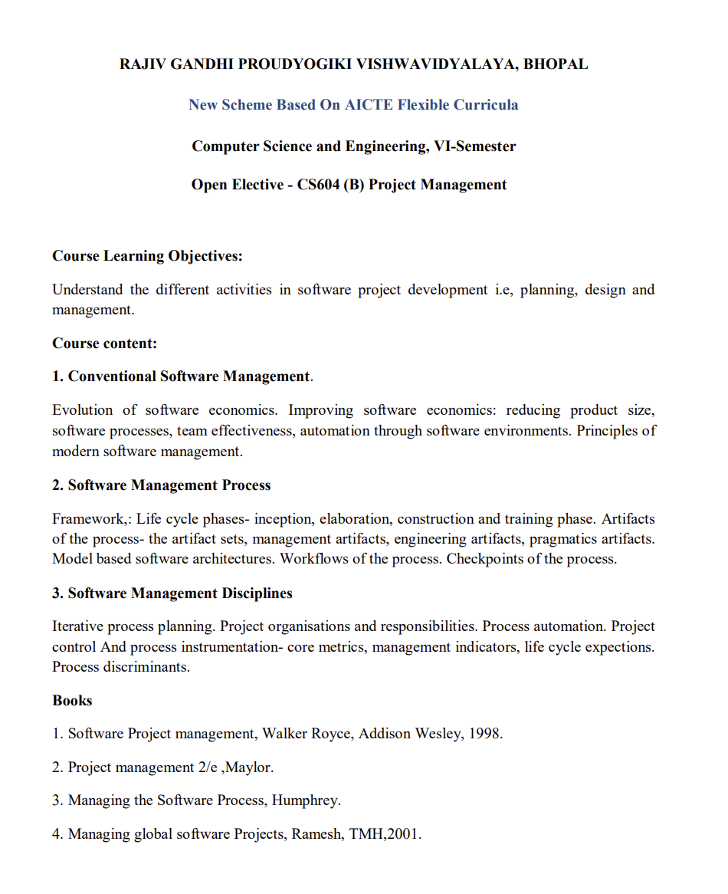8

Linus Torvalds is known worldwide mainly because of the massive impact his work has had on technology and everyday life.
Why people know him:
1. Creator of Linux
He created the Linux kernel in 1991. This became the foundation of the Linux operating system, which is used in:
- Servers (most of the internet runs on it )
- Android phones
- Supercomputers
Without Linux, many websites, apps, and digital services wouldn’t work the same way today.

2. Founder of Open Source Movement (Practical Impact)
While he didn’t start the idea, he made open-source software popular in practice:
- He allowed anyone to use, modify, and share Linux
- This changed how software is built globally

3. Creator of Git
He also created Git, the version control system used by developers:
- Platforms like GitHub rely on it
- Almost every software project today uses Git

4. Changed the Tech Industry
His work influences:
- Cloud computing
- Cybersecurity
- Software development
Big companies like Google, Amazon, and Microsoft use Linux-based systems.

5. Unique Personality
He is also known for:
- Being very straightforward and honest
- Strong opinions in the developer community

Simple Summary:
People know Linus Torvalds because he built the backbone of modern computing (Linux) and a key developer tool (Git)—both used by millions worldwide.

The idea of creating Linux didn’t come suddenly to Linus Torvalds — it was the result of his interest, need, and curiosity.
How did the idea come?
- Around 1990, Linus was a student at University of Helsinki
- He was very interested in operating systems, and he used a system called MINIX
- The problem was that MINIX was:
  - limited in power
  - not easy to modify freely
What happened next?
Linus thought:
“Why not create my own operating system that is better?”
- At first, he started it as a small project just for personal use
- Slowly, the project grew bigger
- In 1991, he announced on the internet that he was building a new operating system
Result:
From this small experiment, Linux was born
In simple terms:
- Curiosity + Problem (limitations of MINIX)

  - Passion for learning
= The idea of Linux

Dashboard Creation
1. Name (Required)*
Example:
- Project Dashboard
- Food App Tracking
- Team Progress Dashboard

- 2. Description (Optional)
Example:
- This dashboard shows project progress and task status
- Tracking development and bugs

3. Viewers
- Option 1: Private
- Option 2: Add
- Users / group select karo

4. Editors
- Option 1: Private (recommended)
- Option 2: Add
- Best Practice (Simple setup)
- assignment practice
- Name: My Project Dashboard
- Description: Tracking tasks using Jira
- Viewers: Private
- Editors: Private
- Dashboard
Add Gadget → Pie Chart

