Research Report: pilot-test-1

Method

Sample
The sample comprised $N=10$ synthetic participants generated via Large Language Model (LLM) simulation in batched subagents. Subject profiles were drawn randomly from a parameterized population model representing US adults with a specified mean age of 35.0 years ($SD=10.0$, bounded within $[18,85]$).
Participants were randomly assigned between-subject in an equal allocation ratio to either the control condition ($n=5$) or the treatment condition ($n=5$). Simulations were conducted using subagent batches with distinct persona conditioning, eliciting independent choice decisions and first-person reasoning without cross-subject contamination.

Design and Stimuli
The experiment employed a two-condition, between-subjects randomized design evaluating the impact of beneficiary framing on financial savings decisions. Each participant was presented with a savings prompt followed by a binary decision whether to sign up:
- Control condition: Presented the baseline savings prompt: > “Save $5 today.”
- Treatment condition: Presented the savings prompt augmented with beneficiary / family framing: > “Save $5 today — for your family’s future.”
Both conditions presented identical decision options: "Not now" versus "Sign Up".

Outcome Variable
The primary dependent variable was sign-up uptake (click_sign_up), recorded as a binary choice: - 0 = Declined / chose "Not now" - 1 = Accepted / chose "Sign Up"

Summary Statistics and Balance
Randomization balance across conditions was evaluated on the sampled demographic covariate (age). Table 1 reports descriptive statistics by condition arm and across the overall sample.

Table 1: Sample Demographics by Condition
Condition | $n$​ | Age Mean | Age $SD$ | Min | Max
Control | 5 | 33.20 | 11.39 | 18 | 44
Treatment | 5 | 30.60 | 6.54 | 22 | 38
Overall | 10 | 31.90 | 8.86 | 18 | 44
A one-way ANOVA F-test indicates that mean age did not differ significantly between the control and treatment conditions ($F(1,8)=0.196,p=0.670$). Additionally, Bartlett’s test confirmed homogeneity of variance across conditions ($χ^{2}(1)=1.041,p=0.308$). Randomization was therefore well-balanced with respect to age.

Results

Primary Outcome: Sign-Up Uptake (click_sign_up)
A binary logistic regression was estimated modeling the log-odds of signing up as a function of the treatment indicator ($0=\text{Control},1=\text{Treatment}$):
$$\text{logit}(P(\text{click_sign_up}=1))=−1.386+1.792×\text{Treatment}$$
In the control condition, 20.0% of participants ($n=1/5$, $SE=20.0\%$) chose to sign up. In the treatment condition, sign-up uptake was 60.0% ($n=3/5$, $SE=24.5\%$).
The logistic regression estimate for the treatment effect was positive ($B=1.792,SE=1.443,z=1.241,p=0.214,95\%\text{ CI }[−1.037,4.621]$), corresponding to an odds ratio of $\text{OR}=6.00$. In this small exploratory pilot sample ($N=10$), this positive directional effect did not reach conventional statistical significance ($p=0.214$).
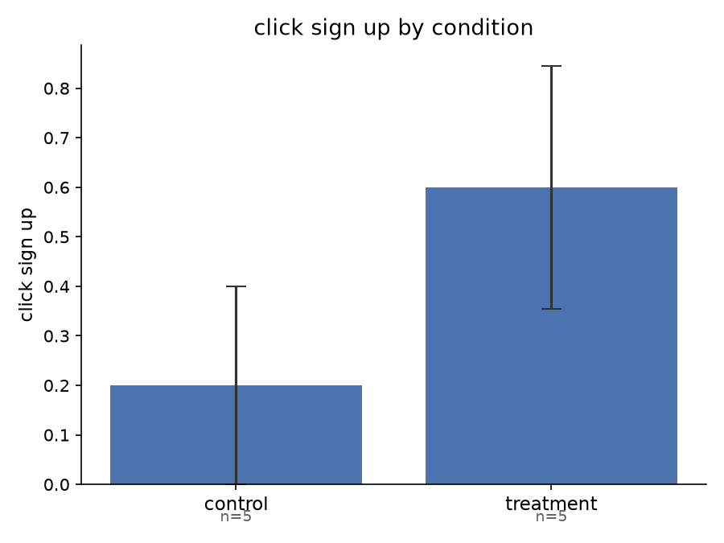
Sign-Up Uptake by Condition
Qualitative examination of participant reasoning indicates that participants in the treatment condition frequently referenced familial responsibilities (e.g., “seeing ‘for your family’s future’ really caught my attention with two kids at home”), whereas younger unattached respondents found the prompt less personally relevant. While directionally supporting the hypothesis that relational framing boosts perceived value, confirmatory testing with a higher-powered sample size is required to substantiate the statistical significance of this effect.

