Timmy Goes to Timbuktu

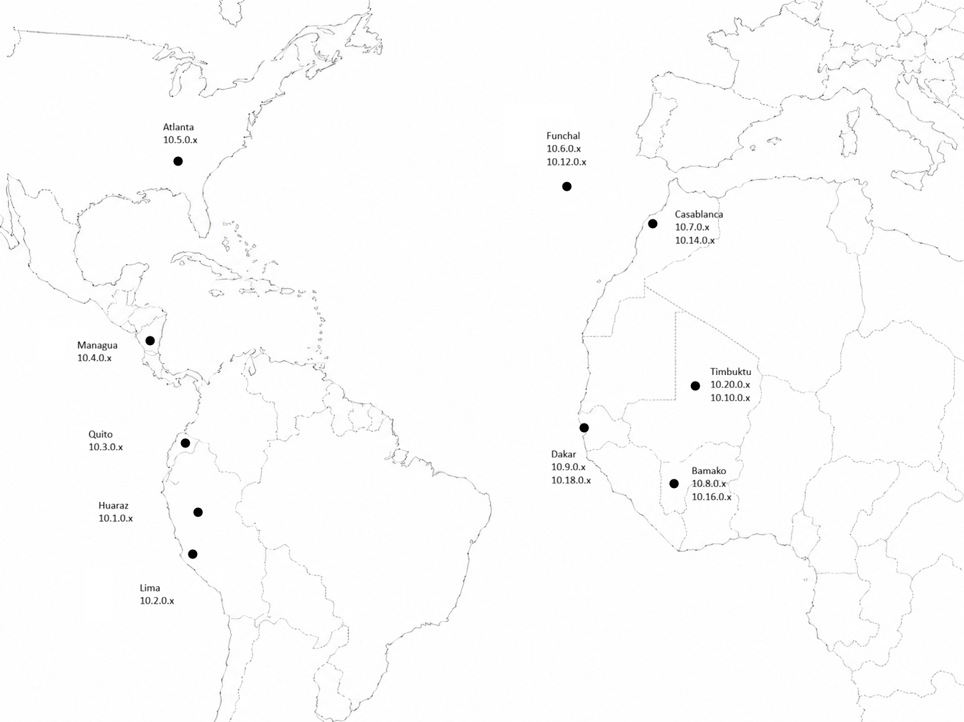

Multiple Routes
For most computers on the internet, there are multiple routes from the source to the destination. Routers will usually choose the shortest route. Shortest usually means the fastest route, but when timing information is not available, it uses the most direct route (e.g., fewest hops). If the shortest route is unavailable, the packets will be sent along the slower alternates. It's a lot like highways with road construction, accidents, and other hazards.
IP Address notation:
10.4.0.x indicates that the network's IP address is 10.4.0 and that every computer on that network has a unique number that we generically indicate as "x" (e.g., .1, .2, .3, …254). The more technical way to write this, which you will see on the homework, is 10.4.0.0/24.

