The first "half" of the IP identifies the _________________ the computer belongs to.

The second "half" of the IP address identifies the specific _________________.

Example packet:

From IP: 10.1.0.1
To IP: 10.5.0.2
Message: Hello from Network A.

On which network does the packet begin its journey?

What is the destination network?

What does the current routing table record as the next hop for the destination network?

The current router will forward the packet to the next hop router. This continues until the packet reaches the destination computer.

Routing tables do change over time as the structure of the internet changes. Routing tables consider things like connection speed and load/capacity.

At the end, we can trace the packet's complete journey from its source to destination.

10.1.0.1 → → 10.5.0.2

Did the sender need to know the whole path to the destination?

Did any router know the whole path?

What information did each router use to make its decision?

Did the routers need to understand the message contents?

What could happen if a routing table were wrong?
Simplified "Internet" Diagram
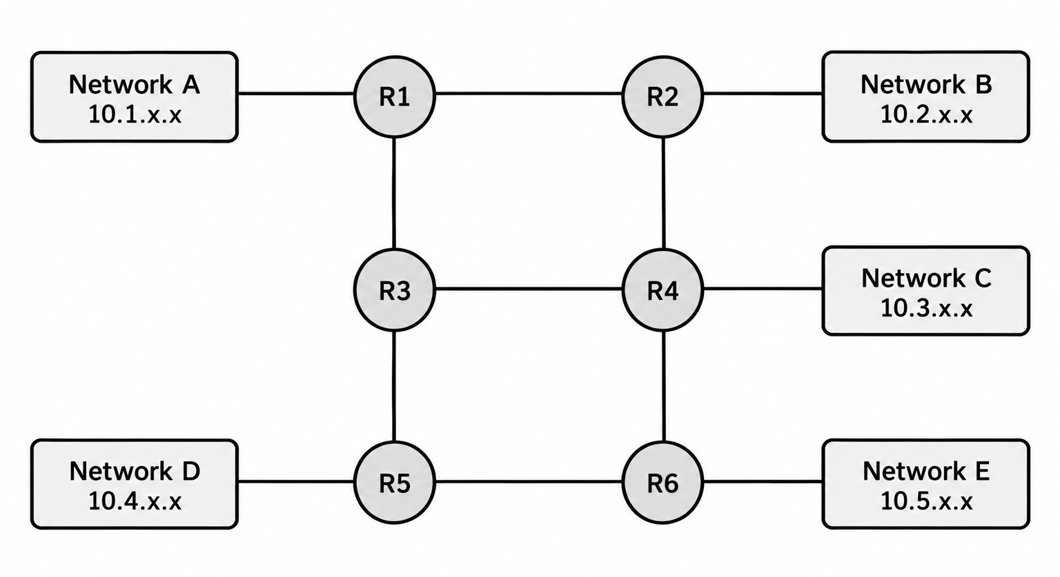
Routing Tables

Routing Table for R1 |  |  | Routing Table for R2 |  |  | Routing Table for R3
Destination:  10.1.x.x  10.2.x.x  10.3.x.x  10.4.x.x  10.5.x.x | Next Hop:  Local  R2  R3  R3  R3 |  | Destination:  10.1.x.x  10.2.x.x  10.3.x.x  10.4.x.x  10.5.x.x | Next Hop:  R1  Local  R4  R1  R4 |  | Destination:  10.1.x.x  10.2.x.x  10.3.x.x  10.4.x.x  10.5.x.x | Next Hop:  R1  R1  R4  R5  R5
Routing Table for R4 |  |  | Routing Table for R5 |  |  | Routing Table for R6
Destination:  10.1.x.x  10.2.x.x  10.3.x.x  10.4.x.x  10.5.x.x | Next Hop:  R3  R2  Local  R6  R6 |  | Destination:  10.1.x.x  10.2.x.x  10.3.x.x  10.4.x.x  10.5.x.x | Next Hop:  R3  R3  R6  Local  R6 |  | Destination:  10.1.x.x  10.2.x.x  10.3.x.x  10.4.x.x  10.5.x.x | Next Hop:  R4  R4  R4  R5  Local

"Local" means the network is adjacent to the router and can be directly delivered.
Computers are configured to send packets to their "Default Gateway" router.

Assigned Source IP Address: ______________________

Assigned Destination IP Address: ______________________

