**PyGame Practice**

The purpose of this exercise is to teach you the basics of PyGame and help you understand the general structure of a small-sized game. We are taking the time to work on a video game in this artificial intelligence class because it will make a great platform for reinforcement learning.

Complete this handout in a small group. For the majority of the exercise, work collectively on the same problems at the same time. Discuss your answers as appropriate. On the last problem, #6 –*hard*, divide the work (a), (b), and (c) up amongst your group members. At the end, share your results with each other.

Introduction

Skim over the README.md file to get a general feel for the file structure and high-level PyGame concepts, then clone the GitHub repository.

<https://github.com/prof-tallman/sidescroller>

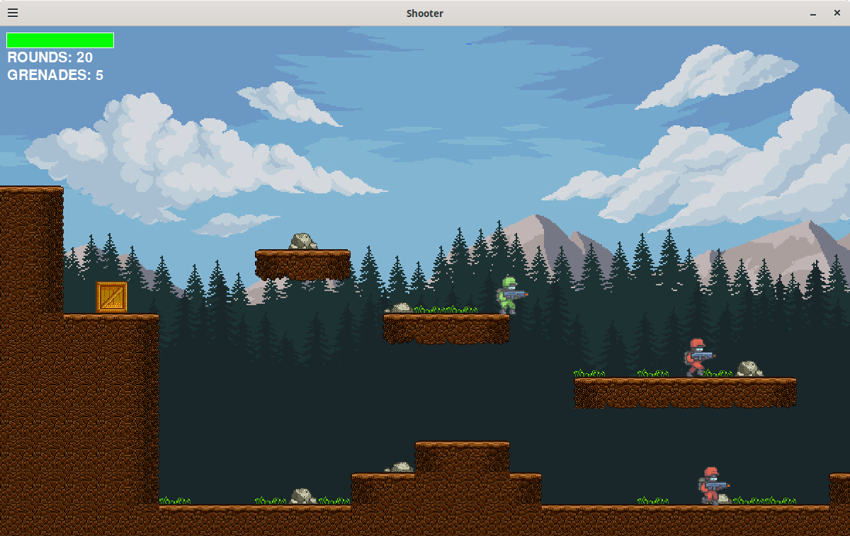

Match the PyGame component to an appropriate description.

Sprites Define the edges of an entity in the game world.

Rects Combines multiple images into one for drawing.

Collisions A means for accessing keystrokes and mouse activity.

Events Objects that can interact with the game environment.

Blitting Occurs when two sprites occupy the same space.

PyGame Jeopardy Sidescroller Edition!

*Heroes $100*: This file contains the "blueprints" for all characters in the game.

What is _______________________________ ?

*Heroes $400*: This class defines the base object for the Player and Enemy objects.

What is _______________________________ ?

*Heroes $600*: This variable, inherited by Player and Enemy objects, is used to distinguish between the different animation types that a character can perform (e.g., idling, running, etc).

What is _______________________________ ?

*Game Loop $300*: This variable, defined in the game engine but used extensively in the main game loop, selects between the main menu and the interactive game.

What is _______________________________ ?

*Engine $200*: This function reads a level from a CSV file and constructs the world environment, one sprite at a time.

What is _______________________________ ?

*Engine $800*: Grenades are added to this sprite group when their fuses expire.

What is _______________________________ ?

*Engine $1000*: This number is the maximum speed a falling object can reach.

What is _______________________________ ?

Game Mods

Here are a series of challenges to improve (?) the game.

1. (*Easy*) Change the game to allow the player to jump higher. You can do this by lowering the strength of gravity or increasing a soldier's jump strength in settings.py. How did you make the player jump higher?
2. (*Easy*) Add a sound effect that plays every time the player collects an item box. You are welcome to use a single sound for all boxes or add three unique sounds, one for each type of box. Download a freely available sound or record your own; WAV files work best. How did you add sound(s)?
3. (*Medium*) Modify the map to add more enemies and item boxes. You'll need to modify one of the CSV files; you can figure out what the integers mean by examining the GameEngine function that builds a world. (Note: Normally, you use a map editing GUI). How did you modify the map?
4. (*Medium*) Right now, the item boxes float in mid-air. Make the item boxes subject to gravity. (Hint: do not change the physics engine; instead, pass the items to the physics engine in the same way as the Grenade and Soldier objects. How did you subject the supply boxes to gravity?
5. (Medium) How would you make the explosion animation last longer so that the fire and smoke would look smoother and more realistic?
6. (*Hard*) Divide these mods up between your group members and work in parallel. Make sure that you share your solutions with each other.  
     
   a. Change the physics engine so that high falls damage the player.  
     
   b. There's a bug in the program that allows "air jumping," where a player can run off a cliff and perform one single jump in midair. If the player is in the air from a previous jump, the air jumping does not work. Prevent all air jumps.  
     
   c. Another bug in the game is that bullets travel through the ground. Detect collisions between the bullets and terrain. Stop the bullets when they hit the dirt.

Write any important notes down here.