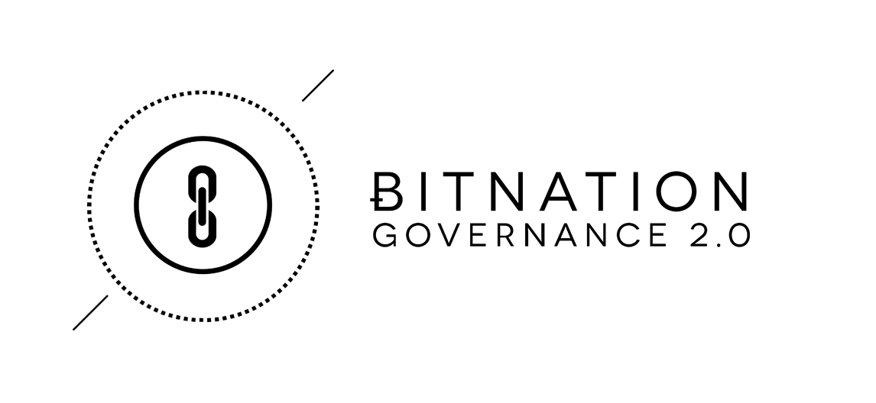
Bitnation Development Plan

Bitnation’s primary service offering is the aggregation of D-I-Y (Do It Yourself) Governance services. and the delivery of those tools through our platform and collections of DAPPs, to the end user in the marketplace. To that end, Bitnation is committed to identifying and aggregating the best technology available, working with industry leaders in the cryptology field to organize it into a comprehensible and user-friendly platform delivered to the end customer. In the spirit of working with the best technology currently available, we are actively looking at and already starting to integrate existing technologies and platforms such as Breach, Codius Smart Oracles, CounterParty, Ethereum, Notary Chains, Ripple, and other so-called “Bitcoin 2.0” technologies / meta protocols.

Bitnation is committed to the open source philosophy both in terms of the technology it uses, as well as in sharing all its code on GitHub for the community to improve or to outright fork. At its core, the Bitnation technology platform is NodeJS and Javascript which has many benefits such as in its modularity and its attractiveness to third-party developers.

Core Infrastructure

Bitnation’s core infrastructure will consist of:
- The User Platform where people interact and get their governance needs
- The DApps Library and APIs, where people can download their own DIY governance DApps, integrate with existing DApps, or create new DApps of their own
- The BitPassport and Identity Services which serve as a backbone for all other services available
- The Dispute Resolution and Smart Contract functions
Bitnation will build, fork, and integrate with numerous open-source technologies; the technology stack will consist of many elements primarily chosen for their resilience, reliability, and security.
Web-Site (Bitnation.co)

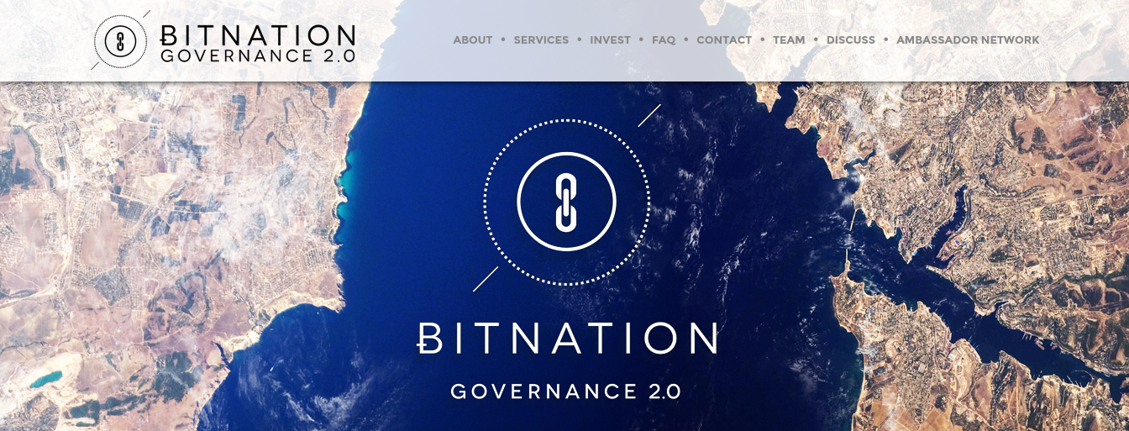

We utilize Bahnhof Secure Hosting which offers us Managed Services and Instant Cloud - Virtual Private Servers presently hosted at Pionen, is both a highly secure and politically safe hosting facility. An example of customers of Bahnhof Secure Hosting include organizations like WikiLeaks.

According to Bahnhof: “Pionen is located in a nuclear bunker from the Cold War era. The entrance is protected by a 40-centimeter thick steel door, and the plant itself has been blasted into the bedrock below the White Mountains in Södermalm in Stockholm, Sweden. The house a powerful IP and carrier service, fully redundant routers, and divergent cable paths. Two redundant diesel generators, battery back ups to cover shorter power outages.”. Hard technical specifications are available here.

User Platform

When people go on to the Bitnation platform they should have all their governance needs met in one comprehensible and easy to use interface - with their ID, network, contracts, DApps, and more. The user experience, and the modular nature of the platform, is key to its adoption potential.


The Bitnation platform relies upon utilizing existing open-source technologies. In particular, the user interface will use the Breach.cc browser, which is composed of 3 layers:

- Layer 1: HTML / JS / CSS. The entire UI (User Interface) is built out of interchangeable modules coded in pure Javascript / HTML5. Each module is a web-app with access to the Breach API.

- Layer 2: Chromium: The Chromium Content API is exposed to Node JS through v8 native bindings and multiplex to modules. Security and performance is at the heart of the design, tabs, and modules run in separate processes.

- Layer 3: Node.js. Breach embeds a NodeJS event loop in charge of running the core browser javascript implementation. Each module is run on its own NodeJS process and interacts with the core browser through IPC (Inter-Process Communication).

DApps Library and APIs

The open-source DApp library is a key functionality of the Bitnation ecosystem because it permits our Ambassadors to download DApps, test them on their communities, and then either feed us data back to inform how to tailor it locally. or simply fork the DApp and adapt it to their own development environments. The Ambassadors can upload it on our DApp library and either give it away for free to people living in similar settings, or make a business out of it by adding a fee structure to it. The modularity is a key future for the buy-in and participation of everyone using the Bitnation platform. Because the Bitnation DApp library is built on top of a NodeJS / Javascript platform, it makes it easy for 3rd party developers to add their own modules for further development and innovation.

Likely User Case Scenario: An ambassador in Afghanistan want to deed his non-deeded land. He download the land deed DApp, and proceeds to work - first recording the land, then filing a deed. However, for the deed to be accepted in his community, namely a small village in Nuristan ruled by Pashtuwali cultural code mixed with Sharia, where the elders of the village traditionally makes decisions through meetings “Shuras” it turns out his land cannot be deeded unless the Shura accepts it. Hence, the Ambassador forks the DApp, adds in a layer of local consensus verification to it, and uploads it on the platform so that everybody who lives in similar socio-cultural environments can also enjoy the same functionality.

Key-purposes:

- Enhance the Bitnation ecosystem of local networks feeding back data on the product design resulting in more locally tailored product that suits the needs of the user.
- Enhance the Bitnation ecosystem in terms of giving Ambassadors the opportunity to make a business for themselves through the creation and selling of DApps.
- Enhance the easy-to-use intuitive DIY governance tools, making it very simple to download a DApp for any governance circumstance that may arise.
- Invite the openness and transparency of various governance applications in different cultures and regions.

DApps API Illustration
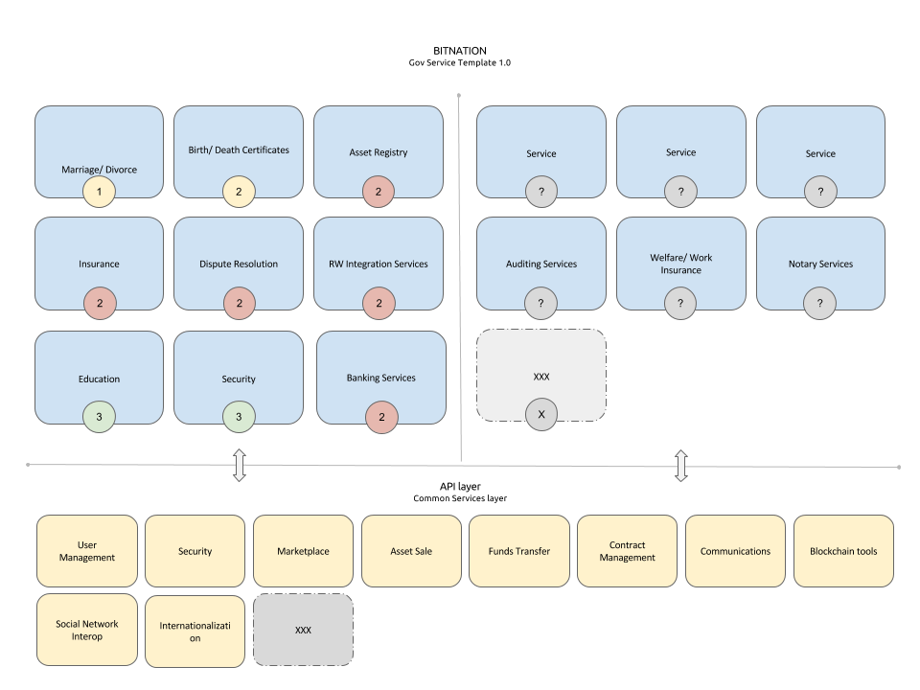

BitPassport and Identity Services

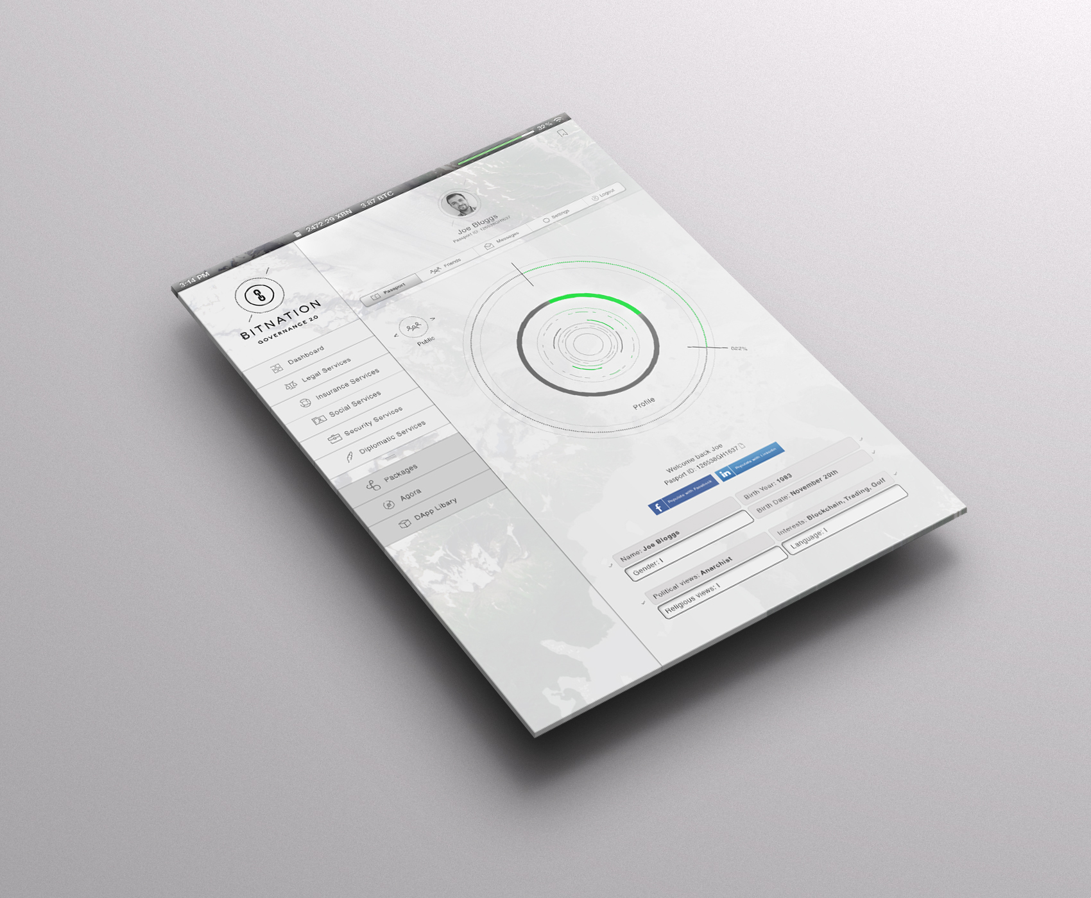

Identity is the foundation of all commercial activity. Most -if not all- transactions involve the transfer of value from one or a group of identified actors to another set. In this paradigm, the ability to reliably distinguish between the actors and for the actors to identify themselves in a non-repudiable way is essential to avoid fraud, inefficiency, and maintain long term relationships.

Furthermore, maintainable systems require actors have the ability to rate their peers in terms of reliability, honesty, quality of service and other metadata relevant to the domain of service. While this seems to be a trivial notion, the challenge with digital systems is the lack of personal contact thus subjecting ratings to the well known Sybil attack. Therefore, we must also add the notion of weight to a particular rating either generic to the system and known to the actors within or, ideally, incumbent via some form of algorithmic construction.

Finally, any digital identity management system must contain a great degree of long term fidelity and persistence in terms of each actor’s identity and all associated metadata. The introduction of blockchains by S. Nakamoto in 2009 provides an elegant foundation to build upon for this end.

Thus we must address the ability to distinguish actors in the system, their ability to reliably verify themselves, the notion of reputation or more abstractly the ability to add metadata to an arbitrary identity, discuss the quality of an identity and provide a persistent, high fidelity means of storage and access.

The BitPassport will be composed, at a minimum, of the following components:

- ID Registry: The ID registry allows users to create unique identities, to which they may attach other identity signifiers like email addresses, government IDs, corporate IDs, OAuth, and so forth. Creation of identities may be subjected to a proof-of-work process in order to mitigate against Sybil attacks.
- Web of Trust: The quality of an identity will be determined by a web-of-trust mechanism. The web-of-trust mechanism will allow other identities to sign a passport and/or sign specific identity signifiers within a passport. A high-quality passport will be one that has multiple signatures from other high-quality identities.
- Decentralized ID Store: Identity credentials will be stored either fully or partially on a well secured blockchain. Local copies of an identity’s private and public keys can be maintained and backed-up by the private key holder for offline operations. Possible blockchains include: IDCoin, Namecoin, and others.
- BitPassport Viewer: Access to an individual BitPassport will require one of the multiple public keys associated with the identity. BitPassport are composed of various layers of identity signifiers, each of which are protected by a separate set of keys. The Viewer is also used by other actors to sign a passport and particular identity attributes.

User Case Scenario: Muhammed who lives in Kabul is using the services of Bitnation because of the poor governance services his local government is offering. In Afghanistan, government issued IDs are not trustable, because the process of issuing them is plagued by heavy corruption. Rather, people tend to ask for a corporate ID for various verification purposes. Hence, Muhammed registers a Bitnation ID to increase his ability to interact with other parties on the Bitnation platform in Afghanistan - to sign contracts, register land, incorporate companies, get married, etc -- all which the use of a secure, verified ID enhances.

As Muhammed performs transactions using his BitPassport as a form of ID, his identity’s reputation with the system increases. Furthermore, Muhammed can call on his friends, business associates, and anyone else with whom he transacts, to sign his BitPassport as a means to further improve the quality and trust in his online identity.

When the system becomes standard, because it’s more fair and cost-efficient, critical mass adoption will happen, even in a relatively low tech environment like Afghanistan - and that means that the BitPassport will not just be a valid form of ID on the blockchain, but also in the “physical realm” e.g. when dealing with employers, government agencies, etc. That’s already the case in some places, like for instance Estonia, where there is a private company issuing ID Cards, which are largely accepted by everyone, including government agencies.

Dispute Resolution

At the root of Bitnation’s Dispute Resolution engine, are three premises:

- You can choose whichever code of law you wish (common law, admiralty law, etc.) or alternatively upload your own form of law to be codified.
- You can choose whichever arbitrator you want or simply register yourself as an arbitrator. The arbitrators will be ‘vetted’ through the Bitnation ID reputation system.
- You can file whatever ‘smart contract’ or ‘smart oracle’ in the blockchain, referring to the above parameters (code of law, arbitrage strategy) as well as tie the contract to other functions; such as wallets or contracts.

Bitnation is working with Bitrated code, a blockchain based arbitration system currently available and fully functional. However Bitnation aspires in the future to bring in more sophisticated functionalities from OpenBazaar and Precedent.io protocols. Smart Oracles are very useful because they are blockchain agnostic, therefore they carry less risk of being undermined by the failure of any particular blockchain.

Arbitration of disputes amongst two parties can be done by one or many arbitrators (following an “x out of n” majority judgement). Any Bitnation actors can register to be an arbitrator; although over time, the reputation will likely recognize a smaller group of actors as being “fair” arbitrators.

Likely User Case Scenario: A Christian family lives in Riyadh. They have a small accounting firm and have encountered a conflict with their Saudi Sunni Muslim partner. Both parties want to resolve the dispute but they cannot because the government of Saudi Arabia only caters to those under Sharia law, so cooperating peacefully under that jurisdiction will be highly unlikely. Now through Bitnation both parties can choose a different alternative that meets their needs and expectations. Let’s say British Common Law, and an arbitrator of choice, to solve the dispute peacefully. The aforementioned would be backed by the identity and a blockchain reputation system.



Smart Contracts

Bitnation will provide a platform for the creation of Smart Contracts. Key functionality will include:

- Hold a registry of easy to use smart contracts, or so called smart oracles, coded in a library. Each contract can be used as-is or modified as desired by the contracting parties.
- Be mutually compatible with both the ID/reputation layer, as well as being able to easily plug in references to other blockchain functionalities (DOs, Identity, etc.).
- Compatible with the overall dispute resolution functions.

Technology: Bitnation will use Smart Oracles developed by Ripple / Codius to keep the contracts easily changeable and blockchain agnostic (apart from in the case of Land Registry). Contract Examples:
- Marriage & Divorce
- Child Care Contracts
- Wills
- Land Registry and Land Deeds

User Case Scenario 1: Alice and Bob, a California couple, are married. Being polyamorous and wanting to take advantage of a polygamous marriage involving the marrying of a third person together; Luke. Alice and Bob’s current jurisdiction does not allow for poly marriages. By filing a smart contract on BitMarriage, Alice, Bob, and Luke would have a blockchain based legal basis, governing how to share their past, current and future assets between them. This would allow them to arbitrate disputes in the event a conflict arises.

User Case Scenario 2: Ricardo own a house in the Vidigal favela in Rio de Janeiro, Brazil. He technically de facto owns it, because he bought it from someone. But he doesn’t have the deeds to it that is registered with the city council. However, if Ricardo occupies his land for a number of years, proves that he paid taxes, and uses the land - the government may grant him the deeds. The land registry function on Bitnation (BitRegistry), combined with the ID function, will add an extra layer of verification for the community, banks, and the local government.


Agora

The key-functionality of Agora include:

- Corporate Incorporation on the blockchain. This is achieved by creating a token. Each unique token represents corporate equity which pay dividends out to its shareholders. Filing a smart contract on the blockchain outlining the terms of equity ownership; via voting rights, payment schedules, etc. This type of organization is commonly called a Distributed Autonomous Organization (DAO) or a Distributed Organization (DO).

- Be able to raise funds through the selling of crypto-equity. Fund-raising activities can be managed through Bitnation using CounterParty and possibly Swarm as a back-end.

- Be able to trade equity on a stock market. CounterParty and other Bitcoin 2.0 technologies will provide the infrastructure necessary to manage equity and dividends.

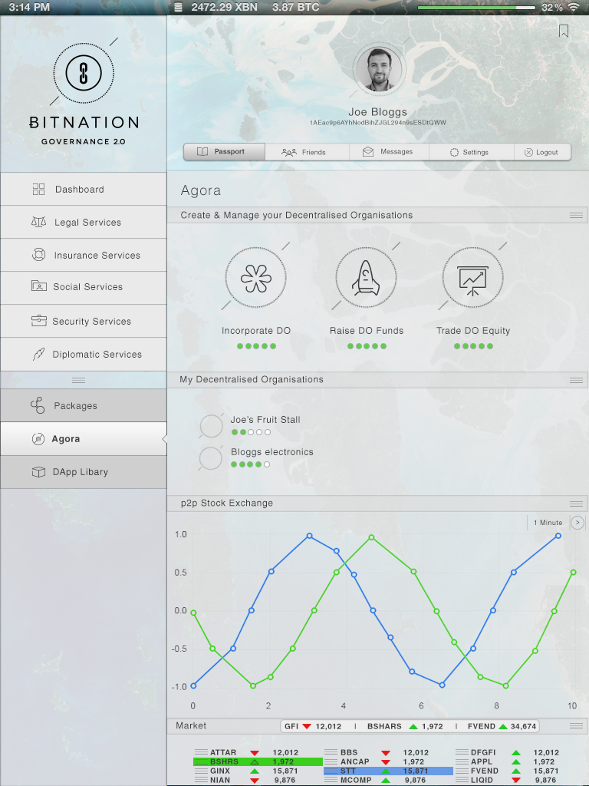

Technology: Bitnation will work closely with CounterParty and CounterWallet to enhance and adapt it for the specific audiences of Bitnation, and their usage (incorporation, equity trade). You can find the CounterParty code on GitHub here. CounterParty is a meta protocol on top of the Bitcoin Blockchain which offers the possibility to create meta tokens, and trade meta tokens.

Likely user scenario: Chayos is a fruit vendor in Bandung, Indonesia. He sells his fruit on a stand on the street. His ambition is to open a fruit shop. However, to expand his operation he needs investment. To get investment, he needs to be able to offer a security. Chayos’ option is to incorporate with the government which is time consuming, corrupt, expensive, and not particularly credible. The other option is that Chayos could instead incorporate on the blockchain through Bitnation. Through creating a ‘token’ e.g. a ‘currency’ he would automatically incorporate a Distributed Organisation (DO), and he could then use the crypto tokens - e.g. corporate DO equity, to sell it on the stock market like a public company. Alternatively he can use a partial equity release to crowdfund the expansion of his firm; empowering him to set-up the fruit store.


Mutual Insurance

Bitnation will partner with insurance services based on blockchain technology. We are seeing more and more grass root insurance organisations being established all around the world. Key features will include:

- Allows for pooling of resources amongst insurance members
- Facilitates bringing members and service providers together
- Peer-to-peer system allows members and providers to contract together without 3rd party involvement
- System provides for mutual agreement with minimal or no fees
What the mutual insurance covers:

- Health Insurance
- Unemployment Insurance (loan)
- Pensions

How the mutual insurance works:

Customers who subscribe to the mutual insurance will pay an extra transaction fee for all transactions they do on the Bitnation platform - from contracts to downloading/uploading DApps, through trading equity on Agora. The voluntary surcharge will be put in a mutual pot to cover insurance needs. The unemployment insurance will be in the shape of a loan to prevent abuse.

Additionally, Bitnation will cooperate with external insurance companies who can add extra layers of insurance through the Bitnation Dapp Library, should the customer require this.



Diplomacy

Key-features include:
- Public Diplomacy / Awareness
- Direct consultancy and when possible, negotiations

These services will not be blockchain based, and will be available post-2015; pending the successful expansion of the Ambassador Network.

Scenario 1: A South Asian country wants to ban the use of cryptocurrencies and blockchain-based smart contracts, which would affect the customers of Bitnation. Bitnation’s Diplomacy Service would start an advocacy campaign around the cause to raise awareness, as well as representing the cause of Bitnation’s customer directly to relevant authorities.

Scenario 2: Alice gets arrested in Turkey by the Turkish authorities while filming a demonstration with her cellphone. She contacts Bitnation who will assist in creating public advocacy for Alice cause, as well as using the local Ambassador network to identify possible people on the ground - local lawyers and authorities - who can assist in her case.

http://www.cs.rice.edu/Conferences/IPTPS02/101.pdf
https://bitcoin.org/bitcoin.pdf

