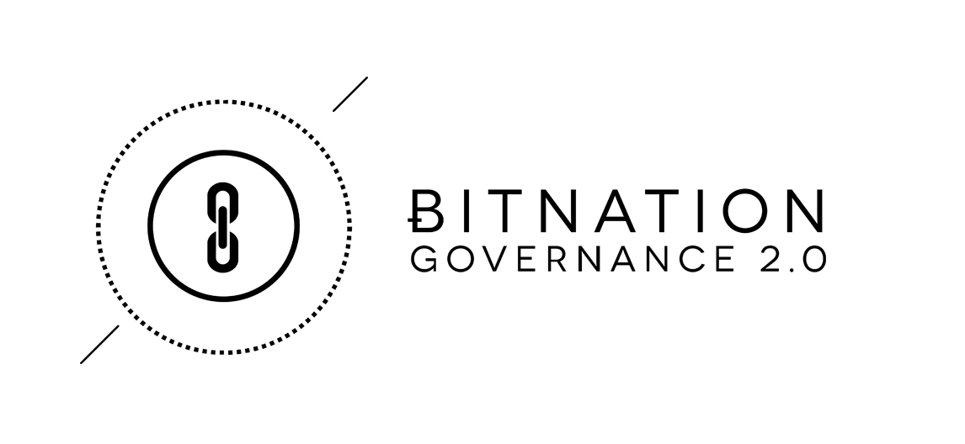
ɃITNATION Whitepaper

By Susanne Tarkowski Tempelhof
With thanks to, amongst others, Rick Falkvinge and Jason Farrell for comments, additions, and revisions.

Decentralized - Borderless - Voluntary - Nations (DBVNs)
ɃITNATION: Governance 2.0 > Borderless > Decentralized > Voluntary

This Whitepaper is open for community input - please give your thoughts and ideas through adding comments. Non-constructive comments will be removed. A final White paper will be produced, based on community input, after the crowd sale close, on January 10th, 2015.
- For more details on the BITNATION platform and services, please see the DEV Plan.
- For more on the BITNATION business strategy and financials, please see the BIZ Plan.
- For further information on the XBNX crowdsale, please see the TERMS Paper

Index
- Abstract
  - Governance 1.0
  - Governance 2.0

- Distributed Borderless Voluntary Nations (DBVN’s)
  - DBVN Definition

- BitNation
  - Bitnation Overview

- Bitnation Human and Regional Architecture
  - Ambassador Network and Embassies
  - The World's FIRST Self-Governance Co-creation Platform.

- Conclusion

- Abstract

1.1 The Current State of Affairs: Governance 1.0

Governance 1.0: We refer to governance 1.0 as the involuntary combination of governance and geographical territory. To clarify, a governance entity - democratic, authoritarian, theocratic or other type of entity - is a body which (successfully or unsuccessfully) claims a monopoly on violence over a specific geographic territory, and in return they commonly provide various degrees of governance services such as security, dispute resolution, and law enforcement to their subjects. More often than not, they also claim a monopoly on these services, even though the services themselves are often poorly executed or non-existent.

Geographic Governance Monopolies Throughout History.

Governments with geographic monopolies have been the rule through most of human civilization, their borders determined largely by the reach of their weapons technology. Since peoples within the borders of a city state, kingdom or nation state tended to have shared culture, history, language and values, with little means of communication outside their own communities, cohesion was relatively easy. In Europe, the Treaty of Westphalia (1648) established the nation state construct as the standard for governance in the West; spreading globally in the 19th century largely through imperial expansion. By the 20th century, the nation state had supplanted vast empires, as well as unincorporated territories and smaller ethnic states such as those in Italy and Germany; creating an of oligopoly of governance and claiming nearly every square meter of the globe (apart from Antarctica). The initial intention was to have mutually recognized borders and international institutions to resolve conflicts peacefully. However good the intentions may have been, with the rise of political elites creating just a semblance of political stability, the borders themselves became a source of conflict and resulted in fueling instability.

Compounding property rights and other governance issues is the fact that nation state borders continue to represent oppression to millions. The tensions created by arbitrarily drawn state borders are perhaps exemplified by the ill-conceived Sykes-Picot agreement (1916). During the last years of the ailing Ottoman Empire, international borders in the Middle East were crudely drawn pursuant to colonial interests of the period and have exacerbated ethnic and religious conflict. Even though the ongoing human tragedy exacerbated by the Sykes-Picot borders is clear to the world, changing decades-old international boundaries that are supported by political interests and international demand for stability is virtually impossible.

The Myth of Choice

Some suggest that individuals living in deplorable conditions are free to “vote with their feet” and move from one country to another to avoid oppression, famine, and other problems. This obtuse and simplistic remedy rarely proves so simple in reality, primarily because truly free and unencumbered movement between countries does not exist. For a farmer in the Central African Republic or a fruit vendor in Bangladesh, obtaining foreign visas or citizenship can be an insurmountable obstacle. Even when they do, they often find little changes from one government to the next.

Even in more prosperous countries such as the U.S., political stagnation may in large part be the result of the confines of nation-statehood. Politicizing government services and forcing conflicting political visions on a very diverse population has led the U.S. down the path of dysfunction, inhibited social mobility, higher debt and lower economic growth; it has driven a wedge between people who otherwise may have little reason for animosity.

Enormous swaths of the global population are forced to support laws and policies they may detest simply because political leaders can convince more than half the voting population of a nation state that preserving a miserable status quo is vital to their security or interests. In response, hundreds of separatist movements have gained traction and asserted a right to independence from central governments viewed as despotic, oppressive, or at least ineffective. The Arab Spring, the Scottish independence referendum, the Catalan independence movement, protests in Hong Kong, the growth of Islamic terrorist networks and nativist movements in Europe have all been the diverse symptoms of a global power struggle exacerbated by ossified nation states that have remained unwilling or unable to ensure economic mobility and political choice.⁴

The Impact of Globalization

The geographical monopoly on governance was perhaps easier to maintain in a time and age before industrialization and globalization happened. Now however, the course is largely irreversible; with the seemingly unstoppable move towards globalization, the world has become increasingly less geographically contingent -- through international trade, instant and borderless connectivity through communication channels like Internet, cheap transport, and large migrant movements. People are increasingly connected across borders, resulting in desires less defined by their geographical origin or location. In essence, this means that over time, nation states and their transnational counterparts such as the United Nations (UN) are becoming less relevant, and transnational institutions such as the United Nations (UN), in tandem with nation states due to being built on the same outdated, top-down monopolistic foundation. The Westphalia system has a “best before” date, and that day has arrived. Why should 7.125 billion people on Earth only be able to choose between perhaps a handful of different types of governance and without freedom of movement between those options? The limited choice of governance systems does not necessarily make sense to the modern global citizen. Enter the birth of Decentralized Borderless Voluntary Nations (DBVNs).

Enter the blockchain technology

Technology is changing human interaction almost faster than scholars, pundits and journalists can keep up with, resulting in the uniting of humans around the globe in an unfathomably complex web of relationships. New “borderless” nations are emerging: communities of people who live all over the world and who share common values, interests, and cultures. We believe that given the right opportunity, these new nations will thrive as geopolitical turmoil continues to constrict the old. With the release in 2009 of Bitcoin’s blockchain technology, enabling for the first time a way to verify transactions without a single authoritative third party, now may be the best time in human history to reassess our reliance on the traditional nation state - a form of governance that is growing outdated, and which is holding back human social and economic evolution.

The reason why the blockchain matters is because the blockchain transactional database has the basic record-keeping properties required of a governance system. Once the information is online, it exists forever on the network. The blockchain has a rigorous verification process that is virtually impossible to crack once the network reaches a certain critical mass. It can record births, marriages, deaths, property ownership, business contracts and a variety of other records traditionally created and held by governments. The identities of individuals on the network can be established definitively through their unique “signatures”, and in turn, those individuals can sign and verify transactions (e.g. the attending physician at your birth or the priest officiating your wedding). Instead of a government official acting as notary or other trusted third party verifier, the consensus of the blockchain now takes on that role.

It is well established that free markets improve quality and reduce cost, while monopolies are generally the subject of derision, a centralization of resources and authority. We believe that it is possible for today’s innovators to apply the competitive spirit of the marketplace to governance and forever end the power of monopolistic bureaucracies to squander resources, abuse authority, and oppress the powerless. By offering real choices rather than controlling and determining the outcomes through central government nation states, entrepreneurs can enable the reclamation of personal sovereignty and enhance their own autonomy.

A Better Future

To that end, BitNation proposes the creation of a platform that will enable the emergence of Decentralized Borderless Voluntary Nations (DBVNs). This platform is entirely open source and forkable, allowing practically anyone to create their own DBVN. We hope that BitNation will be only the first of many alternatives to traditional monopolistic governance to use blockchain verification qualities as a replacement for the “third party” authority hitherto monopolized by governments. We believe the establishment of property rights, marriage, incorporation, identification, dispute resolution and other governance services can be accomplished without resorting to abhorrent behavior such as bribery, exorbitant fees, politicization and coercion through arbitrary authorities. Beyond the aforementioned, the possibilities with DBVNs are both encouraging and virtually limitless.

1.2 The Change of Paradigm: Governance 2.0

Governance 2.0: We refer to governance 2.0 as the dissociation of geography and governance, as well as the voluntary choice between governance service providers. Governance 2.0 allows for a plurality of legal systems to compete on a free market offering more fair services to its member-citizens.

Modern society indicates patterns of behaviors that are not likely to drastically change in a Governance 2.0 context, leading to the assumption that:

- The majority of people do want various degrees of governance services; some want more and some want less, or none at all
- The majority of people want an easy choice of governance service providers - e.g. an end-to-end solution instead of having to chose between every single service provider themselves. Aggregation of services is a key part of the solution.
- Many people do not wish to leave their geographical area because of their attachment to their family, friends, work situation, and culture. Relocation should not be a requirement to choose your governance service provider.
- The existing blockchain technology enables governance 2.0 in its function of being a cryptographically secure public ledger.

Blockchain Technology from a Birds’ Eye View

The reason why the blockchain matters is because the blockchain transactional database has the basic record-keeping properties required of a governance system. Once the information is online, it exists forever on the network. The blockchain has a rigorous verification process that is virtually impossible to crack once the network reaches a certain critical mass. It can record births, marriages, deaths, property ownership, business contracts and a variety of other records traditionally created and held by governments. The identities of individuals on the network can be established definitively through their unique “signatures”, and in turn, those individuals can sign and verify transactions (e.g. the attending physician at your birth or the priest officiating your wedding). Instead of a government official acting as notary or other trusted third party verifier, the consensus of the blockchain now takes on that role.

- Distributed Borderless Voluntary Nations (DBVN’s) Overview

Hence, with the above parameters in mind, we have outlined DBVN’s as a concept -- and Bitnation as an enterprise.

2.1 DBVN Definition

As a ‘nation’ - providing governance services to its customers, the primary purpose of a DBVN is to provide an all-encompassing set of services through identifying and aggregating the best technology and service providers currently available, and then deliver it to the end user in a comprehensive package. However it differs from a normal nation-state government in the following ways:

Decentralized: Decentralization is the process of redistributing or dispersing functions, powers, people or things away from a central location or authority. In the realm of a DBVN, decentralization translates into both technological and human decentralization - through striving for P2P (Peer-to-Peer) technology, modular interfaces, API (Applications Programming Interface) layers, and forkable (duplicated) code. This means that every user can become its own node and transform the platform to their own liking.

Decentralization also benefits from not having any single point of failure in the event of an attack. Human nodes should be able to reorganize themselves in resilient nodes no matter what part of the network comes under attack - be it human or other technological factors. In practice, this means that various clusters, regional or otherwise, are entirely autonomous.
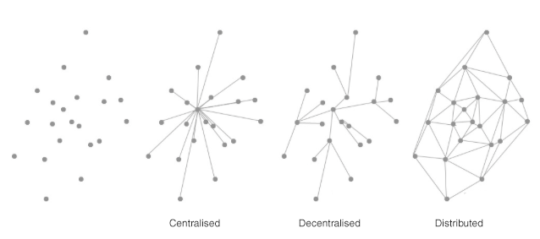

Borderless: DBVN’s do not limit their services to any specific geographical area, ethnicity or other categories of populations. They have no borders or ports of entry: no land boundaries, airports, coastlines, or seaports. DBVN’s provide services to all areas, regardless of where it is located.

Some would claim that a DBVN is ‘virtual’ by design. Although virtual-by-design is an intuitive assumption, it does not have to be based entirely in the virtual world, nor its services.

Voluntary: DBVN’s do not use force, fraud, or coercion, nor subject their citizens to involuntary servitude, peonage, debt bondage, or slavery. Due to the fact that DBVN’s are voluntary in nature, they are inherently free of persecution, intimidation, reprisals, and other forms of systematic violence. DBVN’s compete in a free market where customers, the “citizens” of the platform, voluntarily choose which DBVN’s they want to use-- including the option of using several DBVN’s, or none at all, or if they so choose to create their own DBVN.

Nation: The definition of a nation is the following: “A nation is a large group of people who share a common language, culture, ethnicity, descent, or history”. In the case of DBVN’s it is likely that people would be primarily connected through a mutual culture and lifestyle expectation.

A nation is a voluntary formation rather than a governing entity. This comports with our definition of a DBVN. We provide the tools for governance but do not impose them, nor do we impose any specific code of law or regulations.

In essence, our vision is to make the choice of governance service providers for individual users as easy as choosing to join a social network (Facebook, LinkedIn, Twitter, etc). Users can choose several of them or choose none. Users will also be able to create their own DBVN through forking the Bitnation source code.

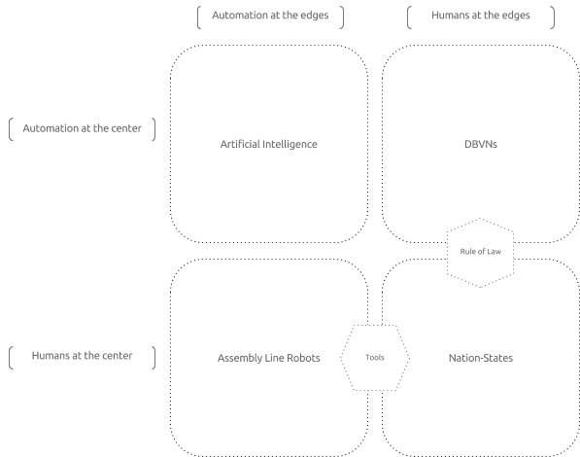

- Ƀitnation

Bitnation is a Decentralized Organization (DO), a for-profit entity incorporated on the Bitcoin Blockchain through the CounterParty technology. Bitnation will offer a platform which includes an ID System, a Decentralized Application (DAPP) Library, a dispute resolution mechanism, insurance, diplomacy and security services and more, mostly through offering a small transaction fee on selected DAPPS downloads and Smart Contracts.

Through making it non-geographical and voluntary, we create a market that is fast moving and competitive allowing for innovation and improvement which the current nation state system is incapable of. Bitnation will aggregate services, both in-house developed services like arbitration, blockchain incorporation, marriage. Additionally, Bitnation will aggregate external services like education, healthcare, security. Services will be available both as independent services and in a collection of packaged services.

Our services will be accessible on any blockchain that is compatible, including but not limited to Bitcoin and Ethereum. The functions of Bitnation will be as “blockchain-agnostic” as possible to mitigate the risk of a 51% attack¹ or poor maintenance of a single blockchain.

As far as we are aware, Bitnation is the first attempt to build a DBVN.

¹ Learn Cryptography, www.learncryptography.com/51-attack/

3.1 Ƀitnation Overview

Bitnation aims to provide services a traditional government provides, including dispute resolution, insurance, social services, security, diplomacy and various packages. Bitnation will identify the best technology out there for our governance services, as well as vetting suitable subcontractors for non-technical governance applications via diplomacy and security.

Bitnation will negotiate prices to buy services in bulk, therefore making it cheaper for its customers to purchase the services from Bitnation than directly from a traditional provider, with a greater vetting of user interface and support. As an organization, Bitnation stands by its principle of being “Borderless, Decentralized, and Voluntary” at all times, having transparency with its plans and finances, as well as solely using and developing open source code.

The key-functionalities of the Bitnation technological platform consist of a P2P browser, an ID System, a DAPP Library with an API layer where everybody can download DIY Governance DAPPs or upload and give away (or sell) their own DAPPs. The dispute resolution and smart contract function key functionalities as well - which supports many other parts of the governance ecosystem in the platform.

However, to clarify some commonly asked question with respect to what we intend to provide, or not provide -- Bitnation will provide:

- An ID system, including physical IDs, based on verification and reputation
- A dispute resolution mechanism with voluntary choice of code of law, and arbitrator
- Diplomacy, as far as global advocacy goes
- Security, as in tools for organising voluntary neighbourhood security systems

Bitnation will not provide the following functions or services:

- A diplomatically recognized “citizenship” enabling international travels (unless it reaches critical mass adoption)
- A code of law (choice of code of law is entirely voluntary)
- Physical law enforcement. Bitnation’s primary crime prevention method is its reputation system²
- A blockchain or a currency. Bitnation will rely on different blockchains, and will be using Bitcoin as the standard currency, and over time, move to accept other currencies such as Litecoin, Peercoin, Dogecoin, and other coins available on CounterWallet and digital currency exchanges.

Please find an overview of Bitnation’s six strands of service categories below. For more information on each individual services, see the DEV PLAN (attached). In this Whitepaper we will focus more on the human aspect of Bitnation, because the human network is a key-enabler of worldwide adoption of governance services; a largely self organizing network building the new and free societies locally, and internationally.

Bitnation is committed to identifying and aggregating the best technology available while working with industry leaders in the cryptology field to organize it into a comprehensible and user friendly platform delivered to the end customer. To that end, we are looking at technologies such as Codius Smart Oracles, CounterParty, Ethereum, Open Transactions and other so-called “Bitcoin 2.0” technologies, and Bitcoin meta protocols.

Bitnation is committed to the open source philosophy both in terms of the technology it uses, as well as in sharing all its code on GitHub (a repository web-based hosting service), for the community to improve, or fork. At its core, the Bitnation platform is NodeJS and JavaScript which makes it very modular and approachable for third-party developers.

Here are some ways which the Bitnation platform, and its DIY Governance DAPPs can be used:

- In emerging and frontier markets, governance services do not exist or are nearly impossible to use because of corruption and the endless red tape of bureaucracies. Yet these services are sorely needed; from deeding land, to corporate incorporation, mutual insurance, dispute resolution, and more. Imagine for example Ricardo who owns a house in the favela in Brazil, but due to government distrust and corruption he cannot deed it to protect it for his children’s future use and enjoyment. Once deeded, he can then invest in building on it, and he can use it to get credit to pay for perhaps setting up a company, or his children’s education.
- Imagine a phone salesman in Cambodia who can’t open a small back office company because it’s difficult to incorporate due to the significant bureaucratic red tape he has to overcome (the incorporation process takes an average of 104 days in Cambodia). But the phone salesman needs to incorporate to sell equity to raise funds, in order to make his vision come true. He can do that through the Bitnation platform, through creating a “coin” and each individual “coin” then becomes a cryptographically secure corporate equity entity, through filing a contract on the blockchain with the Shareholders agreement.
- Or take for instance a Christian family living in a country with strict Sharia Laws, who won’t settle their disputes in the local courts because they only cater to Sharia. The examples of where the existing systems in place, or the lack thereof, are preventing poor and middle-class people worldwide from enjoying political, social and economic mobility are endless!
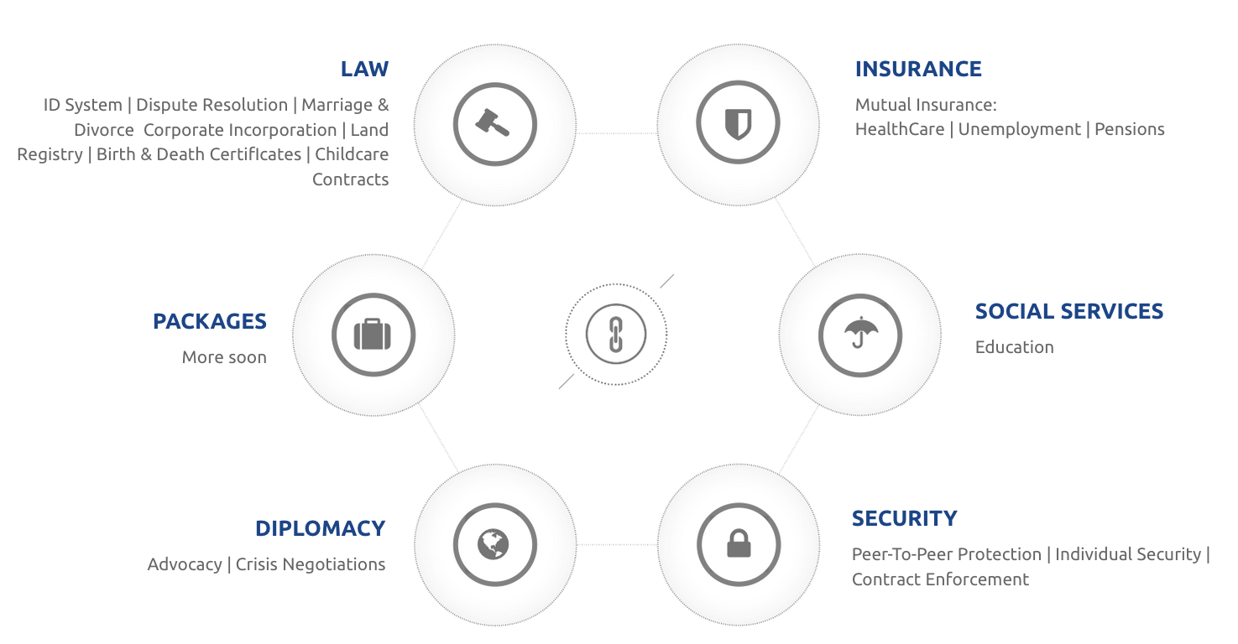

- Ƀitnation Human and Regional Architecture

The ‘human architecture’ of Bitnation through its implementation networks, are more important than its technology. The human architecture is key to its long-term organic survival not only as distributed technology, but also decentralized in its in-person implementation, usage, and development. Through the Ambassador Network and the Embassy hubs, Bitnation is creating a self-sustainable network of semi-autonomous and fully autonomous human nodes who can continue Bitnation’s work regardless if other parts of its structure, such as the management or development components, gets compromised security-wise.

Bitnation’s geographical adaptation strategy is aimed at emerging market and frontier market economies. Arguably, the services Bitnation offers are valuable all over the world, considering that they are more efficient and voluntary than services offered by traditional nation-state governments. However, the part of the world where they are most sorely needed is in the developing world, where either those services does not exist at all, or are so plagued by bureaucracy and corruption that they are generally not used by the population.

Système D

Further on, the regulatory landscape in the Western hemisphere (North America and Western Europe) may make it challenging to introduce new ideas because of the density of regulations already in place, and the capacity of the governments to enforce those regulations. Some recent examples of inventions facing regulatory hurdles are cryptocurrencies, car sharing services, and equity crowdfunding. We should expect that the greatest development of these technologies - although often conceived in the West - will reach mass adoption and perfection faster in the developing world - which may in turn push Western governments to adjust their own strategies, in order to stay competitive for its citizen as a desirable place to live; and in its place as leaders of the global economy. More precisely, we will initially target the so called “System D” Economy, an economy estimated to be worth 10 trillion dollars per-year², consisting of people living ‘outside of the system’ - mainly commercants who are unbanked, undeeded, non-incorporated, as mentioned in the introduction part of this document.

In the developing world, ethnic and religious minorities receive unequal access to government services; deprivation of essential services are even used to punish some groups, and governments as a whole have tended to put their own interests ahead of their citizens. Uneven access to basic services has led to the rise of the massive “shadow economy,” also called System D; an outlet for economic activity when doing business on the books has proven too expensive and impossibly complicated. System D is the second largest economic system in the world, after the U.S. economy, totaling over $10 trillion dollars annually. System D has proven much-needed relief from government oppressiveness around the world, with transactions occurring off the record, generally free of tax and regulatory burdens.

However System D also has an enormous drawback: entrepreneurs who circumvent sclerotic or corrupt government services may be able to engage in trade, but they are unable to secure government protection, legal guarantees and the financial benefits of property rights. Because of this, they are likewise unable to grow a business and capitalize on existing income. The longitudinal study by Hernando de Soto found this to be true on nearly every continent in the world.

Key-regions and countries are defined by its Bitcoin penetration, for two reasons - basic knowledge and understanding of cryptocurrencies helps with popularising the thought of the blockchain being used for other purposes. The second reason is because of the Bitnation Ambassador network - the implementation of the technology will be a lot easier with a lot of tech savvy Bitcoin Entrepreneurs on the ground. Countries with high Bitcoin usage are generally speaking either countries where remittance payments are a large part of the economy (Mexico, Philippines) or countries whose economy is highly unstable (Argentina, Greece, Cyprus etc). The Ambassadors will identify key-locations throughout Latin and Central America, Africa, and Asia for this purpose.

4.1 Ambassador Network

In alignment with the principles of borderless decentralization, autonomy and self-governance, we have structured our Ambassadors Network to enable a large number of volunteers to cooperate on common goals in quantities of people previously not possible before the arrival of the Internet.

The unique proposition of Bitnation’s Ambassador Network is to be the first socio-cultural context for the co-creation of a more humane and people-centered, rather than a money-centered, way of global governance. The Ambassador Network becomes the global social context of shared values, self-organizing direction, co-developing methods, and distributing best practices for all Bitnation users.

The purpose of the Ambassadors is to identify governance needs in their communities, help people discover (and understand) how to implement Do-It-Yourself (DIY) blockchain based solutions to resolve those problems.

We will work with each Ambassador to determine what success criterion we will use to assess their progress, what event constitutes success. Then we will aggregate resources to provide what they will need to get there. What we are offering Ambassadors is the opportunity to capitalize on the ground floor potential of becoming the global team of autonomous people co-creating.

A Self-Governance Co-creation Platform.

Think of it this way...Most of us already are fully engaged in “co-creating” through our use of three of the World's biggest social networking platforms - Facebook, Twitter and YouTube. What we have not been doing yet, however, is capitalizing on those engagements.

All three aforementioned platforms deliver tremendous value to each and every one of us. It should also be noted that when we spend time on these platforms; we are not just users (as in passive consumers), but we are the actual creators and producers of the value that these platforms deliver. In other words, we have already co-created the value the owners of these platforms capitalize. Value/money is acquired from the creative and social value of our content which these platforms sell to advertisers who want to sell their products and services to us.

We have already co-created the Facebook, Twitter and YouTube content their respective stockholders have capitalized into billions. But again, we the content creators, have yet to capitalize on those engagements. The time has come for us to begin to consciously and purposefully engage in capitalizing our collective creativite potential as our new way to attain, beyondmonetary wealth, a more socioeconomically evolved and personally fulfilling way of governance.

Ambassadors and Embassies

Hence, the Governance 2.0 adaptation strategy of Bitnation is through its partners in the field, the Ambassadors, and the Embassies. The Ambassadors are volunteer Bitcoin Enthusiasts across the world. The most important type of Ambassador is the ‘Ambassador Entrepreneur’ who will actively go out and look for governance problems in his community, and find ways to solve them through the blockchain DAPPs (Distributed Applications).

The Ambassador Entrepreneur should be motivated by social good, as well as the opportunity to create his own businesses and make money through the DAPPs, or in other ways.

The other category is the ‘Advocacy Ambassador’ someone who is not an entrepreneur but who is passionate about the cause of bitcoin and voluntary blockchain governance, and who wish to promote it in their circles, or to the media, or lobby for the sake of Bitcoin/cryptocurrencies and Bitnation. For instance if a country want to change the legislation to make it harder for Bitcoin exchanges or markets, the Advocacy Ambassador will assist in this region.

The third category of the Network is the ‘Support Ambassador’ e.g. people who are happy to help other people in the network with their expertise, like local legal systems, management tools, social media, etc. The Support Ambassador is more of an internal network support operator with a distinct skillset that helps the other Ambassadors, particularly the Ambassador Entrepreneur.

The ambassadors will conduct different activities like polling, workshops, meetups, outreach, as well as other activities. Through those activities the ambassadors will meet other enthusiast and entrepreneurs, who will form nodes of entrepreneurs and organize themselves into local hubs. These hubs will be entirely independent and self-organized entity, that make their own profits, but they will be supported by Bitnation in terms of being able to tailor DAPPs to their location, get communication resources to help them market their DAPP’s as well as organization resources. In rare occasion, Bitnation may also help to fund the Embassies. In reward for the support work, Bitnation get a larger user base for its DAPP library, as well as more data to better design locally tailored DAPPS. (see table below for more information)

In order for the network to efficiently build and manage itself in a holacracy manner, well described by Rick Falkvinge in the book Swarmwise. Swarmops was first used to build the Pirate party Network, which started as one political party in Sweden called Pirat Partiet, and grew to a worldwide movement of political parties - with a staggering amount of 70 Pirate Parties around the world, with multiple representatives in governments.

Swarmops is a HR system built for voluntary, decentralized cooperative organizations. It pushes authority and decision-making power to the edges by design, and is built on the philosophy that everybody in an organization is, at least in some aspect, a volunteer for that organization’s goals. By decentralizing authority, HR, and finance, Swarmops makes it possible to scale an organization far beyond traditional methods. This philosophy of power through voluntary collaboration also aligns very well with Bitnation’s core values.

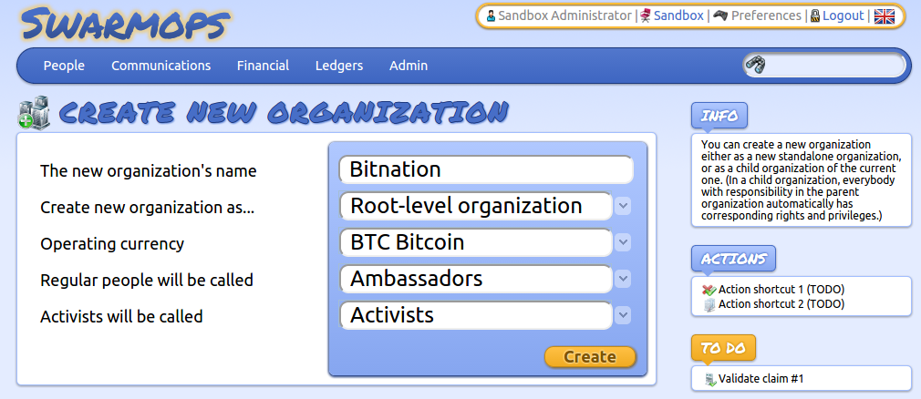

Using Swarmops, the Ambassador network can scale organically across the globe, from regional level down to city level, increasing in density dynamically as interest picks up in a location without central planning, approval, or intervention. As new Ambassador candidates rise to prominence through their actions and visibility, they can be assigned formal recognition in the Ambassador network in a completely decentralized process, without any bottlenecks or centralized approval requirements. In this way, the Ambassador network is expected to quickly grow to a point-of-contact network where you can always ask local people for a way in to Bitnation, looking from the viewpoint of a future client. This network also becomes a Bitnation-internal network of people across all geographic levels - city, region, continent. Swarmops handles this through its basic philosophy and its core functionality.

Swarmops runs on free software, and is free software itself, further aligning well with Bitnation’s core values. It is also going to handle Bitnation’s cryptocurrency-based accounting and provide complete transparency as well as large-scale inclusion, providing easy access to resources for the Ambassador network.

Typical ambassador activities consist in:

- Meetups with other governance 2.0 and blockchain technology enthusiasts
- Workshops with local community members
- Polling - qualitative and quantitative to better understand local governance needs
- Videos: record local workshops
- Blog posts: write occasional blog posts on local challenges and solutions
- Virtual meetups with the international Ambassador network to share ideas and experiences
- Helping other Ambassadors in the international network with advice and support
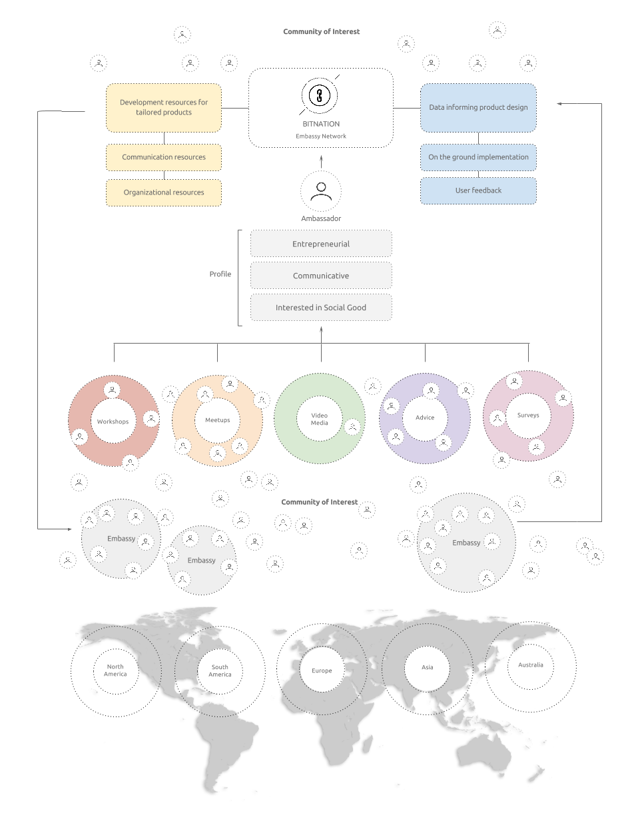

- Conclusion

The challenges facing Bitnation and DBVN’s at large are many, both in terms of technological obstacles, adaptation challenges, and in some cases; legal concerns. It is fair to assume that it will be a bumpy road for the next decade ahead if or when DBVN’s have reached critical mass adoption on a global level.

The technological challenges will be primarily that of the tradeoff between security and mainstream accessibility. To understand what matters most to our customers will be a continual work in progress. Maintaining the quality of services at a time of rapid expansion will also entail further challenges. We are working diligently to mitigate that risk by keeping a large pool of talent engaged and available in our ecosystem.

Adaptation challenges consist in the initial educational process of advertising blockchain technology as a secure public ledger, second will be in regional cultural adaption. Bitnation counts on its Ambassador Network to mitigate this transitional period which we admit will have its initial challenges with great global rewards.

Maintenance of the system and the quality of the services requires a sound monetization strategy which is sustainable long-term, but does not make the services inaccessible to anyone regardless of the reality of their economic situation. The most intuitive way to monetize Bitnation and DBVN’s in general is to charge a minimal transaction fee for transactions on our platform. However the monetization strategy may change over time after having been tested in the market, assessed, and fully analyzed.

Despite all the above known and unknown challenges, the Bitnation team is very optimistic about the future of DBVNs. We believe that the time has come for a new, voluntary, and decentralized governance paradigm. We believe using open-source technology and distributed networks are the most effective way to bring that change into fruition. We believe the value of our services we provide to customers, the improvements it means in their daily lives will be worth all the risks and will lead us to a successful future both for Bitnation, and for all of humanity. Joins us in the Governance 2.0 paradigm.

Ƀitnation is… Borderless. Decentralized. Voluntary.

-----------

From an anonymous forum post on bitcointalk.org:

We are CryptoLand (Ƀitnation).
We are the Birth of a New Virtual Nation.
We are a Future for Our World and Humanity.
We are Sentinel, Universal and Inalienable.
We are Rights and Freedoms.
We are Tolerant and Accepting.
We are Polity and Entity.
We are Privacy and Security.
We are Openness and Transparency.
We are a Dream and a Reality.
We are CryptoLand (Ƀitnation).

http://www.npr.org/2014/06/25/325503790/journalist-dexter-filkins-explains-bitter-consequences-of-iraq-war ⁴ (enter ref to free world report)
http://www.forbes.com/sites/benzingainsights/2011/11/07/rise-of-the-shadow-economy-second-largest-economy-in-the-world/
https://en.wikipedia.org/wiki/Hernando_de_Soto_Polar

