Assignment of Web Technology

Submitted By.
Presha Gautam
BCA 5th

Entrance Exam Registration Form

Introduction
This assignment involves creating an online registration form for students applying for an entrance examination. The form collects essential information such as personal details, contact information, and exam preferences. JavaScript validation is implemented to ensure that all data entered by the user is accurate and complete before submission. The form includes fields for full name, date of birth, age, phone number, email, gender selection, exam stream selection, and a confirmation checkbox. This helps in maintaining data integrity and preventing invalid submissions.

Code Snapshot
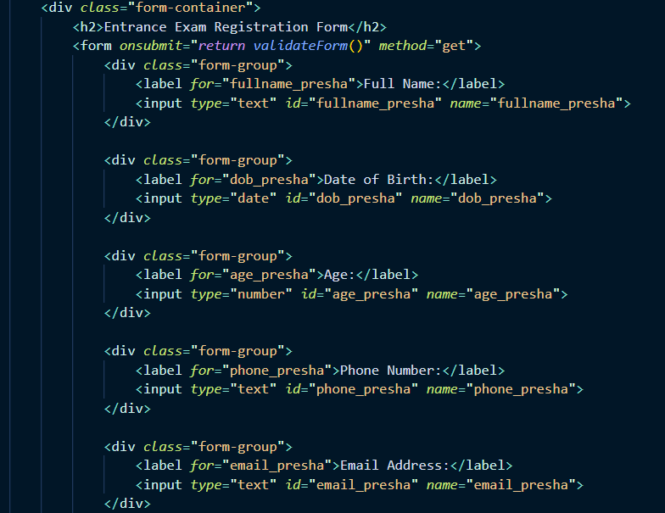

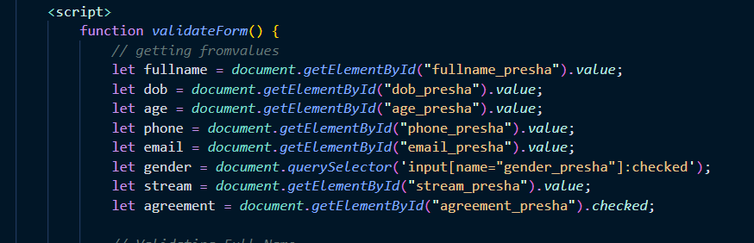

Output Snapshot
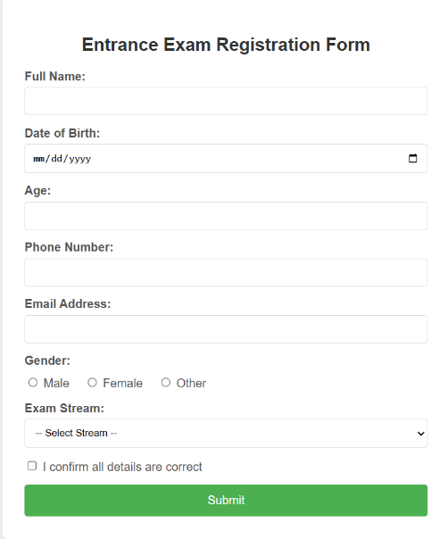

Conclusion
In this assignment, a comprehensive entrance exam registration form was successfully created using HTML and JavaScript. The form implements robust validation rules including name format checking, age range verification, phone number pattern validation, email format validation, and mandatory field checks. Upon successful validation, the form displays a success message and automatically refreshes after 5 seconds. This project demonstrates the importance of client-side validation in web forms and helps in understanding how to create user-friendly registration systems.

Student Mark Sheet Generator

Introduction
This assignment focuses on developing a student mark sheet generator that automatically calculates academic performance metrics. The system takes input of student information and marks in three subjects (English, Math, and Science), then processes this data to generate a comprehensive mark sheet. The form validates that all marks are within the valid range (0-100) and ensures no field is left empty. The generator calculates total marks, percentage, assigns grades based on performance, and determines pass/fail status according to specified criteria.

Code Snapshot
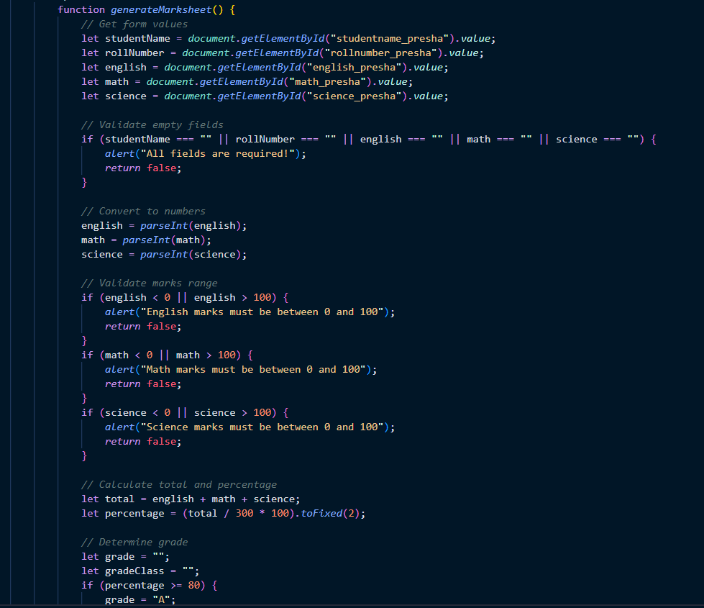
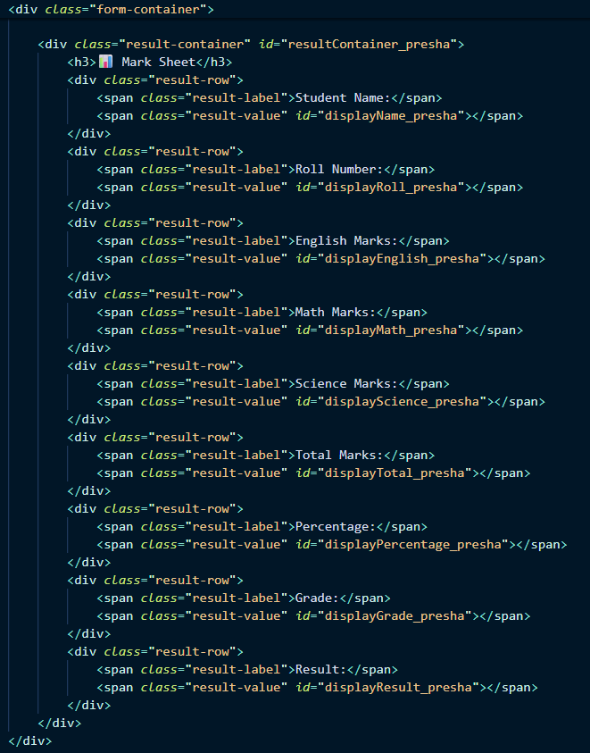


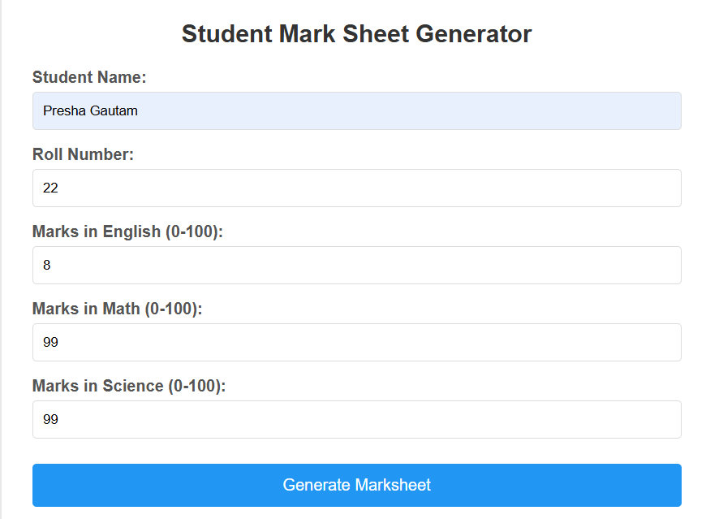
Output Snapshot

Conclusion
In this assignment, a functional mark sheet generator was created that successfully processes student academic data. The system correctly calculates total marks, percentage, and assigns appropriate grades (A for ≥80%, B for 60-79%, C for 40-59%, and Fail for <40%). The pass/fail determination ensures that students must score at least 40 marks in each subject to pass. The result is displayed in a well-formatted mark sheet with color-coded grades. This task enhanced understanding of JavaScript calculations, conditional logic, and dynamic content display in web applications.

SIM Card Registration Form

Introduction
This assignment involves creating a digital registration form for a telecom company's SIM card activation service. The form is designed to collect necessary customer information required for SIM card registration as per regulatory requirements. It includes fields for personal identification, contact details, service preferences, and legal agreements. JavaScript validation ensures that the user provides valid information including proper citizenship documentation, age verification (18+), and acceptance of terms and conditions. The form supports both prepaid and postpaid SIM card registration.

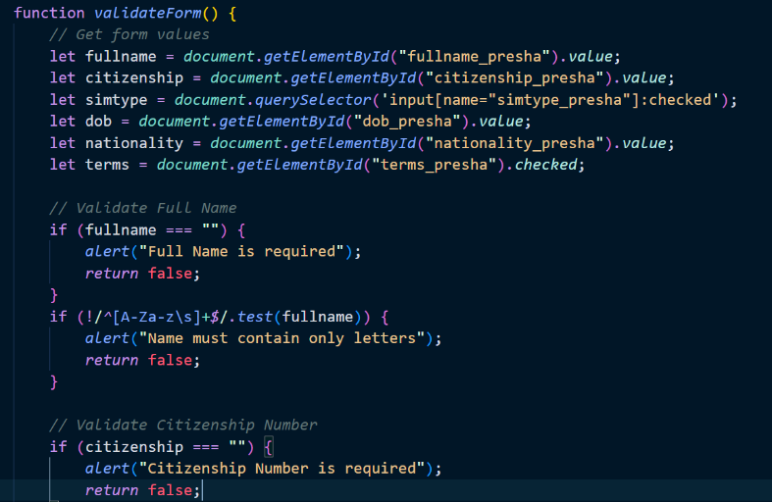
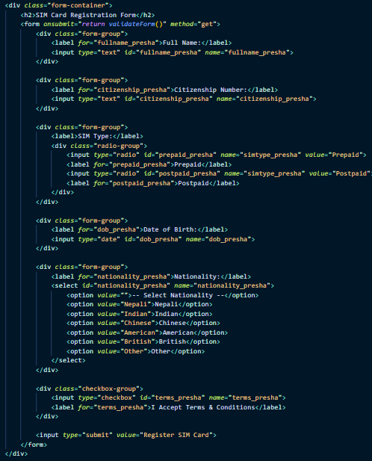
Code Snapshot

Output Snapshot
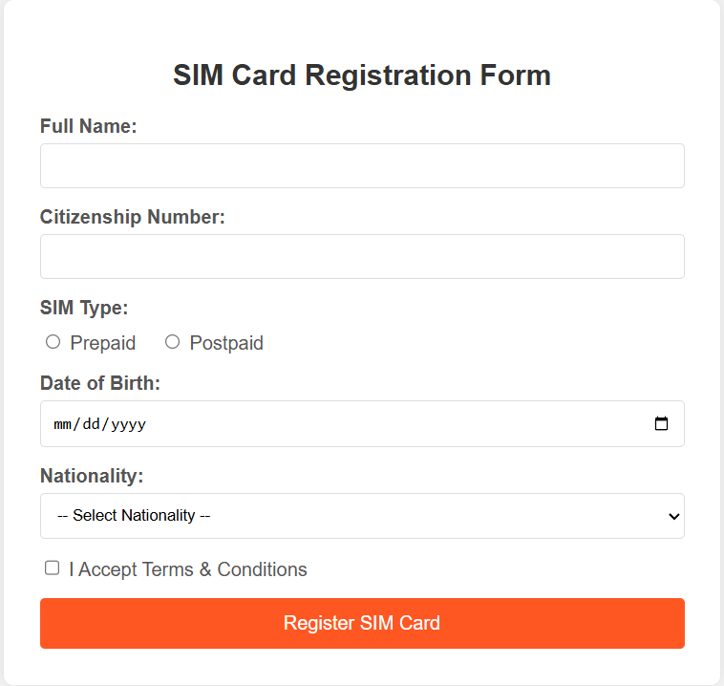

Conclusion
In this assignment, a complete SIM card registration form was successfully developed with comprehensive validation. The form properly validates that the customer's name contains only letters, citizenship number meets the minimum length requirement, the customer is of legal age (18 or above), and all mandatory fields are filled. The radio button selection ensures clear choice between prepaid and postpaid services. This project demonstrated the practical application of form validation in real-world business scenarios and the importance of data verification in telecommunication services.

Online Course Enrollment Form

Introduction
This assignment focuses on building an online course enrollment system for an educational platform. The form allows students to register for various online and offline courses while providing information about their background and learning preferences. A key feature of this form is the dynamic display of additional fields based on user input - specifically, the experience details section appears only when the student indicates they have previous experience. The form validates email format, ensures proper course selection, and checks that all required information is provided before enrollment.

Code Snapshot
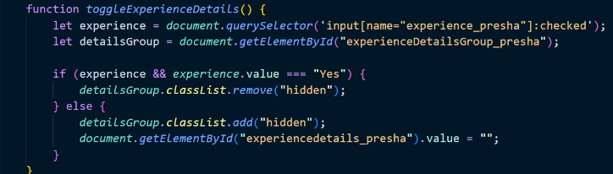
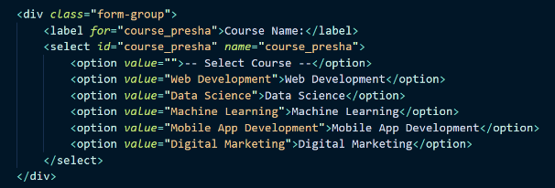

Output Snapshot
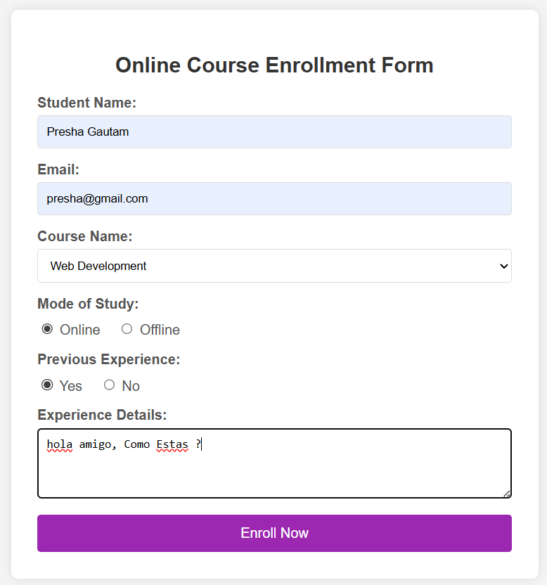

Conclusion
In this assignment, an interactive online course enrollment form was successfully created with conditional field display functionality. The form implements dynamic behavior where the experience details text area appears or disappears based on the user's selection of previous experience. All validation rules work correctly including email format verification, mandatory field checking, and conditional validation for the experience details field. This project enhanced understanding of dynamic form behavior, event handling in JavaScript, and creating interactive user interfaces that adapt based on user input.

Hospital Appointment Booking Form

Introduction
This assignment involves developing a hospital appointment booking system that allows patients to schedule their medical consultations. The form collects patient information including name, age, contact details, preferred department, appointment date, and time slot. An important feature of this system is the validation that prevents booking appointments in the past, ensuring that only future dates can be selected. The form validates phone number format, department selection, and ensures all required information is provided. Upon successful booking, a confirmation message displays all appointment details to the patient.

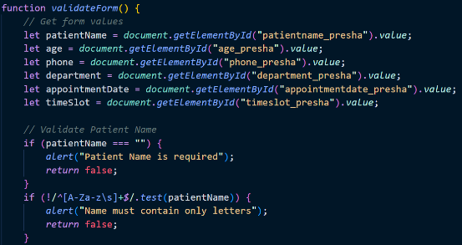
Code Snapshot
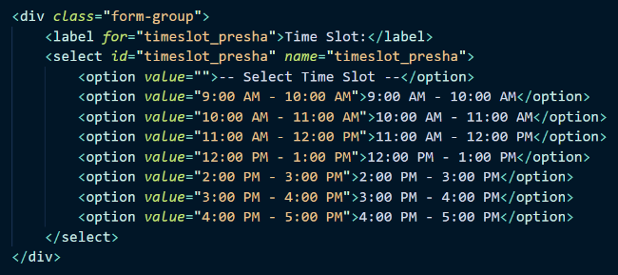

Output Snapshot
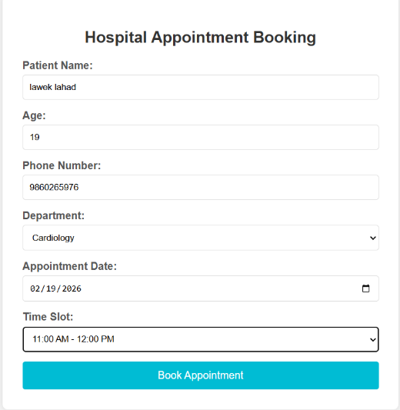

Conclusion
In this assignment, a functional hospital appointment booking form was successfully created with comprehensive validation and date-time handling. The form properly validates that appointment dates cannot be in the past by comparing the selected date with the current date. Patient name validation ensures only alphabetic characters are accepted, and phone number validation confirms the 10-digit format starting with 98 or 97. The confirmation alert displays all booking details including patient name, department, date, and time slot. This project demonstrated practical application of date handling, form validation, and creating real-world booking systems using HTML and JavaScript.

