WV Nation-wide Eclipse Ballooning Project

Mission - System Concept and Requirements

03/20/2023

Trinity Christian School (TCS)

200 Trinity Way

Morgantown, WV 26505

+1 (304) 360-8082

[mfisher@tcswv.org](mailto:mfisher@tcswv.org)

Version: DRAFT

Table of Contents

Problem Statement and Mission Goals 3

Development Approach 4

Domain Model 5

Logical Architecture 6

System-level Use Cases 7

System Requirements 8

Mission State Machine 9

System Behaviors within each State 10

PreFlight Phase 10

Launch Phase 12

Ascent Phase 13

Descent Phase 14

Recovery Phase 15

Launch Hold 15

Safe Hold 16

Monitor Mission Commit Criteria 17

Send and Retrieve Data 18

Subsystem Requirements 19

Ground System Requirements 20

HAB Requirements 20

Launch and Recovery Team Requirements 20

Mission Control Requirements 21

Interface Requirements 21

Failure Modes and Effects Analysis 21

Glossary 23

# Problem Statement and Mission Goals

Building on the highly successful NASA and NSF-sponsored National Eclipse Ballooning Project (NEBP) implemented during the 2017, 2019, and 2020 total solar eclipses, this new effort will broaden participation of STEM learners by immersing teams from a wide range of higher education institutions in an innovative NASA-mission-like adventure in data acquisition and analysis through scientific ballooning during the 10/14/2023 annular and 4/8/2024 total solar eclipses.

At sites along the 2023 and 2024 eclipse paths, student teams will design, develop, operate, and retire high-altitude balloon system to live stream video to the NASA eclipse website. Additionally, the flight balloons will observe in situ perturbations in atmospheric phenomena and conduct individually designed experiments.

The goals for the West Virginia (WV) NEBP include:

1. To provide real-time video of the solar eclipses from the stratosphere to NASA web sites.
2. Acquire stratospheric science data during solar eclipse

The mission concept is depicted in figure 1 in which we will have a high altitude balloon that communicates its position with the Iridium satellite systems, which in turn will allow ground personnel to track the balloons position. The high altitude balloon system will live stream video to the ground system who in turn will upload the stream to NASA website. The ground system will also be able to command the high-altitude balloon system via the Iridium satellite system.

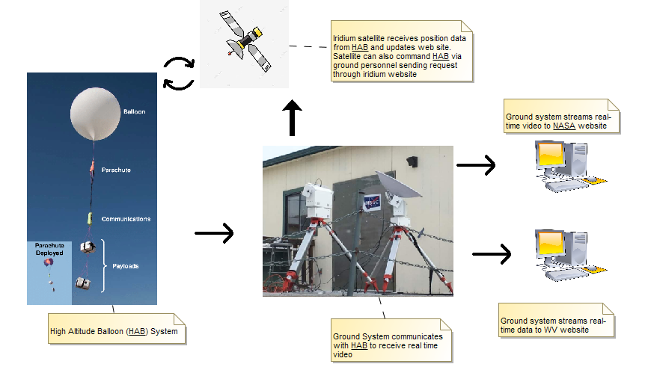

Figure 1. Mission Concept for the WV Eclipse Balloon Mission.

Figure 2 identifies the stakeholders, those that can affect or are affected by this mission. They include the Federal Aviation Administration (FAA), National Aeronautics and Space Administration (NASA), our Principal Investigator on the Nation-wide Eclipse Balloon Project (NEBP), and our WV students and community that we are trying to engage.

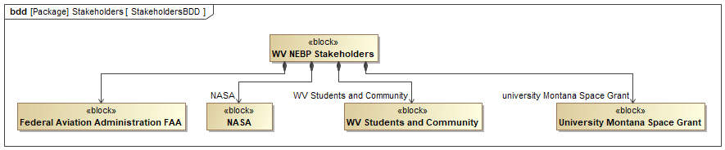

Figure 2. Stakeholders

Taking into consideration these stakeholders will allow the WV team to fully understand any requirements that may not be explicitly called out technically. For example, the FAA has numerous regulations constraining atmospheric flight that need to be taken into consideration.

# Development Approach

The development approach taken was to follow a model-based system engineering (MBSE) approach to defining the mission and subsequently the system needed to realize the mission. As context, several hardware components have already been selected and are being provided by Montana State University. As such, this is not a typical development approach that explores “what” subsystems are needed in order to solve the problem and goals. Instead, this systems engineering process TCS is following is better described as a way to better understand “how” the chosen hardware items fit into the system as a whole in order to solve to the problem and mission goals.

Our team at Trinity Christian School (TCS) utilized the problem statement, mission goals and stakeholders to develop a domain model using a Block Definition Diagram (BDD). The MBSE language being used to represent modeling elements is the Systems Modeling Language (SysML). The BDD, section 3.0, depicts the systems that make up our system as well as it establishes the boundaries of our system and needed interfaces with external systems.

Using the domain model from section 3.0 we developed a logical architecture for how the various subsystems within our system could interact, section 4.0. Taking this approach clearly establishes the needed interfaces among subsystems internal to our system. This perspective is paramount in understanding the selected subsystems and how they are going to communicate, if they interact, during a mission. Since this mission is composed greatly of already selected hardware components this viewpoint enables teams to understand how the selected components fit into the bigger picture.

Using the domain model and logical architecture we then established the system-level use cases, section 5.0, that present how the system is going to be used once it is built. This is one of the last steps utilized to gain insight into how the system would be used so that we could better understand WHAT features our system needs to perform to realize a successful mission.

Using the problem statement, goals, stakeholders, domain model, interfaces, logical architecture, and use cases we then specifically identified all the system requirements and they are presented in section 6.0. One can logically use the requirements perspective and should be able to answer the question that this set of requirements captures all of the needs identified in the previous modeling elements. That question is one of the questions we will ask during the review of this engineering artifact.

Section 7.0 presents the mission state machine and section 8.0 presents the behaviors of the system within each of its states. The state machine represents the phases that our mission will go through, with the word phases substituted with “states”. The Activity Diagrams in section 8.0 reveal the details for what the system is actually achieving while in each of its states. It is these two perspectives that need to be verified because they are essential in (1) ensuring that we have identified all the needed system requirements and that we have captured them in section 6.0 and (2) they are used to help refine the requirements in section 6.0 and allocate them to subsystems within our system. Section 9.0 presents the requirements that have been identified for each of the specific subsystems in our system, or each of the subsystems modeled in section 4.0 our logical architecture.

# Domain Model

Figure 4 represents the domain model for the WV mission. This domain model shows which systems make up our system and which systems are out of scope. For example, our system needs to communicate with the NASA web server to upload video, our system needs to communicate with the Iridium satellites, and our system needs to communicate with the FAA Air Traffic Control (ATC) facilities. None of these systems are within scope and need to be developed by our mission, however our system needs to be able to interact with them.

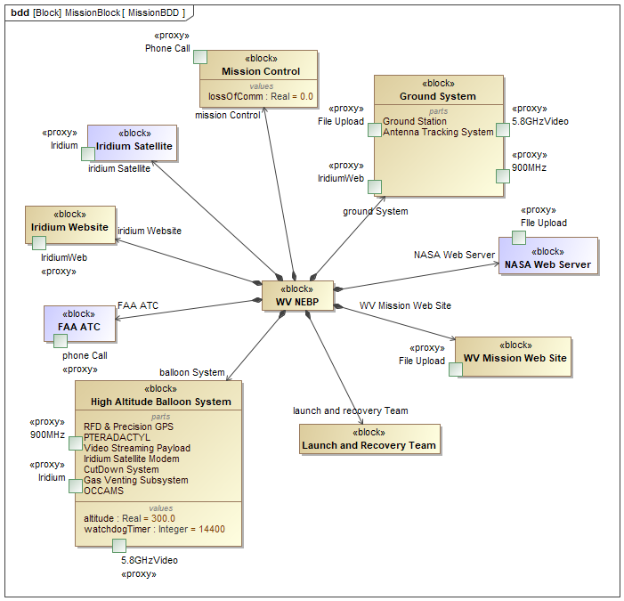

Figure 4. Block Definition Diagram for the WV Nationwide Eclipse Balloon Project. Purple colored blocks indicate that they are out of scope of development.

# Logical Architecture

The logical architecture for the WV NEBP System is depicted in Figure 5. The model shows how the subsystems that make up the overall system are connected together and interact. For example, one can see that for this system there will be a Mission Control component that will interact with the FAA ATC via phone calls. Additionally, the model shows that the ground system interacts with high altitude balloon system over two communication paths, one at 5.8 GHZ and the other at 900 MHZ.

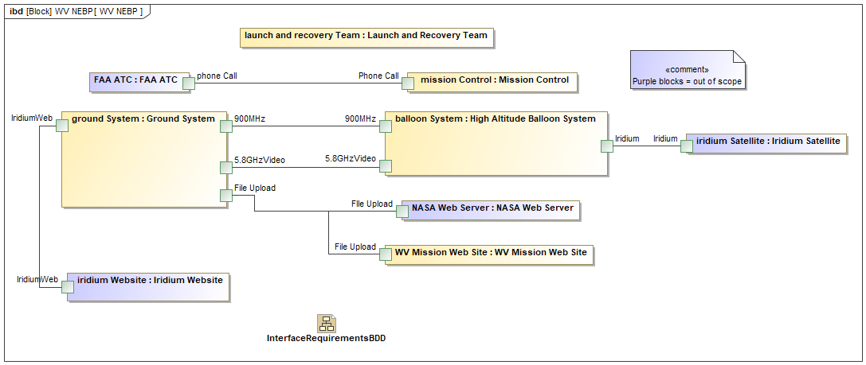

Figure 5. The logical architecture for the WV Nationwide Eclipse Balloon Project. Purple colored blocks indicate that they are out of scope of development

It is this domain model and the logical architecture that identifies the external and internal interfaces for our system, which must be technically managed rigorously since the majority of mission ending failures occur within its interfaces. Our system has the following three external interfaces:

* Mission Control (MC) to FAA ATC
* High Altitude Balloon (HAB) System to Iridium Satellite System
* Ground System (GS) to NASA Web Server

Our system has the following internal interfaces:

* GS to WV web server to upload data
* HAB to GS for video downlink on 5.8 GHZ
* HAB to GS for RFD and Precision GPS data on 900 MHZ
* GS to Iridium website for issuing commands to HAB (aka bent-pipe commanding)

# System-level Use Cases

Using section 1 the problem statement, goals and stakeholders, along with section 3 and 4 the domain model and the logical architecture the team explored various “uses” or ways in which the system will be used during the solar eclipse missions. These uses are captured in the Use Case diagram represented in Figure 6.

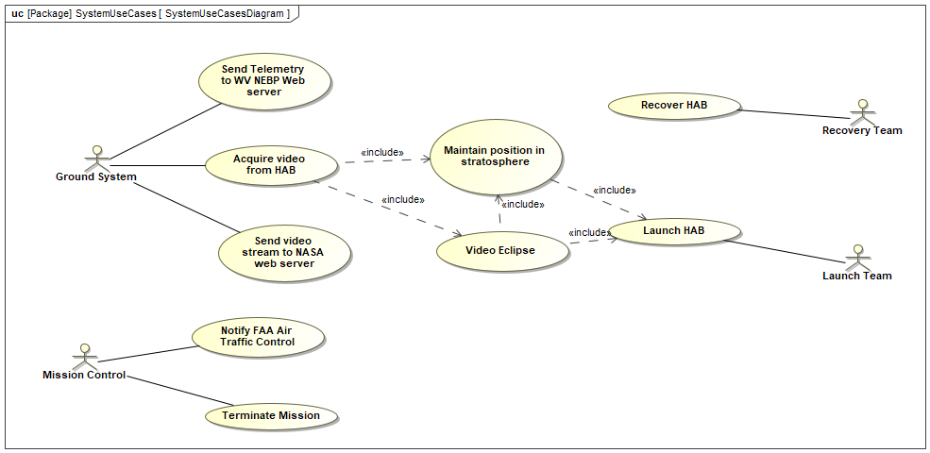

Figure 6. System Use Case Diagram depicting the various use cases for the system needing to be developed

It is a combination of these use cases along with the domain and architecture models that enable us to understand the high-level system requirements for the WV NEBP mission.

# System Requirements

In using the previous sections, the team was able to extract and identify the following set of system requirements for the mission. The team is claiming that this is a complete and accurate set of required functionality that is needed in order to realize a successful mission. Figure 7 encapsulates all the requirements that have been identified.

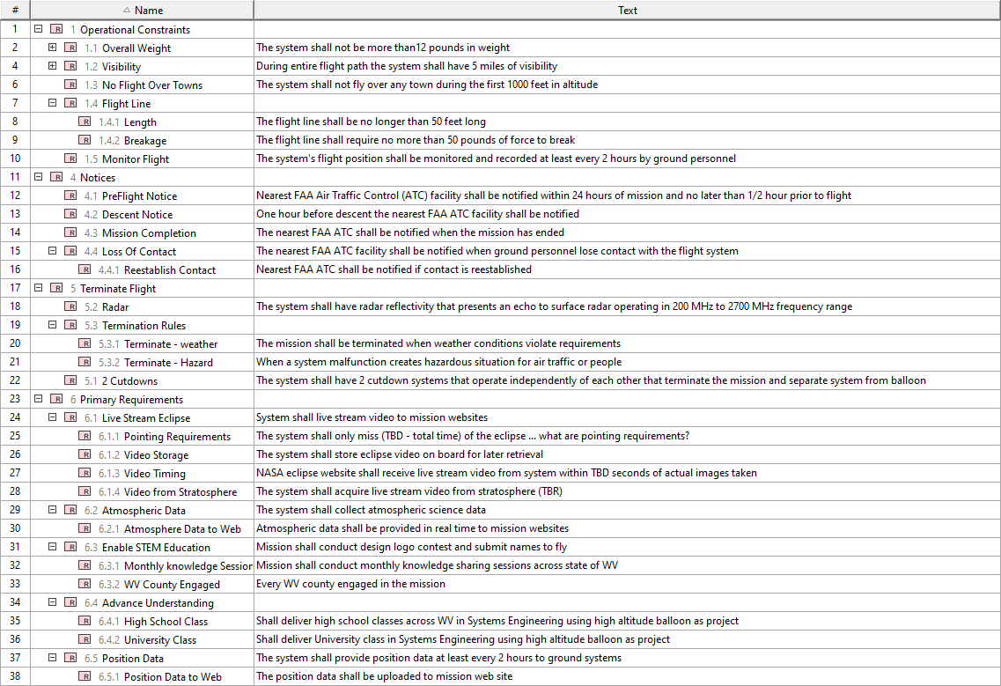

Figure 7. The system-level requirements for WV NEBP Mission

# Mission State Machine

Using the set of requirements identified in Section 6, along with an understanding of the system as represented in sections 1, 3, 4, and 5. A mission state machine was developed that depicts the various phases that our system will go through and operate within during the mission. Figure 8 depicts this state machine.

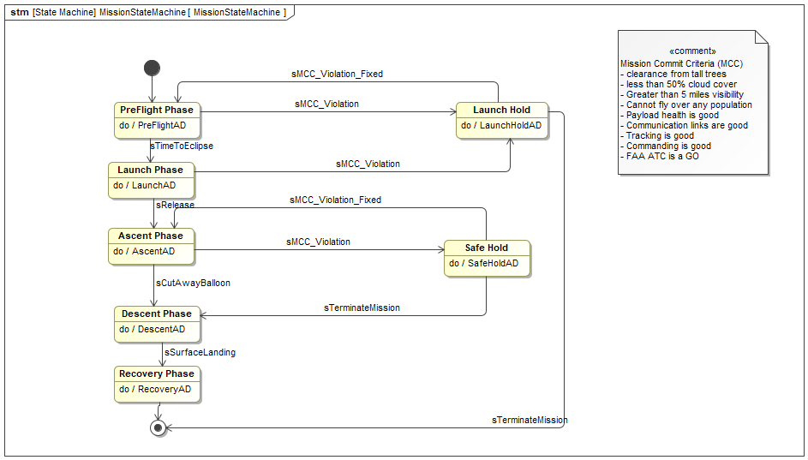

Figure 8. State Machine for the WV NEBP mission

In reading the state machine one can see that the mission starts off in the PreFlight Phase. While in the PreFlight Phase the system is executing functionality called “PreFlightAD”. Additionally, while in PreFlight Phase our system can leave this phase in one of two ways. There can be a sMCC_Violation event that causes the system to transition to the Launch Hold state. Or the sTimeToEclipse event can occur and the system will transition to the Launch Phase state.

Each state within this overarching mission state machine is further defined in Section 8.

# System Behaviors within each State

Each of the states within the Mission State Machine, see section 7.0, are further defined within the following subsections.

## PreFlight Phase

During the PreFlight phase you can see various activities going on by the system. After the system is powered on and initialized you can see three parallel activities are kicked off. The system begins sending data, the system starts monitoring mission commit criteria, and the balloon is filled with Helium.

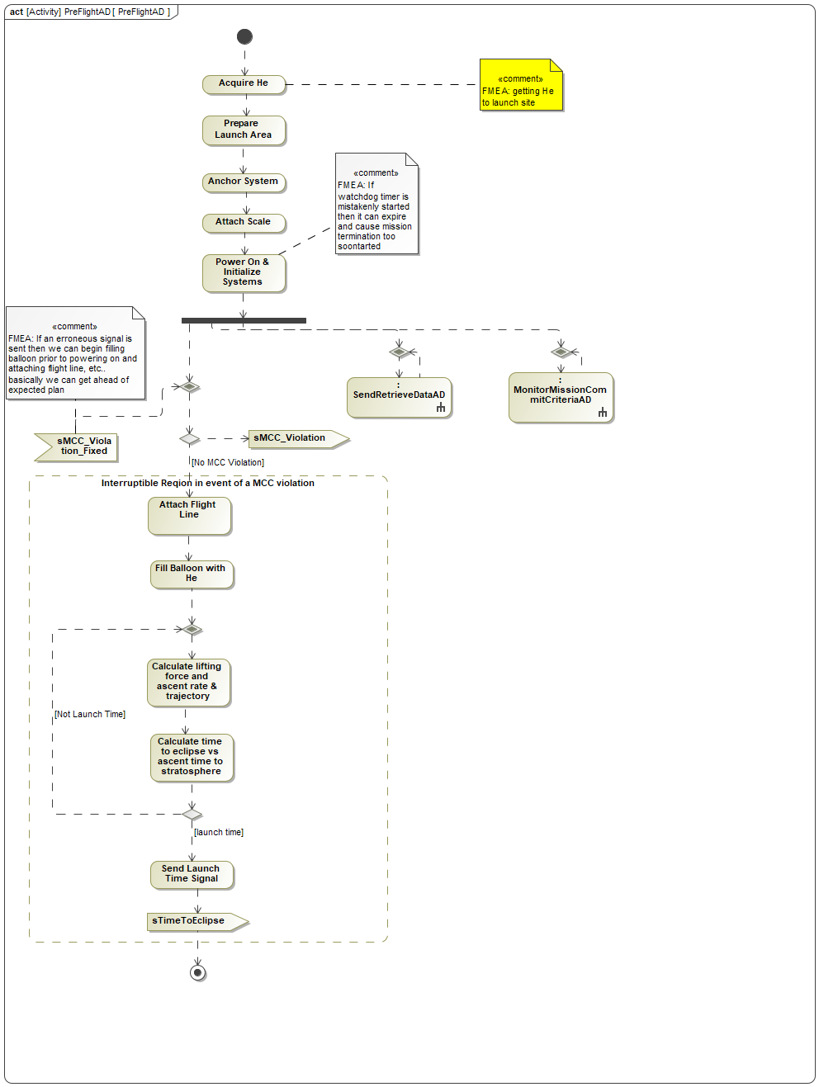

## Launch Phase

The Launch Phase state is represented by the system performing the following activities, the watchdog timer needs started and again three parallel activities are started sending and retrieving data, checking mission commit criteria and the timer counting down. It is critical that we do not have any mission commit criteria violations prior to releasing the balloon. That is why there are guards in place to make sure we have good communications between the GS and HAB, between HAB and Iridium Satellite system, and to make sure we have good weather conditions, good lifting force, and that payloads are healthy. Once we know we do not have any mission commit criteria violations then we can literally release or launch the balloon system. If we have any violations in the mission commit criteria then we can transition the system from the launch phase to a LaunchHold state until we fix the violation or we terminate the launch.

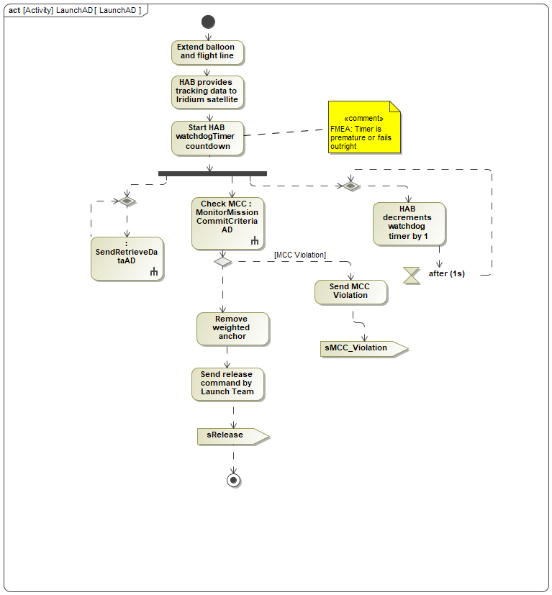

## Ascent Phase

The ascent phase state is represented by the following system activities.

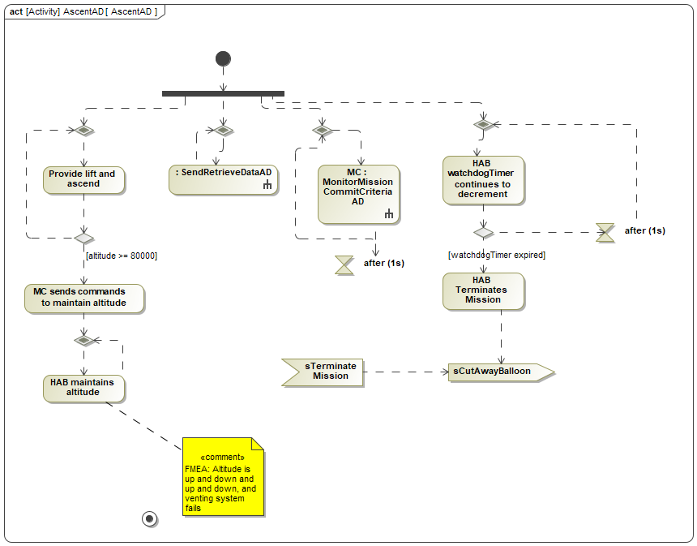

As you can see there are four parallel activities going on:

* The HAB system is providing lift so that the it can ascend in altitude. While providing lift the system is checking its altitude so that once it hits operating altitude of approximately 80,000 feet then the system will begin venting gas in order to maintain that altitude.
* Sending and retrieving data
* Checking mission commit criteria
* Watchdog timer continues to decrement

The system can exit the ascent state in one of two ways:

* A violation in one of the mission commit criteria causes Mission Control to transition the overall system into the Safe Hold state (to possibly terminate the mission or once the violations are fixed the system could reenter the ascent state
* We have a Cut Away event in which the high altitude balloon system separates the balloon from the payloads
  + The Cut Away event can occur in two possible ways (1) the watchdog timer expires and (2) a signal comes in to the HAB to issue the cut away command (coming from Iridium Satellite system as a bent-pipe command sent from GS).

## Descent Phase

The descent state is further described by the following system activities:

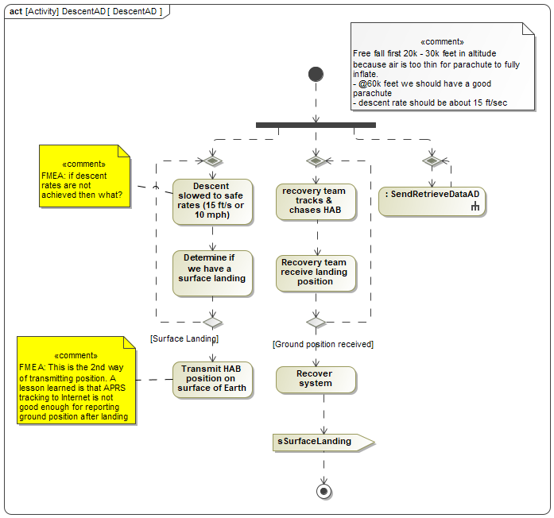

As you can see there are 3 parallel activities going on, the system is still sending and retrieving data. The system is tracking the HAB in order to recover. And the system is trying to slow its descent to an acceptable 15 feet per second of velocity. Since our concept deals with a passive descent approach there are no active steering or failure situations that causes the system to transition to another state except for impacting the Earth. This does raise a question relative to whether a backup descent system is needed or if one parachute is reliable enough.

## Recovery Phase

The recovery state is further described using the following system activity diagram

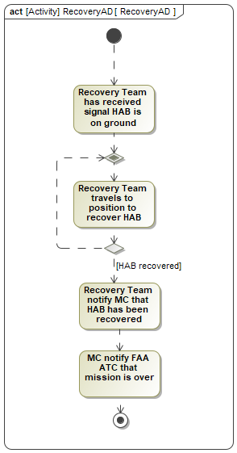

## Launch Hold

The launch hold state is further described using the following system activity diagram

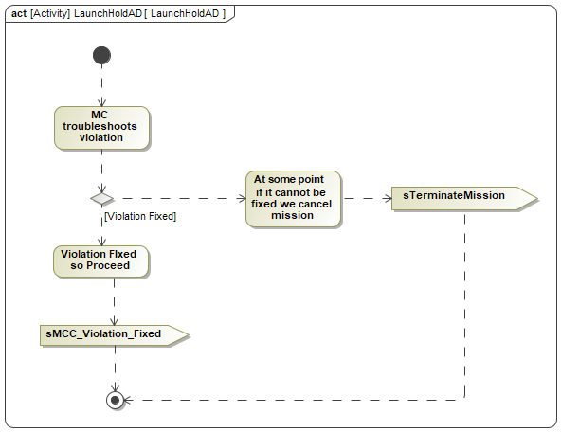

## Safe Hold

The Safe hold state is further described using the following system activity diagram

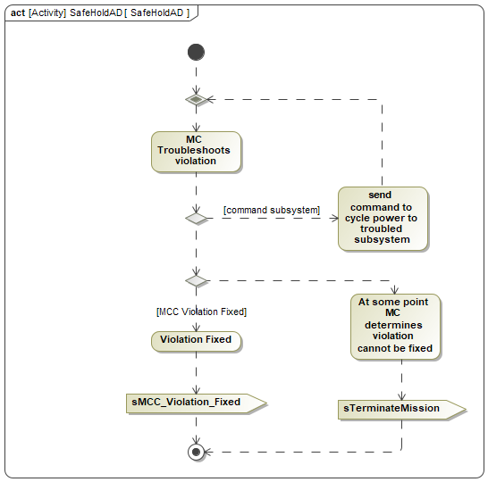

## Monitor Mission Commit Criteria

There are various states that utilize a basic system activity that deals with monitoring system performance in order to make operational decisions. The system activity is further described in the following system-level activity diagram.

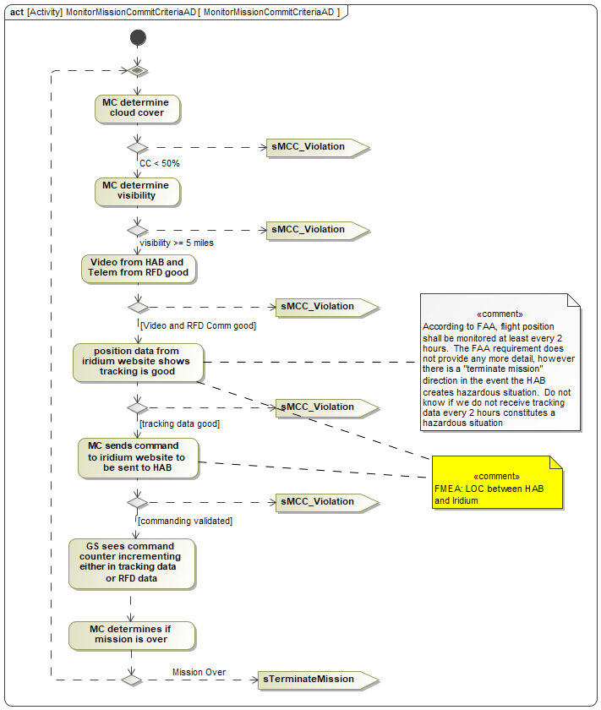

## Send and Retrieve Data

There are various states that utilize a basic system activity that deals with sending and retrieving data. This system capability is further described in the following system-level activity diagram

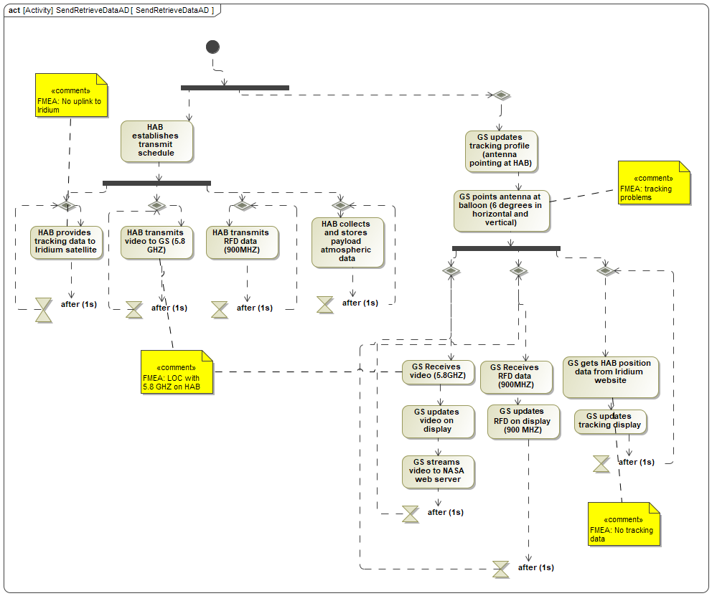

# Subsystem Requirements

The major benefit of section 8 and identifying all the system activities that are going on during a mission is to help refine the system-level requirements depicted in section 6.0. If the entire team agrees that the activities modeled in section 8 are warranted then we can easily identify what the subsystem, or allocated, requirements are. An additional benefit for the models in Section 8 is gaining a system understanding. All team members should be able to follow along well enough to understand what the system should be doing in each of its states. The models present a great avenue for engineering debate and development in order to further refine WHAT the system should be doing.

The following tables represent the allocated requirements for all the subsystems that make up the WV NEBP system.

## Ground System Requirements

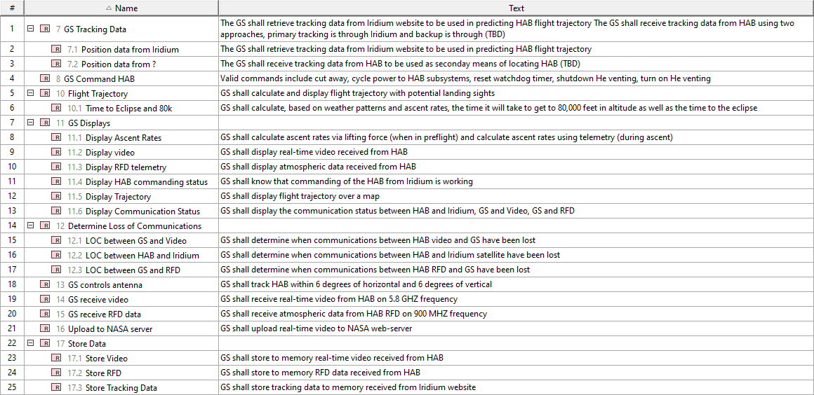

## HAB Requirements

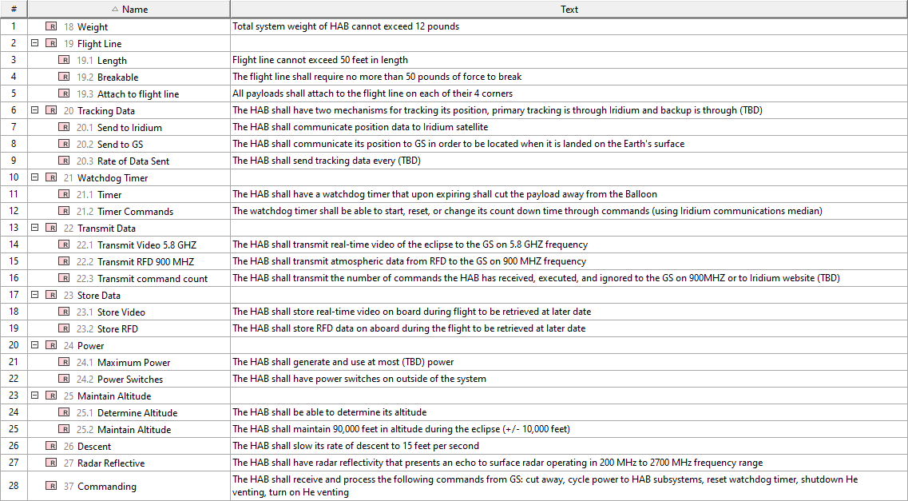

## Launch and Recovery Team Requirements



## Mission Control Requirements

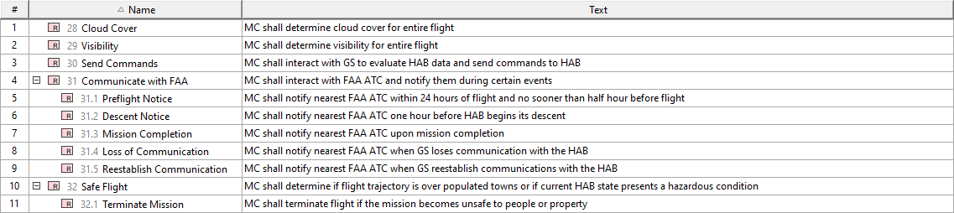

## Interface Requirements

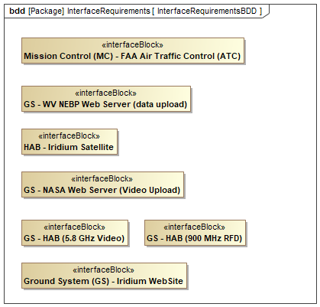

# Failure Modes and Effects Analysis

The last thing the team considered were the potential failures that could occur along with likelihood and reasonability in order to understand areas of the system that might need to be further defined, or redundancy specified, or to just highlight the most critical aspects of the system. All the subsystems are important however we can consider the failures relative to the mission goals to also understand a priority order of subsystem.

The following table depicts a first pass through all this information to come up with an initial set of failure modes.

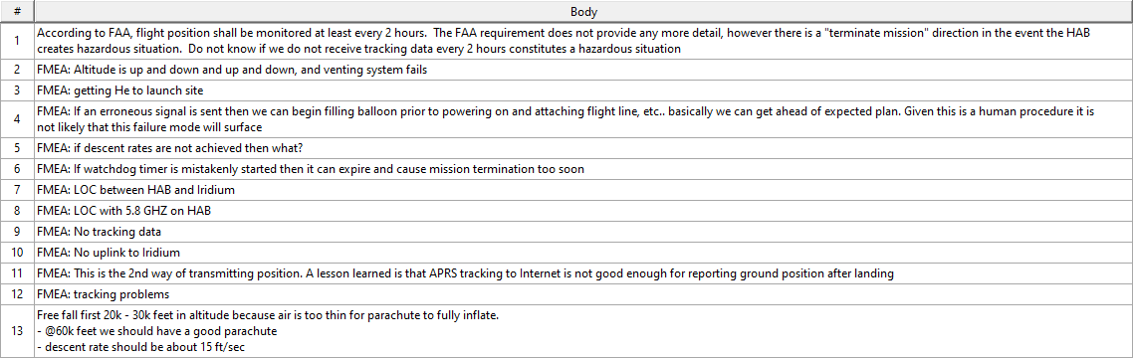

The main items to track and discuss include:

* Item 2: Gaining more understanding for how maintaining of altitude should work
* Item 3: Identify launch site and check on delivery location
* Item 5: do we want any redundancy if descent rates are not achieved?
* Item 6: what will be the procedure to start watchdog timer and what guards will be in place to keep it from prematurely expiring?
* Item 7: LOC between HAB and Iridium
* Item 8: LOC between GS and HAB on 5.8 GHZ
* Item 9: Iridium website not showing tracking data
* Item 11: Lesson learned was to use 2 ways of tracking the system, need to decide on the second way

# Glossary

