**Find the natural frequencies and normal modes of this mass-spring assembly.**

Assumptions: $m_{1}=m{}_{2}=m_{3}=m$, $k_{1}=k_{2}=k_{3}=k$

Free Body Diagrams and F=ma:

$k\left(x{}_{2}-x_{1}\right)=m{\ddot{x}}_{1}$

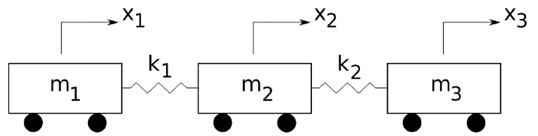



$k\left(x_{3}-x_{2}\right)-k\left(x{}_{2}-x_{1}\right)=m{\ddot{x}}_{2}$

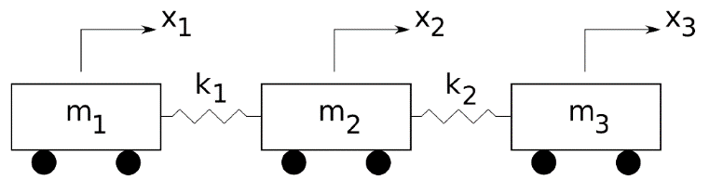





$-k\left(x_{3}-x_{2}\right)=m{\ddot{x}}_{3}$

For these differential equations, we assume $x_{n}={A_{n}e}^{iωt}$ → $\ddot{x_{n}}=-ω^{2}A_{n}e^{iωt}=-ω^{2}x_{n}$

System of equations: Matrix Equation:

$\frac{k}{m}\left(-x_{1}+x_{2}+0x_{3}\right)={-ω}^{2}x_{1}$ $\frac{k}{m}\left[\begin{matrix}-1 & 1 & 0 \\ 1 & -2 & 1 \\ 0 & 1 & -1\end{matrix}\right]\left[\begin{matrix}x_{1} \\ x_{2} \\ x_{2}\end{matrix}\right]=-ω^{2}\left[\begin{matrix}x_{1} \\ x_{2} \\ x_{2}\end{matrix}\right]$ → $\left[\begin{matrix}-1 & 1 & 0 \\ 1 & -2 & 1 \\ 0 & 1 & -1\end{matrix}\right]x=λx$**,**

$\frac{k}{m}\left(x_{1}-2x_{2}+x_{3}\right)=-ω^{2}x_{2}$ where: $λ={-ω}^{2}\frac{m}{k}$

$$\frac{k}{m}\left(0x_{1}+x_{2}-x_{3}\right)={-ω}^{2}x_{3}$$

Solving for the eigenvalues:

$$\left|\begin{matrix}-1-λ & 1 & 0 \\ 1 & -2-λ & 1 \\ 0 & 1 & -1-λ\end{matrix}\right|=-\left(1+λ\right)\left[\left(2+λ\right)\left(1+λ\right)-1\right]-1\left(-1-λ\right)=0$$

$$\left(1+λ\right)\left[1+3λ+λ^{2}\right]-1-λ=0$$

$$\left[1+3λ+λ^{2}\right]+\left[λ+3λ^{2}+λ^{3}\right]-1-λ=0$$

$λ\left(3+4λ+λ^{2}\right)=0$ → $λ\left(λ+3\right)\left(λ+1\right)=0$

So, my eigenvalues are:

$$λ_{1}=0,λ_{2}=-3,λ_{3}=-1$$

Now, calculate corresponding eigenvectors

For λ=0, ω1=0:

→ →

For λ=-3, ω2=(3k/m)0.5:

→ →

For λ=-1, ω3=(k/m)0.5:

→ →