ICCR (Indian Council for Cultural Relations)

Getting Started Guide

ICCR
MINISTRY OF EXTERNAL AFFAIRS

Contents
1. Introduction 3
2. Mission 5
2.1 Application Received 7
2.2 Pending Application with Mission/Post: - 14
2.3 Cases of Re-Submission by Applicant: - 14
2.4 Applications on Hold: - 14
2.5 Processed Application: - 14
2.6 Confirmation from University/Institute: - 17
2.7 Confirmation of University/Institute by HQRS: - 20
2.8 Acceptance/Decline by Applicant: - 22
2.9 Student/Research Visa Endorsement – 23
2.10 Travel Plan of Applicant - 26
2.11 Alumni Application – 29

Introduction
The Indian Council for Cultural Relations (ICCR) is an autonomous organization of the Government of India, involved in India’s external cultural relations, through cultural exchange with other countries and their peoples. It was founded on 9 April 1950 by Maulana Abul Kalam Azad, the first Education Minister of independent India. Its objectives are to actively participate in the formulation and implementation of policies and programmes pertaining to India’s external cultural relations; to foster and strengthen cultural relations and mutual understanding between India and other countries; to promote cultural exchanges with other countries and people; and to develop relations with nations.

Open the URL: http://a2ascholarships.iccr.gov.in/ in any browser or device to access the “ICCR” application.
The Home page will appear:
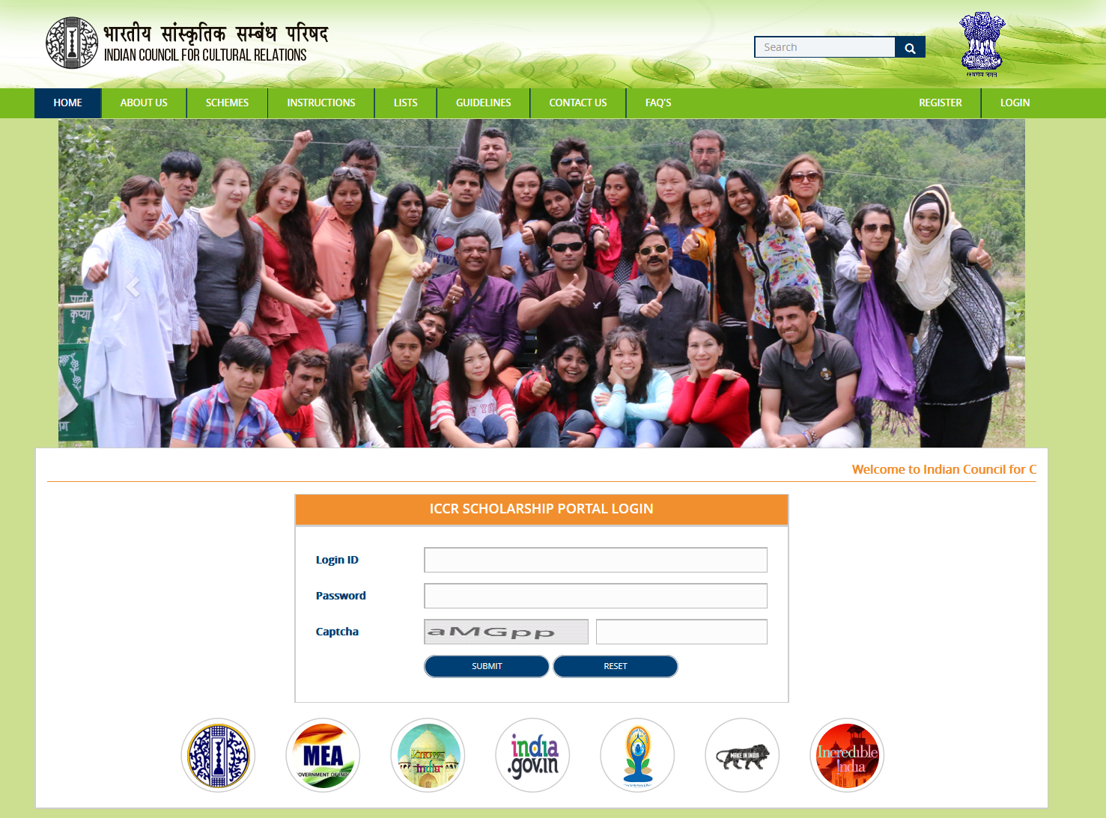

Mission
Mission of that country will login through which applicant has applied an application.
To login, fill the following details in login form
- Enter Login Id
- Enter Password
- Enter Captcha Code
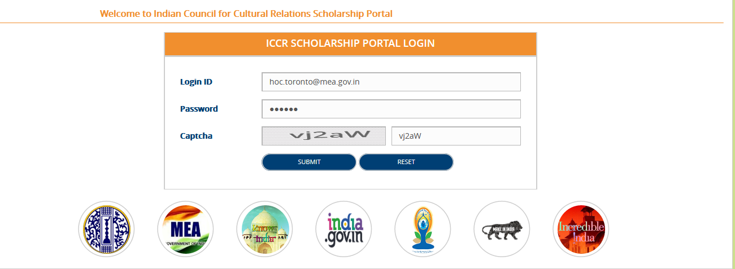
- Click on Submit button, Mission Dashboard will appear

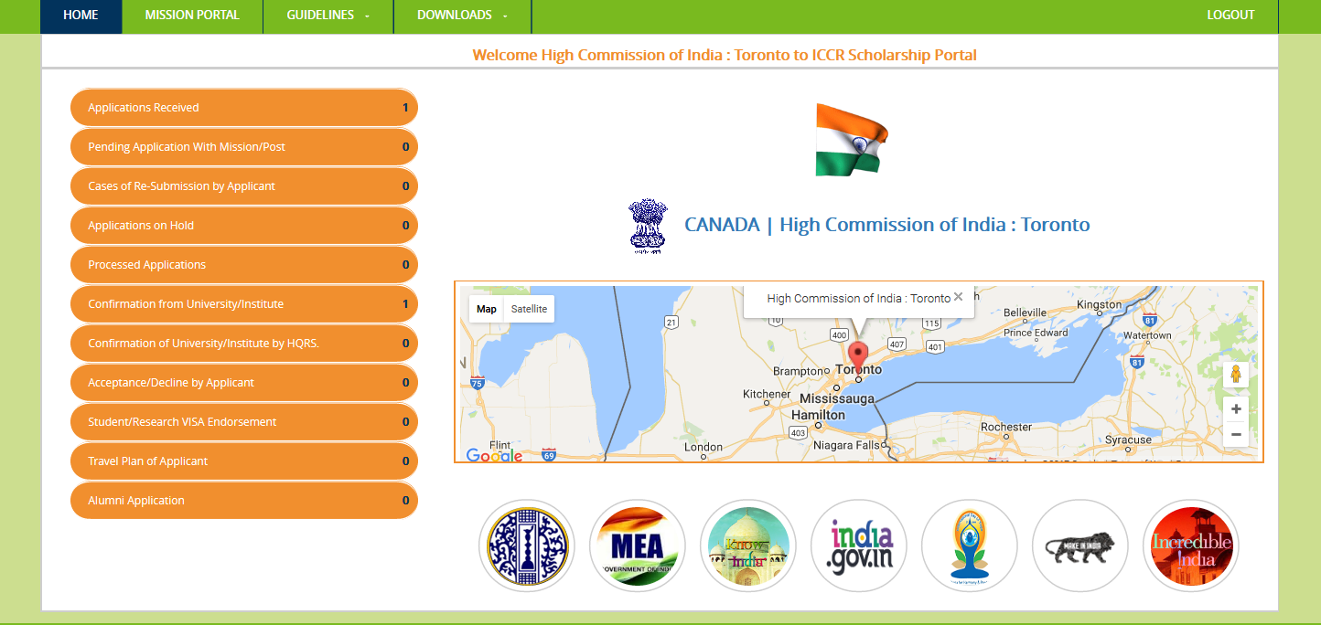

Following Side Menus have been provided on Mission Dashboard

- Application Received
- Pending Application with Mission/Post
- Cases of Re-Submission by Applicant
- Applications on Hold
- Processed Applications
- Confirmation from University/Institute
- Confirmation of University/Institute by HQRS
- Acceptance/Decline by Applicant
- Student/Research Visa Endorsement
- Travel Plan of Applicant
- Alumni Application

Application Received
Applications filled by applicants will appear here.
- Click on Application Received, list of all applications filed to “High Commission of India Toronto” will appear here
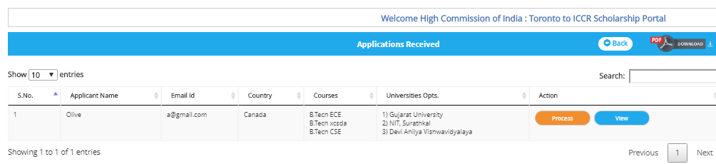
- To process the application, click on Process. Filled application form will appear in non-editable mode
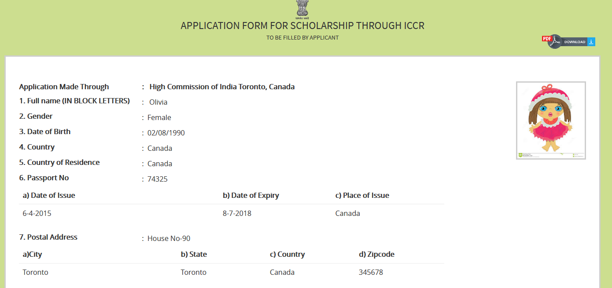
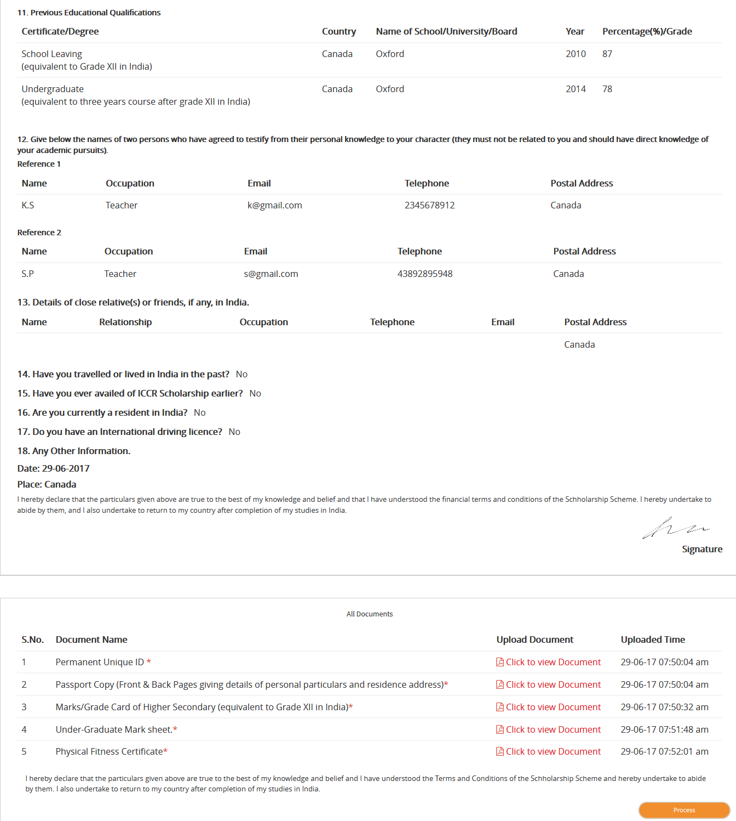

Note: - Mission can view the uploaded documents which are uploaded by applicant by clicking on the “Click to view Document” link.
- Click on Process button, confirmation message will appear

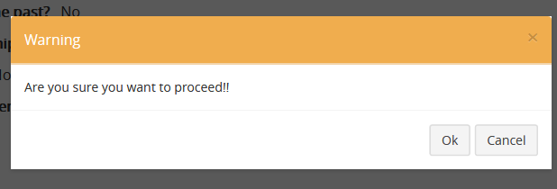
- Click on Ok button to proceed. After click on Ok button Mission check list will appear.
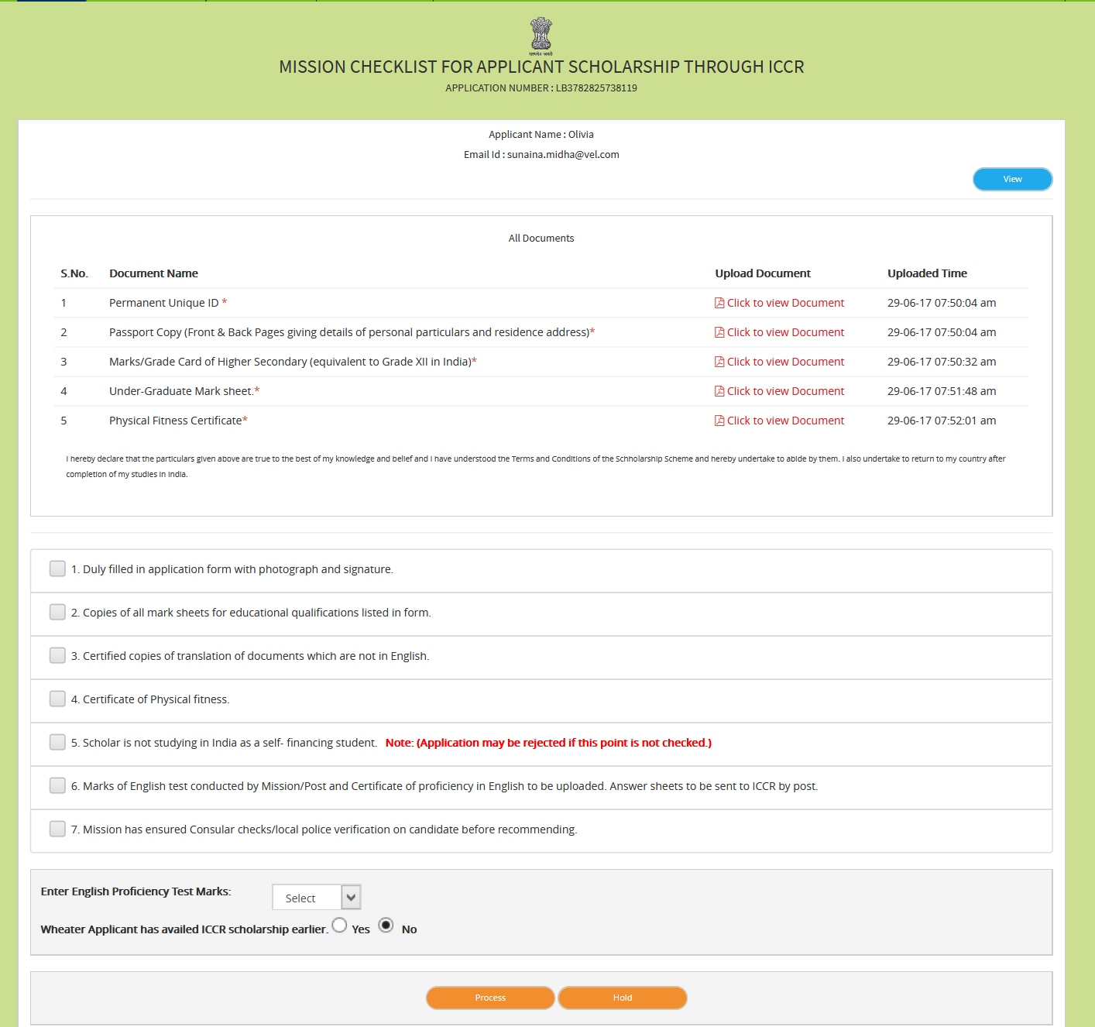

- To process the application Mission has to check the checkboxes.
After clicking all checkboxes, dropdown field “Select Scholarship Programme” will appear
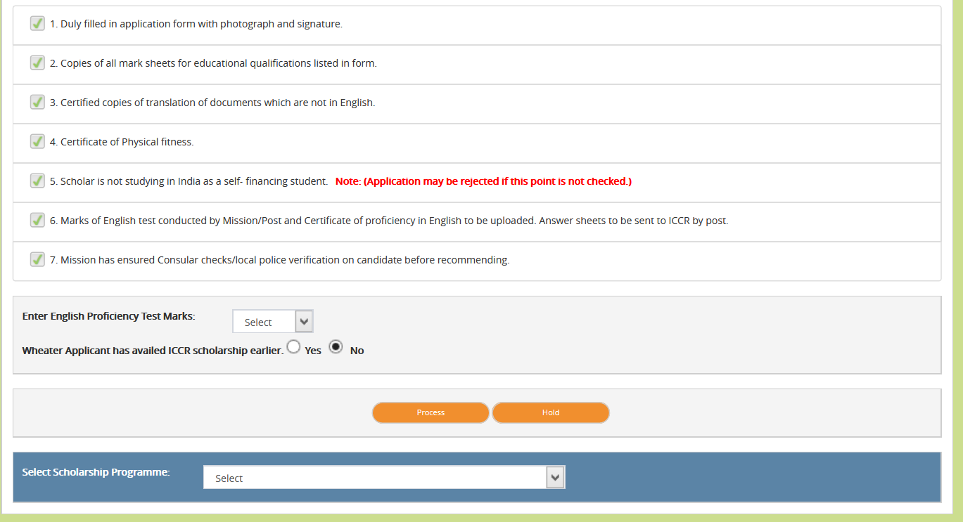

- Select English Proficiency Test Marks
- Select Scholarship Programme

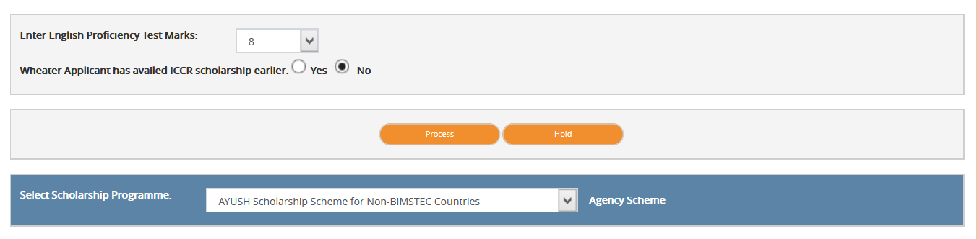

- Click on Process button, another fields will appear as shown in figure below
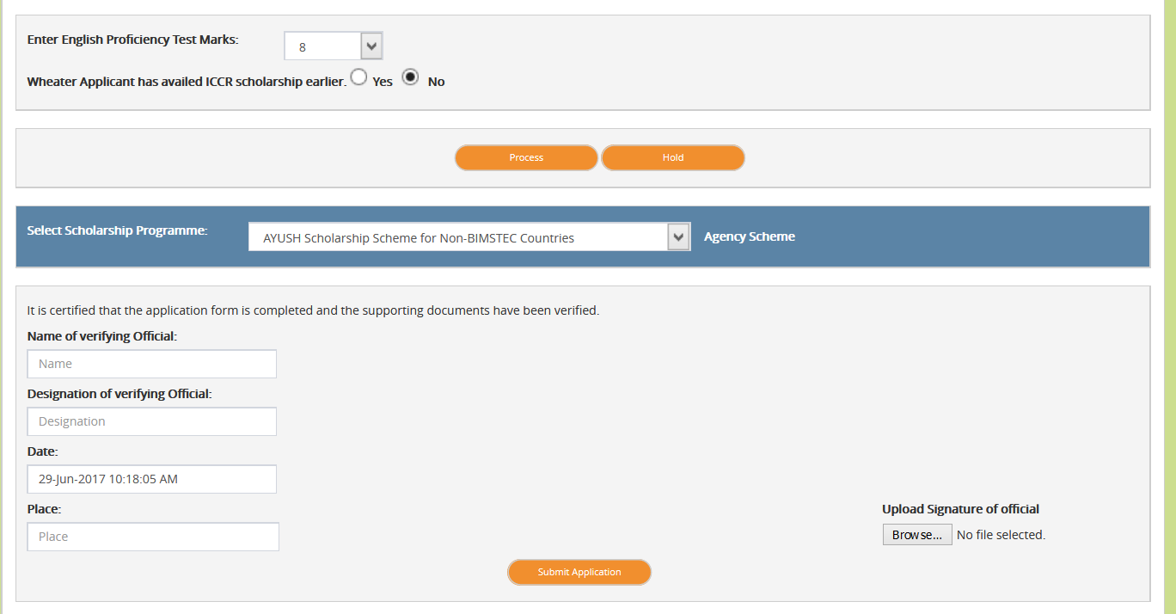
- Enter Name of Verifying Official
- Enter Designation of Verifying Official
- Enter Place
- Upload Signature
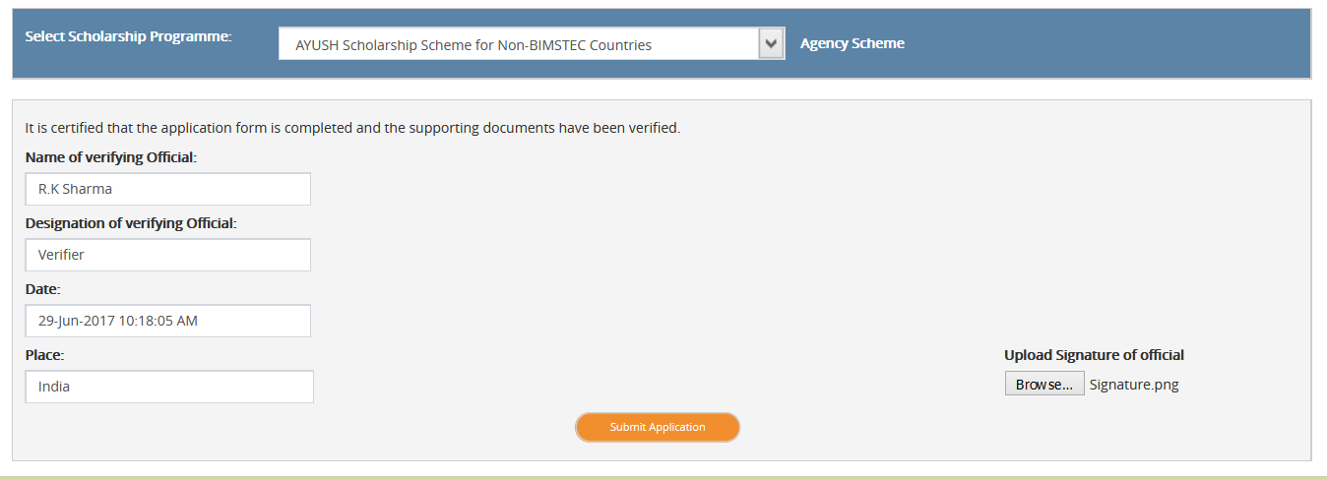

- Click on Submit Application, application will get submitted.

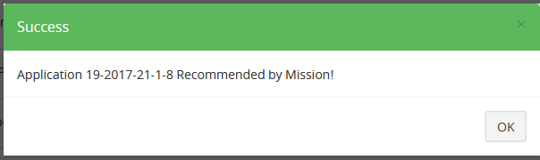
Now application will appear under “Processed Application” section and application will forward to all those State Region to which State University, Applicant has applied admission for course.

Pending Application with Mission/Post: -

Cases of Re-Submission by Applicant: -

Applications on Hold: -
Here list of those applications will appear which user has put on hold during the processing of application.

Processed Application: -
Click on Processed Applications
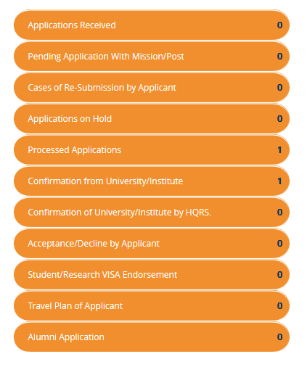
- List of processed applications will appear here
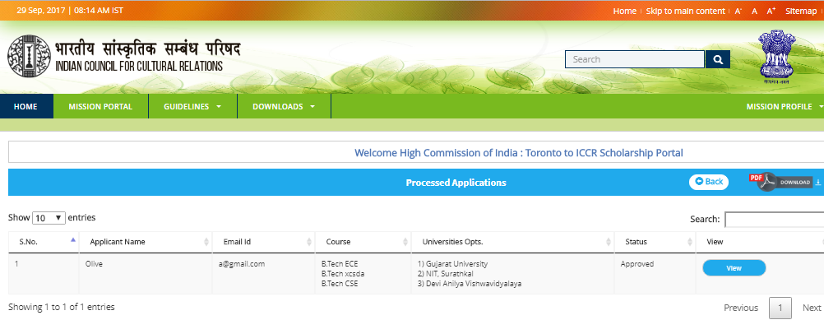
- Click on view button to view the application.
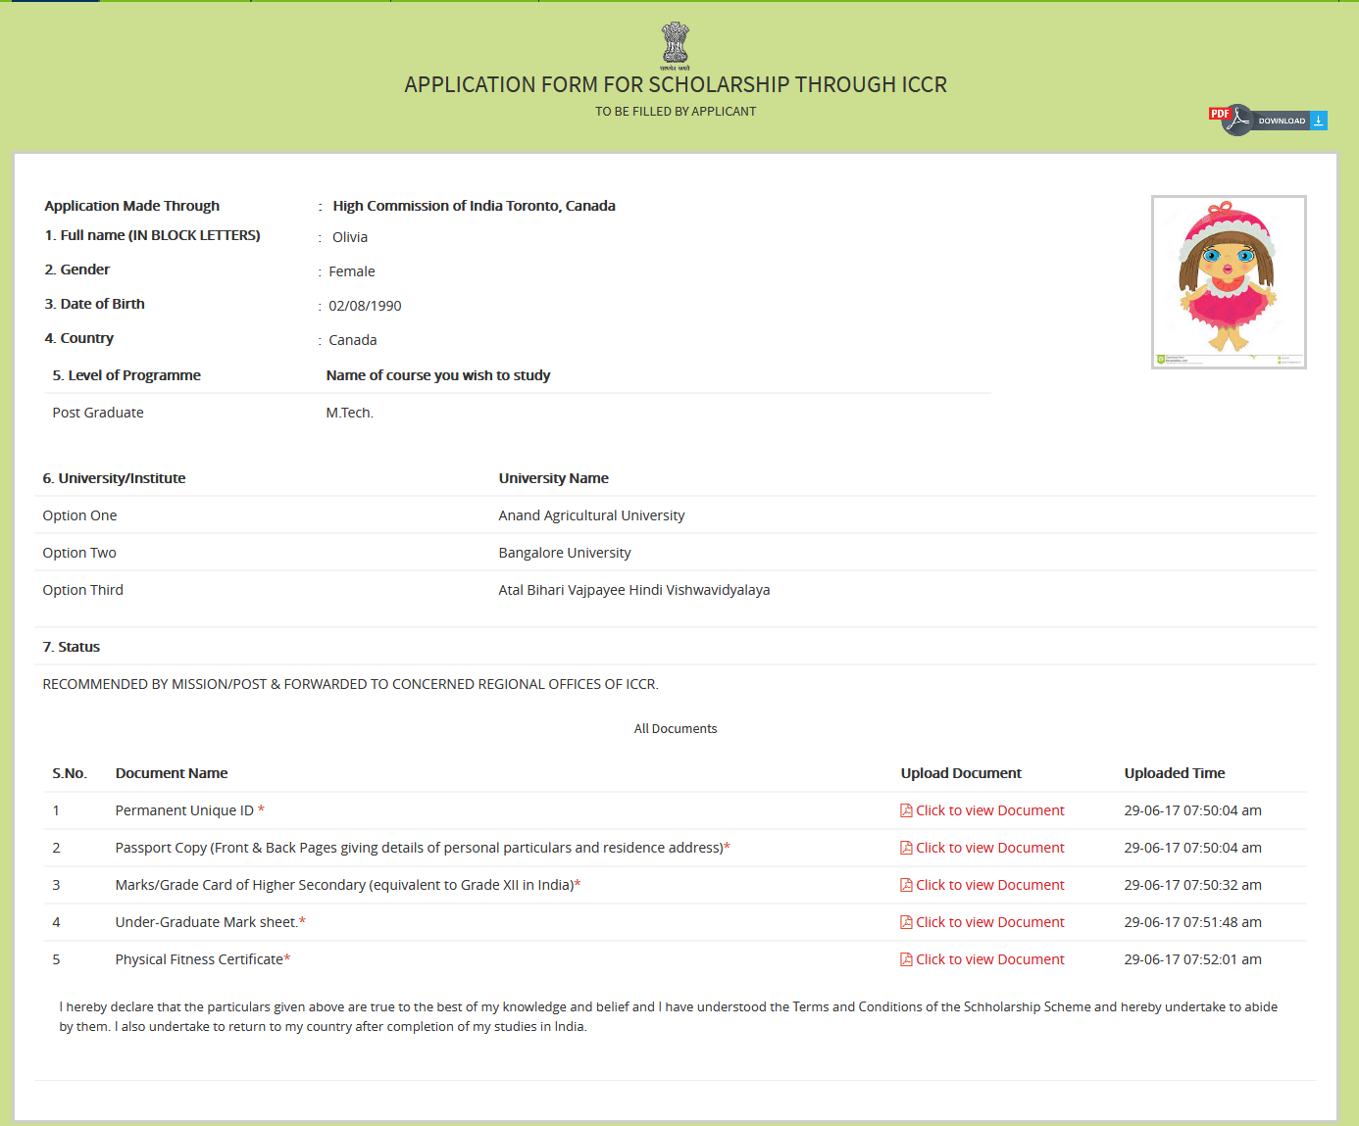

Confirmation from University/Institute: -
Here list of those applications will appear which got approval from region and headquarter.
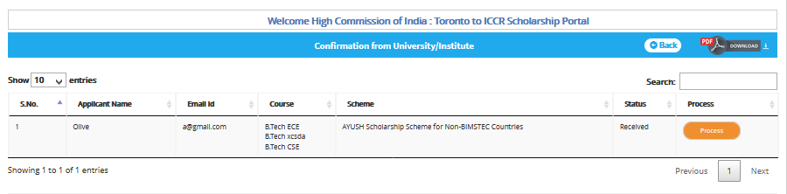

- Click on Process button
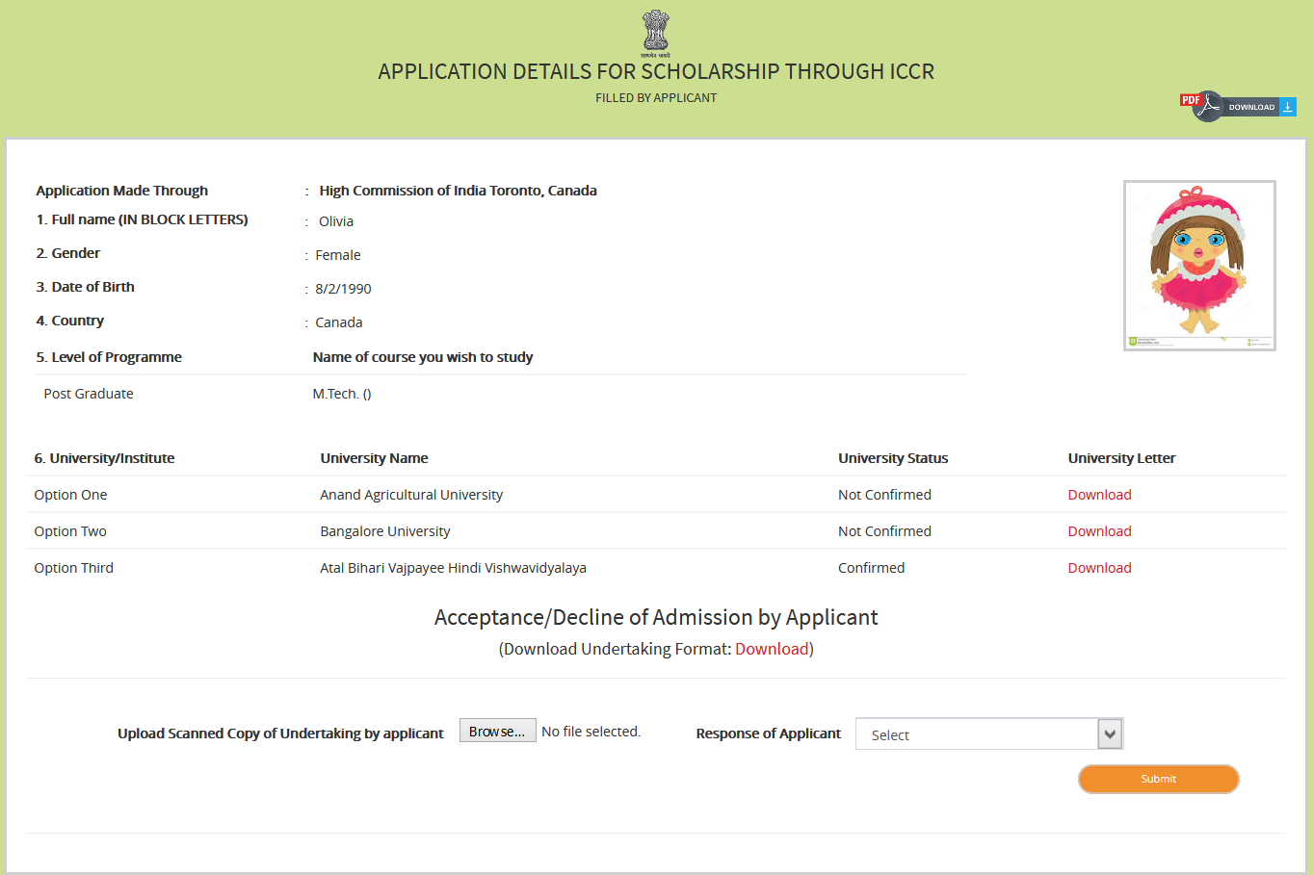

- Click on Browse to upload Scanned copy of Undertaking by applicant
- Select Applicant response from dropdown

- Click on Submit button
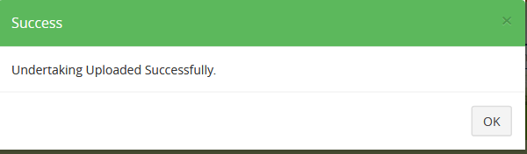

Suppose if Response of applicant is “Declined”.
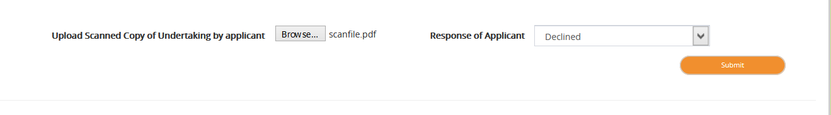

Confirmation of University/Institute by HQRS: -
Here list of those applications will appear which got approval from Agriculture and AYUSH headquarter.
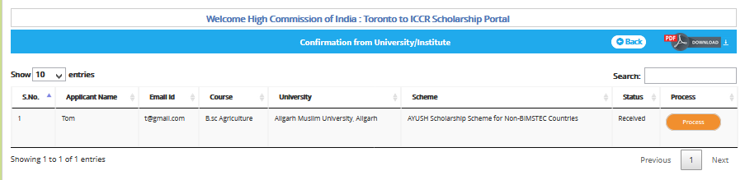

- Click on Process button
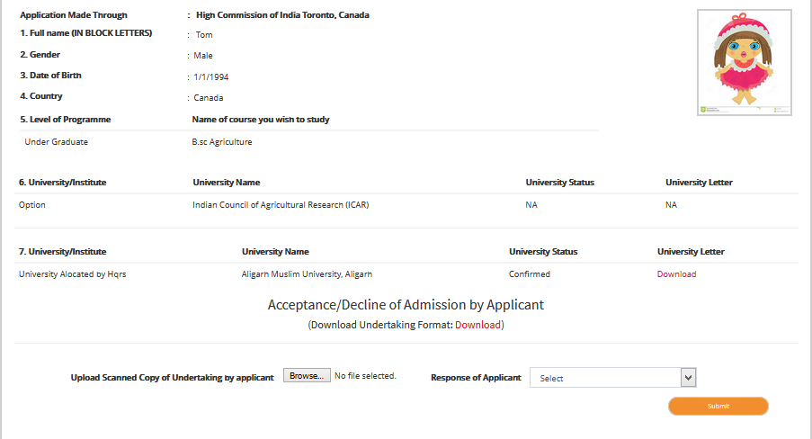

- Click on Browse to upload Scanned copy of Undertaking by applicant
- Select Applicant response from dropdown
- Click on Submit button

Acceptance/Decline by Applicant: -
After the applicant response is set as either “Accepted” or “Declined” application will appear here

- Click on “Acceptance / Decline” by Applicant, list will appear
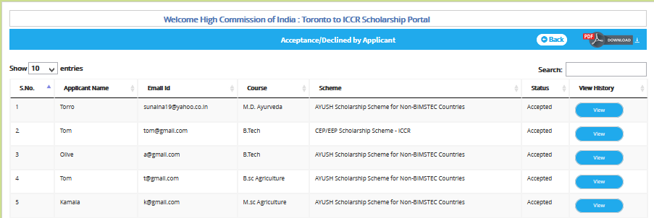
On click on view button, following screen will appear
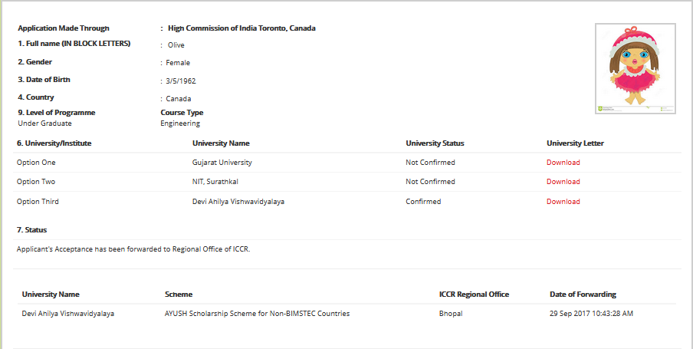

Student/Research Visa Endorsement –
After the applicant response set as selected, mission can process the applicant VISA Endorsement.

- Click on Student/Research Visa Endorsement
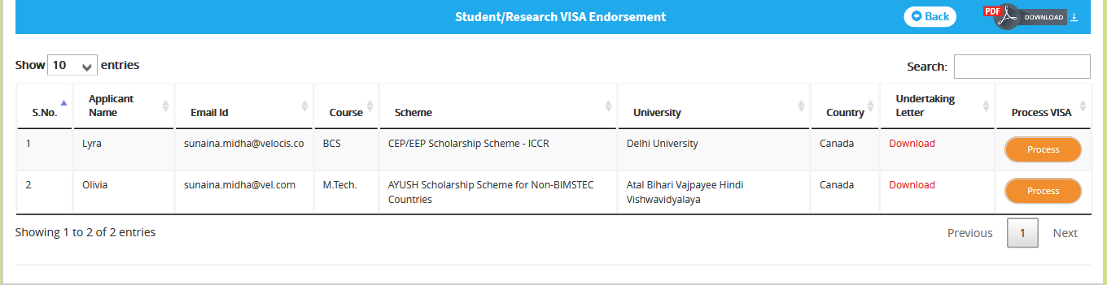
- To process the applicant Visa, click on “Process”, VISA Endorsement form will appear
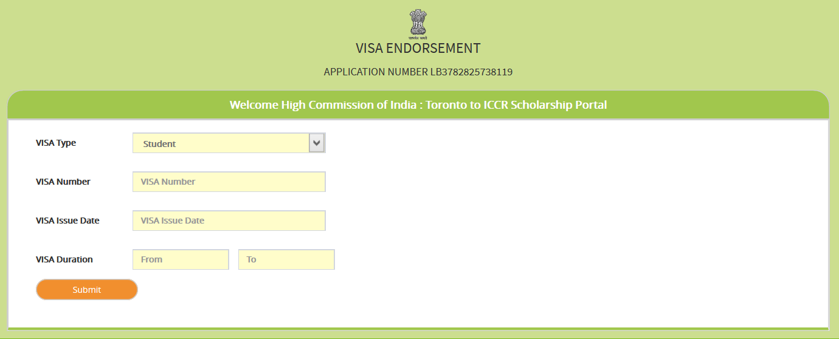
- Fill the details in VISA Endorsement form

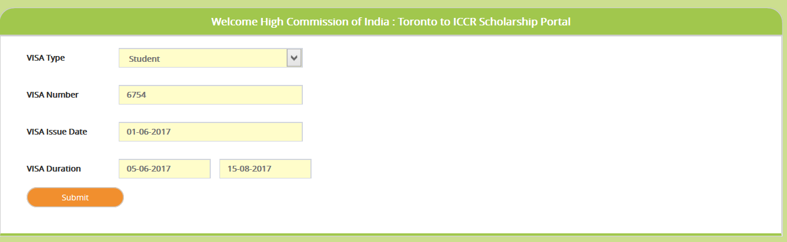
- Click on Submit button, confirmation message will display.
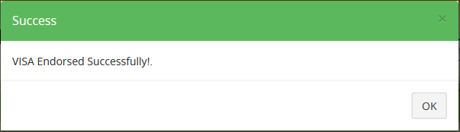
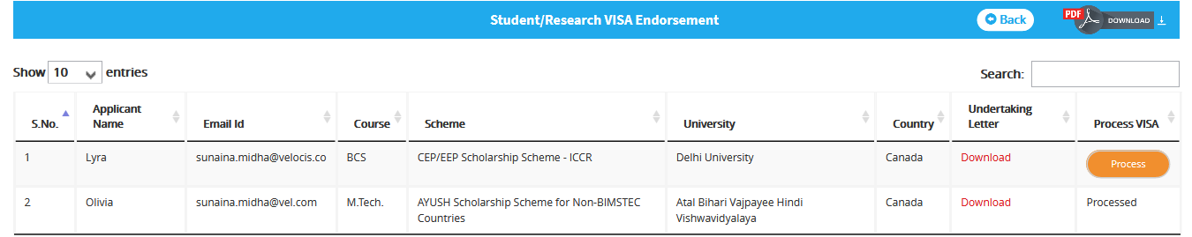

Travel Plan of Applicant -
After the applicant visa get endorsed successfully, mission can process the travel plan of applicant.
- Click on “Travel Plan of Applicant”
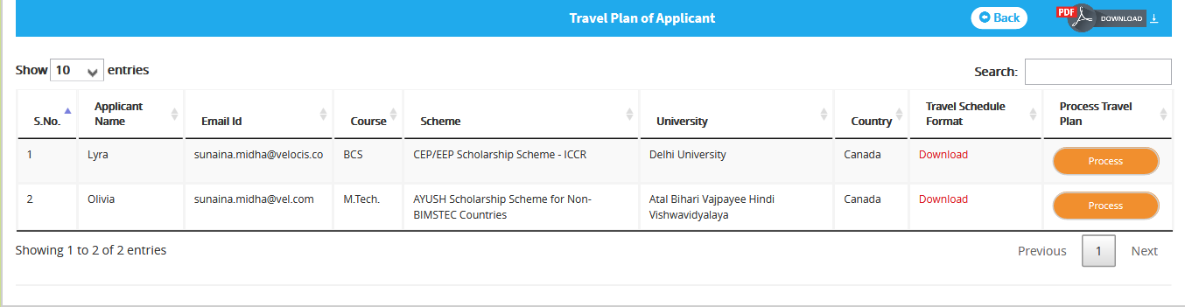
- Click on “Process”, form to enter Travel Plan of an applicant will appear.
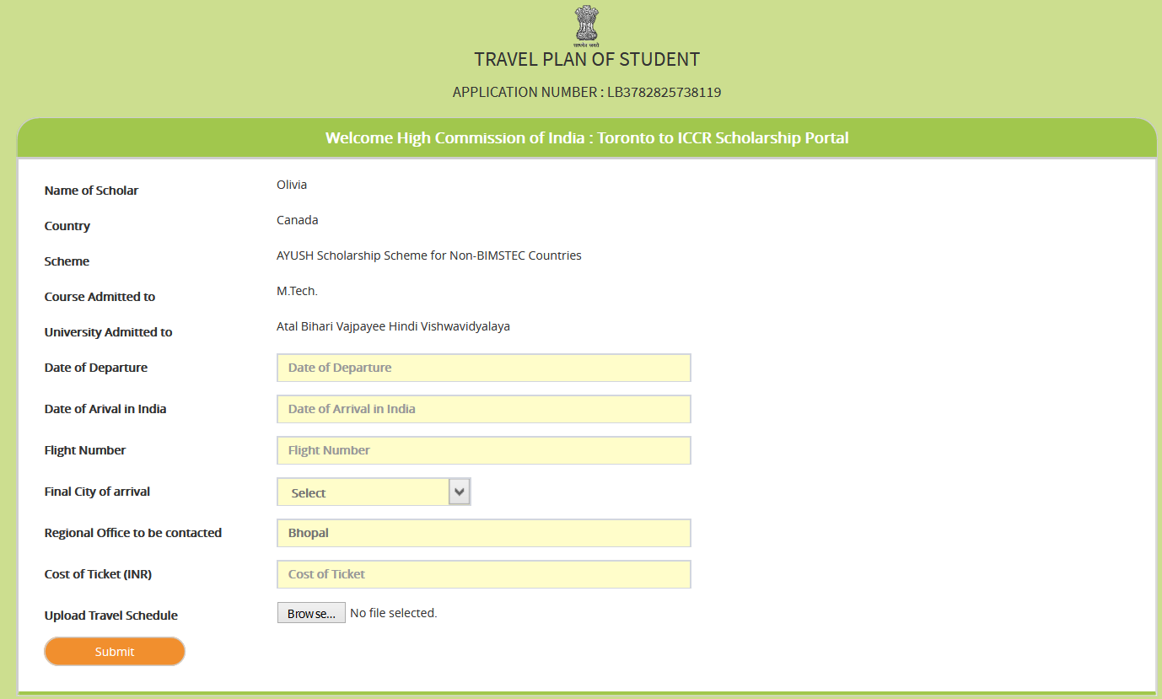
- Fill the details in form
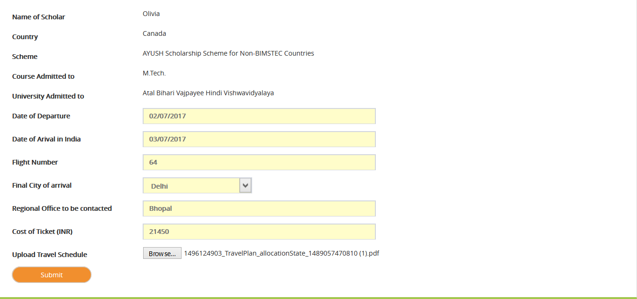
- Click on Submit button
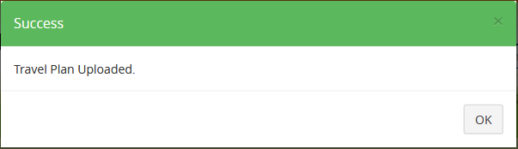
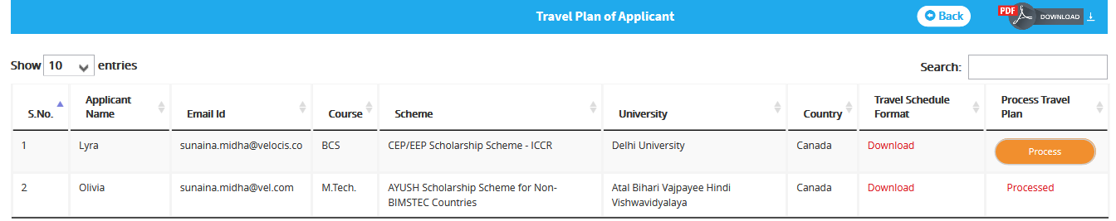

Alumni Application –

Mission can add alumni Details.
- Click on Alumni Details, Alumni Applications screen will appear
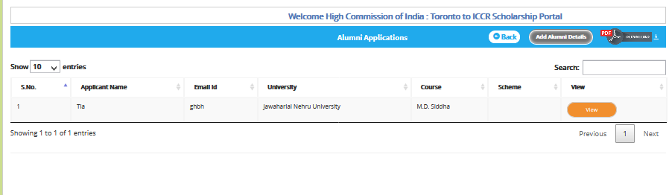
- To add alumni details, click on add alumni details. Personal Details screen will appear
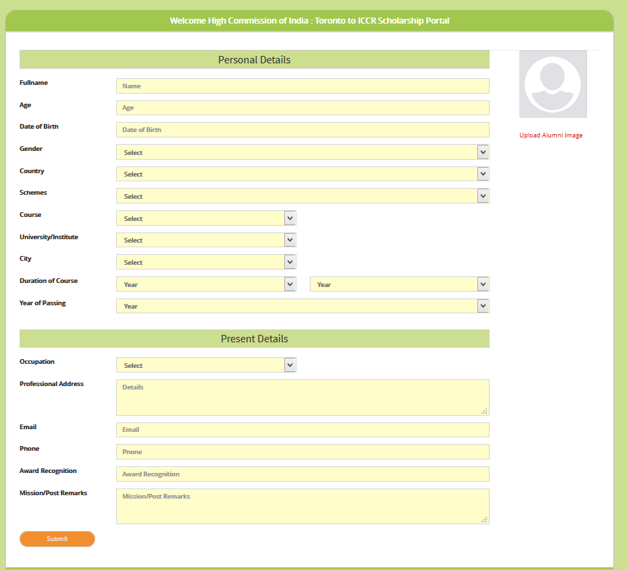
- Fill the form
- Click on Submit, Detail will get save and will display in table.

