ICCR (Indian Council for Cultural Relations)

Getting Started Guide

ICCR
MINISTRY OF EXTERNAL AFFAIRS

Contents
1. Introduction 3
2. Region 5
2.1 Application Received from Mission: - 7
2.2 University Response Sent to Hqrs: - 8
2.3 Arrival Schedule of Student: - 18
2.4 Documents/Certificate: - 20
2.5 Student Wise Academic Details: - 22
2.6 Student VISA Endorsement: - 27
2.7 Student Wise Expenditure: - 29
2.8 Demand to Hqrs: - 36
2.9 Alumni Details: - 38

Introduction
The Indian Council for Cultural Relations (ICCR) is an autonomous organization of the Government of India, involved in India’s external cultural relations, through cultural exchange with other countries and their peoples. It was founded on 9 April 1950 by Maulana Abul Kalam Azad, the first Education Minister of independent India. Its objectives are to actively participate in the formulation and implementation of policies and programmes pertaining to India’s external cultural relations; to foster and strengthen cultural relations and mutual understanding between India and other countries; to promote cultural exchanges with other countries and people; and to develop relations with nations.

Open the URL: http://a2ascholarships.iccr.gov.in/ in any browser or device to access the “ICCR” application.
The Home page will appear:
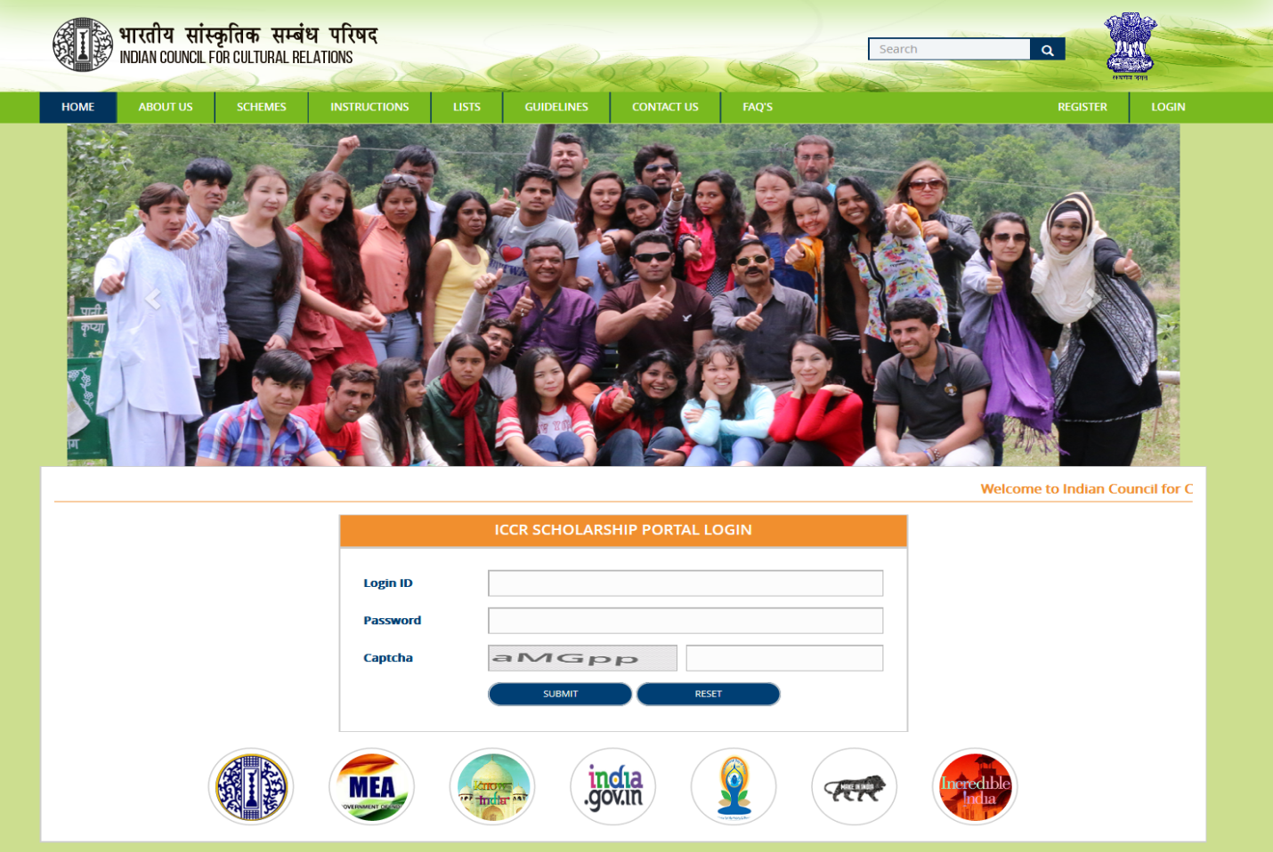
Home Page contains following menu:-
- Home
- About Us
- Schemes
- Instructions
- Lists
- Guidelines
- Contact Us
- FAQ’s
- Register
- Login

Region
Application after processed by Mission will go to that entire state region where applicant has applied for course.
For Example - If applicant has applied course to three different regions i.e. Ahmedabad, Bangalore, Bhopal.
Out of these three regions only one state region can approve the applicant application or all three regions can reject the application.
Now we will login to Ahmedabad Region.
Fill the login detail in login form.
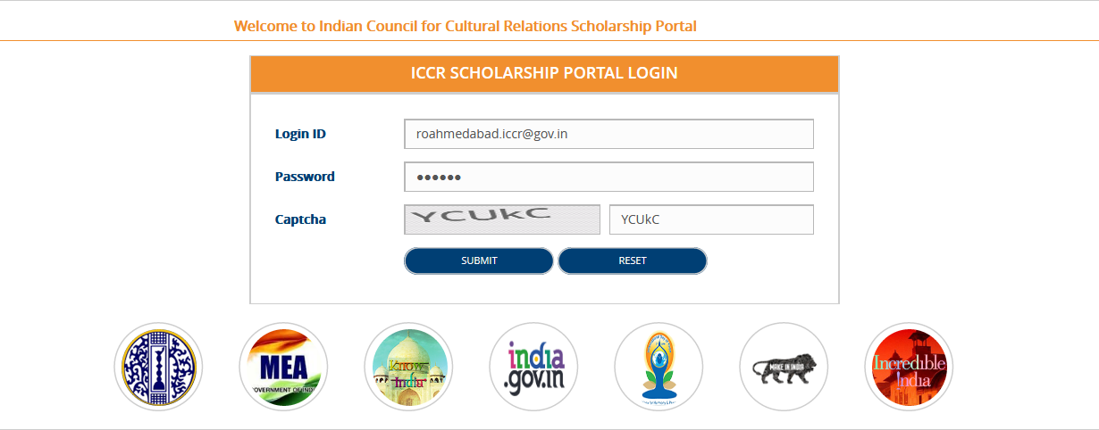

- Click on Submit button, region dashboard will appear.
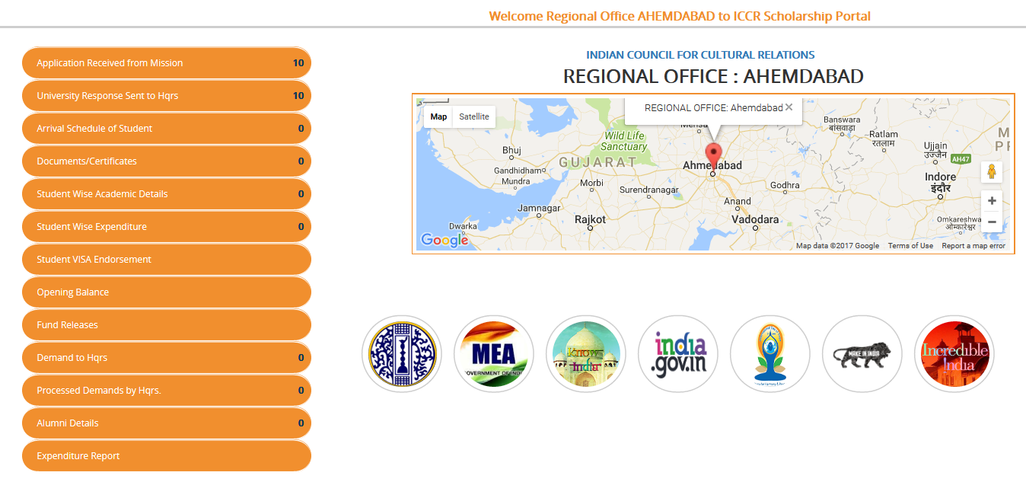
Following Side Menus have been provided on Dashboard
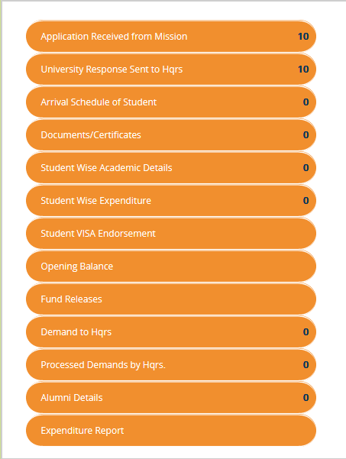

Application Received from Mission: -
Application processed by mission will appear here.
- Click on Application Received from Mission


- List of Applications received from mission will appear.
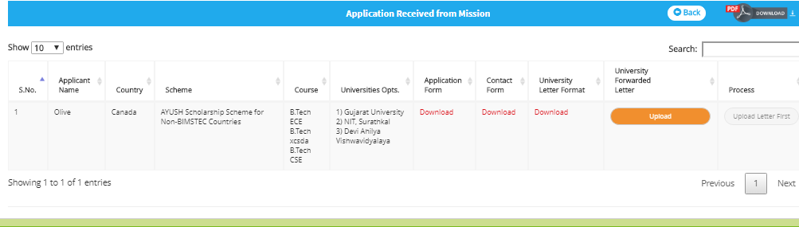
- Click on Upload to upload letter.
After the letter get downloaded, “Download “link will appear.
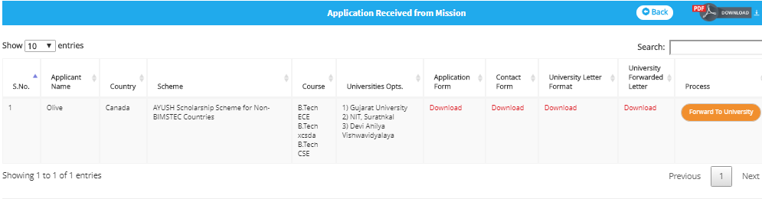

University Response Sent to Hqrs: -
Through this link region can send response for applicant application to Headquarter.
- Click on “University Response Sent to Hqrs”
List will appear.
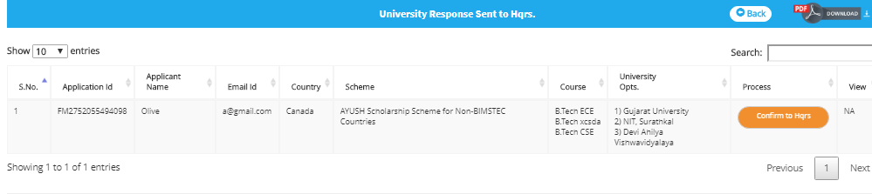
- Click on “Confirm to Hqrs”, Application form will appear along with Process and Cancel button

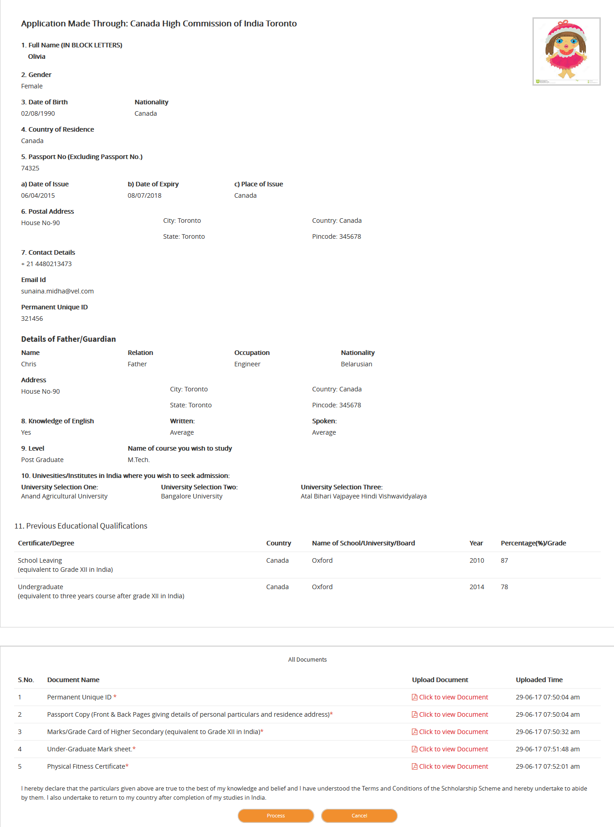

- Click on Process button, another fields will appear
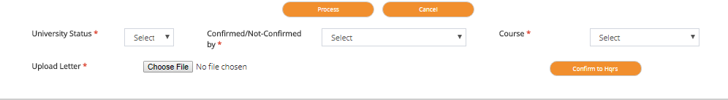
- Select University Status either Yes or No.
Suppose this university select Status as “No” then another two State Regions i.e. Bangalore and Bhopal can send response to Head Quarter.
Note: - If this university select status as “Yes” then another two universities will not be able to send response to Head Quarter.
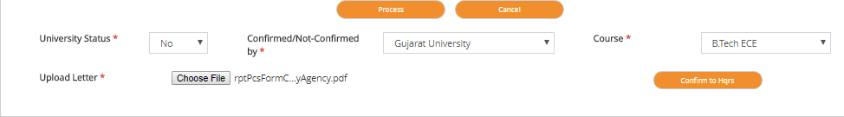
- Click on “Confirm to Hqrs”.
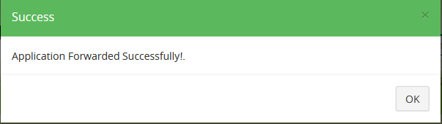

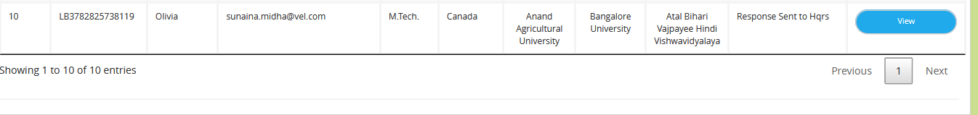

Now login to “Bangalore” Region.
Fill details in Login form.
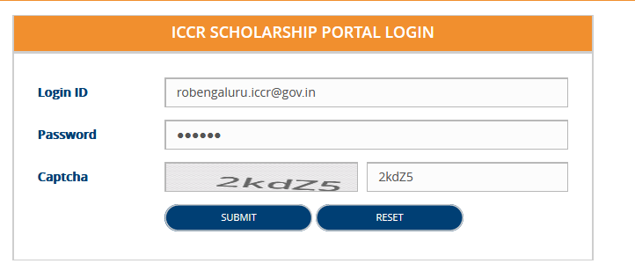
Click on Submit button, region dashboard will appear.
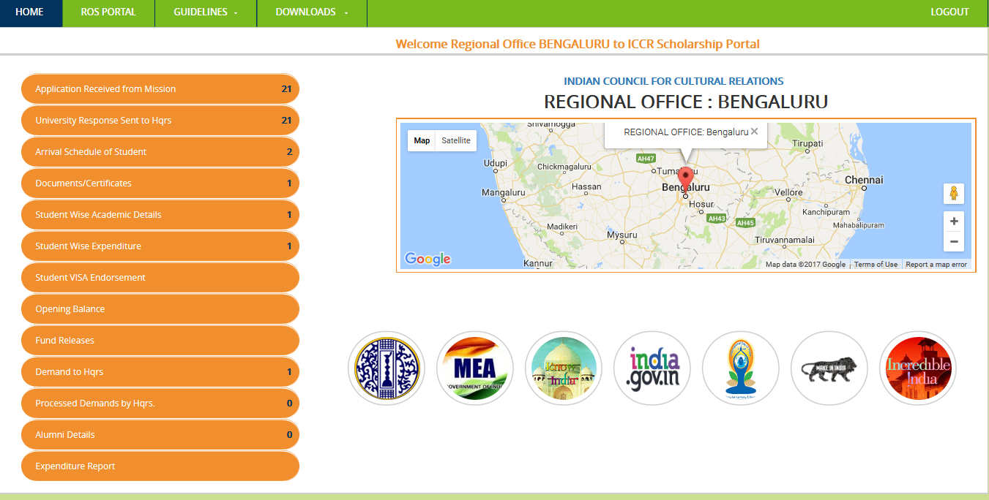
- Click on “University Response Sent to Hqrs”
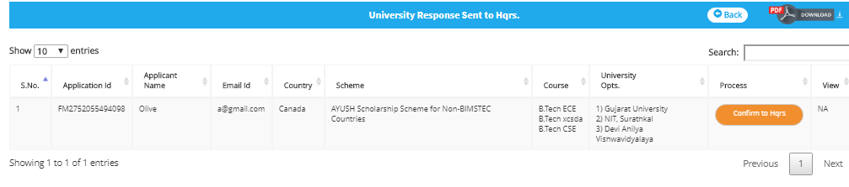

- Click on “Confirm to Hqrs”, Application form will appear along with Process and Cancel button.

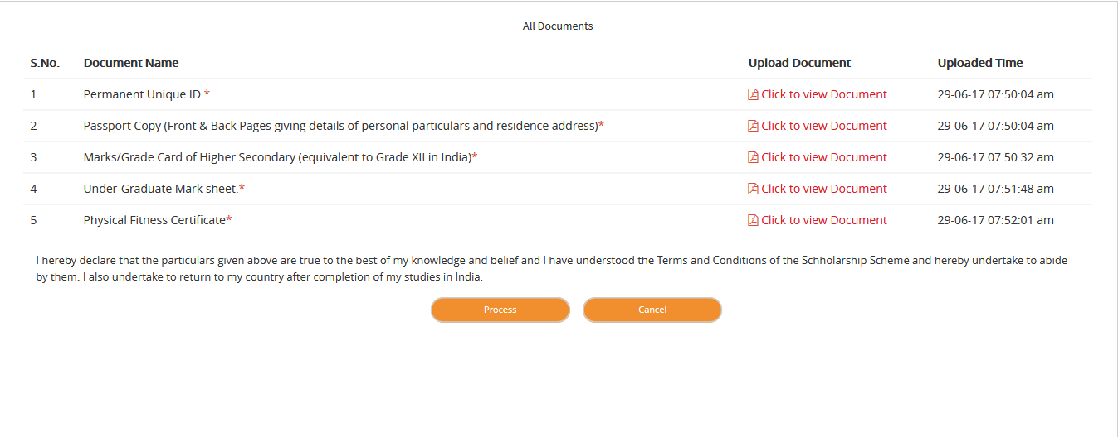

- Click on Process button, another fields will appear
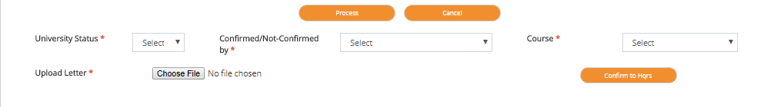

- Select University Status either Yes or No.
Suppose this university selects Status as “No” then third State Region i.e. Bhopal can send response to Head Quarter.

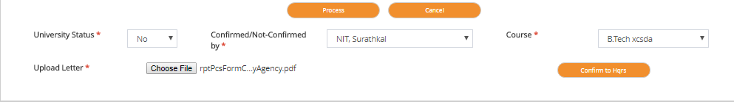

- Click on “Confirm to Hqrs”.
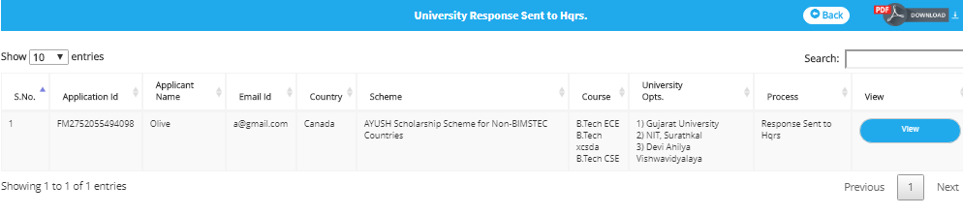

Now login to “Bhopal” Region.
Fill details in Login form.
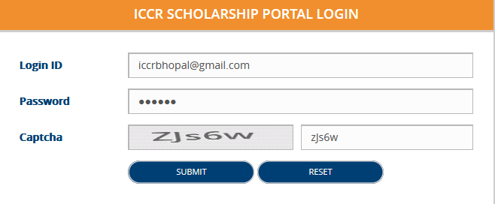
Click on Submit button, region dashboard will appear.
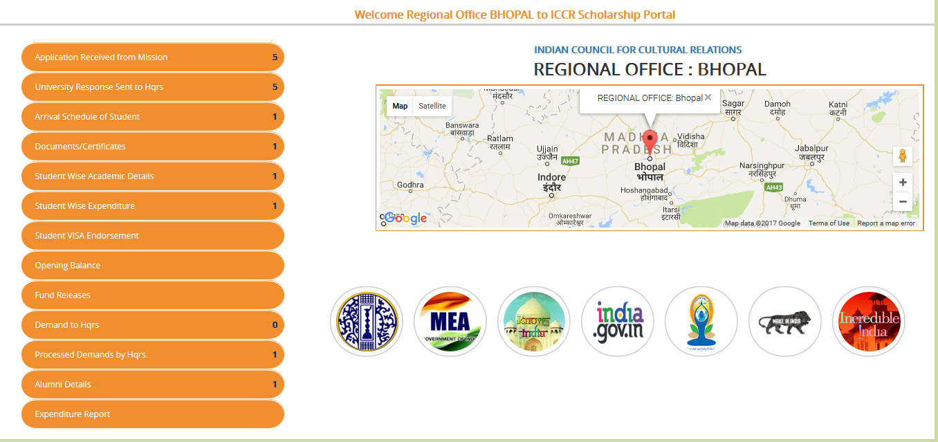
- Click on “University Response Sent to Hqrs”

- Click on “Confirm to Hqrs”, Application form will appear along with Process and Cancel button.

- Click on Process button, another fields will appear

- Select University Status either Yes or No.
Suppose this university selects Status as “Yes”.’
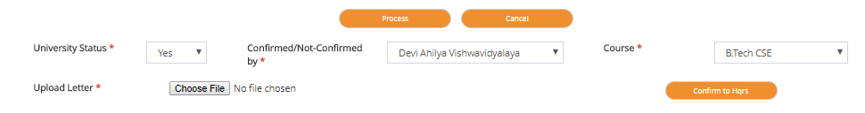
- Click on “Confirm to Hqrs”.
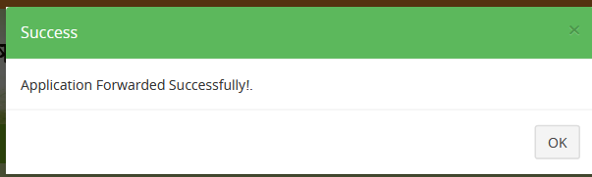

Arrival Schedule of Student: -
Here list of those applications will appear whose travel plan has been processed by mission.
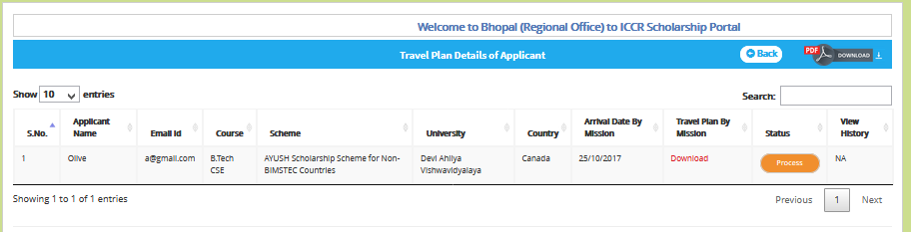
To process the arrival schedule of applicant, click on Process, following screen will appear

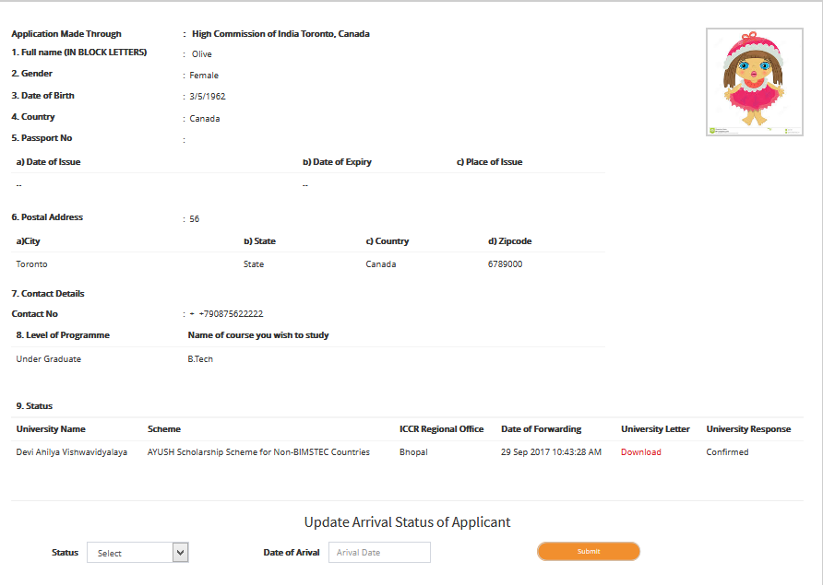

- Select Status
- Enter Date of Arrival



- Click on Submit button

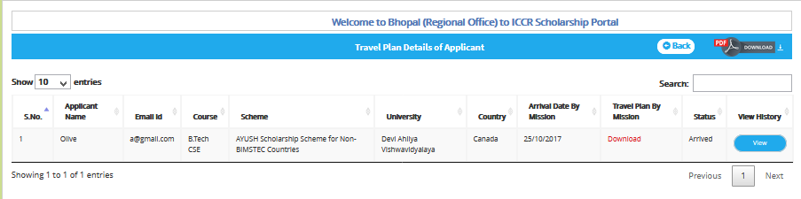

Documents/Certificate: -
Here user will upload documents of applicant.
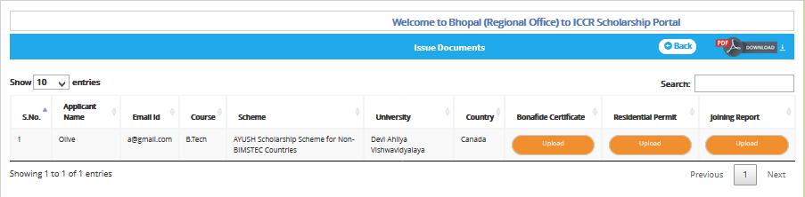
To upload document, click on upload, following screen will appear

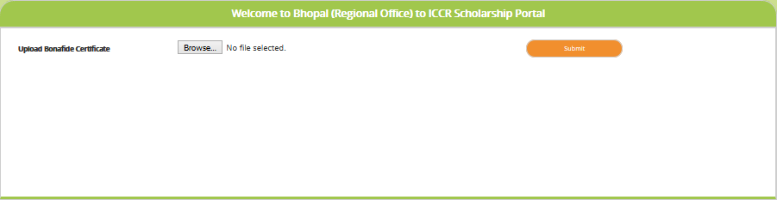

- Click on browse, select the document
- Click on Submit button

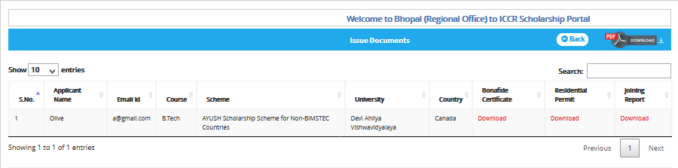

Student Wise Academic Details: -
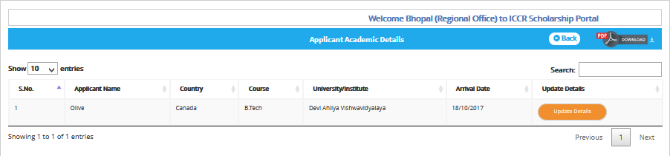

- Click on Update details
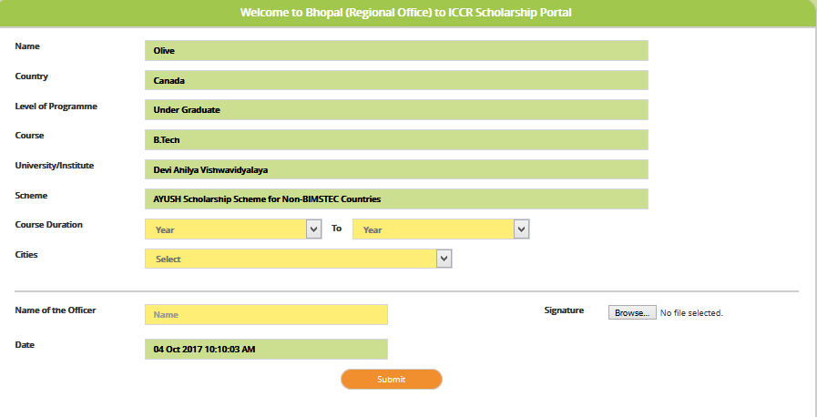

- Select Course Duration
- Select City
- Enter Name of the Officer
- Upload Signature
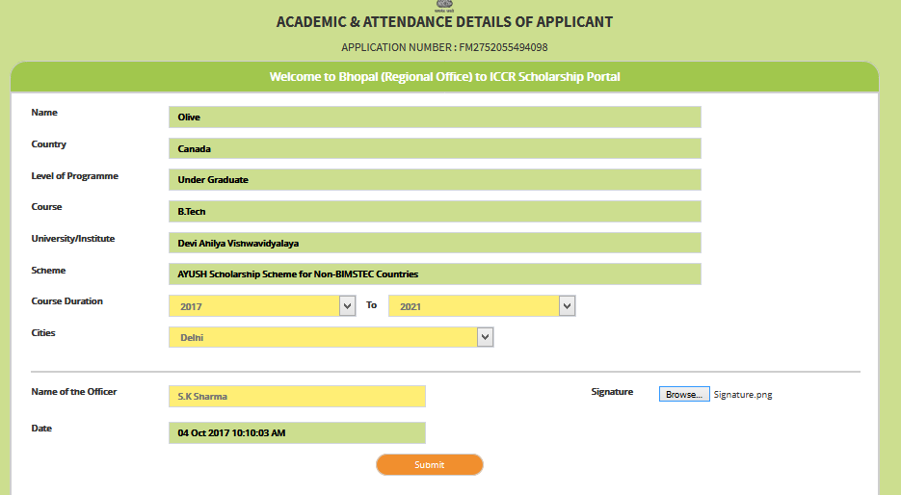

- Click on Submit button
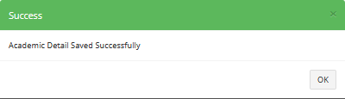
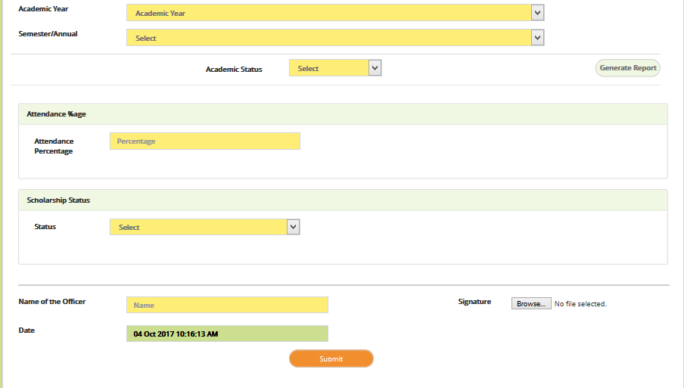

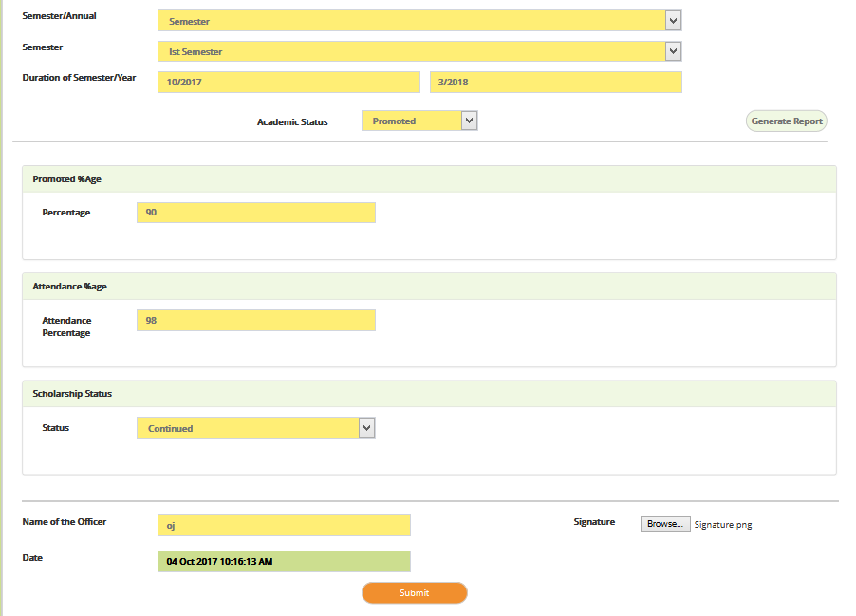

To view the report selects the Academic Year

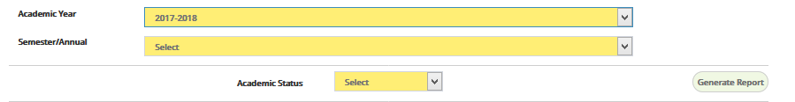

- Click on Generate Report

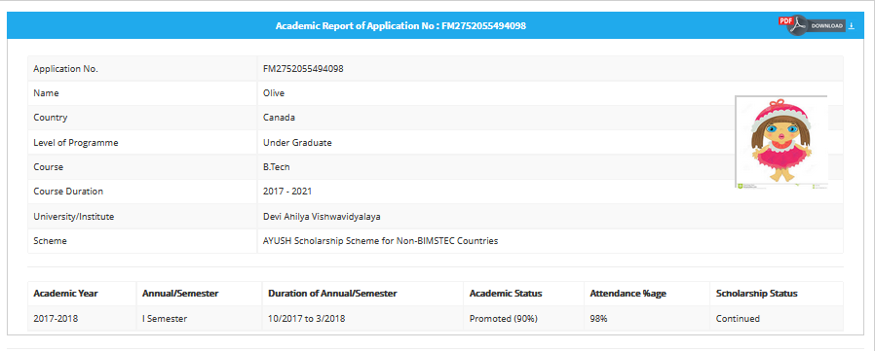

Student VISA Endorsement: -
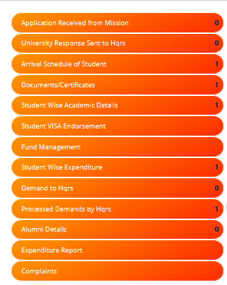
- Click on Student VISA Endorsement
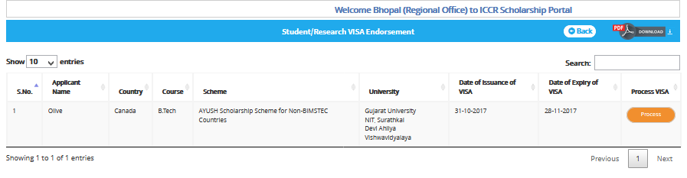
- Click on Process
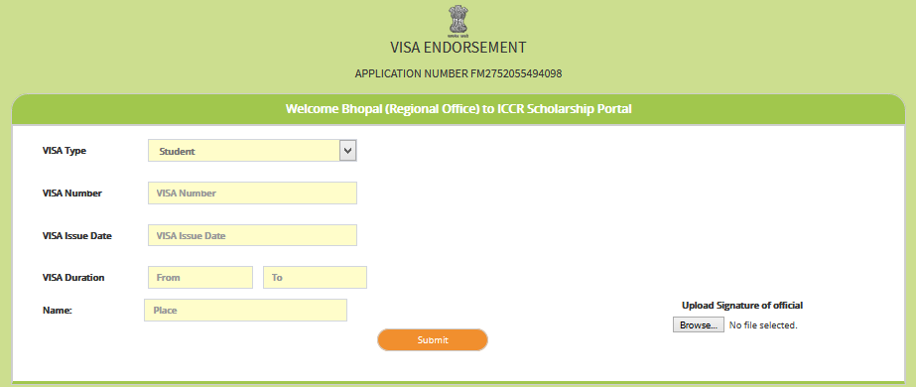

- Fill details

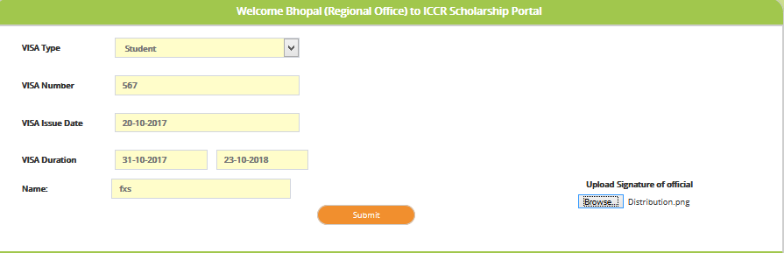

Student Wise Expenditure: -
- Click on Student Wise Expenditure
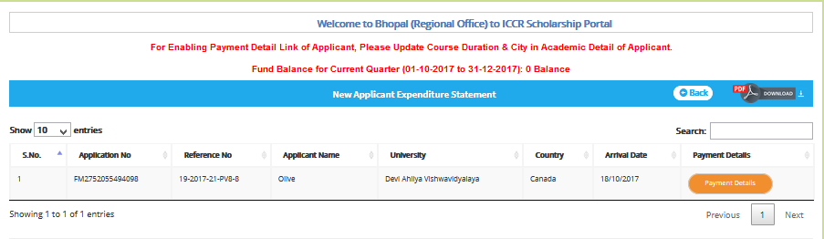

- Click on Payment Details

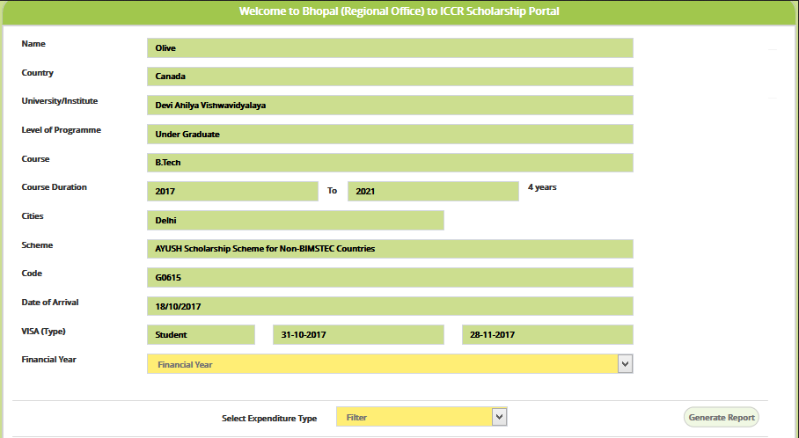

- Select Financial Year
- Select Expenditure Type
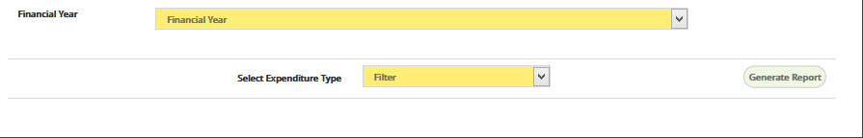
After selecting expenditure type, select payment type will appear
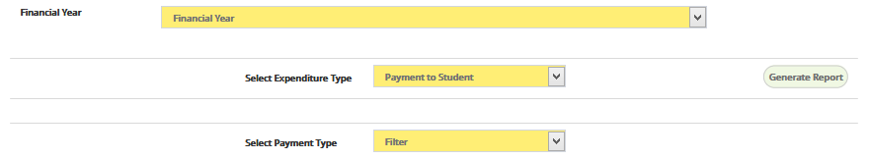

After selecting Payment Type another fields according to selected payment type will display as shown in figure below:-
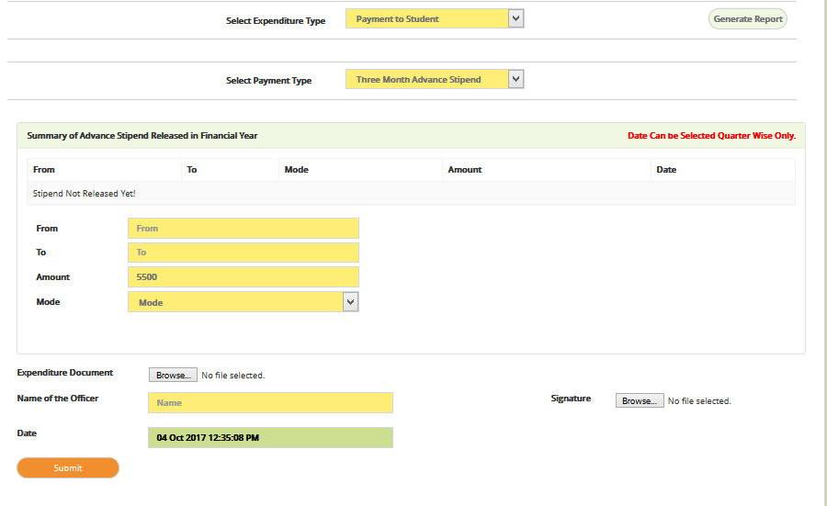
- Fill details
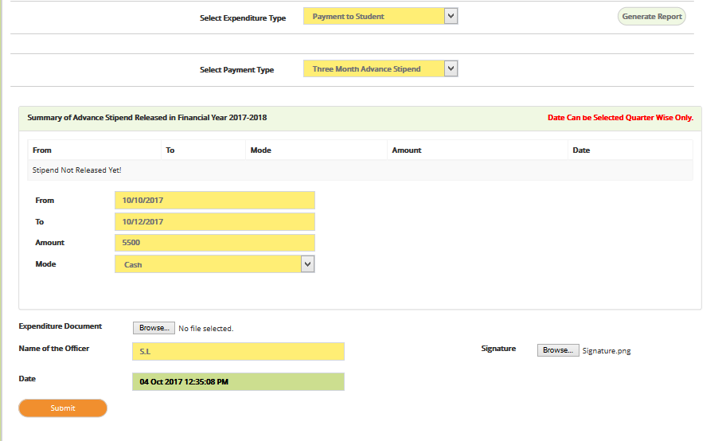

- Click on submit button

To view the report, select the financial year and click on Generate Report

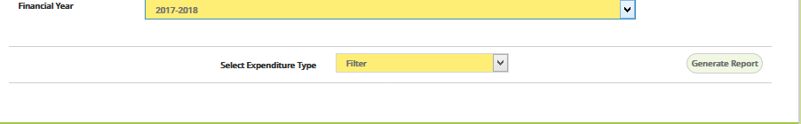

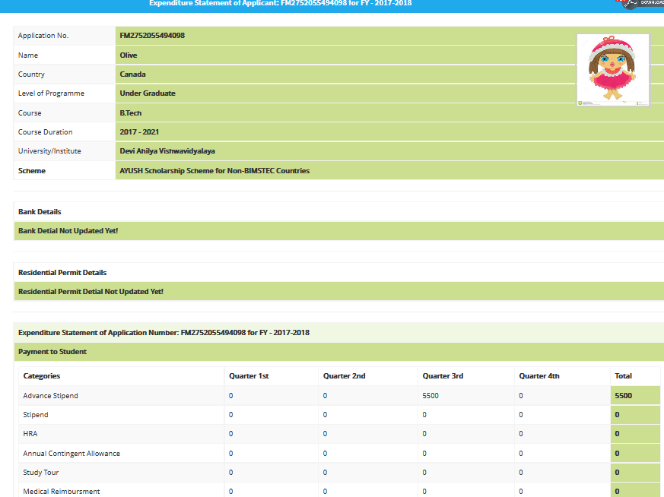

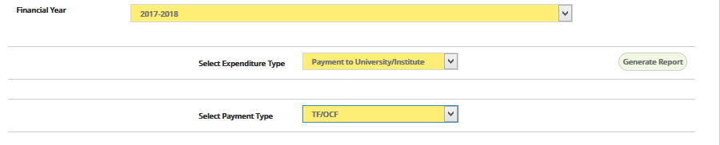After selecting Payment Type another fields according to selected payment type will display as shown in figure below:-

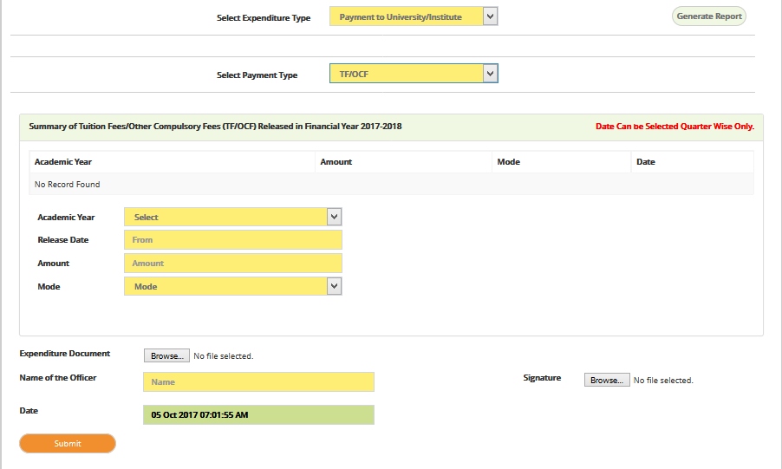

- Fill the details
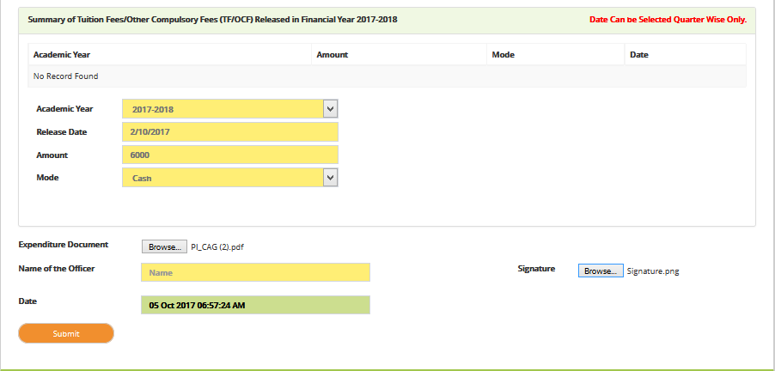
- Click on submit button
User can view the report .

Demand to Hqrs: -
Through this link region can process a demand to Headquarter.

- Click on Demand to Hqrs
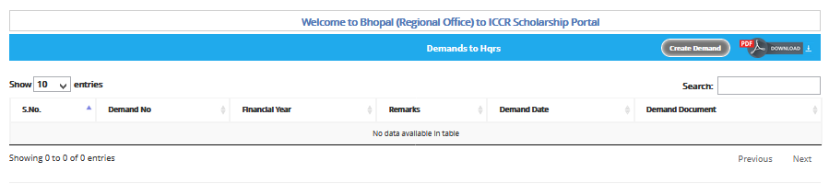
- Click on Create Demand
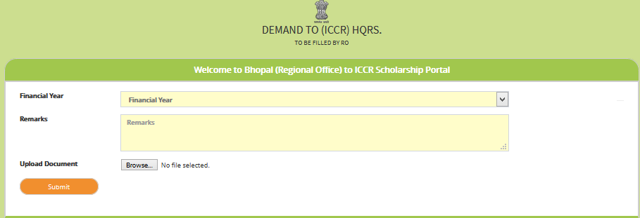

- Select Financial Year
- Enter Remarks
- Upload Document
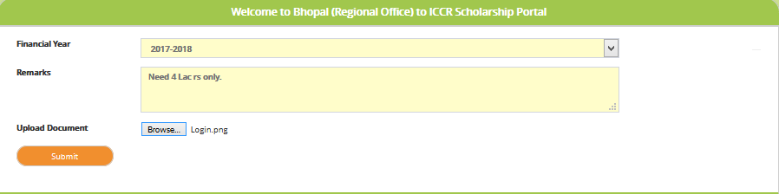
- Click on submit button
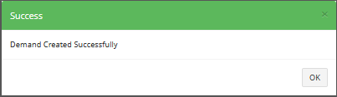

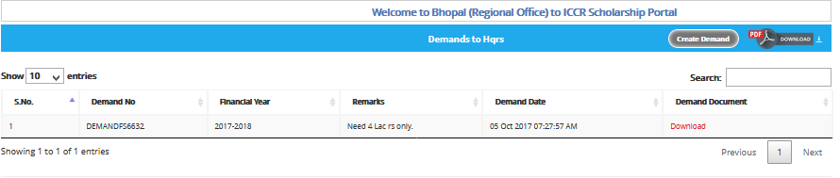
Now headquarter will process the demand. Login by Headquarter

Alumni Details: -
Region can view the details of alumni added by Mission.

- Click on Alumni Application
