# Azure CLI Setup Guide

This tutorial walks through the steps to install, configure, and use the Azure CLI using both desktop and browser-based Cloud Shell methods.

## 1. Download and Install Azure CLI

Visit the official Microsoft page and choose the appropriate installer for your system (32-bit or 64-bit).

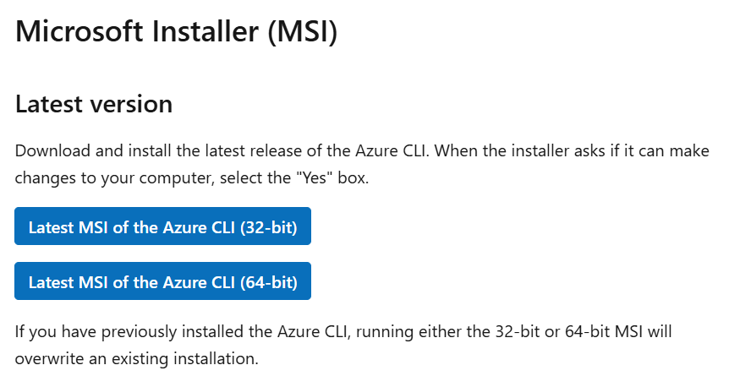

Run the installer and accept the license agreement:

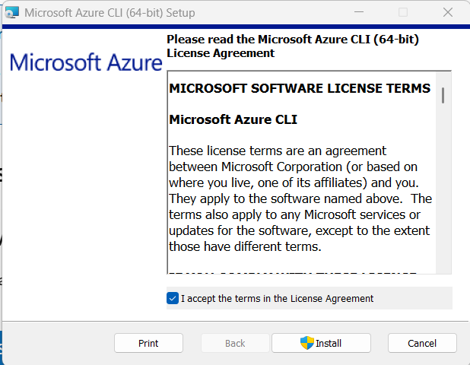

The installation will proceed as shown below:

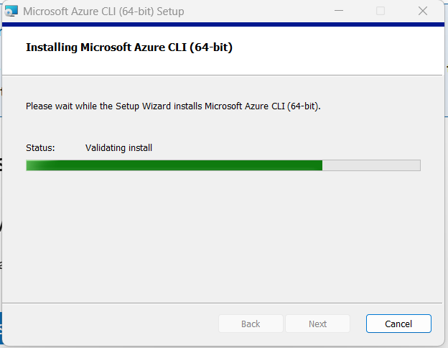

## 2. Access Azure via Portal and Launch Cloud Shell

Login to https://portal.azure.com and access the Azure dashboard.

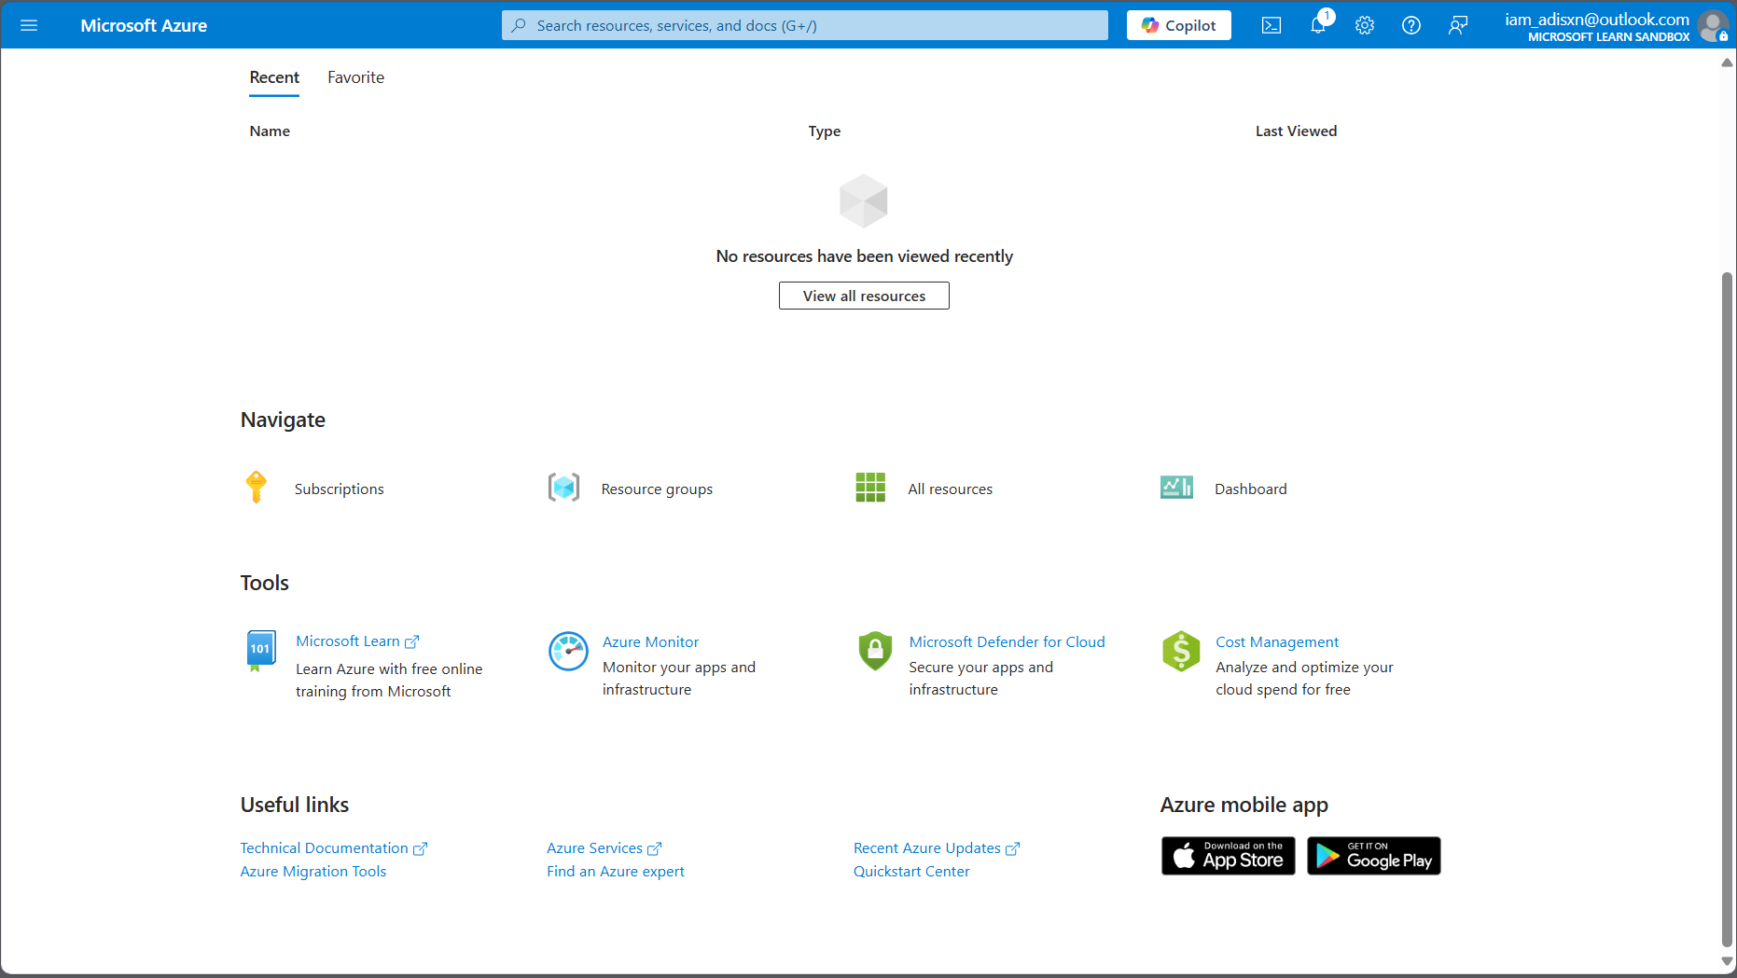

Click on the Cloud Shell icon and choose 'Bash':

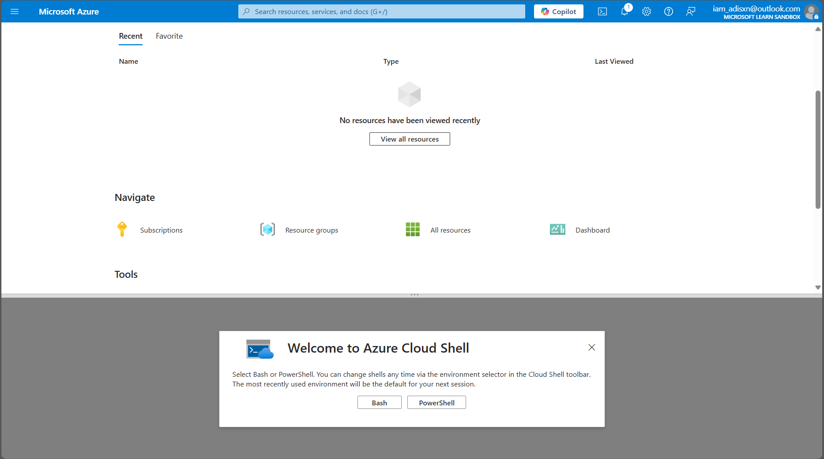

## 3. Use Azure CLI in Bash

After initializing Cloud Shell, you can start using Azure CLI commands such as:

az account show

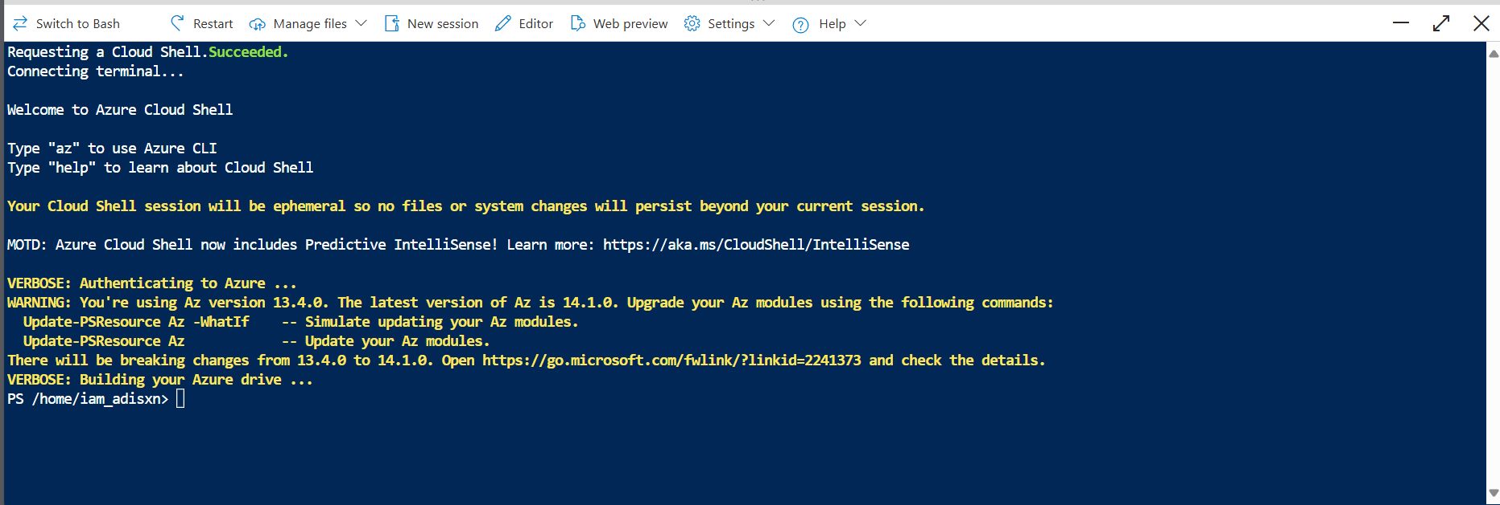

## 4. Switch to PowerShell if Needed

You may also choose to use PowerShell instead of Bash for Azure operations:

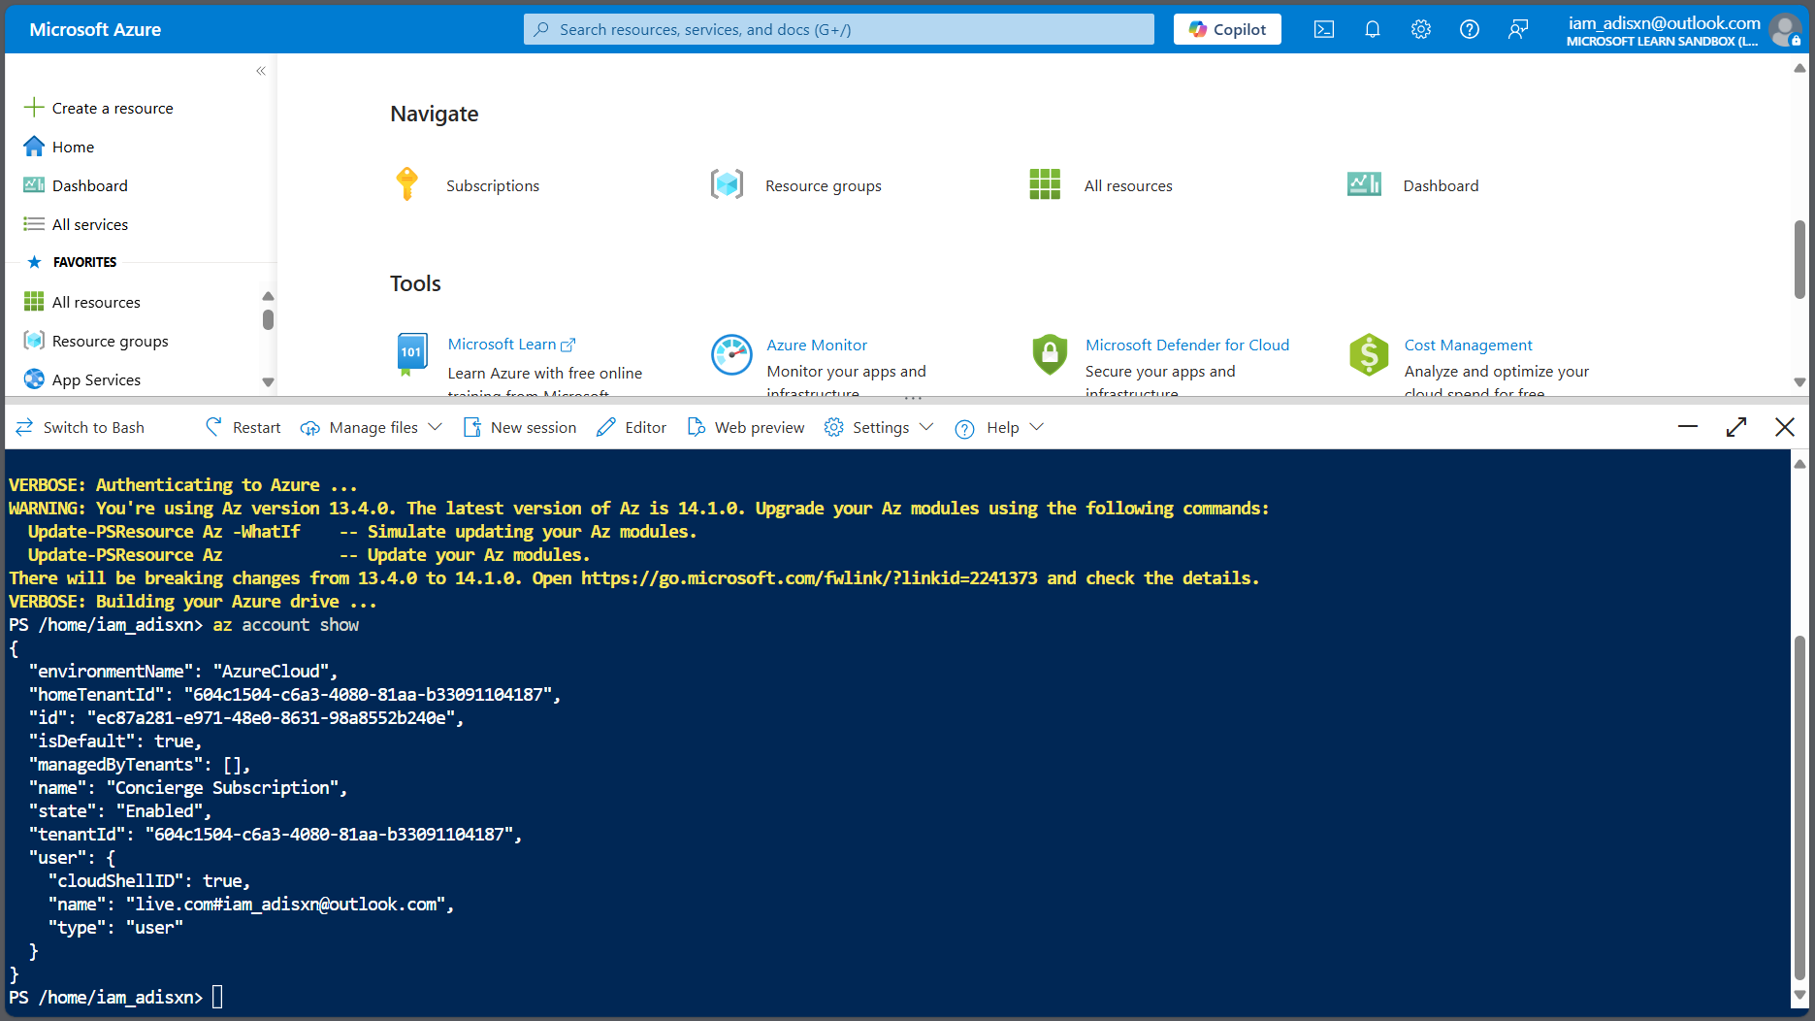

Use the command below to check your subscription:

Get-AzSubscription

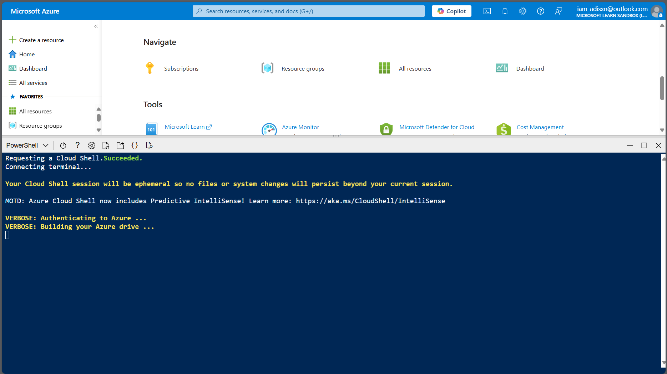

## Summary

- Azure CLI was installed successfully.  
- Accessed Azure through browser-based Cloud Shell.  
- Verified access using CLI commands in Bash and PowerShell.